
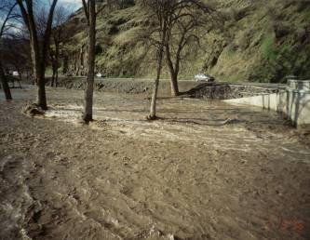
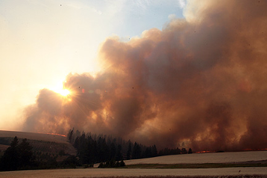
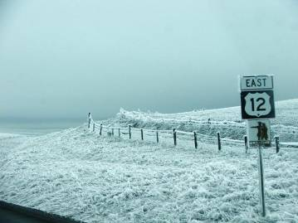
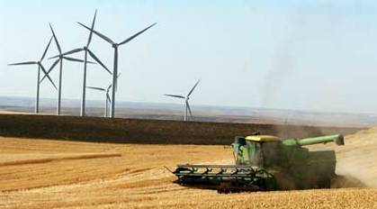
Prepared By
Northwest Management, Inc.

Southeast washington
Multi-hazard mitigation plan

April 2011

Asotin County
Columbia County
GarfieldCounty

Foreword
“Hazard mitigation is any sustained action taken to reduce or eliminate the long-term risk to human life and property from hazards. Mitigation activities may be implemented prior to, during, or after an incident. However, it has been demonstrated that hazard mitigation is most effective when based on an inclusive, comprehensive, long-term plan that is developed before a disaster occurs.”
The Southeast Washington Multi - Hazard Mitigation Plan was developed during 2009-2010 by planning committees in Asotin County, Columbia County, and Garfield County in cooperation with Northwest Management, Inc. of Moscow, Idaho.
This Plan satisfies the requirements for a local multi-hazard mitigation plan and a flood mitigation plan under 44 CFR Part 201.
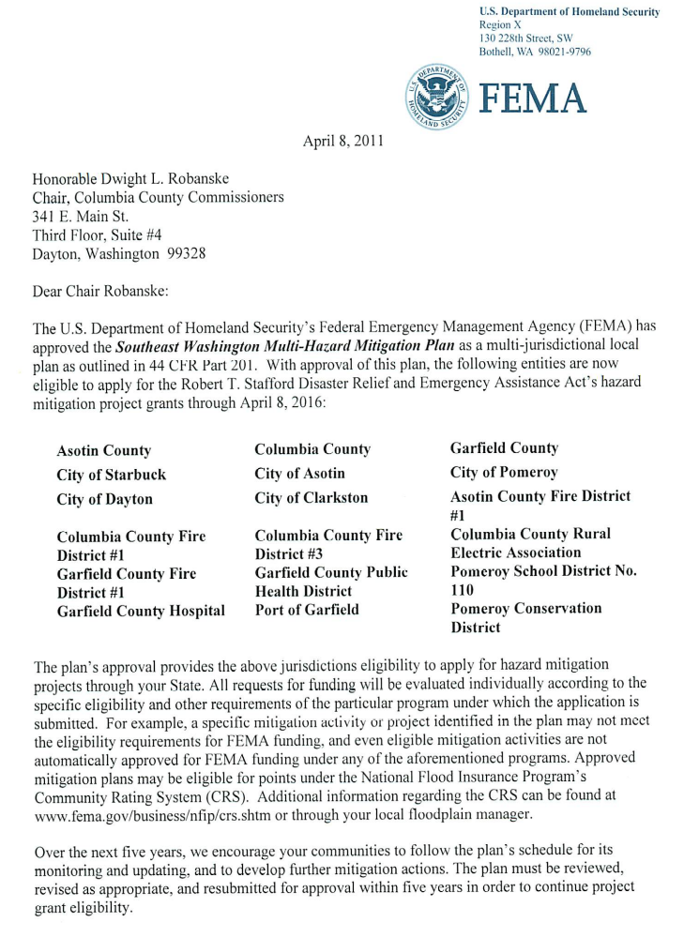
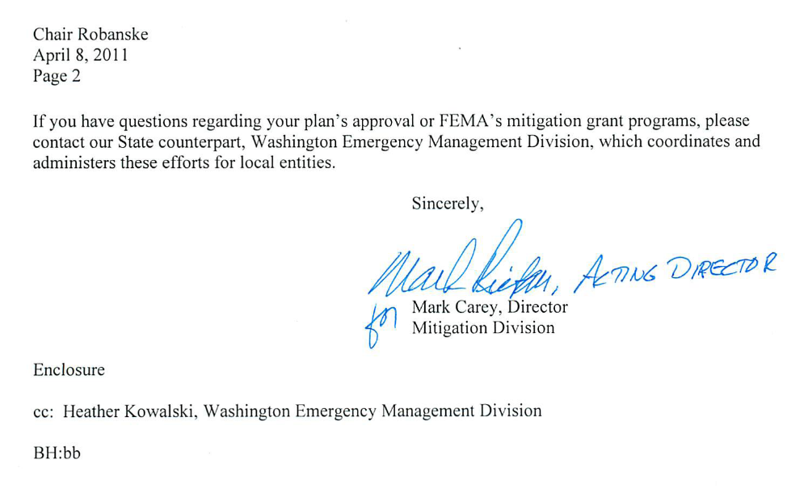

Table of Contents
Foreword 2
Chapter 1 – Plan Overview 8
Overview of this Plan and its Development 8
Phase I Hazard Assessment 9
Goals and Guiding Principles 11
Chapter 2 – Planning Process 28
Documenting the Planning Process 28
Description of the Planning Process 28
The Planning Team 28
Planning Committee Meetings 31
Public Involvement 33
Plan Monitoring and Maintenance 35
Documented Review Process 36
Chapter 3 – Community Profile 40
Southeast Washington Characteristics 40
Description of the Region 40
Geography and Vegetation 40
Demographics 42
Socioeconomics 43
Development Trends 46
Hazard Management Capabilities 47
Regional Hazard Profile 48
Chapter 4 – Regional Hazard Profile 60
Southeast Washington Hazard Profile 60
Flood 60
Earthquake 66
Landslide 72
Severe Weather 76
Wildland Fire 78
Avalanche 88
Tsunami 90
Volcano 92
Drought 96
Chapter 5 – Jurisdictional Assessment 102
Jurisdictional Risk and Vulnerability Assessment 102
Asotin County Annex 103
City of Asotin Annex 127
City of Clarkston Annex 135
Asotin County Fire District #1 Annex 143
Columbia County Annex 146
City of Dayton Annex 172
Town of Starbuck Annex 180
Columbia Rural Electric Association Annex 189
Columbia County Fire District #1 Annex 192
Columbia County Fire District #3 Annex 195
Garfield County Annex 198
City of Pomeroy Annex 223
Garfield County Fire District #1 Annex 232
Pomeroy Conservation District Annex 235
Pomeroy School District No. 110 Annex 238
Garfield County Public Health District Annex 241
Port of Garfield Annex 244
Garfield County Hospital District Annex 247
Regional Issues Annex 250
Levee Certification and Maintenance 250
Wildland Fire 250
Drought 251
Severe Weather 251
Expansion of Windmill Power Generation 251
Snake River Commerce 251
Limited Financial Base 251
Chapter 6 – Mitigation Strategy 254
Administration and Implementation of Action Items 254
Prioritization of Action Items 254
Jurisdictional Mitigation Strategies 261
Chapter 7 – Appendices 302
Supporting Information 302
List of Tables 302
List of Figures 304
List of Figures 304
Local Resolutions of Adoption 305
Planning Committee Minutes 323
Public Meeting Slideshow 331
Potential Funding Sources 334

Chapter 1
Plan Overview
Chapter 1
Plan Overview
IN THIS SECTION:
- Planning Participants
- Phase I Hazard Assessment
- Goals and Guiding Principles
- Integration with Other Local Planning Documents

Chapter 1 – Plan Overview

Overview of this Plan and its Development
This regional Multi - Hazard Mitigation Plan is the result of analyses, professional cooperation and collaboration, assessments of hazard risks and other factors considered with the intent to reduce the potential for hazards to threaten people, structures, infrastructure, and unique ecosystems in Southeast Washington. The planning teams responsible for implementing this project was led by the Emergency Management Departments in each county. Agencies and organizations that participated in the planning process included:
- Asotin County Commissioners and County Departments
- Asotin County Fire District #1
- Cathy McMorris Rodgers’ Office
- City of Asotin
- City of Clarkston
- City of Dayton
- City of Pomeroy
- Columbia County Commissioners and County Departments
- Columbia County Fire District #1
- Columbia County Fire District #3
- Columbia Rural Electric Cooperative
- Garfield County Commissioners and County Departments
- Garfield County Fire District #1
- Garfield County Hospital
- Garfield County Public Health District
- Northwest Management, Inc.
- Pacific Power
- Pomeroy Conservation District
- Pomeroy School District #110
- Port of Garfield
- Puget Sound Energy
- Snake River Salmon Recovery Project
- Town of Starbuck
- USDA Forest Service
- Washington Military Department, Emergency Management Division
In June of 2009, Columbia County Emergency Management solicited competitive bids from companies to provide the service of leading the assessment, developing the data, and writing the Southeast Washington Multi - Hazard Mitigation Plan. Northwest Management, Inc. (NMI) was selected to provide this service to the County. NMI is a natural resources consulting firm located in Moscow, Idaho. The Project Co-Managers from Northwest Management, Inc. were Mr. Vaiden Bloch and Mrs. Tera R. King.

Phase I Hazard Assessment
The Multi - Hazard Mitigation Plan is developed in accordance with the Federal Emergency Management Agency’s (FEMA) and Washington Military Department, Emergency Management Division requirements for a county level pre-disaster mitigation plan. The State of Washington Hazard Mitigation Plan identifies nine natural hazards affecting the State. In an effort to be consistent, the planning committees in Asotin, Columbia, and Garfield Counties developed annexes for the same natural hazards. The hazards addressed in this Plan are:
- Flood  - Earthquake  - Landslide  - Severe Weather  - Wildland Fire | - Avalanche  - Tsunami  - Volcano  - Drought
Additional hazard annexes may be added to this Plan as funding allows. The highest priority hazards to be considered for future evaluation are:
- Hazardous Materials
- Crop Loss
- Dam Failure
- Pandemic
- Terrorism/Civil Unrest
A Phase I Assessment was facilitated with each county planning committee to determine the relative frequency of a hazard’s occurrence and the potential impact a hazard event will have on people, property, infrastructure, and the economy based on local knowledge of past occurrences. A matrix system with hazard magnitude on the x axis and frequency on the y axis was used to score each hazard.
Magnitude of Hazards
Value | Reconstruction Assistance From | Geography (Area) Affected | Expected Bodily Harm | Loss Estimate Range | Population Sheltering Required | Warning Lead Times
1 | Family | Parcel | Little to No Injury / No Death | $1000s | No Sheltering | Months
2 | City | Block or Group of Parcels | Multiple Injuries with Little to No Medical Care / No Death | $10,000s | Little Sheltering | Weeks
2 | County | Section or Numerous Parcels | Major Medical Care Required / Minimal Death | $100,000s | Sheltering Required Neighboring Counties Help | Days
4 | State | Multiple Sections | Major Injuries / Requires Help from Outside County / A Few Deaths | $1,000,000s | Long Term Sheltering Effort | Hours
8 | Federal | Countywide | Massive Casualties / Catastrophic | $10,000,000s | Relocation Required | Minutes
A scoring system (shown above) was also used to categorize the relative magnitude each hazard may have on the community. Frequency was rated as “High” for hazards occurring multiple times per 5 year period, “Medium” for hazards occurring every 5 to 25 years, or “Low” for hazards occurring more than 25 years apart.
The following tables summarize the Phase I Hazard Assessments for each participating county.
Asotin County Phase I Risk Assessment:
Frequency | Magnitude
Frequency |  | Low | Medium | High
Frequency | Low | Avalanche | Tsunami | Earthquake  Volcano
Frequency | Medium | Flood | Landslide
Frequency | High | Severe Weather |  | Wildland Fire  Drought

Garfield County Phase I Risk Assessment:
Frequency | Magnitude
Frequency |  | Low | Medium | High
Frequency | Low | Tsunami  Earthquake  Avalanche | Volcano
Frequency | Medium |  | Wildland Fire  Flood | Drought
Frequency | High |  | Landslide  Severe Weather

Columbia County Phase I Risk Assessment:
Frequency | Magnitude
Frequency |  | Low | Medium | High
Frequency | Low | Earthquake  Landslide  Avalanche  Tsunami |  | Volcano
Frequency | Medium |  |  | Flood  Drought  Wildland Fire
Frequency | High | Severe Weather
The inclusion of additional hazards was considered; however, due to funding limitations, participating jurisdictions chose not to assess technological, man-caused, or other hazards until additional funding becomes available. At such a time, the Multi - Hazard Mitigation Plan will be revised to include additional hazards such as hazardous materials, dam failure, and pandemic.

Goals and Guiding Principles

Federal Emergency Management Agency Philosophy
Effective November 1, 2004, a Multi - Hazard Mitigation Plan approved by the Federal Emergency Management Agency (FEMA) is required for Hazard Mitigation Grant Program (HMGP) and Pre-Disaster Mitigation Program (PDM) eligibility. The HMGP and PDM program provide funding, through state emergency management agencies, to support local mitigation planning and projects to reduce potential disaster damages.
The new local Multi - Hazard Mitigation Plan requirements for HMGP and PDM eligibility is based on the Disaster Mitigation Act of 2000, which amended the Stafford Disaster Relief Act to promote an integrated, cost effective approach to mitigation. Local Multi - Hazard Mitigation Plans must meet the minimum requirements of the Stafford Act-Section 322, as outlined in the criteria contained in 44 CFR Part 201. The plan criteria cover the planning process, risk assessment, mitigation strategy, plan maintenance, and adoption requirements.
In order to be eligible for project funds under the Flood Mitigation Assistance (FMA) program, communities are required under 44 CFR Part 79.6(d)(1) to have a mitigation plan that addresses flood hazards. On October 31st, 2007, FEMA published amendments to the 44 CFR Part 201 at 72 Federal Reg. 61720 to incorporated mitigation planning requirements for the FMA program (44 CFR Part 201.6). The revised Local Mitigation Plan Review Crosswalk (July 2008) used by FEMA to evaluate local hazard mitigation plans is consistent with the Robert T. Stafford Disaster Relief and Emergency Assistance Act, as amended by Section 322 of the Disaster Mitigation Act of 2000, the National Flood Insurance Act of 1968, as amended by the National Flood Insurance Reform Act of 2004 and 44 Code of Federal Regulations (CFR) Part 201 – Mitigation Planning, inclusive of all amendments through October 31, 2007 was used as the official guide for development of a FEMA-compatible Southeast Washington Regional Multi-Hazard Mitigation Plan.
FEMA will only review a local Multi - Hazard Mitigation Plan submitted through the appropriate State Hazard Mitigation Officer (SHMO). Draft versions of local Multi - Hazard Mitigation Plans will not be reviewed by FEMA. FEMA will review the final version of a plan prior to local adoption to determine if the plan meets the criteria, but FEMA will be unable to approve it prior to adoption.
In Washington the SHMO is:
Mark Stewart
Washington Military Department
Emergency Management Division
Building 20, M/S: TA-20
Camp Murray, WA 98430-5122
A FEMA designed plan will be evaluated on its adherence to a variety of criteria.
- Adoption by the Local Governing Body
- Multi-jurisdictional Plan Adoption
- Multi-jurisdictional Planning Participation
- Documentation of Planning Process
- Identifying Hazards
- Profiling Hazard Events
- Assessing Vulnerability: Identifying Assets
- Assessing Vulnerability: Estimating Potential Losses
- Assessing Vulnerability: Analyzing Development Trends
- Multi-jurisdictional Risk Assessment
- Local Hazard Mitigation Goals
- Identification and Analysis of Mitigation Measures
- Implementation of Mitigation Measures
- Multi-jurisdictional Mitigation Strategy
- Monitoring, Evaluating, and Updating the Plan
- Implementation Through Existing Programs
- Continued Public Involvement

Planning Philosophy and Goals

Southeast Washington Planning Philosophy
This effort will utilize the best and most appropriate science from all partners and will integrate local and regional knowledge about natural hazards while meeting the needs of local citizens, the regional economy.
Mission Statement
To make residents, communities, state agencies, local governments, and businesses less vulnerable to the effects of hazards through the effective administration of hazard mitigation grant programs, hazard risk assessments, wise and efficient infrastructure hardening, and a coordinated approach to mitigation policy through federal, state, regional, and local planning efforts. Our combined priorities will be the protection of people, structures, infrastructure, and unique ecosystems that contribute to our way of life and the sustainability of the local and regional economy.

Jurisdictional Planning and Mitigation Goals
Southeast Washington:
- Planning Goal - Prioritize the protection of people, structures, infrastructure, and unique ecosystems that contribute to our way of life and the sustainability of the local and regional economy.
- Planning Goal - Educate communities about the unique challenges of natural hazard preparedness in the county.
- Planning Goal - Develop land use policies to alleviate potential hazard risks and impacts for future development.
- Planning Goal - Establish mitigation priorities and develop mitigation strategies.
- Planning Goal - Strategically locate and plan infrastructure projects that take into consideration the impacts of natural hazards.
- Planning Goal - Strengthen emergency operations plans and procedures by increasing collaboration among public agencies, non-profit organizations, business, and industry.
- Planning Goal - Seek opportunities to protect, enhance, and integrate emergency and essential services with land use planning and natural resource management.
- Planning Goal - Identify, prioritize, and implement strategies to integrate land use and protection of unique ecosystems in a manner consistent with the protection of essential infrastructure.
- Mitigation Goal - Reduce the impact of hazard events and potential losses incurred by both public and private residents and entities.
- Mitigation Goal - Increase county and city participation in the National Flood Insurance Program and strive to reduce premiums by lowering their Community Rating System score.
Asotin County:
- Planning Goal - Work with the cities of Asotin and Clarkston to reduce losses from structure fires.
- Planning Goal - Work with the city of Asotin to alleviate flood impacts and develop an emergency flood warning system for citizens living on Asotin Creek within the city limits.
- Planning Goal - Work with the cities of Asotin and Clarkston and local organizations to improve sheltering capacity in case of severe hazard events.
- Planning Goal – Improve Asotin County’s emergency response capabilities and disaster preparedness.
- Mitigation Goal - Identify hazardous material flow through the county.
City of Clarkston
- Planning Goal - Strive for improved fire protection through beneficial mutual aid agreements that benefit all jurisdictions involved.
- Planning Goal - Provide an educational process that identifies simple measures citizens can accomplish to help prevent personal property flooding and other damages from severe storms.
- Mitigation Goal - Provide proper enforcement of applicable codes to assure protection of properties during severe storms or other natural disasters.
- Mitigation Goal - Participate in the National Flood Insurance Program.
- Mitigation Goal - Identify and protect critical infrastructure through proper operations and maintenance.
City of Asotin
- Mitigation Goal - Improve the functionality of the city fire station.
- Mitigation Goal - Reestablish the marina as a functional resource and asset for Asotin.
- Mitigation Goal - Lessen the impact of flooding on the community, particularly public infrastructure.
Asotin County Fire District #1
- Planning Goal - Improve all risk preparedness to protect life, property and environment.
- Planning Goal - Help educate public on hazard/disaster preparedness.
- Planning Goal - Seek opportunities to strengthen hazard and rescue response on the rivers.
- Planning Goal - Strengthen Emergency Operations Center and plans with the County.
- Mitigation Goal - Improve fire hazards in the urban interface.
- Mitigation Goal - Increase County participation to alleviate hazard risks with future development.
- Mitigation Goal - Identify high risk areas for natural or manmade hazards.
- Planning Goal - Identify funding sources for mandatory equipment and personal protective gear upgrades and work on recruitment and retention of firefighters.
Columbia County:
- Planning Goal - Ensure prompt restoration of critical transportation functions following hazard events.
- Planning Goal - Use effective administration of hazard mitigation grant programs, hazard risk assessments, wise and efficient infrastructure hardening, and a coordinated approach to mitigation policy through federal, state, regional, and local planning efforts.
- Mitigation Goal - Reduce damage to infrastructure caused by flash flooding.
- Mitigation Goal - Reduce the loss of life and injuries, reduce property damage, protect critical infrastructure from riverine flooding.
- Mitigation Goal - Reduce water demand, conserve water, augment existing water supplies, and improve public information regarding drought.
- Mitigation Goal - Protect infrastructure, reduce damage to structures, and improve public awareness regarding wildland fire.
- Mitigation Goal - Reduce damage to power supplies, infrastructure, and structures from severe storm damage.
- Mitigation Goal - Make the residents and businesses of Columbia County, the city of Dayton, and the Town of Starbuck less vulnerable to the effects of natural and man-made hazards.
City of Dayton
- Planning Goal - Use effective administration of hazard mitigation grant programs, hazard risk assessments, wise and efficient infrastructure hardening, and a coordinated approach to mitigation policy through federal, state, regional, and local planning efforts.
- Planning Goal - Ensure prompt restoration of critical transportation functions following hazard events.
- Mitigation Goal - Make the residents and businesses of Dayton less vulnerable to the effects of natural and man-made hazards.
- Mitigation Goal - Reduce damage to infrastructure caused by flash flooding.
- Mitigation Goal - Reduce the loss of life and injuries, reduce property damage, protect critical infrastructure from riverine flooding.
- Mitigation Goal - Reduce water demand, conserve water, augment existing water supplies, and improve public information regarding drought.
- Mitigation Goal - Protect infrastructure, reduce damage to structures, and improve public awareness regarding wildland fire.
- Mitigation Goal - Reduce damage to power supplies, infrastructure, and structures from severe storm damage.
- Mitigation Goal - Provide residents of Dayton reliable and safe drinking water and solid waste treatment during a flood event.
Town of Starbuck
- Planning Goal - Educate residents of Starbuck on the use of the existing Evacuation Plan, plan evacuation drills, and update the Evacuation Plan as is necessary.
- Planning Goal - Further protect the Town of Starbuck from major flooding events.
- Planning Goal - Protect personal property from fire and alleviate the potential risk to volunteer firemen by encouraging and enforcing a biomass reduction program within the Town of Starbuck.
- Planning Goal - Coordinate an emergency response effort by local personnel in the event of a medical emergency.
- Mitigation Goal - Encourage Columbia County to prioritize placement of a new bridge over the Tucannon River at Kellogg Hollow Road.
- Mitigation Goal - Continue to enforce the current Town of Starbuck Flood Protection Ordinances by adhering to floodway and floodplain guidelines.
- Mitigation Goal - Prevent contamination of the Town of Starbuck Wastewater Treatment site by enforcing compliance with individual onsite septic regulation and rules and revising the current ordinances.
- Mitigation Goal - Design an effective water use policy to preserve the existing aquifer in compliance with the newly drafted Washington State Water Use Rule.
- Mitigation Goal – Prepare residents for the impacts of severe weather events and implement practices that will help reduce these impacts overall.
- Mitigation Goal – Use the Tucannon River Floodplain study to identify areas of insufficiency in the current levee system.
Columbia County Fire District #1
- Mitigation Goal - Provide better service to constituents and assistance to neighbors.
Columbia County Fire District #3
- Mitigation Goal - Install safety systems in main station.
- Mitigation Goal - Improve the functionality of the main station facility.
- Mitigation Goal - Provide better services to constituents.
Columbia Rural Electric Association
- Mitigation Goal - Reduce damage to power delivery infrastructure from severe storms.
- Mitigation Goal - Protect and reduce damage to power delivery infrastructure from wildland fire.
- Mitigation Goal - Protect and reduce damage to power delivery infrastructure from flooding along waterways.
Garfield County:
- Planning Goal - Identify all hazards that may affect life and property in Garfield County and develop solutions to effectively mitigate those risks.
- Mitigation Goal - Enhance the County’s ability to respond to and notify the public about hazard situations.
- Mitigation Goal - Improve response capabilities within the Garfield County Sheriff’s office, Road Department, and in the City of Pomeroy.
- Mitigation Goal - Improve County’s GIS capabilities in order to better identify and track hazards and risks.
- Mitigation Goal - Improve Sheriff’s office ability to respond to all types of hazards.
City of Pomeroy
- Planning Goal - Prioritize the protection of people, structures, infrastructure, and unique ecosystems that contribute to our way of life and the sustainability of the local and regional economy.
- Planning Goal - Educate communities about the unique challenges of natural hazard preparedness.
- Planning Goal - Seek ways to reduce fire hazards in critical areas.
- Planning Goal - Strategically locate and plan infrastructure projects that take into consideration the impacts of natural hazards.
- Planning Goal - Strengthen emergency operations plans and procedures by increasing collaboration among public agencies, non-profit organizations, business, and industry.
- Planning Goal - Seek opportunities to protect, enhance, and integrate emergency and essential services with land use planning and natural resource management.
- Planning Goal - Look for ways to protect City water supplies from vandalism and other hazards.
- Mitigation Goal - Reduce the impact of hazard events and potential losses incurred by both public and private residents and entities.
- Mitigation Goal - Develop land use policies to alleviate potential hazard risks and impact for future development. Increase county and city participation in the NFIP and strive to reduce premiums by lowering their CRS score.
- Mitigation Goal - Establish mitigation priorities and develop mitigation strategies.
- Mitigation Goal - Identify areas of potential flooding and work with emergency management personnel to establish an action plan for future events.
- Mitigation Goal - Work with local government agencies to develop a flood warning system for local citizens.
- Mitigation Goal - Work with local organizations to improve sheltering capacity during severe weather events.
Garfield County Fire District #1
- Planning Goal - Identify hazards related to structure and wildland fires, hazardous materials, and natural disasters.
- Mitigation Goal - Provide fire, rescue, and emergency medical response to the residents of Garfield County and the city of Pomeroy.
Pomeroy Conservation District
- Planning Goal - Promote conservation practices and best management practices that will protect and enhance the natural resources of Garfield County.
- Planning Goal - Identify conditions on the land that may harm the public.
- Mitigation Goal - Assist the farmers and ranchers of Garfield County with service, expertise, and funding to manage for the conservation, preservation, and enhancement of the natural resources within the Pomeroy Conservation District.
- Mitigation Goal - Help mitigate the cost of conservation activities to landowners and operators.
- Mitigation Goal - Assist the public in the event of hazards affecting the quality of life and safety.
Garfield County Health District
- Planning Goal - Provide professional, caring services that motivate individuals to a higher level of physical, mental, and environmental health awareness and responsibility.
- Mitigation Goal - Assist the public in the event of hazards affecting the quality of life and safety.

Pomeroy School District No. 110
  - Planning Goal - Identify hazards related to structure and wildland fires, hazardous materials, and natural disasters.
  - Mitigation Goal - Continue to improve emergency plans and procedures to reduce or eliminate long-term risk to life and property as a result of hazard events.
Garfield County Hospital District
- Planning Goal - Improve Incident Command Training for personnel throughout the facility.
- Mitigation Goal - Continue to improve emergency plans and procedures to reduce or eliminate long-term risk to life and property as a result of hazard events.
Port of Garfield:
- Planning Goal - Develop plans that would lessen hazard impacts (flooding, fire, wind, and rain) on the future economic development on the Port of Garfield industrial property.
- Mitigation Goal - Create mitigation strategies that will alleviate hazard impacts such as:
  - Not locating development in the 100-year floodplain without consulting with FEMA
  - Installing enough fire hydrants to accommodate all structures
  - Locate new structures out of damaging wind flow patterns
  - Maintaining industrial grounds to prevent hazardous situations.

Integration with Other Local Planning Documents
During the development of this Multi - Hazard Mitigation Plan several planning and management documents were reviewed in order to avoid conflicting goals and objectives as well as to identify planning mechanisms that may incorporate the information and requirements contained in this Plan. Existing programs and policies were reviewed in order to identify those that may weaken or enhance the hazard mitigation objectives outlined in this document. The following narratives help identify and briefly describe some of the existing planning documents and ordinances considered during the development of this plan.

Emergency Action Plan for the Hells Canyon Dam and Power Plant
The purpose of the Emergency Action Plan is to provide a detailed plan of operations and a notification flowchart in the event of a hazardous or an emergency condition existing at the Hells Canyon Dam. Following the guidelines and notification flowcharts described in the Emergency Action Plan will provide maximum early warning of a potentially hazardous condition at the Hells Canyon Dam to persons downstream. The document includes contact information, inundation maps, and predicted timeframes for flood waves in the event of a dam break.

Flood Emergency Subplans for Notification and Inundation Maps – Dworshak Dam and Reservoir
The document provides flood emergency planning and guidance for implementing flood control procedures and evacuation of flood areas in case of flood emergencies. The document includes inundation maps and predicted timeframes for floodwaves in the event of a dambreak.

Asotin County Emergency Operations Plan
In 2009, Asotin County Emergency Management completed an Emergency Operations Plan including 16 emergency support functions that are critical to effective disaster response. This document provides guidance regarding which entities are responsible for what actions and what types of capabilities are available in Asotin County.

Asotin County Hazard Identification and Vulnerability Assessment
The Asotin County Hazard Identification and Vulnerability Assessment (HIVA) provides information on potential natural and technological (man-made) hazards, which can adversely impact the people, economy, environment, and property of Asotin County. It serves as a basis for City/County-level emergency management programs and assists political subdivisions in the development of similar documents focused on local hazards. It is the foundation of effective emergency management and identifies the hazards that organizations must mitigate against, prepare for, respond to, and recover from in order to minimize the effects of disasters and emergencies. The information is extracted from various publications with contributions from technical experts. The HIVA is not a detailed study, but a general overview of hazards that can cause emergencies and disasters.

Asotin County Shorelines Management Program
Uses and activities along the state shorelines are managed through shoreline master programs. Each Master Program is both a plan and a set of regulations created specifically for the shorelines of that community. While Master Programs are tailored to local issues and physical constraints, they must conform to statewide guidelines, goals, and policies. The State’s Shoreline Management Act (SMA) sets up a process for managing development of the state’s shorelines through state-monitored, locally administered permitting programs. Asotin County is required to prepare a detailed shoreline inventory and a “Shoreline Master Program” to manage shoreline development. Following approval of the its Master Program, Asotin County is required to administer and enforce a procedure for issuing permits for activities in the shoreline area.

Asotin County Flood Damage Prevention Ordinance
The Flood Damage Prevention Ordinance was adopted to promote public health, safety, and general welfare, and to minimize public and private losses due to flood conditions in specific areas through participation in the National Flood Insurance Program (NFIP). The ordinance includes standards and provisions that encourage sound floodplain management and when implemented allows property owners to obtain flood insurance at a more affordable rate. In order to accomplish its purposes, the ordinance includes methods and provisions for:
- Restricting or prohibiting uses which are dangerous to health, safety, and property due to water or erosion hazards, or which result in damaging increases in erosion or in flood heights or velocities;
- Requiring that uses vulnerable to floods, including facilities which serve such uses, be protected against flood damage at the time of initial construction;
- Controlling the alteration of natural flood plains, stream channels, and natural protective barriers, which help accommodate or channel flood water;
- Controlling filling, grading, dredging, and other development which may increase flood damage; and
- Preventing or regulating the construction of flood barriers which will unnaturally divert flood waters or may increase flood hazards in other areas.

Asotin County Community Wildfire Protection Plan
This Community Wildfire Protection Plan (CWPP) for Asotin County is the result of analyses, professional cooperation and collaboration, assessments of wildfire risks and other factors considered with the intent to reduce the potential for wildfires to threaten people, structures, infrastructure, and unique ecosystems in Asotin County, Washington. The Plan details the County’s response capabilities as well as lists a mitigation strategy and proposed projects recommended to lessen the impacts wildland fire.

Columbia County Comprehensive Emergency Management Plan
The Columbia County Department of Emergency Management’s mission is to coordinate and facilitate resources to minimize the impacts of disasters and emergencies on people, property, the environment and the economy of Columbia County. Through planning, coordination, education, training, and community awareness, the County will prepare for; respond to; recover from; and mitigate the effects of a disaster for all who live, work or visit here. The purpose of the Plan is to establish responsibilities for agencies and organizations within Columbia County for preparation for, response to, recovery from, and mitigation of the effects of emergencies and disasters.

Columbia County Comprehensive Flood Hazard Management Plan
The Comprehensive Flood Hazard Management Plan (CFHMP) was prepared to address flood hazard management issues associated primarily with the Touchet, Patit, and Tucannon Rivers. The primary goal was to identify and evaluate flood problems caused by these rivers and develop cost effective alternatives for the mitigation of these problems.

Columbia County Community Wildfire Protection Plan
This Community Wildfire Protection Plan (CWPP) for Columbia County is the result of analyses, professional cooperation and collaboration, assessments of wildfire risks and other factors considered with the intent to reduce the potential for wildfires to threaten people, structures, infrastructure, and unique ecosystems in Columbia County, Washington. The Plan details the County’s response capabilities as well as lists a mitigation strategy and proposed projects recommended to lessen the impacts wildland fire.

City of Dayton Comprehensive Land Use Plan
Recognizing the importance of planning, the Columbia County Board of Commissioners opted into the state's Growth Management Act [GMA] in 1991. The GMA requires the City to address several aspects of planning including adopting and revising a comprehensive plan. The primary reason for a comprehensive plan is to enable local government officials and citizens to anticipate and to deal constructively with the changes occurring within the city. Change is inevitable in every community whether it is growing or declining. By looking at the past, what is liked and disliked about the community now, we can acquire insight into the possibilities for the future and influence future development. The Comprehensive Plan is a vehicle through which Dayton's governmental officials and citizens can express their goals for the future of their City and guide the City towards those goals.

Town of Starbuck Emergency Evacuation Plan
The Starbuck Emergency Evacuation Plan has been developed to provide an organized community response for a complete or partial evacuation in the event of a community disaster. To order a mandatory evacuation, the local authority must declare a “State of Emergency” as enables under the Emergency Management Act. The Plan identifies hazardous spill/explosion, wildfire, flood, and ice storms with power outages as the most likely events to cause and community-wide evacuation.

Garfield County Hazard Identification and Vulnerability Assessment
The Garfield County Hazard Identification and Vulnerability Assessment (HIVA) provides information on potential natural and technological (man-made) hazards, which can adversely impact the people, economy, environment, and property of Garfield County. It serves as a basis for County-level emergency management programs and assists political subdivisions in the development of similar documents focused on local hazards. It is the foundation of effective emergency management and identifies the hazards that organizations must mitigate against, prepare for, respond to, and recover from in order to minimize the effects of disasters and emergencies. The information is extracted from various publications with contributions from technical experts. The HIVA is not a detailed study, but a general overview of hazards that can cause emergencies and disasters.

Garfield County Comprehensive Emergency Management Plan
The Comprehensive Plan is in compliance with Washington State Comprehensive Emergency Management Plan, May 2002. The Plan, including its appendices, check lists and other supporting documents, provides for coordination of man -made or natural emergency disaster operations throughout all levels of county and municipal governments within Garfield County. The basic concept of operations in a major disaster is the use of mutual aid agreements and letters of understanding entered upon by the City of Pomeroy and Garfield County. The Plan provides guidance and direction to all of Garfield County. The Plan provides a foundation for a continuing effort to incorporate National Incident Management System (NIMS) in plans to meet and overcome emergencies and disasters of all scales, establishing mutual understanding among the numerous government and tribal agencies, business’s, industries, volunteer organizations, and citizens of Garfield county, and coordination with comprehensive emergency management plans and programs of the federal government, the State of Washington, emergency management jurisdictions of Garfield County, and the surrounding jurisdictions.

Garfield County Health District Emergency Response Plan
The Garfield County Health District Emergency Response Plan covers the Health District’s operational procedures for dealing with communicable disease and other emergencies, mass prophylaxis treatment and vaccination, and pandemic flu. The Plan includes contact information, response partners, stockpile plans, and other critical information.

Garfield County and City of Pomeroy Hazardous Material/Radiological Disaster Preparedness Plan
The plan is intended to provide guidance for hazardous materials incident notification and response; off-site emergency planning/notification procedures as required by SARA Title III; and the Emergency Planning & Community Right-to-Know Act of 1986, which shall be referred to as EPCRA. The plan provides a foundation for a continuing effort to incorporate National Incident Management System (NIMS) in plans to meet and overcome emergencies and disasters of all scales, establishing mutual understanding among the numerous government and tribal agencies, businesses, industries, volunteer organizations, and citizens of Garfield County, and coordination with comprehensive emergency management plans and programs of the federal government, the State of Washington, emergency management jurisdictions of Garfield County, and the surrounding jurisdictions.

Garfield County Mass Casualty Plan
Fire Departments are tasked with the protection of property and life safety. In the event of a disaster, whether natural or the result of a man made event, the immediate response to that incident will be by the fire jurisdiction. Mutual aid and first response agreement s allow for the immediate resources of additional staffing and equipment. In the event of a major incident, the demand for an orchestrated plan allowing coordination of multiple agencies will facilitate resolving that incident safely and efficiently. The purpose of a county (region) wide adopted plan for mass casualty incidents is to achieve overall understanding of personnel assisting neighboring departments. In addition, with a coordinated county plan the use of the common terminology and systematic delivery to a mass casualty incident will integrate the immediate involvement of mutual aid, strike teams, and task forces when requested by incident commanders.

Garfield County Hospital Emergency Incident Command System
The purpose of this policy statement is to define the operating policies, procedures, staffing, qualifications and use of the Hospital Emergency Incident Command System (HEICS) and to provide for command & control structure in the event of any incident that places a burden on Hospital District Resources exceeding routine conditions.

Garfield County Hospital District Emergency Polices and Procedures Manual
The Garfield County Hospital District has developed a manual outlining all of its policies and procedures for a number of potential incidents including hazard events. The manual includes contact numbers, appropriate reporting forms, evacuation plans, and operational procedures to follow in the event of an emergency or other type of incident.

Garfield County Community Wildfire Protection Plan
This Community Wildfire Protection Plan (CWPP) for Garfield County is the result of analyses, professional cooperation and collaboration, assessments of wildfire risks and other factors considered with the intent to reduce the potential for wildfires to threaten people, structures, infrastructure, and unique ecosystems in Garfield County, Washington. The Plan details the County’s response capabilities as well as lists a mitigation strategy and proposed projects recommended to lessen the impacts wildland fire.

Pomeroy School District No. 110 Emergency Procedures
The Pomeroy School District #110 is committed to emergency planning. Emergency procedures specific to the school district have been developed and revised in coordination with community emergency agencies. These procedures will facilitate a rapid, coordinated, effective response in the event of a disaster or other emergency event such as inclement weather, earthquakes, etc.

This page was intentionally left blank.

Chapter 2
Chapter 2
Planning Process
Planning Process
IN THIS SECTION:
- Description of the Planning Process
- The Planning Team
- Planning Committee Meetings
- Public Involvement

Chapter 2 – Planning Process

Documenting the Planning Process
Documentation of the planning process, including public involvement, is required to meet FEMA’s DMA 2000 (44CFR§201.4(c)(1) and §201.6(c)(1)). This section includes a description of the planning process used to develop this plan, including how it was prepared, who was involved in the process, and how all of the involved agencies participated.

Description of the Planning Process
The Southeast Washington Multi - Hazard Mitigation Plan was developed through a collaborative process involving all of the organizations and agencies detailed in Chapter 1 of this document. The planning effort began by organizing and convening countywide planning committees. Once basic information for each county and participating jurisdiction was collected and discussed at county-level committee meetings, representative from all three county planning committees met to discuss more regional hazard and mitigation issues.
The planning process included five distinct phases which were in some cases sequential (step 1 then step 2) and in some cases intermixed (step 4 completed throughout the process):
- Collection of Data about the extent and periodicity of hazards in each County to ensure a robust dataset for making inferences about hazards in Asotin, Columbia, and Garfield Counties specifically.
- Field Observations and Estimations about risks, juxtaposition of structures and infrastructure to risk areas, access, and potential mitigation projects.
- Mapping of data relevant to pre-disaster mitigation control and mitigation, structures, resource values, infrastructure, risk assessments, and related data.
- Facilitation of Public Involvement from the formation of the planning committee to news releases, public meetings, public review of draft documents, and acknowledgement of the final plan by the signatory representatives.
- Analysis and Drafting of the Report to integrate the results of the planning process, providing ample review and integration of committee and public input, followed by signing of the final document.

The Planning Team
The Emergency Managers in each county lead the individual planning committee efforts and facilitated the regional group meeting. In Asotin County, the Disaster and Emergency Manager is Butch Aiken. In Columbia County, Bill Peters is the coordinator for the Emergency Management Department and in Garfield County, the Disaster and Emergency Manager is Clay Barr. Northwest Management, Inc. Project Co-Managers were Tera R. King and Vaiden Bloch.
These individuals led a team of resource professionals that included county and city elected officials and staff, fire protection districts, law enforcement, hospital and school district representatives, port and levee district representatives, conservation districts, and local interest groups.
The planning committees met with many residents of the County during the community risk assessments and at public meetings. Additionally, the press releases encouraged interested citizens to contact their county emergency managers or attend planning committee meetings to ensure that all issues, potential solutions, and ongoing efforts were thoroughly discussed and considered by the committee. When the public meetings were held, many of the committee members were in attendance and shared their support and experiences with the planning process and their interpretations of the results.
The planning philosophy employed in this project included the open and free sharing of information with interested parties. Information from federal and state agencies was integrated into the database of knowledge used in this project. Meetings with the committee were held throughout the planning process to facilitate a sharing of information between cooperators.

Multi Jurisdictional Participation
CFR requirement §201.6(a)(3) calls for multi-jurisdictional planning in the development of Hazard Mitigation Plans that impact multiple jurisdictions. To be included as an adopting jurisdiction in the Southeast Washington Multi-Hazard Mitigation Plan, jurisdictions were required to participate in at least one planning committee meeting, provide a goals statement, and submit at least one mitigation strategy.
This following is a list of jurisdictions that have met the requirements for an adopting jurisdiction and are thereby included in the Multi - Hazard Mitigation Plan:
Asotin County
- Asotin County
- Asotin County Fire District #1
- City of Asotin
- City of Clarkston
Columbia County
- Columbia County
- City of Dayton
- Town of Starbuck
- Columbia County Fire District #1
- Columbia County Fire District #3
- Columbia Rural Electric Association

Garfield County
- Garfield County
- City of Pomeroy
- Garfield County Fire District#1
- Garfield County Public Health District
- Pomeroy Conservation District
- Pomeroy School District #110
- Garfield County Hospital
- Port of Garfield
These jurisdictions were represented on the planning committee and at public meetings and participated in the development of hazard profiles, risk assessments, and mitigation measures. In order to be included as a participating and adopting jurisdiction, planning committee leadership required that each jurisdiction attend at least one planning committee meeting, submit a goals statement, and develop a mitigation strategy including at least one action item.
The monthly planning committee meetings were the primary venue for authenticating the planning record. However, additional input was gathered from each jurisdiction in a combination of the following ways:
- Planning committee leadership visits to local government meetings where planning updates were provided and information was exchanged. The County Emergency Managers provided regular updates at their respective Board of Commissioner meetings. Additionally, representatives on the planning committee periodically attended city council meetings to provide municipality leadership with updates on the project and request reviews of draft material. All of the adopting jurisdictions maintained active participation in the monthly planning committee meetings.
- NMI representatives also met individually with several of the adopting jurisdictions in order to explain the importance of their participation and gather data including pertinent planning documents, ordinances, GIS data, and maps. For example, NMI met with Asotin County leadership to develop a critical infrastructure base map. NMI also met with the GIS departments in both Columbia County and Garfield County/City of Pomeroy to identify critical facilities and tour flood prone areas and flood control structures.
- One-on-one correspondence and discussions between the planning committee leadership and the representatives of the municipalities and special districts was facilitated as needed to ensure understanding of process, collect data and other information, and develop specific mitigation strategies. NMI representatives emailed and/or called each jurisdiction individually at least once during the planning process to answer questions and request additional information. Additionally, NMI worked with the town of Starbuck, Columbia County Fire District #1, Asotin County Public Utilities District, and the city of Clarkston via conference call in order to ensure the accuracy of data and develop mitigation strategies.
- Public meetings were hosted Asotin County, Garfield County School District #110, and the cities of Dayton and Starbuck. Each meeting was attended by involved elected officials, county and municipality representatives, local volunteers, and local citizenry.
- Written correspondence was provided at least monthly between the planning committee leadership and each participating jurisdictions updating the cooperators on the document’s progress, making requests for information, and facilitating feedback. NMI representatives used an email distribution list of all the stakeholders to announce meetings, distribute meeting minutes, provide draft sections for review, and request information. All of the participating jurisdictions provided comments to the draft document during the data gathering phase as well as during the various committee and public review processes.
- At the request of planning committee leadership, several participating jurisdictions hosted copies of the draft Southeast Washington Multi-Hazard Mitigation Plan and provided staff to be on hand to answer any questions during the public review phase of the planning process.
Like other rural areas of Washington and the USA, the planning area organizations’ human resources have many demands put on them in terms of time and availability. Several of the elected officials (County Commissioners and City Mayors) do not serve in a full-time capacity. Many of them have other employment and serve the community through a convention of public service. Recognizing this, many of the jurisdictions decided to identify a representative to cooperate on the planning committee serve as a conduit between the planning committee and the jurisdiction.

Planning Committee Meetings
The following list of people participated in at least one of the planning committee meetings and volunteered time or responded to elements of the Southeast Washington Multi - Hazard Mitigation Plan’s preparation. A few participants served on the committee as dual representatives of more than one jurisdiction.
Asotin County Participants:
*Indicates Adopting Jurisdiction
- *Asotin County (Landfill)…………………………Steve Becker
- *Asotin County (Board of Commissioners)…………………………Doug Mattoon
- *Asotin County (Disaster and Emergency Management) …………………………Butch Aiken
- *Asotin County (Planning) …………………………Karst Riggers
- *Asotin County (Sheriff’s Office) …………………………Scott Cappess
- *Asotin County (Sheriff’s Office) …………………………Ken Bancroft
- *Asotin County Fire District #1…………………………Noel Hardin
- Asotin County Public Utilities District…………………………Tim Simpson
- *City of Asotin (City Council)…………………………Greg Fry
- *City of Asotin (Fire Department) …………………………Dave Weissenfels
- *City of Clarkston (Public Works) …………………………Jim Martin
- Northwest Management, Inc.…………………………Tera King
- Northwest Management, Inc.…………………………Vaiden Bloch
Columbia County Participants:
*Indicates Adopting Jurisdiction
- Cathy McMorris Rodgers’ Office…………………………Gerri Coleman
- *City of Dayton…………………………Craig George
- *City of Dayton…………………………Merle Jackson
- *Town of Starbuck…………………………Darcy Linklatter
- *Columbia County (Emergency Management)…………………………Bill Peters
- *Columbia County (Emergency Management)…………………………Lisa Caldwell
- *Columbia County (Public Works) …………………………Drew Woods
- *Columbia County Fire District #1…………………………Thomas Hawks
- *Columbia County Fire District #3…………………………Cimmaron Perkins
- *Columbia County Fire District #3…………………………Rick Turner
- *Columbia County (Planning and Building) …………………………Rich Hendrickson
- Northwest Management, Inc.…………………………Tera King
- Northwest Management, Inc.…………………………Vaiden Bloch
- Snake River Salmon Recovery Project…………………………Steve Martin
- Puget Sound Energy…………………………Anne Walsh
- Pacific Power…………………………Bill Clemens
- *Columbia Rural Electric Cooperative…………………………Glenn Hagfeldt
Garfield County Participants:
*Indicates Adopting Jurisdiction
- *City of Pomeroy…………………………Kenny Landkammer
- *Garfield County (Disaster & Emergency Management) …………………………Clay Barr
- *Garfield County (Sheriff’s Office) …………………………Ben Keller
- *Garfield County (Sheriff’s Office) …………………………Bruce Barkhuff
- *Garfield County (Sheriff’s Office) …………………………Steve Krouse
- *Garfield County (Public Works) …………………………Rod Norland
- *Garfield County Fire District #1…………………………Kyle Gingerich
- *Garfield County Fire District #1…………………………Larry W. Bunch
- *Garfield County Public Health District…………………………Tina Warren
- *Garfield County Public Health District…………………………Leta Travis
- *Garfield County Hospital…………………………Shannon Long
- *Pomeroy School District #110…………………………Kim Spacek
- *Port of Garfield…………………………Lora Brazell
- Northwest Management, Inc.…………………………Tera King
- Northwest Management, Inc.…………………………Vaiden Bloch
- *Pomeroy Conservation District…………………………Duane Bartels

Committee Meeting Minutes
In June of 2009, Columbia County Emergency Management, Asotin County Disaster and Emergency Management, and Garfield County Disaster and Emergency Management began inviting local jurisdictions, special districts, and other organizations to participate in the development of the Southeast Washington Multi-Hazard Mitigation Plan. All planning meetings were advertised and open to the public including neighboring communities, agencies, businesses, academia, non-profits, and other interested parties. The minutes of each planning committee meeting are included in the Appendices.

Public Involvement
Public involvement in this plan was made a priority from the inception of the project. There were a number of ways that public involvement was sought and facilitated. In some cases this led to members of the public providing information and seeking an active role in protecting their own homes and businesses, while in other cases it led to the public becoming more aware of the process without becoming directly involved in the planning.

News Releases
Under the auspices of the southeast Washington county planning committees, news releases were submitted to the Dayton Chronicle, Lewiston Morning Tribune, East Washingtonian, and Blue Mountain News. Informative flyers were also distributed around towns and to local offices within communities.
Figure 2.1. Press Release #1.
Regional Multi - Hazard Mitigation Project Underway!
The planning process has been launched to complete a Regional Multi - Hazard Mitigation Plan for Columbia, Garfield, and Asotin Counties as part of the FEMA Pre-Disaster Mitigation program. This project is being funded through a FEMA Pre-Disaster Mitigation grant. The Southeast Washington Multi - Hazard Mitigation Plan will include risk analyses, vulnerability assessments, and a summary of mitigation recommendations for disasters such as floods, landslides, wildfire, earthquakes, severe storms, and drought.
Northwest Management, Inc. has been retained by the Emergency Management departments in each county to provide risk assessments, mapping, field inspections, interviews, and to collaborate with the planning committees to author the plan. The coordinating team includes all area fire districts, land managers, elected officials, county departments, law enforcement, local agencies, city officials, and others. Northwest Management specialists will conduct analyses and work with the committees to formulate recommendations for potential treatments that will help lessen potential impacts and losses from various natural hazards.
One of the goals of the planning process will be to increase the participating jurisdictions’ eligibility for additional grants that will help reduce the risk and potential impact of disaster events. The planning team will be conducting public meetings to discuss preliminary findings and to seek public input on the Plan’s recommendations. For more information on the Southeast Washington Multi - Hazard Mitigation Plan project for Asotin, Garfield, and Columbia Counties contact Bill Peters, Columbia County Emergency Management, at (509) 382-2534; Clay Barr, Garfield County Disaster and Emergency Management at (509) 843-3369; or Butch Aiken, Asotin County Disaster and Emergency Management at (509) 243-2088.

Public Meetings
Public meetings were scheduled in a variety of communities in Asotin County, Columbia County, and Garfield County during the hazard assessment phase of the planning process. Public meetings focused on sharing information regarding the planning process, presenting details of the hazard assessments, and discussing potential mitigation treatments. Attendees at the public meetings were asked to give their impressions of the accuracy of the information generated and provide their opinions of potential treatments.
The schedule of public meetings included 4 locations; the Asotin County Annex Building in Asotin, the Pomeroy High School in Pomeroy, the Seneca Building in Dayton, and the City Hall in Starbuck. These meetings were attended by a number of individuals on the committee and from the general public. The public meeting announcement was sent to the local newspapers and distributed by committee members. A sample of the flyer is included below in Figure 2.2.
Figure 2.2. Public Meeting Flyer.
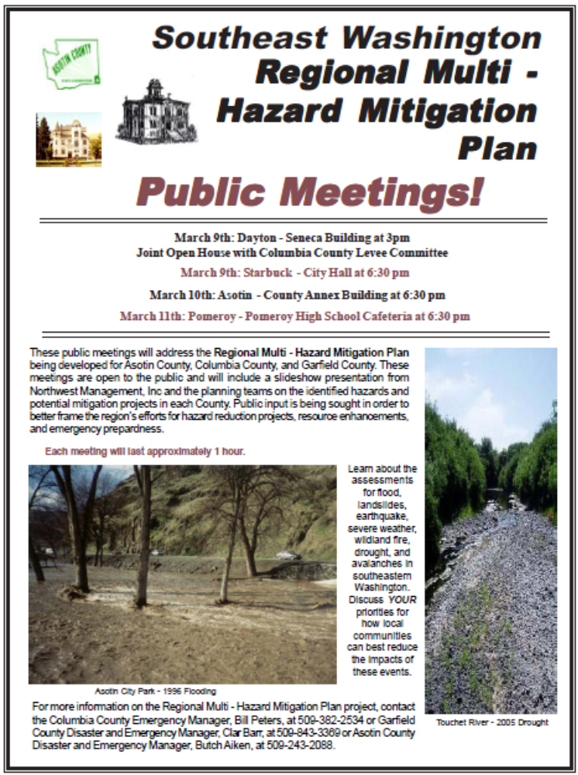
The slideshow presentation used during the public meetings is included in the Appendices.

Continued Public Involvement
The Southeastern Washington counties are dedicated to involving the public directly in review and updates of this Multi - Hazard Mitigation Plan. The County Emergency Managers, through their respective planning committees, are responsible for the annual review and update of the plan as recommended in the Chapter 6, “Mitigation Strategy” section of this document.
The public will have the opportunity to provide feedback about the Plan annually on the anniversary of the adoption at a meeting of the County Board of Commissioners. Copies of the Plan will be kept at the County Courthouses. The Plan also includes contact information for the Emergency Manager in each county, who is responsible for keeping track of public comments.
A public meeting will also be held as part of each annual evaluation or when deemed necessary by the planning committees. The meetings will provide the public a forum for which they can express concerns, opinions, or ideas about the Plan. The County Commissioner’s Offices will be responsible for using County resources to publicize the annual meetings and maintain public involvement through the Counties’ webpage and local newspapers.

Plan Monitoring and Maintenance
As part of the policy of Asotin County, Columbia County, and Garfield County in relation to this planning document, this entire Multi - Hazard Mitigation Plan should be reviewed annually (from date of adoption) at a special meeting of a joint planning committee, open to the public and involving all jurisdictions, where action items, priorities, budgets, and modifications can be made or confirmed. Each County Emergency Manager (or an official designee of the joint committee) is responsible for the scheduling, publicizing, and leadership of the annual review meeting. During this meeting, participating jurisdictions will report on their respective projects and identify needed changes and updates to the existing Plan. Maintenance to the Plan should be detailed at this meeting, documented, and attached to the formal plan as an amendment to the Multi - Hazard Mitigation Plan. Re-evaluation of this plan should be made on the 5th anniversary of its acceptance, and every 5-year period following.

Annual Review Agenda
The focus of the joint planning committee at the annual review meeting should include at least the following topics:
- Update historical events record based on any events in the past year.
- Review county profile and individual community assessments for each hazard and note any major changes or mitigation projects that have altered the vulnerability of each entity.
- Update the Emergency Resources information as necessary for each emergency response organization.
- Add a section to note accomplishments or current mitigation projects.
- All action items in Chapter 6 will need updated as projects are completed and as new needs or issues are identified.
- Address Emergency Operations Plans – how can we dovetail the two plans to make them work for each other? Specifically, how do we incorporate each County’s EOP into the action items for the regional MHMP?
- Address Updated County Comprehensive Land Use Plans – how can we dovetail the two plans to make them work for each other? Specifically, how do we incorporate each County’s Comprehensive Plan into the action items for the regional MHMP?
- Incorporate additional hazard chapters as funding allows.
All meeting minutes, press releases, and other documentation of revisions should be kept on record by Columbia County Emergency Management.

Five Year Re-evaluation Agenda
The focus of the planning committee at the five year re-evaluation should include all of the topics suggested for the annual review in addition to the following items:
- Update County demographic and socioeconomic data.
- Address any new planning documents, ordinances, codes, etc. that have been developed by the County or cities.
- Review listed communication sites.
- Review municipal water sources, particularly those in the floodplain or landslide impact areas.
- Redo all risk analysis models incorporating new information such as an updated County parcel master database, new construction projects, development trends, population vulnerabilities, changing risk potential, etc.
- Update county risk profiles and individual community assessments based on new information reflected in the updated models.
All meeting minutes, press releases, and other documentation of revisions should be kept on record by Columbia County Emergency Management.

Documented Review Process
Review and comment on this Plan has been provided through a number of avenues for the committee members as well as for members of the general public.
During regularly scheduled committee meetings in 2009-10, the committees met to discuss findings, review mapping and analysis, and provide written comments on draft sections of the document. During the public meetings attendees observed map analyses, photographic collections, discussed general findings from the community assessments, and made recommendations on potential project areas.
The first draft of the document was prepared after the public meetings and presented to the committee during the May 2010 planning committee meetings for full committee review. The completed draft document was released for public review on July 19th, 2010. The public review period remained open until August 6th, 2010.

This page was intentionally left blank.

Chapter 3
Community Profile
Chapter 3
Community Profile
IN THIS SECTION:
- Description of the Region
- Geography and Vegetation
- Demographics
- Socioeconomics
- Development Trends
- Hazard Management Capabilities
- Regional Hazard Profile

Chapter 3 – Community Profile

Southeast Washington Characteristics
The information in this chapter has been excerpted from the respective Asotin, Columbia, and Garfield County Community Wildfire Protection Plans.

Description of the Region
This region is situated in the southeastern corner of Washington State and is occupied by approximately 27,012 people. The largest communities in this area are the cities of Clarkston, Asotin, Dayton, and Pomeroy. The economy is directly tied to dryland farming. Principal crops include wheat, barley, and grass seed. Livestock production consists of cattle and sheep.
In 1805-1806, Lewis and Clark passed through the region as well as Captain Bonneville in 1834. A ferry was established on the Snake River in 1855 to accommodate thousands of miners rushing to the goldfields. A stage route established in 1862 between Walla Walla and Lewiston brought many settlers to the area. The city of Pomeroy, in the Pataha Valley, is one of the pioneer communities of the State of Washington. Pomeroy was established in 1864 by its founder, Joseph M. Pomeroy. He arrived in the Pataha Valley in 1864 and operated a stage station and a farm. In 1881, a ferry was established at Asotin. Settlers continued to pour into the region in the latter 1870’s and early 1880’s. The railroad arrived in 1886 and provided an outlet for wheat shipment that replaced movement by steamship. Today, the regions economy is primarily agricultural, based on food and livestock raising and processing, fruit growing, and wheat and barley production.

Geography and Vegetation
The southeastern Washington counties are comprised of a geologically diverse landscape that ranges from a rather arid four-season climate to mountainous slopes covered with evergreen forests. To the north this region is bordered by the Snake River. This river connects the counties to the world with barge access to ports from as far east as Lewiston, Idaho as far west as the mouth of the Columbia River. From this region’s southern border with Oregon, rise the Blue Mountains. These mountains vary in elevation from 3,000 feet in the valleys to over 6,300 feet at the highest peaks. The Blue Mountain Range is characterized by steep, rugged terrain, deeply disected by streams. Most of the forested lands throughout these counties are found within the Umatilla National Forest, which is managed by the U.S. Forest Service. These forested lands are primarily drained by the Grand Ronde, Walla Walla, Tucannon and Touchet River systems. At lower elevations in the central and north regions of the counties, rolling hills with steep slopes and narrow valleys characterize the topography. The hills and valleys generally exhibit good agricultural soil, which is highly conducive for wheat production.
The Cascade Mountain Range helps protect this region from the damp coastal weather that is often associated with the Northwest, particularly the Puget Sound area. The Rocky Mountains to the east of this region help keep winters relatively mild. As a result, the climate in southeastern Washington is typical of eastern Washington. The summers are warm and dry with temperatures approaching 100 degrees and winters are cold with temperatures reaching below zero. The annual average temperature is about 51 degrees Fahrenheit. The annual precipitation ranges from 13 inches near Central Ferry to 20 inches in parts of the Umatilla National Forest.
The prevailing winds are generally from the southwest. During spring and fall seasons, rapidly moving weather systems result in considerable blowing dust. Wind speeds may reach 50 mph once in two years and 80 mph winds are expected once in 50 years. In severe winters with light snow cover, frost may penetrate the soil at depths between 20 and 30 inches.
Vegetation in this region is a mix of forestland and agricultural ecosystems. An evaluation of satellite imagery provides some insight to the composition of the vegetation in the area. The full extent of the area was evaluated for cover type by the USDA Forest Service in 2001 as determined from Landsat 7 ETM+ imagery in tabular format. The most represented vegetated cover types per county for this tri-county region can be seen in the following tables.
Table 3.1. Vegetation Cover by Types in Southeast Washington.
Cover Type | Columbia County (558,641 acres) | Asotin County (409,684 acres) | Garfield County (459,252 acres)
Open Water | 0.6% | 1.0% | 1.0%
Developed, Open Space | 1.9% | 2.0% | 2.0%
Developed, Low Intensity | 0.2% | 1.0% | 0.0%
Developed, Medium Intensity | 0.0% | 0.0% | 0.0%
Developed, High Intensity | 0.0% | 0.0% | 0.0%
Barren Land (Rock/Sand/Clay) | 0.0% | 0.0% | 0.0%
Deciduous Forest | 0.0% | 0.0% | 0.0%
Evergreen Forest | 34.0% | 17.0% | 20.0%
Mixed Forest | 0.1% | 0.0% | 0.0%
Shrub/Scrub | 17.2% | 17.0% | 10.0%
Grassland Herbaceous | 10.8% | 46.0% | 27.0%
Pasture/Hey | 0.7% | 0.0% | 1.0%
Cultivated Crops | 34.0% | 16.0% | 39.0%
Woody Wetlands | 0.1% | 0.0% | 0.0%
Emergent Herbaceous Wetlands | 0.4% | 0.0% | 0.0%
Vegetative communities within this region follow the strong moisture and temperature gradients related to the major drainages. As moisture availability increases, so does the abundance of conifer species, with subalpine forest communities present in the highest elevations where precipitation and elevation provide more moisture during the growing season.
Generally, the soils located within this region present no limitations for conventional development except when combined with the steeper topography. The Soil Survey conducted by the US Soil Conservation Service includes detailed soil maps which can be used for examining a particular site’s suitability for specific land uses.
More specifically, the soils on the valley floors typically consist of well-drained bottom lands. These soils formed under bunchgrass in alluvium mixed with wind-laid deposits and some volcanic ash. The permeability of these soils is moderate, run-off is slow, and hazards for water and wind erosion are slight.
Climbing out of the valley bottom soils, a variety of soil series are encountered. These typically consist of well-drained soils in the uplands, which were formed under bunchgrass and sagebrush in calcareous loess. There is a high potential for erosion of this soil, especially on the steeper slopes. In areas where slopes often exceed 50%, soil types resulting from soil formed under rabbitbrush and bunchgrass in a mixture of wind-laid silty material and material weathered from basalt are quiet common. Generally, the basalt can be found at 10-20 inches below the soil surface. In these areas, the erosion hazard is severe.

Demographics
According to the 2000 US Census, this region reported a slight increase in total population from 23,877 in 1990 to 27,012 in 2000 with approximately 12,417 households. Garfield County has one incorporated community, Pomeroy , which has a population of 1,517. Columbia County has two incorporated communities, which are Dayton (pop. 2,655) and Starbuck (pop. 130). Asotin County has two incorporated communities, Asotin (pop. 1,095) and Clarkston (pop. 7,337).
Table 3.2. Selected Demographic Statistics.
 | Garfield County |  |  | Columbia County |  |  | Asotin County
 | Number | Percent |  | Number | Percent |  |  | Number | Percent
Total Population | 2,397 | 100.0 |  | 4,064 | 100.0 |  |  | 20,551 | 100.0
Male | 1,186 | 49.5 |  | 1,982 | 48.8 |  |  | 9,798 | 47.7
Female | 1,211 | 50.5 |  | 2,082 | 51.2 |  |  | 10,753 | 52.3
Median Age (years) | 43 | (x) |  | 42.4 | (x) |  |  | 38.8 | (x)
18 years and over | 1,775 | 74.1 |  | 3,091 | 76.1 |  |  | 15,310 | 74.5
Male | 859 | 35.8 |  | 1,504 | 37.0 |  |  | 7,094 | 34.5
Female | 916 | 38.2 |  | 1,587 | 39.1 |  |  | 8,216 | 40.0
21 years and over | 1,694 | 70.7 |  | 2,950 | 72.6 |  |  | 14,507 | 70.6
62 years and over | 579 | 24.2 |  | 880 | 21.7 |  |  | 3,935 | 19.1
65 years and over | 501 | 20.9 |  | 753 | 18.5 |  |  | 3,355 | 16.3
Male | 222 | 9.3 |  | 333 | 8.2 |  |  | 1,343 | 6.5
Female | 279 | 11.6 |  | 420 | 10.3 |  |  | 2,012 | 9.8

Socioeconomics
This region has a total of 11,738 occupied housing units and a population density ranging from 3.4-32.3 persons per square mile as reported in the 2000 Census. Ethnicity by county is as follows. Garfield County is distributed white 96.5%, black or African American 0%, American Indian or Alaskan Native 0.4%, Asian 0.7%, Hispanic or Latino 2.0%, two or more races 1.1%, and some other race 1.4%. Ethnicity in Columbia County is distributed white 93.7%, black or African American 0.2%, American Indian or Alaskan Native 1.0%, Asian 0.4%, Hispanic or Latino 6.3%, two or more races 1.9%, and some other race 3.3%. Ethnicity in Asotin County is distributed white 95.6%, black or African American 0.2%, American Indian or Alaskan Native 1.3%, Asian 0.5%, Hispanic or Latino 2.0%, two or more races 1.8%, and some other race 0.6%.
Specific economic data for individual communities is collected by the US Census. In southeast Washington this information is limited to the incorporated cities. In Garfield County, the city of Pomeroy households earn a median income of $28,958 annually while the Garfield County median income during the same period is $33,398. In Columbia County, the city of Dayton households earn a median income of $31,409 annually and Starbuck households earn a medium income of $18,125 annually. The Columbia County median income during the same period is $33,500. In Asotin County, the city of Clarkston households earn a median income of $25,907 annually and the city of Asotin households earn a median income of $33,524 annually. The Asotin County median income during the same period is $33,524.
Table 3.3. Selected Socioeconomic Statistics.
 |  |  | Garfield County |  |  | Columbia County |  |  |  |  | Asotin County
 |  |  | Number | Percent |  | Number |  | Percent |  | Number |  |  | Percent
Households |  |  | 999 | 100.0 |  | 1,688 | 100.0 |  |  | 8,352 |  | 100.0
Less than $10,000 |  |  | 123 | 12.3 |  | 159 | 9.4 |  |  | 874 |  | 10.5
$10,000-$14,999 |  |  | 78 | 7.8 |  | 171 | 10.1 |  |  | 667 |  | 8.0
$15,000-$24,999 |  |  | 177 | 17.7 |  | 279 | 16.5 |  |  | 1529 |  | 18.3
$25,000-$34,999 |  |  | 142 | 14.2 |  | 247 | 14.6 |  |  | 1266 |  | 15.2
$35,000-$49,999 |  |  | 159 | 15.9 |  | 341 | 20.2 |  |  | 1503 |  | 18.0
$50,000-$74,999 |  |  | 210 | 21.0 |  | 294 | 17.4 |  |  | 1375 |  | 16.5
$75,000-$99,999 |  |  | 63 | 6.3 |  | 111 | 6.6 |  |  | 602 |  | 7.2
$100,000-$149,999 |  |  | 38 | 3.8 |  | 63 | 3.7 |  |  | 377 |  | 4.5
$150,000-$199,999 |  |  | 5 | 0.5 |  | 5 | 0.3 |  |  | 72 |  | 0.9
$200,000 or more |  |  | 4 | 0.4 |  | 18 | 1.1 |  |  | 87 |  | 1.0
Median household income (dollars) |  |  | $33,398 | (x) |  | $33,500 | (x) |  |  | $33,524 |  | (x)
Executive Order 12898, Federal Actions to Address Environmental Justice in Minority Populations and Low Income Populations, directs federal agencies to identify and address any disproportionately high adverse human health or environmental effects of its projects on minority or low-income populations. In this region a statistically significant percentage of families are at or below the poverty level.
Table 3.4. Poverty Status Statistics.
 |  |  | Garfield County |  |  | Columbia County |  |  |  |  | Asotin County
 |  |  | Number | Percent |  | Number |  | Percent |  | Number |  |  | Percent
Families |  |  | 82 | (x) |  | 98 | (x) |  |  | 657 |  | (x)
Percent below poverty level |  |  | (x) | 12.0 |  | (x) | 8.6 |  |  | (x) |  | 11.6
With related children under 18 years |  |  | 48 | (x) |  | 69 | (x) |  |  | 550 |  | (x)
Percent below poverty level |  |  | (x) | 15.4 |  | (x) | 13.6 |  |  | (x) |  | 19.5
With related children under 5 years |  |  | 15 | (x) |  | 30 | (x) |  |  | 340 |  | (x)
Percent below poverty level |  |  | (x) | 19.5 |  | (x) | 17.8 |  |  | (x) |  | 29.1
Individuals |  |  | 334 | (x) |  | 507 | (x) |  |  | 3,132 |  | (x)
Percent below poverty level |  |  | (x) | 14.2 |  | (x) | 12.6 |  |  | (x) |  | 15.4
With related children under 18 years |  |  | 226 | (x) |  | 354 | (x) |  |  | 1,940 |  | (x)
Percent below poverty level |  |  | (x) | 13 |  | (x) | 11.6 |  |  | (x) |  | 12.8
65 years and over |  |  | 48 | (x) |  | 80 | (x) |  |  | 216 |  | (x)
Percent below poverty level |  |  | (x) | 10.2 |  | (x) | 11.1 |  |  | (x) |  | 6.7
With unemployment rates at 2.7% in Garfield County, 5.3% in Columbia County, and 4.0% in Asotin County, the regional unemployment rate was close to or below the national unemployment rate of 4.4% (1999 unemployment rates). The natural resource field comprises approximately 18.6% of the employed population in Garfield County, 16.0% in Columbia County, and 3.3% in Asotin County. As a result, much of the indirect employment within this region relies on the employment created through these natural resource occupations.
Table 3.5. Employment and Industry Statistics.
 |  |  | Garfield County |  |  | Columbia County |  |  |  |  | Asotin County
 |  |  | Number | Percent |  | Number |  | Percent |  | Number |  |  | Percent
OCCUPATION
Management, professional, and related occupations |  |  | 386 | 39.5 |  | 4,577 | 29.8 |  |  | 2,619 |  | 28.4
Service occupations |  |  | 125 | 12.8 |  | 2,818 | 18.3 |  |  | 1,764 |  | 19.2
Sales and office occupations |  |  | 238 | 24.4 |  | 3,402 | 22.1 |  |  | 2,280 |  | 24.8
Farming, fishing, and forestry occupations |  |  | 35 | 3.6 |  | 1,463 | 9.5 |  |  | 131 |  | 1.4
Production, transportation, and material moving occupations |  |  | 77 | 7.9 |  | 1,261 | 8.2 |  |  | 975 |  | 10.6
INDUSTRY
Agriculture, forestry, fishing and hunting, and mining |  |  | 182 | 18.6 |  | 2,464 | 16.0 |  |  | 300 |  | 3.3
Construction |  |  | 52 | 5.3 |  | 891 | 5.8 |  |  | 684 |  | 7.4
Manufacturing |  |  | 26 | 2.7 |  | 723 | 4.7 |  |  | 1,107 |  | 12.0
Wholesale trade |  |  | 88 | 9.0 |  | 675 | 4.4 |  |  | 287 |  | 3.1
Retail trade |  |  | 111 | 11.4 |  | 1,756 | 11.4 |  |  | 1,240 |  | 13.5
Transportation and warehouse, and utilities |  |  | 36 | 3.7 |  | 700 | 4.6 |  |  | 469 |  | 5.1
Information |  |  | 8 | 0.8 |  | 277 | 1.8 |  |  | 142 |  | 1.5
Finance, insurance, real estate, and rental and leasing |  |  | 37 | 3.8 |  | 474 | 3.1 |  |  | 563 |  | 6.1
Professional, scientific, management, administrative, and waste management services |  |  | 28 | 2.9 |  | 64 | 3.7 |  |  | 546 |  | 5.9
Educational, health and social services |  |  | 229 | 23.5 |  | 344 | 20.0 |  |  | 2,158 |  | 23.4
Arts, entertainment, recreation, accommodation and food services |  |  | 38 | 3.9 |  | 139 | 8.1 |  |  | 791 |  | 8.6
Other services (except public administration) |  |  | 47 | 4.8 |  | 126 | 73.0 |  |  | 578 |  | 6.3
Public administration |  |  | 94 | 9.6 |  | 160 | 9.3 |  |  | 346 |  | 3.8
Employment within this region leans heavily towards private wage and salary workers which together, comprise more than 50% of the region’s workforce. Government workers throughout this region represent a significantly smaller proportion of the work force at approximately 25%.
Table 3.6. Class of Worker
 |  |  | Garfield County |  |  | Columbia County |  |  |  |  | Asotin County
 |  |  | Number | Percent |  | Number |  | Percent |  | Number |  |  | Percent
Private wage and salary workers |  |  | 493 | 50.5 |  | 1,073 | 62.4 |  |  | 6,780 |  | 73.6
Government workers |  |  | 305 | 31.3 |  | 431 | 25.1 |  |  | 1,486 |  | 16.1
Self-employed workers in own not incorporated business |  |  | 171 | 17.5 |  | 207 | 12 |  |  | 892 |  | 9.1
Unpaid family workers |  |  | 7 | 0.7 |  | 9 | 0.5 |  |  | 53 |  | 0.6

Development Trends
Southeastern Washington is primarily a rural, agricultural area with a handful of thriving communities. Development and growth in these areas has been relatively slow and often decreasing for more than 100 years.
A relatively large percentage of the region is privately owned. Private parcels are becoming more and more expensive as the population grows and properties close to communities or in desirable recreation areas are developed. Additionally, new jobs associated with the establishment of the numerous wind turbines may bring additional population growth and a higher demand for land. Eastern Washington is also becoming more well-known for its wineries, which has contributed to increased business and a reduction in poverty levels. In the city of Dayton, the downtown business district is enjoying its highest occupancy level in over 20 years and population of the community is increasing for the first time in over a century.
The city of Clarkston in Asotin County is the largest population center in the region. As such, the nearby communities of Asotin, Pomeroy, and unincorporated areas are experiencing some added growth due to people seeking to live in rural areas and commute to the Lewis-Clark Valley for work. Clarkston also has a high rate of development in unincorporated Asotin County just outside the city limits.
Agriculture is the dominant industry throughout the area, but particularly in Columbia and Garfield County. Port districts in each county handle a significant amount of barge traffic carrying grains to ports in the Portland-Vancouver area.
Table 3.7. Land Ownership Categories.
 |  |  | Garfield County |  |  | Columbia County |  |  |  |  | Asotin County
 |  |  | Number | Percent |  | Number |  | Percent |  | Number |  |  | Percent
City or Municipal Government |  |  | N/A | N/A |  | 0 | 0 |  |  | N/A |  | N/A
County Government |  |  | N/A | N/A |  | N/A | N/A |  |  | 168 |  | <1%
Forest Industry |  |  | 1,011 | <1% |  | 6,936 | 1% |  |  | 4,022 |  | 1%
Incorporated Cities |  |  | 1,120 | <1% |  | 1,024 | <1% |  |  | 2,039 |  | <1%
Private |  |  | 328,718 | 72% |  | 358,203 | 64% |  |  | 288,729 |  | 70%
US Army Corps of Engineers |  |  | 8,617 | 2% |  | 5,851 | 1% |  |  | 2,673 |  | 1%
US Bureau of Land Management |  |  | 140 | <1% |  | 390 | <1% |  |  | 14,417 |  | 4%
US Forest Service |  |  | 95,266 | 21% |  | 158,982 | 28% |  |  | 54,151 |  | 13%
Washington Department of Natural Resources |  |  | 17,299 | 4% |  | 15,750 | 3% |  |  | 20,150 |  | 5%
Washington State Department of Fish and Wildlife |  |  | 7,081 | 2% |  | 11,463 | 2% |  |  | 22,496 |  | 5%
Washington State Parks and Recreation Commission |  |  | N/A | N/A |  | 43 | <1% |  |  | 842 |  | <1%
Total |  |  | 459,252 |  |  | 558,642 |  |  |  | 409,687

Hazard Management Capabilities
Asotin, Columbia, and Garfield County each maintain their own Emergency Manager and fire and emergency medical services districts.
Currently, Asotin County Fire District #1 covers the majority of the population in the unincorporated areas surrounding the communities of Clarkston and Asotin. These cities each have their own fire department that works within the city limits. The recently formed (2009) Blue Mountain Fire District covers the greater Anatone area. Due to limited capabilities at this time, the new district will respond only to wildland fire events. Much of the Snake River canyon and the Cloverland area still do not have structural or wildland fire protection.
Columbia County is protected by 3 rural fire districts. The town of Starbuck is included in the coverage area for Columbia County Fire District #1 and Dayton is covered by the Columbia County Fire District #3. Columbia County Fire District #2’s coverage area is located in the west central portion of the County and is shared with Walla Walla County. Mutual aid agreements are in place with each Columbia County Fire District and surrounding Districts for both medical and fire protection response.
Columbia County’s Sheriff’s Office provides law enforcement for all of Columbia County and is contracted for service with the city of Dayton and the town of Starbuck. Columbia County Sheriff’s Office staffs a 24 hour 911 dispatch center for all of Columbia County.
In Garfield County, Garfield County Fire District #1 provides structural and wildland fire protection as well as emergency medical service to all of the populated areas in the County (excludes the National Forest). The District will also respond to emergency medical calls on the Umatilla National Forest.
All of these rural fire districts are highly integrated with emergency medical services and often are the same individuals providing both types of service.

Regional Hazard Profile
SHELDUS is a county-level hazard data set for the U.S. for 18 different natural hazard event types such thunderstorms, hurricanes, floods, wildfires, and tornados. For each event, the database includes the beginning date, location (county and state), property losses, crop losses, injuries, and fatalities that affected each county.
The data were derived from several existing national data sources such as National Climatic Data Center's monthly Storm Data publications and NGDC's Tsunami Event Database. With the release of SHELDUS 7.0, the database includes loss causing and/or deadly event between 1960 through 1975 and from 1995 onward. Between 1976 and 1995, SHELDUS reflects only events that caused at least one fatality or more than $50,000 in property or crop damages.
Prior to 2001, property and crop losses occurring on the same day within the same geography (i.e. county) are aggregated by hazard type. For events that covered multiple counties, the dollar losses, deaths, and injuries were equally divided among the counties (e.g. if 4 counties were affected, then each was given 1/4 of the dollar loss, injuries and deaths). Where dollar loss estimates were provided in ranges (e.g. $50,000 - 100,000) - such as in NCDC Storm data until 1995 - the lowest value in the range of the category was used. This results in the most conservative estimate of losses during the time period of 1960-1995. Since 1995 all events that were reported by the National Climatic Data Center (NCDC) with a specific dollar amount are included in the database.
It is important to keep in mind that the SHELDUS database does not include every hazard event that occurred within an area. Only those events that met a specific reporting criterion as explained above are listed. This means that many local events are not included in this database. Some of the missing events are considered to be major local hazard events such as the 1996 and 1997 flood events that caused some of the worst damages in decades and was declared a State Disaster.

Table 3.8. SHELDUS Database for Southeastern Washington Counties.
Start Date | End Date | Hazard Type | County | Injuries Reported | Fatalities Reported | Reported Property Damage | Reported Crop Damage
September 3, 1960 | September 3, 1960 | Lightning | Asotin | - | - | $ 62.50 | $ -
September 3, 1960 | September 3, 1960 | Lightning | Columbia | - | - | $ 62.50 | $ -
September 3, 1960 | September 3, 1960 | Lightning | Garfield | - | - | $ 62.50 | $ -
June 6, 1961 | June 6, 1961 | Hail - Severe Storm/Thunder Storm | Asotin | - | - | $ 62.50 | $ 6,250.00
June 6, 1961 | June 6, 1961 | Hail - Severe Storm/Thunder Storm | Columbia | - | - | $ 62.50 | $ 6,250.00
June 6, 1961 | June 6, 1961 | Hail - Severe Storm/Thunder Storm | Garfield | - | - | $ 62.50 | $ 6,250.00
September 28, 1961 | September 28, 1961 | Wind | Asotin | - | - | $ 128.21 | $ 128.21
September 28, 1961 | September 28, 1961 | Wind | Columbia | - | - | $ 128.21 | $ 128.21
September 28, 1961 | September 28, 1961 | Wind | Garfield | - | - | $ 128.21 | $ 128.21
December 20, 1961 | December 21, 1961 | Wind | Asotin | - | - | $ 1,282.05 | $ -
December 20, 1961 | December 21, 1961 | Wind | Columbia | - | - | $ 1,282.05 | $ -
December 20, 1961 | December 21, 1961 | Wind | Garfield | - | - | $ 1,282.05 | $ -
April 27, 1962 | April 27, 1962 | Wind | Asotin | - | 0.03 | $ 128.21 | $ 128.21
April 27, 1962 | April 27, 1962 | Wind | Columbia | - | 0.03 | $ 128.21 | $ 128.21
April 27, 1962 | April 27, 1962 | Wind | Garfield | - | 0.03 | $ 128.21 | $ 128.21
November 19, 1962 | November 20, 1962 | Severe Storm/Thunder Storm - Wind | Asotin | 0.05 | - | $ 13,157.89 | $ -
November 19, 1962 | November 20, 1962 | Severe Storm/Thunder Storm - Wind | Columbia | 0.05 | - | $ 13,157.89 | $ -
November 19, 1962 | November 20, 1962 | Severe Storm/Thunder Storm - Wind | Garfield | 0.05 | - | $ 13,157.89 | $ -
November 24, 1962 | November 25, 1962 | Wind | Asotin | - | - | $ 1,315.79 | $ -
November 24, 1962 | November 25, 1962 | Wind | Columbia | - | - | $ 1,315.79 | $ -
November 24, 1962 | November 25, 1962 | Wind | Garfield | - | - | $ 1,315.79 | $ -
February 2, 1963 | February 4, 1963 | Flooding - Severe Storm/Thunder Storm | Asotin | - | - | $ 62,500.00 | $ 6,250.00
February 2, 1963 | February 4, 1963 | Flooding - Severe Storm/Thunder Storm | Columbia | - | - | $ 62,500.00 | $ 6,250.00
February 2, 1963 | February 4, 1963 | Flooding - Severe Storm/Thunder Storm | Garfield | - | - | $ 62,500.00 | $ 6,250.00
August 11, 1963 | August 13, 1963 | Severe Storm/Thunder Storm | Asotin | 0.08 | - | $ 1,282.05 | $ 1,282.05
August 11, 1963 | August 13, 1963 | Severe Storm/Thunder Storm | Columbia | 0.08 | - | $ 1,282.05 | $ 1,282.05
August 11, 1963 | August 13, 1963 | Severe Storm/Thunder Storm | Garfield | 0.08 | - | $ 1,282.05 | $ 1,282.05
October 21, 1963 | October 24, 1963 | Wind | Asotin | - | - | $ 1,282.05 | $ 1,282.05
October 21, 1963 | October 24, 1963 | Wind | Columbia | - | - | $ 1,282.05 | $ 1,282.05
October 21, 1963 | October 24, 1963 | Wind | Garfield | - | - | $ 1,282.05 | $ 1,282.05
January 19, 1964 | January 19, 1964 | Wind | Asotin | - | - | $ 1,282.05 | $ -
January 19, 1964 | January 19, 1964 | Wind | Columbia | - | - | $ 1,282.05 | $ -
January 19, 1964 | January 19, 1964 | Wind | Garfield | - | - | $ 1,282.05 | $ -
June 1, 1964 | June 1, 1964 | Hail - Severe Storm/Thunder Storm | Asotin | - | - | $ 625.00 | $ 625.00
June 1, 1964 | June 1, 1964 | Hail - Severe Storm/Thunder Storm | Columbia | - | - | $ 625.00 | $ 625.00
June 1, 1964 | June 1, 1964 | Hail - Severe Storm/Thunder Storm | Garfield | - | - | $ 625.00 | $ 625.00
December 16, 1964 | December 23, 1964 | Severe Storm/Thunder Storm - Winter Weather | Asotin | - | 0.03 | $ 128,205.13 | $ -
December 16, 1964 | December 23, 1964 | Severe Storm/Thunder Storm - Winter Weather | Columbia | - | 0.03 | $ 128,205.13 | $ -
December 16, 1964 | December 23, 1964 | Severe Storm/Thunder Storm - Winter Weather | Garfield | - | 0.03 | $ 128,205.13 | $ -
January 26, 1965 | January 31, 1965 | Flooding - Landslide - Winter Weather | Asotin | - | - | $ 12,820.51 | $ -
January 26, 1965 | January 31, 1965 | Flooding - Landslide - Winter Weather | Columbia | - | - | $ 12,820.51 | $ -
January 26, 1965 | January 31, 1965 | Flooding - Landslide - Winter Weather | Garfield | - | - | $ 12,820.51 | $ -
February 5, 1965 | February 5, 1965 | Wind | Asotin | - | - | $ 2,941.18 | $ -
February 5, 1965 | February 5, 1965 | Wind | Columbia | - | - | $ 2,941.18 | $ -
February 5, 1965 | February 5, 1965 | Wind | Garfield | - | - | $ 2,941.18 | $ -
February 27, 1965 | February 27, 1965 | Wind | Asotin | - | - | $ 128.21 | $ -
February 27, 1965 | February 27, 1965 | Wind | Columbia | - | - | $ 128.21 | $ -
February 27, 1965 | February 27, 1965 | Wind | Garfield | - | - | $ 128.21 | $ -
May 15, 1965 | May 16, 1965 | Wind | Asotin | - | 0.03 | $ 128.21 | $ -
May 15, 1965 | May 16, 1965 | Wind | Columbia | - | 0.03 | $ 128.21 | $ -
May 15, 1965 | May 16, 1965 | Wind | Garfield | - | 0.03 | $ 128.21 | $ -
July 25, 1965 | July 27, 1965 | Severe Storm/Thunder Storm | Asotin | - | - | $ 128.21 | $ 12.82
July 25, 1965 | July 27, 1965 | Severe Storm/Thunder Storm | Columbia | - | - | $ 128.21 | $ 12.82
July 25, 1965 | July 27, 1965 | Severe Storm/Thunder Storm | Garfield | - | - | $ 128.21 | $ 12.82
October 4, 1965 | October 5, 1965 | Wind | Asotin | - | - | $ 128.21 | $ -
October 4, 1965 | October 5, 1965 | Wind | Columbia | - | - | $ 128.21 | $ -
October 4, 1965 | October 5, 1965 | Wind | Garfield | - | - | $ 128.21 | $ -
November 10, 1965 | November 10, 1965 | Severe Storm/Thunder Storm - Tornado | Asotin | - | - | $ 357.14 | $ -
November 10, 1965 | November 10, 1965 | Severe Storm/Thunder Storm - Tornado | Columbia | - | - | $ 357.14 | $ -
November 10, 1965 | November 10, 1965 | Severe Storm/Thunder Storm - Tornado | Garfield | - | - | $ 357.14 | $ -
January 29, 1967 | January 29, 1967 | Wind | Asotin | - | - | $ 1,282.05 | $ -
January 29, 1967 | January 29, 1967 | Wind | Columbia | - | - | $ 1,282.05 | $ -
January 29, 1967 | January 29, 1967 | Wind | Garfield | - | - | $ 1,282.05 | $ -
February 17, 1967 | February 17, 1967 | Wind | Asotin | - | - | $ 1,282.05 | $ -
February 17, 1967 | February 17, 1967 | Wind | Columbia | - | - | $ 1,282.05 | $ -
February 17, 1967 | February 17, 1967 | Wind | Garfield | - | - | $ 1,282.05 | $ -
March 9, 1967 | March 9, 1967 | Wind | Asotin | - | - | $ 128.21 | $ -
March 9, 1967 | March 9, 1967 | Wind | Columbia | - | - | $ 128.21 | $ -
March 9, 1967 | March 9, 1967 | Wind | Garfield | - | - | $ 128.21 | $ -
March 15, 1967 | March 16, 1967 | Wind | Asotin | - | - | $ 128.21 | $ -
March 15, 1967 | March 16, 1967 | Wind | Columbia | - | - | $ 128.21 | $ -
March 15, 1967 | March 16, 1967 | Wind | Garfield | - | - | $ 128.21 | $ -
March 23, 1967 | March 23, 1967 | Wind | Asotin | - | - | $ 128.21 | $ 12.82
March 23, 1967 | March 23, 1967 | Wind | Columbia | - | - | $ 128.21 | $ 12.82
March 23, 1967 | March 23, 1967 | Wind | Garfield | - | - | $ 128.21 | $ 12.82
October 2, 1967 | October 3, 1967 | Wind | Asotin | - | - | $ 128.21 | $ 128.21
October 2, 1967 | October 3, 1967 | Wind | Columbia | - | - | $ 128.21 | $ 128.21
October 2, 1967 | October 3, 1967 | Wind | Garfield | - | - | $ 128.21 | $ 128.21
December 3, 1968 | December 4, 1968 | Severe Storm/Thunder Storm - Wind | Asotin | - | - | $ 1,282.05 | $ -
December 3, 1968 | December 4, 1968 | Severe Storm/Thunder Storm - Wind | Columbia | - | - | $ 1,282.05 | $ -
December 3, 1968 | December 4, 1968 | Severe Storm/Thunder Storm - Wind | Garfield | - | - | $ 1,282.05 | $ -
December 30, 1968 | December 31, 1968 | Winter Weather | Asotin | - | - | $ 1,282.05 | $ -
December 30, 1968 | December 31, 1968 | Winter Weather | Columbia | - | - | $ 1,282.05 | $ -
December 30, 1968 | December 31, 1968 | Winter Weather | Garfield | - | - | $ 1,282.05 | $ -
March 22, 1969 | March 22, 1969 | Wind | Asotin | - | - | $ 1,282.05 | $ -
March 22, 1969 | March 22, 1969 | Wind | Columbia | - | - | $ 1,282.05 | $ -
March 22, 1969 | March 22, 1969 | Wind | Garfield | - | - | $ 1,282.05 | $ -
June 7, 1969 | June 8, 1969 | Severe Storm/Thunder Storm | Asotin | - | - | $ 312.50 | $ 312.50
June 7, 1969 | June 8, 1969 | Severe Storm/Thunder Storm | Columbia | - | - | $ 312.50 | $ 312.50
June 7, 1969 | June 8, 1969 | Severe Storm/Thunder Storm | Garfield | - | - | $ 312.50 | $ 312.50
January 17, 1970 | January 19, 1970 | Winter Weather | Asotin | - | - | $ 4,166.67 | $ 41,666.67
January 17, 1970 | January 19, 1970 | Winter Weather | Columbia | - | - | $ 4,166.67 | $ 41,666.67
January 17, 1970 | January 19, 1970 | Winter Weather | Garfield | - | - | $ 4,166.67 | $ 41,666.67
September 10, 1970 | September 12, 1970 | Wind | Asotin | - | - | $ 128.21 | $ 12,820.51
September 10, 1970 | September 12, 1970 | Wind | Columbia | - | - | $ 128.21 | $ 12,820.51
September 10, 1970 | September 12, 1970 | Wind | Garfield | - | - | $ 128.21 | $ 12,820.51
January 14, 1971 | January 15, 1971 | Wind - Winter Weather | Asotin | - | 0.03 | $ 1,282.05 | $ -
January 14, 1971 | January 15, 1971 | Wind - Winter Weather | Columbia | - | 0.03 | $ 1,282.05 | $ -
January 14, 1971 | January 15, 1971 | Wind - Winter Weather | Garfield | - | 0.03 | $ 1,282.05 | $ -
February 10, 1971 | February 10, 1971 | Wind | Asotin | - | - | $ - | $ 555.56
February 10, 1971 | February 10, 1971 | Wind | Columbia | - | - | $ - | $ 555.56
February 10, 1971 | February 10, 1971 | Wind | Garfield | - | - | $ - | $ 555.56
February 24, 1971 | February 24, 1971 | Wind | Asotin | - | - | $ - | $ 128.21
February 24, 1971 | February 24, 1971 | Wind | Columbia | - | - | $ - | $ 128.21
February 24, 1971 | February 24, 1971 | Wind | Garfield | - | - | $ - | $ 128.21
March 26, 1971 | March 26, 1971 | Wind | Asotin | - | - | $ 12,820.51 | $ -
March 26, 1971 | March 26, 1971 | Wind | Columbia | - | - | $ 12,820.51 | $ -
March 26, 1971 | March 26, 1971 | Wind | Garfield | - | - | $ 12,820.51 | $ -
August 30, 1971 | August 30, 1971 | Hail - Lightning - Severe Storm/Thunder Storm - Wind | Asotin | - | - | $ 3,125.00 | $ 312.50
August 30, 1971 | August 30, 1971 | Hail - Lightning - Severe Storm/Thunder Storm - Wind | Columbia | - | - | $ 3,125.00 | $ 312.50
August 30, 1971 | August 30, 1971 | Hail - Lightning - Severe Storm/Thunder Storm - Wind | Garfield | - | - | $ 3,125.00 | $ 312.50
December 8, 1971 | December 8, 1971 | Winter Weather | Asotin | - | - | $ 416.67 | $ -
December 8, 1971 | December 8, 1971 | Winter Weather | Columbia | - | - | $ 416.67 | $ -
December 8, 1971 | December 8, 1971 | Winter Weather | Garfield | - | - | $ 416.67 | $ -
January 11, 1972 | January 11, 1972 | Wind | Asotin | 0.15 | 0.05 | $ 12,820.50 | $ 128.21
January 11, 1972 | January 11, 1972 | Wind | Columbia | 0.15 | 0.05 | $ 12,820.50 | $ 128.21
January 11, 1972 | January 11, 1972 | Wind | Garfield | 0.15 | 0.05 | $ 12,820.50 | $ 128.21
January 20, 1972 | January 21, 1972 | Flooding | Asotin | - | - | $ 62,500.00 | $ 625.00
January 24, 1972 | January 25, 1972 | Winter Weather | Asotin | - | - | $ 12,820.51 | $ 1,282.05
January 24, 1972 | February 4, 1972 | Winter Weather | Asotin | - | - | $ 12,820.51 | $ 128.02
January 24, 1972 | January 25, 1972 | Winter Weather | Columbia | - | - | $ 12,820.51 | $ 1,282.05
January 24, 1972 | February 4, 1972 | Winter Weather | Columbia | - | - | $ 12,820.51 | $ 128.02
January 24, 1972 | January 25, 1972 | Winter Weather | Garfield | - | - | $ 12,820.51 | $ 1,282.05
January 24, 1972 | February 4, 1972 | Winter Weather | Garfield | - | - | $ 12,820.51 | $ 128.02
February 15, 1972 | February 16, 1972 | Wind | Asotin | 0.26 | - | $ 12,820.51 | $ 128.02
February 15, 1972 | February 16, 1972 | Wind | Columbia | 0.26 | - | $ 12,820.51 | $ 128.02
February 15, 1972 | February 16, 1972 | Wind | Garfield | 0.26 | - | $ 12,820.51 | $ 128.02
March 6, 1972 | March 6, 1972 | Wind | Asotin | - | - | $ 333.33 | $ 33.33
March 6, 1972 | March 6, 1972 | Wind | Columbia | - | - | $ 333.33 | $ 33.33
March 6, 1972 | March 6, 1972 | Wind | Garfield | - | - | $ 333.33 | $ 33.33
April 16, 1972 | April 16, 1972 | Severe Storm/Thunder Storm | Asotin | - | - | $ 3,333.33 | $ -
April 16, 1972 | April 16, 1972 | Severe Storm/Thunder Storm | Columbia | - | - | $ 3,333.33 | $ -
April 16, 1972 | April 16, 1972 | Severe Storm/Thunder Storm | Garfield | - | - | $ 3,333.33 | $ -
December 4, 1972 | December 15, 1972 | Winter Weather | Asotin | - | - | $ 12,820.51 | $ -
December 4, 1972 | December 15, 1972 | Winter Weather | Columbia | - | - | $ 12,820.51 | $ -
December 4, 1972 | December 15, 1972 | Winter Weather | Garfield | - | - | $ 12,820.51 | $ -
December 16, 1972 | December 17, 1972 | Winter Weather | Columbia | - | - | $ 8.33 | $ -
October 6, 1973 | October 7, 1973 | Wind | Columbia | - | - | $ 10,000.00 | $ -
December 20, 1974 | December 21, 1974 | Wind | Asotin | - | - | $ 3,571.43 | $ 3.57
December 20, 1974 | December 21, 1974 | Wind | Columbia | - | - | $ 3,571.43 | $ 3.57
December 20, 1974 | December 21, 1974 | Wind | Garfield | - | - | $ 3,571.43 | $ 3.57
January 7, 1975 | January 8, 1975 | Wind - Winter Weather | Asotin | 0.05 | - | $ 1,282.05 | $ -
January 7, 1975 | January 8, 1975 | Wind - Winter Weather | Columbia | 0.05 | - | $ 1,282.05 | $ -
January 7, 1975 | January 8, 1975 | Wind - Winter Weather | Garfield | 0.05 | - | $ 1,282.05 | $ -
February 19, 1975 | February 19, 1975 | Wind | Asotin | - | - | $ 1,282.05 | $ -
February 19, 1975 | February 19, 1975 | Wind | Columbia | - | - | $ 1,282.05 | $ -
February 19, 1975 | February 19, 1975 | Wind | Garfield | - | - | $ 1,282.05 | $ -
May 18, 1975 | May 18, 1975 | Wind | Asotin | 0.08 | - | $ 384.62 | $ 3.85
May 18, 1975 | May 18, 1975 | Wind | Columbia | 0.08 | - | $ 384.62 | $ 3.85
May 18, 1975 | May 18, 1975 | Wind | Garfield | 0.08 | - | $ 384.62 | $ 3.85
July 11, 1975 | July 11, 1975 | Hail | Asotin | - | - | $ 416.67 | $ 416.67
July 11, 1975 | July 11, 1975 | Hail | Columbia | - | - | $ 416.67 | $ 416.67
July 11, 1975 | July 11, 1975 | Hail | Garfield | - | - | $ 416.67 | $ 416.67
July 12, 1975 | July 12, 1975 | Flooding - Severe Storm/Thunder Storm - Wildfire - Wind | Asotin | - | - | $ 4,166.67 | $ 4,166.67
July 12, 1975 | July 12, 1975 | Flooding - Severe Storm/Thunder Storm - Wildfire - Wind | Columbia | - | - | $ 4,166.67 | $ 4,166.67
July 12, 1975 | July 12, 1975 | Flooding - Severe Storm/Thunder Storm - Wildfire - Wind | Garfield | - | - | $ 4,166.67 | $ 4,166.67
July 14, 1975 | July 14, 1975 | Hail | Asotin | - | - | $ 416.67 | $ 416.67
July 14, 1975 | July 14, 1975 | Hail | Columbia | - | - | $ 416.67 | $ 416.67
July 14, 1975 | July 14, 1975 | Hail | Garfield | - | - | $ 416.67 | $ 416.67
July 7, 1978 | July 7, 1978 | Severe Storm/Thunder Storm | Columbia | - | - | $ 125,000.00 | $ -
July 7, 1978 | July 7, 1978 | Severe Storm/Thunder Storm | Garfield | - | - | $ 125,000.00 | $ -
November 4, 1978 | November 4, 1978 | Wind | Columbia | - | - | $ 4,545.45 | $ -
May 30, 1980 | May 30, 1980 | Flooding | Columbia | - | - | $ 16,666.67 | $ 16,666.67
May 30, 1980 | May 30, 1980 | Flooding | Garfield | - | - | $ 16,666.67 | $ 16,666.67
November 14, 1981 | November 15, 1981 | Wind | Asotin | - | - | $ 128,205.00 | $ -
November 14, 1981 | November 15, 1981 | Wind | Columbia | - | - | $ 128,205.00 | $ -
November 14, 1981 | November 15, 1981 | Wind | Garfield | - | - | $ 128,205.00 | $ -
January 23, 1982 | January 23, 1982 | Severe Storm/Thunder Storm | Asotin | - | - | $ 13,158.00 | $ -
January 23, 1982 | January 23, 1982 | Severe Storm/Thunder Storm | Columbia | - | - | $ 13,158.00 | $ -
January 23, 1982 | January 23, 1982 | Severe Storm/Thunder Storm | Garfield | - | - | $ 13,158.00 | $ -
December 2, 1985 | December 2, 1985 | Winter Weather | Asotin | - | - | $ 128.21 | $ -
December 2, 1985 | December 2, 1985 | Winter Weather | Columbia | - | - | $ 128.21 | $ -
December 2, 1985 | December 2, 1985 | Winter Weather | Garfield | - | - | $ 128.21 | $ -
May 13, 1986 | May 13, 1986 | Wind | Asotin | - | - | $ 3,571.43 | $ -
May 13, 1986 | May 13, 1986 | Wind | Columbia | - | - | $ 3,571.43 | $ -
May 13, 1986 | May 13, 1986 | Wind | Garfield | - | - | $ 3,571.43 | $ -
July 25, 1987 | July 25, 1987 | Hail - Severe Storm/Thunder Storm | Asotin | - | - | $ 10,000.00 | $ -
July 25, 1987 | July 25, 1987 | Hail - Severe Storm/Thunder Storm | Columbia | - | - | $ 10,000.00 | $ -
July 25, 1987 | July 25, 1987 | Hail - Severe Storm/Thunder Storm | Garfield | - | - | $ 10,000.00 | $ -
December 9, 1987 | December 9, 1987 | Severe Storm/Thunder Storm | Asotin | - | - | $ 1,282.05 | $ 1.00
December 9, 1987 | December 9, 1987 | Wind | Asotin | - | - | $ 12,820.51 | $ -
December 9, 1987 | December 9, 1987 | Severe Storm/Thunder Storm | Columbia | - | - | $ 1,282.05 | $ 6.00
December 9, 1987 | December 9, 1987 | Wind | Columbia | - | - | $ 12,820.51 | $ -
December 9, 1987 | December 9, 1987 | Severe Storm/Thunder Storm | Garfield | - | - | $ 1,282.05 | $ 11.00
December 9, 1987 | December 9, 1987 | Wind | Garfield | - | - | $ 12,820.51 | $ -
May 12, 1988 | May 12, 1988 | Severe Storm/Thunder Storm - Wind | Asotin | - | - | $ 4,166.67 | $ -
May 12, 1988 | May 12, 1988 | Severe Storm/Thunder Storm - Wind | Columbia | - | - | $ 4,166.67 | $ -
May 12, 1988 | May 12, 1988 | Severe Storm/Thunder Storm - Wind | Garfield | - | - | $ 4,166.67 | $ -
February 1, 1989 | February 1, 1989 | Winter Weather | Asotin | - | 0.03 | $ 128,205.00 | $ -
February 1, 1989 | February 1, 1989 | Winter Weather | Columbia | - | 0.03 | $ 128,205.00 | $ -
February 1, 1989 | February 1, 1989 | Winter Weather | Garfield | - | 0.03 | $ 128,205.00 | $ -
January 8, 1990 | January 8, 1990 | Wind | Asotin | - | - | $ 41,666.67 | $ -
January 8, 1990 | January 8, 1990 | Wind | Columbia | - | - | $ 41,666.67 | $ -
January 8, 1990 | January 8, 1990 | Wind | Garfield | - | - | $ 41,666.67 | $ -
January 28, 1990 | January 28, 1990 | Wind | Asotin | - | - | $ 14,705.88 | $ -
January 28, 1990 | January 28, 1990 | Wind | Columbia | - | - | $ 14,705.88 | $ -
January 28, 1990 | January 28, 1990 | Wind | Garfield | - | - | $ 14,705.88 | $ -
May 30, 1990 | May 30, 1990 | Flooding | Asotin | - | - | $ 12,500.00 | $ -
May 30, 1990 | May 30, 1990 | Flooding | Columbia | - | - | $ 12,500.00 | $ -
May 30, 1990 | May 30, 1990 | Flooding | Garfield | - | - | $ 12,500.00 | $ -
November 22, 1990 | November 23, 1990 | Wind | Asotin | - | - | $ 12,820.51 | $ -
November 22, 1990 | November 23, 1990 | Wind | Columbia | - | - | $ 12,820.51 | $ -
November 22, 1990 | November 23, 1990 | Wind | Garfield | - | - | $ 12,820.51 | $ -
December 19, 1990 | December 25, 1990 | Winter Weather | Asotin | - | - | $ 1,282.05 | $ -
December 19, 1990 | December 25, 1990 | Winter Weather | Columbia | - | - | $ 1,282.05 | $ -
December 19, 1990 | December 25, 1990 | Winter Weather | Garfield | - | - | $ 1,282.05 | $ -
December 29, 1990 | December 31, 1990 | Winter Weather | Asotin | - | - | $ 1,282.05 | $ -
December 29, 1990 | December 31, 1990 | Winter Weather | Columbia | - | - | $ 1,282.05 | $ -
December 29, 1990 | December 31, 1990 | Winter Weather | Garfield | - | - | $ 1,282.05 | $ -
October 16, 1991 | October 16, 1991 | Wind | Asotin | - | 0.33 | $ 416,666.67 | $ -
October 16, 1991 | October 16, 1991 | Wind | Columbia | - | 0.33 | $ 416,666.67 | $ -
October 16, 1991 | October 16, 1991 | Wind | Garfield | - | 0.33 | $ 416,666.67 | $ -
June 28, 1992 | June 28, 1992 | Hail - Severe Storm/Thunder Storm - Wind | Asotin | - | - | $ 41,666.67 | $ -
June 28, 1992 | June 28, 1992 | Hail - Severe Storm/Thunder Storm - Wind | Columbia | - | - | $ 41,666.67 | $ -
June 28, 1992 | June 28, 1992 | Hail - Severe Storm/Thunder Storm - Wind | Garfield | - | - | $ 41,666.67 | $ -
September 12, 1992 | September 12, 1992 | Wind | Asotin | 0.21 | - | $ 3,571.43 | $ -
September 12, 1992 | September 12, 1992 | Wind | Columbia | 0.21 | - | $ 3,571.43 | $ -
September 12, 1992 | September 12, 1992 | Wind | Garfield | 0.21 | - | $ 3,571.43 | $ -
February 18, 1993 | February 19, 1993 | Winter Weather | Columbia | - | 0.05 | $ 2,380.95 | $ -
February 18, 1993 | February 19, 1993 | Winter Weather | Garfield | - | 0.05 | $ 2,380.95 | $ -
July 6, 1995 | July 6, 1995 | Severe Storm/Thunder Storm - Wind | Garfield | - | - | $ - | $ 140,000.00
July 9, 1995 | July 9, 1995 | Severe Storm/Thunder Storm - Wind | Garfield | - | - | $ - | $3,000,000.00
September 8, 1998 | September 8, 1998 | Flooding | Asotin | - | - | $ 30,000.00 | $ -
September 25, 1998 | September 25, 1998 | Flooding | Asotin | - | - | $ 30,000.00 | $ -
December 27, 1998 | December 27, 1998 | Wind | Asotin | - | - | $ 10,000.00 | $ -
December 27, 1998 | December 27, 1998 | Wind | Garfield | - | - | $ 10,000.00 | $ -
February 2, 1999 | February 2, 1999 | Wind | Asotin | - | - | $ 363,636.36 | $ -
February 2, 1999 | February 2, 1999 | Wind | Garfield | - | - | $ 363,636.36 | $ -
May 26, 1999 | May 26, 1999 | Flooding | Asotin | - | - | $ 7,500.00 | $ -
May 26, 1999 | May 26, 1999 | Flooding | Garfield | - | - | $ 7,500.00 | $ -
June 15, 1999 | June 15, 1999 | Hail | Garfield | - | - | $ 5,000.00 | $ 10,000.00
September 25, 1999 | September 25, 1999 | Wind | Asotin | - | - | $ 5,000.00 | $ 3,333.33
September 25, 1999 | September 25, 1999 | Wind | Garfield | - | - | $ 5,000.00 | $ 3,333.33
January 9, 2000 | January 9, 2000 | Wind | Asotin | - | - | $ 4,545.45 | $ -
January 9, 2000 | January 9, 2000 | Wind | Columbia | - | - | $ 25,000.00 | $ -
January 9, 2000 | January 9, 2000 | Wind | Garfield | - | - | $ 4,545.45 | $ -
January 16, 2000 | January 16, 2000 | Tornado | Columbia | - | - | $ 100.00 | $ -
January 16, 2000 | January 16, 2000 | Severe Storm/Thunder Storm - Wind | Garfield | - | - | $ 15,000.00 | $ -
May 30, 2000 | May 31, 2000 | Winter Weather | Columbia | - | - | $ 22,500.00 | $ -
December 14, 2000 | December 15, 2000 | Wind | Columbia | - | - | $ 14,285.71 | $ -
December 14, 2000 | December 14, 2000 | Wind | Columbia | - | - | $ 12,500.00 | $ -
December 15, 2000 | December 15, 2000 | Wind | Asotin | - | - | $ 15,000.00 | $ -
December 15, 2000 | December 15, 2000 | Wind | Garfield | - | - | $ 15,000.00 | $ -
November 28, 2001 | November 28, 2001 | Wind | Columbia | - | - | $ 25,000.00 | $ -
February 7, 2002 | February 7, 2002 | Wind | Columbia | 0.50 | - | $ 125,000.00 | $ -
June 26, 2002 | June 26, 2002 | Severe Storm/Thunder Storm - Wind | Asotin | - | - | $ 5,000.00 | $ -
November 1, 2002 | November 4, 2002 | Winter Weather | Columbia | - | - | $ - | $9,285,714.29
December 14, 2002 | December 14, 2002 | Wind | Columbia | - | - | $ 500.00 | $ -
December 15, 2002 | December 16, 2002 | Wind | Columbia | - | - | $ 75,000.00 | $ -
November 11, 2003 | November 11, 2003 | Wind | Asotin | - | - | $ 2,000.00 | $ -
November 19, 2003 | November 19, 2003 | Wind | Asotin | - | - | $ 142,857.14 | $ -
November 19, 2003 | November 19, 2003 | Wind | Garfield | - | - | $ 142,857.14 | $ -
January 30, 2004 | January 30, 2004 | Wind | Columbia | - | - | $ 5,666.67 | $ -
May 19, 2006 | May 19, 2006 | Severe Storm/Thunder Storm - Wind | Asotin | - | - | $ 2,000.00 | $ -
December 14, 2006 | December 15, 2006 | Wind | Asotin | 0.08 | - | $ 207,692.31 | $ -
December 14, 2006 | December 15, 2006 | Wind | Garfield | 0.08 | - | $ 207,692.31 | $ -
June 29, 2007 | June 29, 2007 | Hail | Asotin | - | - | $ 1,000.00 | $ -
August 31, 2007 | August 31, 2007 | Severe Storm/Thunder Storm - Wind | Asotin | - | - | $ 1,000.00 | $ -
January 4, 2008 | January 4, 2008 | Wind | Columbia | - | - | $2,470,000.00 | $ -
February 7, 2008 | February 7, 2008 | Wind | Asotin | - | - | $ 20,000.00 | $ -
February 7, 2008 | February 7, 2008 | Wind | Garfield | - | - | $ 20,000.00 | $ -
August 8, 2008 | August 8, 2008 | Severe Storm/Thunder Storm - Wind | Asotin | - | - | $ 2,000.00 | $ -
August 8, 2008 | August 8, 2008 | Severe Storm/Thunder Storm - Wind | Asotin | - | - | $ 2,000.00 | $ -
December 26, 2008 | December 26, 2008 | Winter Weather | Asotin | - | 0.14 | $ - | $ -
December 26, 2008 | December 26, 2008 | Winter Weather | Garfield | - | 0.14 | $ - | $ -
December 29, 2008 | December 29, 2008 | Wind | Asotin | - | - | $ 1,750.00 | $ -
December 29, 2008 | December 29, 2008 | Wind | Garfield | - | - | $ 1,750.00 | $ -

Chapter 4
Regional Hazard Profiles
Chapter 4
Regional Hazard Profiles
IN THIS SECTION:
- Flood Annex
- Earthquake Annex
- Landslide Annex
- Severe Storm Annex
- Wildland Fire Annex
- Avalanche Annex
- Tsunami Annex
- Volcano Annex
- Drought Annex

Chapter 4 – Regional Hazard Profile

Southeast Washington Hazard Profile

Flood
Floods have been a serious and costly natural hazard affecting Washington. Floods damage roads, farmlands, and structures, often disrupting lives and businesses. Simply put, flooding occurs when water leaves the river channels, lakes, ponds, and other confinements where we expect it to stay. Flood-related disasters occur when human property and lives are impacted by flood waters. An understanding of the role of weather, runoff, landscape, and human development in the floodplain is therefore the key to understanding and controlling flood-related disasters. Major disasters declarations related to flooding were made for Washington in 1956, 1957, 1963, 1964, 1971, 1972, 1974, 1975, 1977, 1979, 1983, 1986 (x3), 1989, 1990 (x2), 1996, 1997 (x3), 1998, 2003, 2006 (x2), 2007, and 2009. Every county has received a Presidential Disaster Declaration since 1970. Since 1980, federal, state, and local governments have invested more than $522 million to repair public facilities, help individuals recover from flood disasters, and pay for measures to prevent future flood damage. This is nearly 40% of the more than 1.37 billion amount spent on disaster relief and hazard mitigation during this time. There has been only 1 federal disaster declaration directly impacting southeastern Washington since 1948.
Riverine flooding includes those events that are classically thought of as flooding; i.e., a gradual rise of volume of a stream until that stream exceeds its normal channel and spills onto adjacent lands. Such events are generally associated with major meteorological events: spring runoff, winter rain/snowmelt events, and ice jams. Riverine floods typically have low velocities, affect large land areas, and persist for a prolonged period.
In contrast, flash floods may have a higher velocity in a smaller area and may recede relatively quickly. Such floods are caused by the introduction of a large amount of water into a limited area (e.g., extreme precipitation events in watersheds less than 50 square miles), crest quickly (e.g., eight hours or less), and generally occur in hilly or otherwise confined terrain. Steep mountainous terrain is particularly susceptible to flash floods and debris flows which can occur within thirty (30) minutes of the onset of heavy rain. Flash floods occur in both urban and rural settings, principally along smaller rivers and drainage ways that do not typically carry large amounts of water.
Occasionally, floating ice or debris can accumulate at a natural or man-made obstruction and restrict the flow of water. Ice and debris jams can result in two types of flooding:
- Water held back by the ice jam or debris dam can cause flooding upstream, inundating a large area and often depositing ice or other debris which remains after the waters have receded. This inundation may occur well outside of the normal floodplain.
- High velocity flooding can occur downstream when the jam breaks. These flood waters can have additional destructive potential due to the ice and debris load that they may carry.
The most commonly reported flood magnitude measure is the “base flood.” This is the magnitude of a flood having a one-percent chance of being equaled or exceeded in any given year. Although unlikely, “base floods” can occur in any year, even successive ones. This magnitude is also referred to as the “100-year Flood” or “Regulatory Flood” by State government. Floods are usually described in terms of their statistical frequency. A "100-year flood" or "100-year floodplain" describes an event or an area subject to a 1% probability of a certain size flood occurring in any given year. This concept does not mean such a flood will occur only once in one hundred years. Whether or not it occurs in a given year has no bearing on the fact that there is still a 1% chance of a similar occurrence in the following year. Since floodplains can be mapped, the boundary of the 100-year flood is commonly used in floodplain mitigation programs to identify areas where the risk of flooding is significant. Any other statistical frequency of a flood event may be chosen depending on the degree of risk that is selected for evaluation, e.g., 5-year, 20-year, 50-year, 500-year floodplain.
The areas adjacent to the channel that normally carry water are referred to as the floodplain. In practical terms, the floodplain is the area that is inundated by flood waters. In regulatory terms, the floodplain is the area that is under the control of floodplain regulations and programs (such as the National Flood Insurance Program which publishes the FIRM maps). The floodplain is often defined as:
“That land that has been or may be covered by floodwaters, or is surrounded by floodwater and inaccessible, during the occurrence of the regulatory flood.”
Winter weather conditions are the main driving force in determining where and when base floods will occur. The type of precipitation that a winter storm produces is dependent on the vertical temperature profile of the atmosphere over a given area. Southeast Washington experiences riverine flooding from two distinct types of meteorological events; spring runoff and winter rain-on-snow events.
The major source of flood waters in Washington is normal spring snow melt. As spring melt is a “natural” condition, the stream channel is defined by the features established during the average spring high flow (bank-full width). Small flow peaks exceeding this level and the stream’s occupation of the floodplain are common events.
Unusually heavy snow packs or unusual spring temperature regimes (e.g., prolonged warmth) may result in the generation of runoff volumes significantly greater than can be conveyed by the confines of the stream and river channels. Such floods are often the ones that lead to widespread damage and disasters. Floods caused by spring snow melt tend to last for a period of several days to several weeks, longer than the floods caused by other meteorological sources.
Floods that result from rainfall on frozen ground in the winter, or rainfall associated with a warm, regional frontal system that rapidly melts snow at low and intermediate altitudes (rain-on-snow) can be the most severe. Both of these situations quickly introduce large quantities of water into the stream channel system, easily overloading its capacity.
On small drainages, the most severe floods are usually a result of rainfall on frozen ground but moderate quantities of warm rainfall on a snow pack, especially for one or more days, can also result in rapid runoff and flooding in streams and small rivers. Although meteorological conditions favorable for short-duration warm rainfall are common, conditions for long-duration warm rainfall are relatively rare. Occasionally, however, the polar front becomes situated along a line from Hawaii through Oregon, and warm, moist, unstable air moves into the region.
The nature and extent of a flood event is the result of the hydrologic response of the landscape. Factors that affect this hydrologic response include soil texture and permeability, land cover and vegetation, land use and land management practices. Precipitation and snow melt, known collectively as runoff, follow one of three paths, or a combination of these paths, from the point of origin to a stream or depression: overland flow, shallow subsurface flow, or deep subsurface (“ground water”) flow. Each of these paths delivers water in differing quantities and rates. The character of the landscape will influence the relative allocation of the runoff and will, accordingly, affect the hydrologic response.
There are three types of flash flooding:
- Extreme precipitation and runoff events
- Inadequate urban drainage systems overwhelmed by small intense rainstorms
- Dam failures
Debris flows are hazards that are closely related to flash floods, triggered by heavy rainfall, are more commonly considered as a type of earth movement (a ―geological hazard).
Extreme Precipitation and Runoff Events: Events that may lead to flash flooding include:
- Significant rainfall and/or snowmelt on frozen ground in the winter and early spring months.
- High intensity thunderstorms, usually during the summer months.
- Rainfall onto burn areas (such as those affected by wildfire) where high heat has caused the soil to become hydrophobic or water repellent which dramatically increases runoff potential during rain.
Flash floods from thunderstorms do not occur as frequently as those from general rain and snowmelt conditions but are far more severe. The onset of these flash floods varies from slow to very quick and is dependent on the intensity and duration of the precipitation and the soil types, vegetation, topography, and slope of the basin. When intensive rainfall occurs immediately above developed areas, the flooding may occur in a matter of minutes. Sandy soils and sparse vegetation, especially recently burned areas, are conducive to flash flooding. Mountainous areas are especially susceptible to damaging flash floods, as steep topography may stall thunderstorms in a limited area and may also funnel runoff into narrow canyons, intensifying flow. A flash flood can, however, occur on any terrain when extreme amounts of precipitation accumulate more rapidly than the terrain can allow runoff.
Flooding from ice jams is relatively common in southeastern Washington. Ice jam formation depends on air temperature and physical conditions in the river channel. Ice cover on a river (a precursor to the ice jam) is formed when water reaches the freezing point and air temperature is sub-freezing; large quantities of ice are produced, flow downstream, and consolidate.
An ice jam is a stationary accumulation of ice that restricts flow. Ice jams can cause considerable increases in upstream water levels, while at the same time downstream water levels may drop, exposing water intakes for power plants or municipal water supplies. Types of ice jams include freezeup jams, made primarily of frazil ice; breakup jams, made primarily of fragmented ice pieces; and combinations of both.
River geometries, weather characteristics, and floodplain land-use practices contribute to the ice jam flooding threat at a particular location. Ice jams initiate at a location in the river where the ice transport capacity or ice conveyance of the river is exceeded by the ice transported to that location by the river's flow.
The magnitude of most floods in southeast Washington depend on the particular combinations of intensity and duration of rainfall, pre-existing soil conditions, area of a basin, elevation of the rain or snow level, and amount of snow pack. Man-made changes to a basin also can affect the size of floods. Although floods can happen at any time during the year, there are typical seasonal patterns for flooding in southeast Washington, based on the variety of natural processes that cause floods:
- Heavy rainfall on wet or frozen ground, before a snow pack has accumulated, typically cause fall and early winter floods
- Rainfall combined with melting of the low elevation snow pack typically cause winter and early spring floods
- Late spring floods in southeast Washington result primarily from melting of the snow pack
Flooding on rivers east of the Cascades usually results from periods of heavy rainfall on wet or frozen ground, mild temperatures, and from the spring runoff of mountain snow pack. Southeastern Washington is also prone to flash flooding. Thunderstorms, combined with steep ravines, alluvial fans, dry or frozen ground, and lightly vegetated ground that does not absorb water, can cause flooding.
Occasionally, communities experience surface water flooding due to high groundwater tables or inadequate urban storm drainage. This occurred during the 1996-97 winter storms. In many communities, residents outside the flood plain had several inches of water in basements due to groundwater seepage. These floods contaminated domestic water supplies, fouled septic systems, and inundated electrical and heating systems. Firefighting access was restricted, leaving homes vulnerable to fire. Lake levels were the highest in recent history, and virtually every county had areas of ponding not previously seen.
In general, the meteorological factors leading to flooding are well understood. They are also out of human control, so flood mitigation must address the other contributing factors. Unlike precipitation and ice formation, steps can be taken to mitigate flooding through manipulation or maintenance of the floodplain. Insufficient natural water storage capacity and changes to the landscape can be offset through water storage and conveyance systems that run the gamut from highly engineered structures to constructed wetlands.
Careful planning of land use can build on the natural strengths of the hydrologic response. Re-vegetation of burned slopes diverts overland flow (fast and flood producing) to subsurface flow (slower and flood moderating). Details on rehabilitating burned areas to reduce flash floods, debris flows and landslides can be found in the Landslide chapter of this document.
Floods generally come with warnings and flood waters rarely go where they are totally unexpected by experts. Those warnings are not always heeded, though, and despite the predictability, flood damage continues.
The failure to recognize or acknowledge the extent of the natural hydrologic forces in an area has led to development and occupation of areas that can clearly be expected to flood on a regular basis. Despite this, communities are often surprised when the stream leaves its channel to occupy its floodplain. A past reliance on structural means to control floodwaters and “reclaim” portions of the floodplain has also contributed to inappropriate development and continued flood-related damages.
Development in or near floodplains increases the likelihood of flood damage in two ways. First, new developments near a floodplain add structures and people in flood areas. Secondly, new construction alters surface water flows by diverting water to new courses or increases the amount of water that runs off impervious pavement and roof surfaces. This second effect diverts waters to places previously safe from flooding. Unlike the weather and the landscape, this flood-contributing factor can be controlled. Development and occupation of the floodplain places individuals and property at risk. Such use can also increase the probability and severity of flood events (and consequent damage) downstream by reducing the water storage capacity of the floodplain, or by pushing the water further from the channel or in larger quantities downstream.

Dam Failure
Dam failure is typically evaluated as a stand alone hazard in multi-hazard mitigation planning documents; however, because it poses such a significant flood potential for the region, basic information on the impacts of dam failure are included here for reference.
The Snake River defines the northern border of Columbia and Garfield County and both the northern and eastern border of Asotin County. Because this major watershed is regulated by upstream dams, potential flooding as a result of a malfunction or dam break is a serious, but unlikely concern for all three Southeast Washington counties.
There are two upstream dams that could impact the Snake River in this area; the Hells Canyon Dam on the Snake River approximately 106 miles upstream from Clarkston and Dworshak Dam on the Clearwater River approximately 43 miles upstream from Clarkston. According to the inundation maps included in the Emergency Action Plan for the Hells Canyon Dam, the community of Rogersburg, the city of Asotin, and the City of Clarkston would be heavily impacted by a floodwave within 9 hours of a Hells Canyon Dam breach. The river is expected to rise approximately 4 feet at Clarkston under probable maximum flood conditions. Shorelines in Asotin County, Garfield County, and Columbia County are likely to be affected by floodwaters from a breach at Hells Canyon Dam. While this type of event is expected to cause considerable property damages in the form of erosion and land use changes, there are relatively few structures, critical infrastructure, or other improvements in the areas likely to be affected by this type of flood water..
According to the inundations maps included in the Dworshak Dam Flood Emergency Subplans, a breach of Dworshak Dam would heavily impact the city of Asotin and the city of Clarkston as well as the Snake River shorelines in Asotin, Garfield, and Columbia Counties. The Corps of Engineers anticipates that the initial floodwave from a complete Dworshak Dam breach would arrive in Clarkston within approximately 3 hours and that the peak flood would occur within 9.5 hours of failure. The peak water surface elevation at Clarkston is expected to reach 793 feet under the assumed conditions of the study.
The Emergency Action Plan for the Hells Canyon Dam and Power Plant developed by the Idaho Power Company and the Flood Emergency Subplans for Notification and Inundation Maps – Dworshak Dam and Reservoir North Fork Clearwater River developed by the US Army Corps of Engineers provide detailed emergency operational information including protocols, authorities, contact information, maps, and timelines. There is very little the Southeast Washington Counties can do to mitigate risk or lessen the impacts of a dam break flood event; however, all jurisdictions in this area should be prepared to deal with this type of disaster as much as possible.

Earthquake
An earthquake is trembling of the ground resulting from the sudden shifting of rock beneath the earth’s crust. Earthquakes may cause landslides and rupture dams. Severe earthquakes destroy power and telephone lines, gas, sewer, or water mains, which, in turn, may set off fires and/or hinder firefighting or rescue efforts. Earthquakes also may cause buildings and bridges to collapse.
Figure 4.1. Cascadia Earthquake Sources.
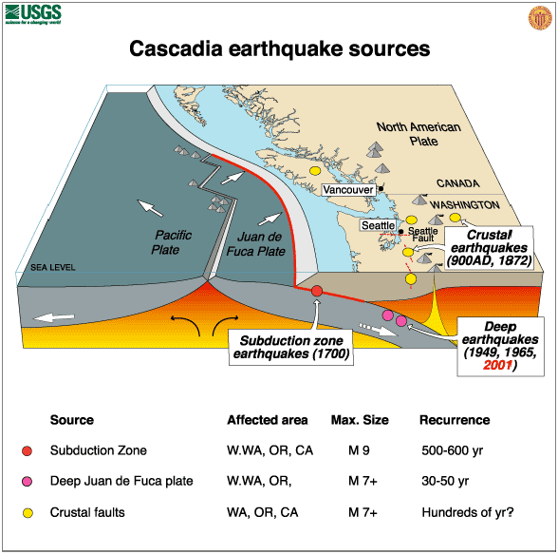
By far, earthquakes pose the largest single natural hazard exposure faced by Washington. They may affect large areas, cause great damage to structures, cause injury, loss of life and alter the socioeconomic functioning of the communities involved. The hazard of earthquakes varies from place to place, dependent upon the regional and local geology.
Earthquakes occur along faults, which are fractures or fracture zones in the earth across which there may be relative motion. If the rocks across a fault are forced to slide past one another, they do so in a stick-slip fashion; that is, they accumulate strain energy for centuries or millennia, then release it almost instantaneously. The energy released radiates outward from the source, or focus, as a series of waves - an earthquake. The primary hazards of earthquakes are ground breaking, as the rocks slide past one another, and ground shaking, by seismic waves. Secondary earthquake hazards result from distortion of the surface materials such as water, soil, or structures.
Ground shaking may affect areas 65 miles or more from the epicenter (the point on the ground surface above the focus). As such, it is the greatest primary earthquake hazard. Ground shaking may cause seiche, the rhythmic sloshing of water in lakes or bays. It may also trigger the failure of snow (avalanche) or earth materials (landslide). Ground shaking can change the mechanical properties of some fine grained, saturated soils, whereupon they liquefy and act as a fluid (liquefaction). The dramatic reduction in bearing strength of such soils can cause buried utilities to rupture and otherwise undamaged buildings to collapse.
The earth’s crust breaks along uneven lines called faults. Geologists locate these faults and determine which are active and inactive. This helps identify where the greatest earthquake potential exists. Many faults mapped by geologists, are inactive and have little earthquake potential; others are active and have a higher earthquake potential.
Ground shaking from earthquakes can collapse buildings and bridges; disrupt gas, electric, and phone service; and sometimes trigger landslides, avalanches, flash floods, fires, and huge, destructive ocean waves (tsunamis). Buildings with foundations resting on unconsolidated landfill and other unstable soil, or trailers and homes not tied to their foundations are at risk because they can be shaken off their mountings during an earthquake. When an earthquake occurs in a populated area, it may cause deaths and injuries and extensive property damage.
Aftershocks are smaller earthquakes that follow the main shock and can cause further damage to weakened buildings. Aftershocks can occur in the first hours, days, weeks, or even months after the quake. Be aware that some earthquakes are actually foreshocks, and a larger earthquake might occur.
Ground movement during an earthquake is seldom the direct cause of death or injury. Most earthquake-related injuries result from collapsing walls, flying glass, and falling objects as a result of the ground shaking, or people trying to move more than a few feet during the shaking.
Damaging Pacific Northwest earthquakes can arise from three distinct source zones:
- Deep earthquakes beneath the Puget Sound have damaged Seattle and Olympia
- Shallow faults can cause intense local shaking – urban areas are especially vulnerable
- An offshore subduction zone fault can cause strong shaking across the entire region.
More than 1,000 earthquakes are recorded in Washington each year; a dozen or more of these produce significant shaking or damage. Large earthquakes in 1949 and 1965 killed 15 people and caused more than $200 million (1984 dollars) property damage.
Earth scientists believe that most earthquakes are caused by slow movements inside the Earth that push against the Earth's brittle, relatively thin outer layer, causing the rocks to break suddenly. This outer layer is fragmented into a number of pieces, called plates. Most earthquakes occur at the boundaries of these plates. In Washington, the small Juan de Fuca plate off the coast of Washington, Oregon, and northern California is slowly moving eastward beneath a much larger plate that includes both the North American continent and the land beneath part of the Atlantic Ocean. Plate motions in the Pacific Northwest result in shallow earthquakes widely distributed over Washington and deep earthquakes in the western parts of Washington and Oregon. The movement of the Juan de Fuca plate beneath the North America plate is in many respects similar to the movements of plates in South America, Mexico, Japan, and Alaska, where the world's largest earthquakes occur.
We cannot predict precisely where, when, and how large the next destructive earthquake will be in Washington, but seismological and geological evidence supports several possibilities. Large earthquakes reported historically in Washington have most frequently occurred deep beneath the Puget Sound region. The most recent and best documented of these were the 1949 Olympia earthquake and the 1965 Seattle-Tacoma earthquake. The pattern of earthquake occurrence observed in Washington so far indicates that large earthquakes similar to the 1965 Seattle-Tacoma earthquake are likely to occur about every 35 years and large earthquakes similar to the 1949 Olympia earthquake about every 110 years.
The northeastern Oregon Milton-Freewater earthquake of July 15, 1936, is the most destructive recorded earthquake of the eastern Washington-Oregon border region. Its intensity was greatest (VII) at Freewater, State Line, and Umapine in Oregon. Moderate damage occurred in Athena and Milton. Windows broke, walls cracked, a few chimneys collapsed, a two-story concrete house near Umapine lost part of the top of its second story, and some standing railroad cars near Milton were derailed. Two schools in Umapine were damaged and water issued from cracks as much as 60 meters long. Numerous aftershocks were reported until November 1936.
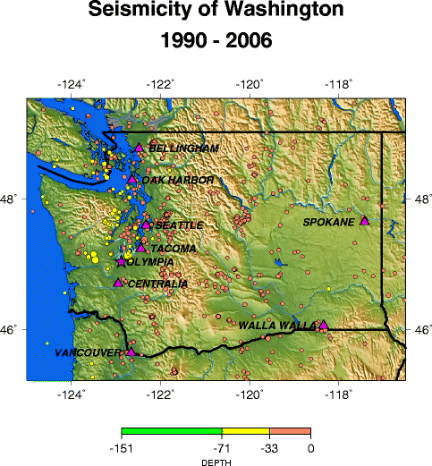
Seismicity of Washington 1990-2006.
Depth represented in kilometers.
The largest earthquake reported in Washington did not occur in the Puget Sound region, but rather at a shallow depth under the North Cascade Mountains. Recent studies in the southern Cascades near Mount St. Helens indicate that other areas in the Cascades may produce large, shallow earthquakes, comparable in size to the 1949 and 1965 Puget Sound earthquakes. The average interval of time between occurrences of such earthquakes in the Cascade Mountains is uncertain because they have occurred infrequently.
Table 4.1. Largest Known Earthquakes Felt in Washington.
Earthquakes are measured in two ways. One determines the power, the other describes the physical effects. Magnitude is calculated by seismologists from the relative size of seismograph tracings. This measurement has been named the Richter scale, a numerical gauge of earthquake energy ranging from 1.0 (very weak) to 9.0 (very strong). The Richter scale is most useful to scientists who compare the power in earthquakes. Magnitude is less useful to disaster planners and citizens, because power does not describe and classify the damage an earthquake can cause. The damage we see from earthquake shaking is due to several factors like distance from the epicenter and local rock types. Intensity defines a more useful measure of earthquake shaking for any one location. It is represented by the modified Mercalli scale. On the Mercalli scale, a value of I is the least intense motion and XII is the greatest ground shaking. Unlike magnitude, intensity can vary from place to place. In addition, intensity is not measured by machines. It is evaluated and categorized from people's reactions to events and the visible damage to man-made structures. Intensity is more useful to planners and communities because it can reasonably predict the effects of violent shaking for a local area.
Year | Max. Modified Mercalli Intensity | Felt Area (sq km) | Location
1872 | IX(3) | 1,010,000 | North Cascades
1877 | VII(9) | 48,000 | Portland
1880 | VII(10) |  | Puget Sound
1891 | VII(10) |  | Puget Sound
1893 | VII(8) | 21,000 | Southeastern Washington
1896 | VII(12) |  | Puget Sound
1904 | VII(5) | 50,000 | Olympic Peninsula
1909 | VII(5) | 150,000 | Puget Sound
1915 | VI(5) | 77,000 | North Cascades
1918 | VIII(5) | 650,000 | Vancouver Island
1920 | VII(14) | 70,000 | Puget Sound
1932 | VII(15) | 41,000 | Central Cascades
1936 | VII(14) | 270,000 | Southeastern Washington
1939 | VII(14) | 200,000 | Puget Sound
1945 | VII(14) | 128,000 | Central Cascades
1946 | VII(14) | 270,000 | Puget Sound
1946 | VIII(4) | 1,096,000 | Vancouver Island
1949 | VIII(22) | 594,000 | Puget Sound
1949 | VIII | 2,220,000 | Queen Charlotte Island
1959 | VI(12) | 64,000 | North Cascades
1959 | X(26) | 1,586,000 | Hebgen Lake (Montana)
1962 | VII(14) | 51,000 | Portland
1965 | VIII(14) | 500,000 | Puget Sound
1980 | IV |  | Mount St Helens
1981 | VII(39) | 104,000 | South Cascades
1983 | VII(42) | 800,000 | Borah Peak (Idaho)
1993 | VII |  | Klamath Falls, Or
2001 |  |  | Nisqually, Wa
The largest earthquake now considered a possibility in the Pacific Northwest is a shallow subduction-style earthquake similar to recent destructive earthquakes in Alaska and Mexico, which had magnitudes greater than 8. An earthquake this large would be expected to occur along the coast of Washington or Oregon. Although we have no record of such large earthquakes in the Pacific Northwest within the last 150 years, some scientists believe that rocks and sediments exposed along the coasts of Washington and Oregon show evidence that as many as eight such earthquakes have occurred in the last several thousand years. This evidence indicates an average interval of time between subduction earthquakes of several hundred years. A magnitude 8 subduction earthquake would not only cause widespread dangerous ground shaking but would also likely produce water waves capable of inundating coastal areas in a matter of minutes.
Earthquake damage is primarily caused by ground shaking. However, wood frame houses, well attached to their foundations and built on firm ground, generally sustain little structural damage during earthquakes. In contrast, unreinforced brick buildings commonly suffer severe damage. Ground shaking may also displace and distort the non-structural parts of a building including windows, ceiling tiles, partitions and furniture-producing property damage and endangering life. Other hazards such as ground liquefaction are commonly triggered by strong ground shaking.
The U.S. Geological Survey has gathered data and produced maps of the nation, depicting earthquake shaking hazards. This information is essential for creating and updating seismic design provisions of building codes in the United States. The USGS Shaking Hazard maps for the United States are based on current information about the rate at which earthquakes occur in different areas and on how far strong shaking extends from quake sources. The values shown on the map are "peak ground acceleration (PGA) in percent of g with 2% probability of exceedance in 50 years". Therefore, the map represents longer-term likelihood of ground accelerations. The "2% probability of exceedance in 50 years" refers to the fact that earthquakes are somewhat random in occurrence. One can not predict exactly whether an earthquake of a given size will or will not occur in the next 50 years. The map takes the random nature of earthquakes into account. It was constructed so that there is a 2% chance (2 chances in 100) that the ground acceleration values shown on the map will be exceeded in a 50 year time period. This map is based on seismic activity and fault-slip rates and takes into account the frequency of occurrence of earthquakes of various magnitudes. Locally, this hazard may be greater than that shown, because site geology may amplify ground motions.
Figure 4.2. Washington Peak Acceleration Map.
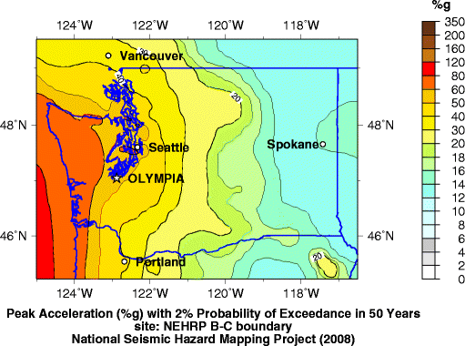
The International Building Code (IBC), a nationwide industry standard, sets construction standards for different seismic zones in the nation. IBC seismic zone rankings for Washington are among the highest in the nation. When structures are built to these standards they have a better chance to withstand earthquakes.
Structures that are in compliance with the 1970 Uniform Building Codes (UBC), which are now replaced by the International Building Code, are generally less vulnerable to seismic damages because that was when the UBC started including seismic construction standards to be applied based on regional location. This stipulated that all structures be constructed to at least seismic risk Zone 2 Standards. The State of Washington adopted the UBC as its state building code in 1972, so it is assumed that buildings built after that date were built in conformance with UBC seismic standards and have a lesser degree of vulnerability. Obviously, issues such as code enforcement and code compliance are factors that could impact this assumption. However, for planning purposes, establishing this line of demarcation can be an effective tool for estimating vulnerability. In 1994, seismic risk Zone 3 Standards of the UBC went into effect in Washington, requiring all new construction to be capable of withstanding the effects of 0.3 times the force of gravity. More recent housing stock is in compliance with Zone 3 standards. In 2003, the state again upgraded the building code to follow International Building Code Standards.
The Washington State Legislature has also adopted the 2006 version of the International Residential Code (2006 WBCC) as the official state building code starting on July 1, 2007. The 2006 IRC governs the new construction of detached one- and two-family dwellings and multiple single-family dwellings (townhouses) not more than three stories in height with separate means of egress. Provisions in the 2006 IRC for earthquake structural and foundation design are determined by the seismic design category of a proposed structure as defined in Figure R301.2(2) of the 2006 IRC.
Future injuries and property losses from earthquake hazards can be reduced by considering these hazards when making decisions about land use, by designing structures that can undergo ground shaking without collapse, by securely attaching the non-structural elements of a building, and by educating the public about what to do before, during, and after an earthquake to protect life and property.

Landslide
Landslide is a general term for a wide variety of down slope movements of earth materials that result in the perceptible downward and outward movement of soil, rock, and vegetation under the influence of gravity. The materials may move by falling, toppling, sliding, spreading, or flowing. Some landslides are rapid, occurring in seconds, whereas others may take hours, weeks, or even longer to develop. Although landslides usually occur on steep slopes, they also can occur in areas of low relief. Landslides can occur as ground failure of river bluffs, cut and-fill failures that may accompany highway and building excavations, collapse of mine-waste piles, and slope failures associated with quarries and open-pit mines. While gravity is the primary reason for landslides, there can be other contributing factors, including:
- Saturation, by snowmelt or heavy rains, that weaken rock or soils on slopes
- Erosion by rivers, glaciers, or ocean waves that create over-steepened slopes
- Topography of slope – its shape, size, degree of slope and drainage
- Stress from earthquakes magnitude 4.0 and greater can cause weak slopes to fail
- Volcanic eruptions that produce loose ash deposits and debris flows
- Excess weight, from accumulation of rain or snow, from stockpiling of rock or ore, from waste piles, or from manmade structures, may stress weak slopes to failure
- Human action, such as construction, logging or road building that disturbs soils and slopes
Determining probability of future landslide events in specific locations is difficult because so many factors can contribute to the cause of a landslide or ground failure. Landslides typically occur on slopes and in areas where they have taken place before. Areas historically subject to landslides in Washington include the Columbia River Gorge, the banks of Lake Roosevelt, the Interstate 5 corridor, U.S. 101 Highway corridor along the Pacific Coast and from the coast to Olympia, in the Cascades, Olympics, and Blue Mountains and along Puget Sound coastal bluffs.
Washington State has six landslide provinces, each with its own characteristics. Southeastern Washington is part of the Columbia Basin province. This province has extensive layers of sediments intermingling with basalt flows; sediments generally are thicker in the western part of the province. Landslides in this province include slope failures in bedrock and landslides in overlying sediments. Bedrock slope failures are most common in the form of very large ancient slumps or earth flows. A final triggering mechanism appears to have been over-steepening of a slope or removal of toe support by streams or glacial floods. Sediments contemporary with or overlying Columbia River basalt make up a major part of the large landslide complexes in the province. Major landslide problems occurred during the relocation of transportation routes required by the filling of the reservoir behind the John Day dam. Irrigation in the Columbia Basin compounds the province’s landslide problems. For example, irrigation near Pasco has increased drainage and landslide problems ten-fold since 1957.
Landslides range from shallow debris flows to deep-seated slumps. They destroy homes, businesses, and public buildings, undermine bridges, derail railroad cars, interrupt transportation infrastructure, damage utilities, and take lives. Sinkholes affect roads and utilities. Losses often go unrecorded because insurance claims are not filed, no report is made to emergency management, there is no media coverage, or the transportation damages are recorded as regular maintenance.
Significant landslide events (those resulting in disasters) are rarer but several have been recorded in the State. Major events had a significant impact on transportation, communities, and natural resources in 1977, 1979, 1986, 1989, 1997, 1998, 2006 (x2), 2007 (x2), and 2009.
Figure 4.3. Washington Geological Survey Landslide Database.
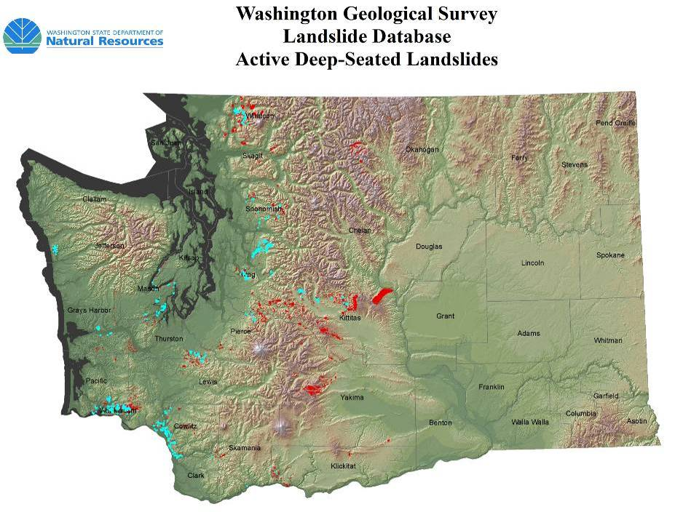
Land stability cannot be absolutely predicted with current technology. The best design and construction measures are still vulnerable to slope failure. The amount of protection, usually correlated to cost, is proportional to the level of risk reduction. Debris and vegetation management is integral to prevent landslide damages. Corrective measures help, but can often leave the property vulnerable to risk.
These are characteristics that may be indicative of a landside hazard area:
- Bluff retreat caused by sloughing of bluff sediments, resulting in a vertical bluff face with little vegetation.
- Pre-existing landside area.
- Tension or ground cracks along or near the edge of the top of a bluff.
- Structural damage caused by settling and cracking of building foundations and separation of steps from the main structure.
- Toppling bowed or jack sawed trees.
- Gullying and surface erosion.
- Mid-slope ground water seepage from a bluff face.
By studying the effects of landslides in slide prone areas we can plan for the future. More needs to be done to educate the public and to prevent development in vulnerable areas. WAC 365-190-080 states that geologically hazardous areas pose a threat to the health and safety of citizens when incompatible development is sited in areas of significant hazard. Some hazards can be mitigated by engineering, design, or construction so that risks are acceptable. When technology cannot reduce the risk to acceptable levels, building in hazardous areas should be avoided.
The primary factors that increase landslide risk are slope and certain soil characteristics. In general, the potential for landslide occurrence intensifies as slope increases on all soil types and across a wide range of geological formations. Landslide may occur on slopes steepened by man during construction, or on natural ground never disturbed. However, most slides occur in areas that have had sliding in the past. All landslides are initiated by factors such as weaknesses in the rock and soil, earthquake activity, the occurrence of heavy snow or rainfall, or construction activity that changes a critical factor involved with maintaining stability of the soil or geology of the area. A prime example of this includes previously stable slopes where home construction utilizing independent septic systems are added. The increased moisture in the ground, when coupled with an impermeable layer below the septic systems has led to surface soil movements and mass wasting.
Landslides can be triggered by natural changes in the environment or by human activities. Inherent weaknesses in the rock or soil often combine with one or more triggering events, such as heavy rain, snowmelt, or changes in ground water level. Late spring-early summer is slide season, particularly after days and weeks of greater than normal precipitation. Long-term climate change may result in an increase in precipitation and ground saturation and a rise in ground-water level, reducing the shear strength and increasing the weight of the soil.
Stream and riverbank erosion, road building or other excavation can remove the toe or lateral slope and exacerbate landslides. Seismic or volcanic activity often triggers landslides as well. Urban and rural living with excavations, roads, drainage ways, landscape watering, logging, and agricultural irrigation may also disturb the solidity of landforms, triggering landslides. In general, any land use changes that affects drainage patterns or that increase erosion or change ground-water levels can augment the potential for landslide activity.
Landslides are a recurrent menace to waterways and highways and a threat to homes, schools, businesses, and other facilities. The unimpeded movement over roads—whether for commerce, public utilities, school, emergencies, police, recreation, or tourism—is essential to the normal functioning of southeastern Washington. The disruption and dislocation of these or any other routes caused by landslides can quickly jeopardize travel and vital services. Although small slumps on cut and fill slopes along roads and highways is relatively common, nearly all of the landslide risk in Asotin, Columbia, and Garfield County is associated with the steeper slopes of the Blue Mountains. There are very few structures and little infrastructure at risk in the landslide prone areas of the Blue Mountains; however, a major slide could cause severe damage to any of the major watersheds, which would have significant negative impacts on communities downstream.

Severe Weather
The overall weather patterns that affect Asotin, Columbia, and Garfield Counties are prevalent throughout Eastern Washington. This section of the State is part of the large inland basin between the Cascade and Rocky Mountains. In an easterly and northerly direction, the Rocky Mountains shield the inland basin from the winter season’s cold air masses traveling southward across Canada. In a westerly direction, the Cascade Range forms a barrier to the easterly movement of moist and comparatively mild air in winter and cool air in summer. Some of the air from each of these source regions reaches this section of the State and produces a climate which has some of the characteristics of both continental and marine types. Most of the air masses and weather systems crossing eastern Washington are traveling under the influence of the prevailing westerly winds. Infrequently, dry continental air masses enter the inland basin from the north or east.
East of the Cascades, summers are warmer, winters are colder and precipitation is less than in western Washington. Annual precipitation ranges from seven to nine inches near the confluence of the Snake and Columbia Rivers and 15 to 30 inches along the eastern state line. During July and August, it is not unusual for four to eight weeks to pass with only a few scattered showers. Thunderstorms can be expected on one to three days each month from April through September. Most thunderstorms in the warmest months occur as isolated cells covering only a few square miles. A few damaging hailstorms are reported each summer. Maximum rainfall intensities to expect in one out of ten years are .6 of an inch in one hour; 1.0 inch in three hours; 1.0 to 1.5 inches in six hours; and 1.2 to 2.0 inches in 12 hours.
Figure 4.4. Annual Precipitation Map for Washington.
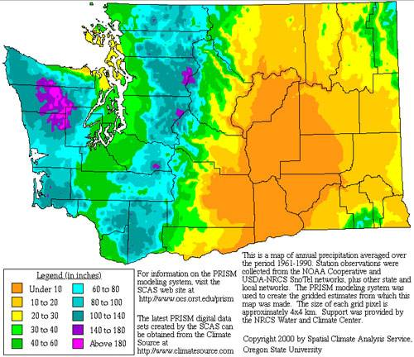
During the coldest months, a loss of heat by radiation at night and moist air crossing the Cascades and mixing with the colder air in the inland basin results in cloudiness and occasional freezing drizzle. A “chinook” wind which produces a rapid rise in temperature occurs a few times each winter. Frost penetration in the soil depends to some extent on the vegetative cover, snow cover and the duration of low temperatures. In an average winter, frost in the soil can be expected to reach a depth of 10 to 20 inches. During a few of the colder winters, with little or now snow cover, frost has reached a depth of 25 to 35 inches.
Winter season snowfall in the valleys varies from 40 to 80 inches. Both rainfall and snowfall increase along the slopes of the mountains. Snow can be expected in the higher elevations in October and in the lower valleys by the last of November. In the lower elevations, snow reaches a depth of 15 to 30 inches and remains on the ground most of the time from the first of December until March. The few snow survey reports available for elevations above 5,000 feet indicate six to eight feet of snow on the ground the first of April and four to five feet the first of May.
Cold continental air moving southward through Canada will occasionally cross the higher mountains and follow the north-south valleys into the Columbia Basin. On clear, calm winter nights, the loss of heat by radiation from over a snow cover produces ideal conditions for low temperatures. The lowest temperature in the State, -48° F, was recorded December 30, 1965, at Mazama and Winthrop. In January, the average maximum temperature is near 30° F and the minimum temperature is 15° F. Minimum temperatures from -10° to -20°F are recorded almost every winter and temperatures ranging from -25° to -42° F have been recorded in the colder valleys. In July, the average maximum temperature is 85° to 90° and the minimum temperature 45° to 50° F. Maximum temperatures reach 100° F on a few afternoons each summer and temperatures between 105° to 110° F have been recorded. The record high temperature of 118° F was recorded at Ice Harbor Dam on August 5, 1961. Temperatures in the mountains decrease three to five degrees Fahrenheit with each 1,000 feet increase in elevation. The average date of the freezing temperatures can be expected in the colder valleys by the first of September and before mid-October in the warmer areas.
Storms are naturally occurring atmospheric disturbances manifested in strong winds accompanied by rain, snow, or other precipitation, and often by thunder or lightning. All areas within this region are vulnerable to severe local storms. The affects are generally transportation problems and loss of utilities. When transportation accidents occur, motorists are stranded and schools and businesses close. The affects vary with the intensity of the storm, the level of preparation by local jurisdictions and residents, and the equipment and staff available to perform tasks to lessen the effects of severe local storms.
Major disaster declarations related to severe storms in Washington occurred in 1962, 1972, 1974, 1975, 1977, 1979, 1983, 1986 (x3), 1990 (x2), 1991, 1993, 1996, 1997, 2003, 2006 (x2), 2007 (x2), and 2009 (x2). Regional operational plans should reflect warning and notification of the public, prioritization of roads and streets to be cleared, provision of emergency services, mutual aid with other public entities, and procedures for requesting state and federal assistance if needed. To prepare for severe local storms, local jurisdictions should provide public information on emergency preparedness and self-help.

Wildland Fire
An informed discussion of fire mitigation is not complete until basic concepts that govern fire behavior are understood. In the broadest sense, wildland fire behavior describes how fires burn; the manner in which fuels ignite, how flames develop and how fire spreads across the landscape. The three major physical components that determine fire behavior are the fuels supporting the fire, topography in which the fire is burning, and the weather and atmospheric conditions during a fire event. At the landscape level, both topography and weather are beyond our control. We are powerless to control winds, temperature, relative humidity, atmospheric instability, slope, aspect, elevation, and landforms. It is beyond our control to alter these conditions, and thus impossible to alter fire behavior through their manipulation. When we attempt to alter how fires burn, we are left with manipulating the third component of the fire environment; fuels which support the fire. By altering fuel loading and fuel continuity across the landscape, we have the best opportunity to determine how fires burn.
A brief description of each of the fire environment elements follows in order to illustrate their effect on fire behavior.
Weather
Weather conditions contribute significantly to determining fire behavior. Wind, moisture, temperature, and relative humidity ultimately determine the rates at which fuels dry and vegetation cures, and whether fuel conditions become dry enough to sustain an ignition. Once conditions are capable of sustaining a fire, atmospheric stability and wind speed and direction can have a significant affect on fire behavior. Winds fan fires with oxygen, increasing the rate at which fire spreads across the landscape. Weather is the most unpredictable component governing fire behavior, constantly changing in time and across the landscape.
Topography
Fires burning in similar fuel conditions burn dramatically different under different topographic conditions. Topography alters heat transfer and localized weather conditions, which in turn influence vegetative growth and resulting fuels. Changes in slope and aspect can have significant influences on how fires burn. Generally speaking, north slopes tend to be cooler, wetter, more productive sites. This can lead to heavy fuel accumulations, with high fuel moistures, later curing of fuels, and lower rates of spread. In contrast, south and west slopes tend to receive more direct sun, and thus have the highest temperatures, lowest soil and fuel moistures, and lightest fuels. The combination of light fuels and dry sites lead to fires that typically display the highest rates of spread. These slopes also tend to be on the windward side of mountains. Thus these slopes tend to be “available to burn” a greater portion of the year.
Slope also plays a significant roll in fire spread, by allowing preheating of fuels upslope of the burning fire. As slope increases, rate of spread and flame lengths tend to increase. Therefore, we can expect the fastest rates of spread on steep, warm south and west slopes with fuels that are exposed to the wind.
Fuels
Fuel is any material that can ignite and burn. Fuels describe any organic material, dead or alive, found in the fire environment. Grasses, brush, branches, logs, logging slash, forest floor litter, conifer needles, and buildings are all examples. The physical properties and characteristics of fuels govern how fires burn. Fuel loading, size and shape, moisture content and continuity and arrangement all have an affect on fire behavior. Generally speaking, the smaller and finer the fuels, the faster the potential rate of fire spread. Small fuels such as grass, needle litter and other fuels less than a quarter inch in diameter are most responsible for fire spread. In fact, “fine” fuels, with high surface to volume ratios, are considered the primary carriers of surface fire. This is apparent to anyone who has ever witnessed the speed at which grass fires burn. As fuel size increases, the rate of spread tends to decrease, as surface to volume ratio decreases. Fires in large fuels generally burn at a slower rate, but release much more energy, burn with much greater intensity. This increased energy release, or intensity, makes these fires more difficult to control. Thus, it is much easier to control a fire burning in grass than to control a fire burning in timber.
When burning under a forest canopy, the increased intensities can lead to torching (single trees becoming completely involved) and potentially development of crown fire (fire carried from tree crown to tree crown). That is, they release much more energy. Fuels are found in combinations of types, amounts, sizes, shapes, and arrangements. It is the unique combination of these factors, along with the topography and weather, which determine how fires will burn.
The study of fire behavior recognizes the dramatic and often-unexpected affect small changes in any single component has on how fires burn. It is impossible to speak in specific terms when predicting how a fire will burn under any given set of conditions. However, through countless observations and repeated research, some of the principles that govern fire behavior have been identified and are recognized.

Wildfire Hazard Assessment
Southeastern Washington was analyzed using a variety of models, managed on a Geographic Information System (GIS) system. Physical features of the region including roads, streams, soils, elevation, and remotely sensed images were represented by data layers. Field visits were conducted by specialists from Northwest Management, Inc. and others. Discussions with area residents and local fire suppression professionals augmented field visits and provided insights into forest health issues and treatment options. This information was analyzed and combined to develop an objective assessment of wildland fire risk in the region.

Historic Fire Regime
Historical variability in fire regime is a conservative indicator of ecosystem sustainability, and thus, understanding the natural role of fire in ecosystems is necessary for proper fire management. Fire is one of the dominant processes in terrestrial systems that constrain vegetation patterns, habitats, and ultimately, species composition. Land managers need to understand historical fire regimes, the fire return interval (frequency) and fire severity prior to settlement by Euro-Americans, to be able to define ecologically appropriate goals and objectives for an area. Moreover, managers need spatially explicit knowledge of how historical fire regimes vary across the landscape.
Many ecological assessments are enhanced by the characterization of the historical range of variability which helps managers understand: (1) how the driving ecosystem processes vary from site to site; (2) how these processes affected ecosystems in the past; and (3) how these processes might affect the ecosystems of today and the future. Historical fire regimes are a critical component for characterizing the historical range of variability in fire-adapted ecosystems. Furthermore, understanding ecosystem departures provides the necessary context for managing sustainable ecosystems. Land managers need to understand how ecosystem processes and functions have changed prior to developing strategies to maintain or restore sustainable systems. In addition, the concept of departure is a key factor for assessing risks to ecosystem components. For example, the departure from historical fire regimes may serve as a useful proxy for the potential of severe fire effects from an ecological perspective.
Table 4.2. Assessment of Historic Fire Regimes in Southeastern Washington.
Regime | Description | Percent | Acres
1 | <= 35 Year Fire Return Interval, Low and Mixed Severity | 157,489 | 11%
2 | <= 35 Year Fire Return Interval, Replacement Severity | 287,747 | 20%
3 | 35 - 200 Year Fire Return Interval, Low and Mixed Severity | 723,013 | 51%
4 | 35 - 200 Year Fire Return Interval, Replacement Severity | 245,863 | 17%
5 | > 200 Year Fire Return Interval, Any Severity | 2,255 | 0%
 | Water | 11,140 | 1%
 | Barren | 513 | 0%
 | Sparsely Vegetated | 693 | 0%
 | Indeterminate Fire Regime Characteristics | 6 | 0%
 | Total | 1,428,719 | 100%
The table above shows the amount of acreage in each defined fire regime in Asotin, Columbia, and Garfield Counties. The historic fire regime model shows that the vast majority of the area has historically experienced a fire return rate of 35 to 200 years with low and high severity fires.
Figure 4.5. Historic Fire Regime in Southeast Washington.
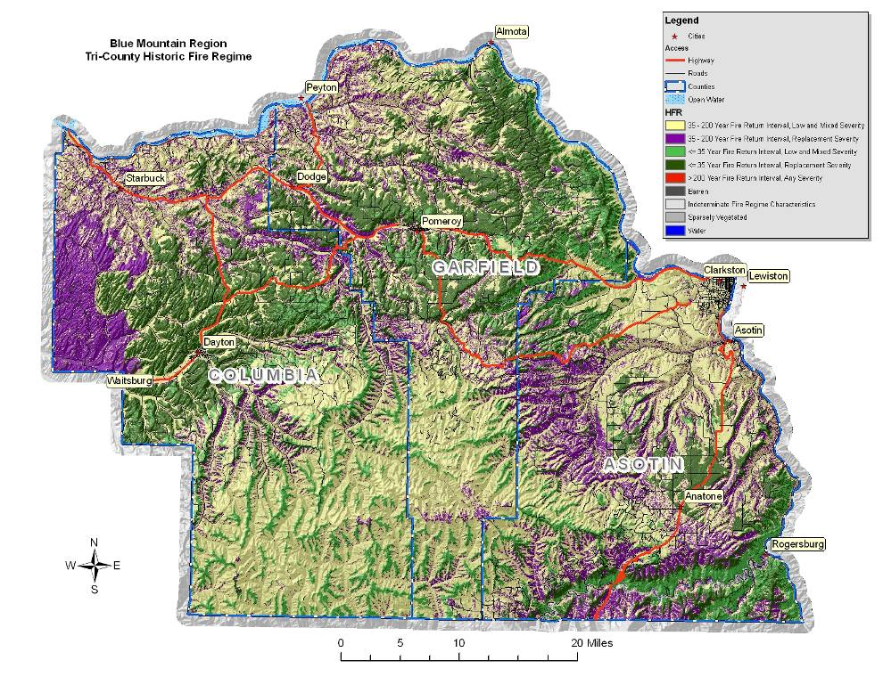

Fire Regime Condition Class
A natural fire regime is a general classification of the role fire would play across a landscape in the absence of modern human mechanical intervention, but including the influence of aboriginal burning., Coarse scale definitions for historic fire regimes have been developed by Hardy et al and Schmidt et al and interpreted for fire and fuels management by Hann and Bunnell.
A fire regime condition class (FRCC) is a classification of the amount of departure from the historic regime. The three classes are based on low (FRCC 1), moderate (FRCC 2), and high (FRCC 3) departure from the central tendency of the natural (historical) regime., The central tendency is a composite estimate of vegetation characteristics (species composition, structural stages, stand age, canopy closure, and mosaic pattern); fuel composition; fire frequency, severity, and pattern; and other associated natural disturbances. Low departure is considered to be within the natural (historical) range of variability, while moderate and high departures are outside.
An analysis of Fire Regime Condition Classes in southeastern Washington shows that a significant portion of the county is either moderately departed (30%) or severely departed (23%) from its natural fire regime and associated vegetation and fuel characteristics. In most scenarios, the more departed an area is from its natural fire regime, the higher the wildfire potential; however, this is not true 100% of the time.
Table 4.3. Assessment of Fire Regime Condition Class in Southeast Washington.
Condition Class | Acres | Percent
Fire Regime Condition Class I | 109,425 | 8%
Fire Regime Condition Class II | 423,443 | 30%
Fire Regime Condition Class III | 329,743 | 23%
Water | 11,140 | 1%
Urban | 33,530 | 2%
Barren | 513 | 0%
Sparsely Vegetated | 693 | 0%
Agriculture | 520,231 | 36%
Total | 1,428,719 | 100%
Much of the Umatilla National Forest and surrounding forestlands are classified as Condition Class III due most likely to successful fire suppression efforts over the past 100 years. The exclusion of wildland fires in this area has led to overcrowded forest conditions and changes in species composition, which will tend to increase fire severity and result in more stand replacing wildland fires. The recent School Fire and Columbia Complex Fire are good examples of the trend towards higher severity, stand replacing fires in this area.
Figure 4.6. Fire Regime Condition Class in Southeast Washington.
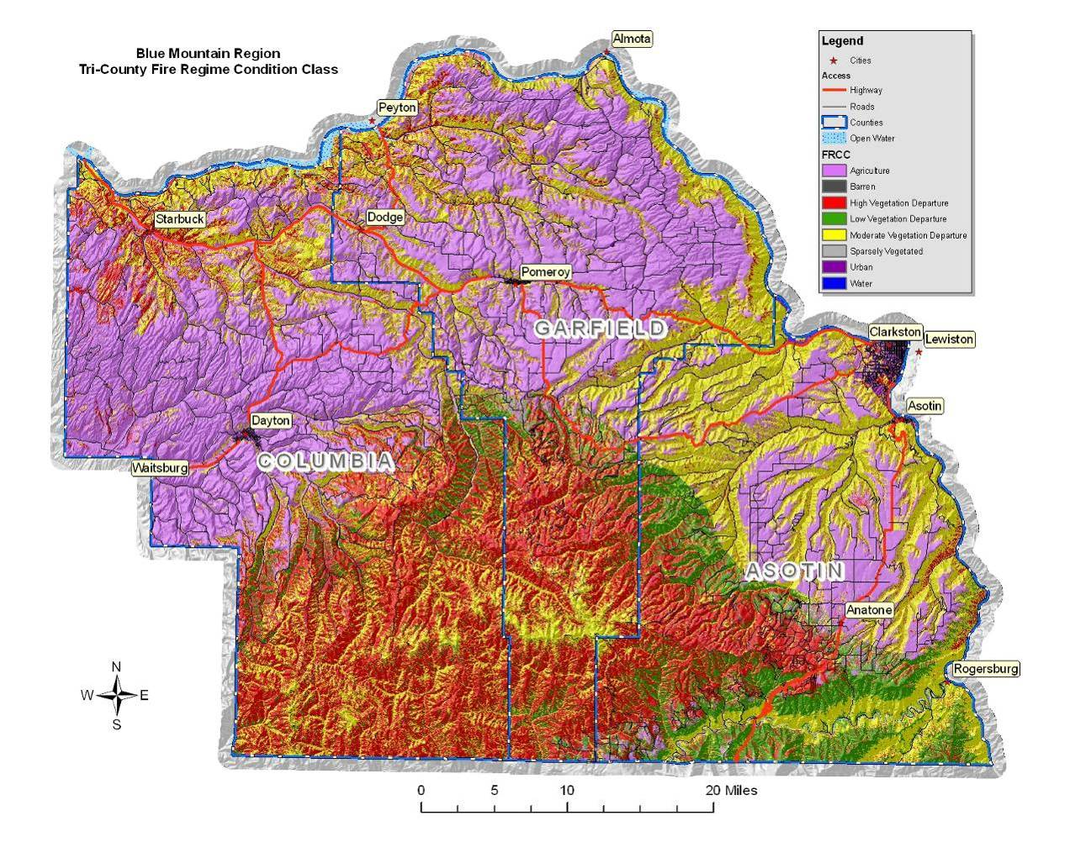

Fire Prone Landscapes
Northwest Management, Inc. developed a methodology to assess the location of fire prone landscapes on forested and non-forested ecosystems in the western US. The goal of developing the Fire Prone Landscapes analysis is to make inferences about the relative risk factors across large geographical regions (multiple counties) for wildfire spread. This analysis uses the extent and occurrence of past fires as an indicator of characteristics for a specific area and their propensity to burn in the future. Concisely, if a certain combination of vegetation cover type, canopy closure, aspect, slope, stream and road density have burned with a high occurrence and frequently in the past, then it is reasonable to extrapolate that they will have the same tendency in the future, unless mitigation activities are conducted to reduce this potential.
The Fire Prone Landscapes model assesses the potential for the landscape to burn during the fire season. The entire region was evaluated at a resolution of 10 to determine the propensity for a particular area to burn in the case of a wildfire. The analysis ranked factors from 0 (little to no risk) to 100 (extremely high risk) based on past fire occurrence.
Table 4.4. Fire Prone Landscape Rankings.
Color Code | Value | Acres | Percent of  Total Area
 | 0 | 0 | 0%
 | 10 | 23,829 | 2%
 | 20 | 359,870 | 25%
 | 30 | 240,048 | 17%
 | 40 | 272,519 | 19%
 | 50 | 72,460 | 5%
 | 60 | 7,332 | 1%
 | 70 | 33,921 | 2%
 | 80 | 256,806 | 18%
 | 90 | 145,985 | 10%
 | 100 | 14,810 | 1%
 | Total | 1,427,579
The risk category values developed in this analysis should be considered ordinal data, that is, while the values presented have a meaningful ranking, they neither have a true zero point nor scale between numbers. Rating in the “40” range is not necessarily twice as “risky” as rating in the “20” range. These category values also do not correspond to a rate of fire spread, a fuel loading indicator, or measurable potential fire intensity. Each of those scales is greatly influenced by weather, seasonal and daily variations in moisture (relative humidity), solar radiation, and other factors. The risk rating presented here serves to identify where certain constant variables are present, aiding in identifying where fires typically spread into the largest fires across the landscape.
Figure 4.7. Fire Prone Landscapes in Southeastern Washington.
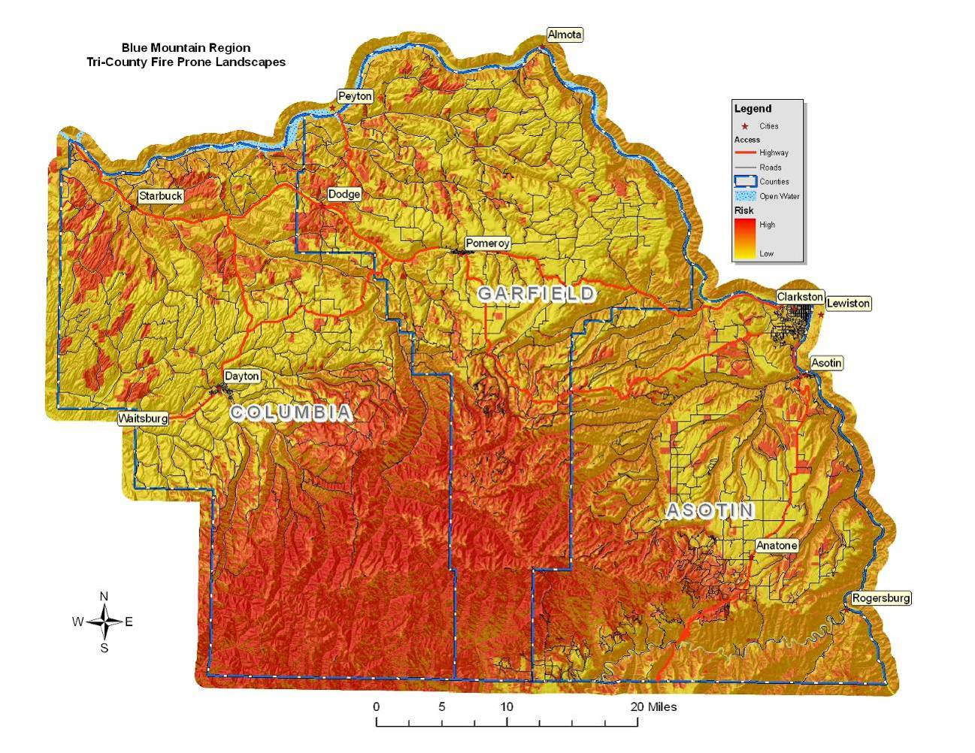

Wildland Urban Interface
The wildland-urban interface (WUI) has gained attention through efforts targeted at wildfire mitigation; however, this analysis technique is also useful when considering other hazards because the concept looks at where people and structures are concentrated in any particular region.
A key component in meeting the underlying need for protection of people and structures is the protection and treatment of hazards in the wildland-urban interface. The wildland-urban interface refers to areas where wildland vegetation meets urban developments or where forest fuels meet urban fuels such as houses. The WUI encompasses not only the interface (areas immediately adjacent to urban development), but also the surrounding vegetation and topography. Reducing the hazard in the wildland-urban interface requires the efforts of federal, state, and local agencies and private individuals. “The role of [most] federal agencies in the wildland-urban interface includes wildland firefighting, hazard fuels reduction, cooperative prevention and education, and technical experience. Structural fire protection [during a wildfire] in the wildland-urban interface is [largely] the responsibility of Tribal, state, and local governments”. The role of the federal agencies in southeast Washington is and will be much more limited. Property owners share a responsibility to protect their residences and businesses and minimize danger by creating defensible areas around them and taking other measures to minimize the risks to their structures. With treatment, a wildland-urban interface can provide firefighters a defensible area from which to suppress wildland fires or defend communities against other hazard risks. In addition, a wildland-urban interface that is properly treated will be less likely to sustain a crown fire that enters or originates within it.
By reducing hazardous fuel loads, ladder fuels, and tree densities, and creating new and reinforcing existing defensible space, landowners can protect the wildland-urban interface, the biological resources of the management area, and adjacent property owners by:
- minimizing the potential of high-severity ground or crown fires entering or leaving the area;
- reducing the potential for firebrands (embers carried by the wind in front of the wildfire) impacting the WUI. Research indicates that flying sparks and embers (firebrands) from a crown fire can ignite additional wildfires as far as 1¼ miles away during periods of extreme fire weather and fire behavior;
- improving defensible space in the immediate areas for suppression efforts in the event of wildland fire.
Three wildland-urban interface conditions have been identified (Federal Register 66(3), January 4, 2001) for use in wildfire control efforts. These include the Interface Condition, Intermix Condition, and Occluded Condition. Descriptions of each are as follows:
- Interface Condition – a situation where structures abut wildland fuels. There is a clear line of demarcation between the structures and the wildland fuels along roads or back fences. The development density for an interface condition is usually 3+ structures per acre;
- Intermix Condition – a situation where structures are scattered throughout a wildland area. There is no clear line of demarcation; the wildland fuels are continuous outside of and within the developed area. The development density in the intermix ranges from structures very close together to one structure per 40 acres; and
- Occluded Condition – a situation, normally within a city, where structures abut an island of wildland fuels (park or open space). There is a clear line of demarcation between the structures and the wildland fuels along roads and fences. The development density for an occluded condition is usually similar to that found in the interface condition and the occluded area is usually less than 1,000 acres in size.
In addition to these classifications detailed in the Federal Register, four additional classifications of population density have been included to augment these categories:
- Rural Condition – a situation where the scattered small clusters of structures (ranches, farms, resorts, or summer cabins) are exposed to wildland fuels. There may be miles between these clusters. The condition of the WUI connects these clusters into a relatively homogenous area.
- High Density Urban Areas – those areas generally identified by the population density consistent with the location of larger incorporated cities, however, the boundary is not necessarily set by the location of city boundaries: it is set by very high population densities (more than 15-30 structures per acre or more). Many counties and reservations in the west do not have high density urban areas. Asotin County, Washington, was determined not to have any areas of high density urban based on current (2006) structure locations. However, in the nearby Asotin County, Clarkston, Washington, is representative of a high density urban condition.
- Infrastructure Area WUI – those locations where critical and identified infrastructure are located outside of populated regions and may include high tension power line corridors, critical escape or primary access corridors, municipal watersheds, areas immediately adjacent to facilities in the wildland such as radio repeater towers or fire lookouts. These are identified by county or reservation level core teams.
- Non-WUI Condition - a situation where the above definitions do not apply because of a lack of structures in an area or the absence of critical infrastructure crossing these unpopulated regions. This classification is not WUI.
Asotin, Columbia, Garfield County’s wildland-urban interface (WUI) is based on population density. Relative population density across the county was estimated using a GIS based kernel density population model that uses object locations to produce, through statistical analysis, concentric rings or areas of consistent density. To graphically identify relative population density across the county, structure locations were determined by examining aerial photography. The aerial photographs used are 1 meter resolution (very high quality) and show land based features with acceptable resolution and quality. County level mosaics were obtained for Asotin, Columbia, and Garfield Counties, and for the adjacent counties, and were used to provide locations for digitized structures in the region. The resulting output identified the extent and level of population density throughout the county. Based on committee review and discussion, the output was adjusted to include areas of significant infrastructure and to incorporate gaps along important transportation routes.
By evaluating structure density in this way, WUI areas can be identified on maps by using mathematical formulae and population density indexes. The resulting population density indexes create concentric circles showing high density areas, interface, and intermix condition WUI, as well as rural condition WUI (as defined above). This portion of the analysis allows us to “see” where the highest concentrations of structures are located in reference to relatively high risk landscapes, limiting infrastructure, and other points of concern.
The WUI, as defined here, is unbiased and consistent, allows for edge matching with other counties, and most importantly – it addresses all of the county, not just federally identified communities at risk. It is a planning tool showing where homes and businesses are located and the density of those structures leading to identified WUI categories. It can be determined again in the future, using the same criteria, to show how the WUI has changed in response to increasing population densities. It uses a repeatable and reliable analysis process that is unbiased.
Figure 4.8. Wildland-Urban Interface Map for Southeastern Washington Counties
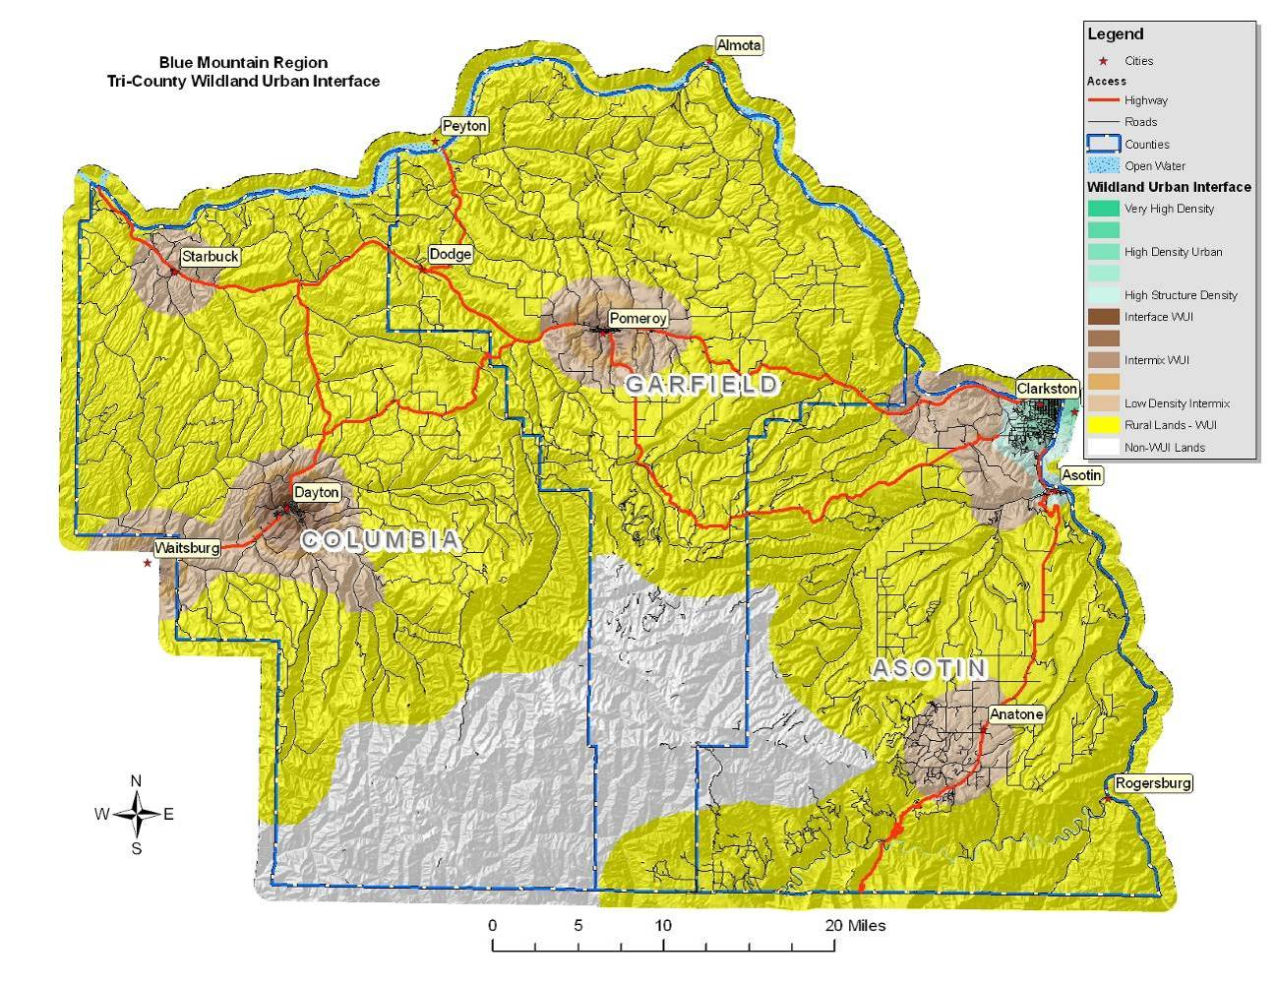

Avalanche
An avalanche is a rapid flow of snow downslope from either natural triggers or human activity. Typically occurring in mountainous terrain, an avalanche can mix air and water with the descending snow. Powerful avalanches have the capability to entrain ice, rocks, trees, and other material on the slope. Avalanches are primarily composed of flowing snow, and are distinct from mudslides, rock slides, rock avalanches, and serac collapses on an icefall. In mountainous terrain, avalanches are among the most serious objective hazards to life and property, with their destructive capability resulting from their potential to carry an enormous mass of snow rapidly over large distances.
There are two types of avalanches, loose and slab, and two types of slab avalanches, dry and wet. Although the most dangerous avalanche is the slab avalanche, loose slides can and do produce injury and death. Loose avalanches occur when grains of snow cannot hold onto a slope and begin sliding downhill, picking up more snow and fanning out in an inverted V. Slab avalanches occur when a cohesive mass of snow breaks away from the slope all at once. Most slides in the Northwest are slab avalanches. Dry slab avalanches occur when the stresses on a slab overcome the internal strength of the slab and its attachment to surrounding snow. A decrease in strength produced through warming, melting snow, or rain, or an increase in stress produced by the weight of additional snowfall, a skier or a snowmobile cause this type of avalanche. Dry slab avalanches can travel 60 to 80 miles per hour or more, reaching these speeds within five seconds after the fracture; they account for most avalanche fatalities. Wet slab avalanches occur when water percolating through the top slab weakens it and dissolves its bond with a lower layer, decreasing the ability of the weaker, lower layer to hold on to the top slab, as well as decreasing the slab’s strength.
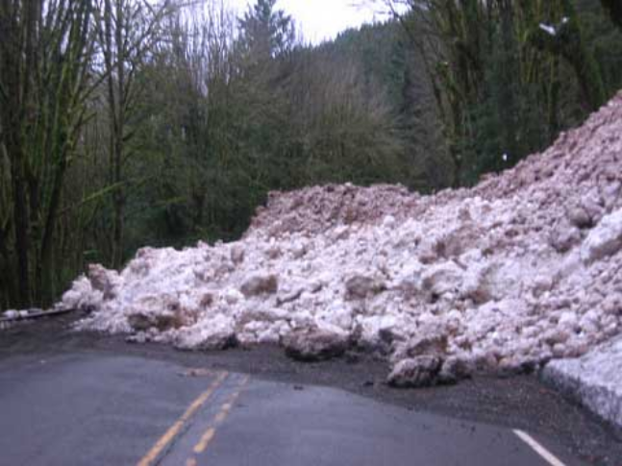
Avalanche in neighboring Walla Walla County.
For a slope to generate an avalanche it must be simultaneously capable of retaining snow and allowing snow to accelerate once set in motion. The angle of the slope that can hold snow depends on the ductile and shear strength of the snow, which is determined by the temperature and moisture content. Drier and colder snow, with lower ductile and shear strength, will only bond to lower angle slopes; while wet and warm snow, with higher ductile and shear strength, can bind to very steep surfaces. Snow that has been water saturated to the point of slush can accelerate on shallow angled terrain; while a cohesive snow pack will not accelerate on steep slopes.

A number of weather and terrain factors determine avalanche danger:
Weather:
- Storms – A large percentage of all snow avalanches occur during and shortly after storms.
- Rate of snowfall – Snow falling at a rate of one inch or more per hour rapidly increases avalanche danger.
- Temperature – Storms starting with low temperatures and dry snow, followed by rising temperatures and wetter snow, are more likely to cause avalanches than storms that start warm and then cool with snowfall.
- Wet snow – Rainstorms or spring weather with warm, moist winds and cloudy nights can warm the snow cover resulting in wet snow avalanches. Wet snow avalanches are more likely on sun-exposed terrain (south-facing slopes) and under exposed rocks or cliffs.
Terrain:
- Ground cover – Large rocks, trees and heavy shrubs help anchor snow.
- Slope profile – Dangerous slab avalanches are more likely to occur on convex slopes.
- Slope aspect – Leeward slopes are dangerous because windblown snow adds depth and creates dense slabs. South facing slopes are more dangerous in the springtime.
- Slope steepness – Snow avalanches are most common on slopes of 30 to 45 degrees.
Avalanches have killed more than 190 people in the past century in Washington State, exceeding deaths from any other natural hazard. One of the nation’s worst avalanche disasters occurred in 1910 when massive avalanches hit two trains stopped on the west side of Stevens Pass; 96 people were killed. Avalanches kill one to two people, on average, every year in Washington, although many more are involved in avalanche accidents that do not result in fatalities. Avalanches occur in four mountain ranges in the state – the Cascade Range, which divides the state east and west, the Olympic Mountains in northwest Washington, the Blue Mountains in southeast Washington, and the Selkirk Mountains in northeast Washington. The avalanche season begins in November and continues until early summer for all mountain areas of the state.
The only known avalanche in southeastern Washington occurred in Pomeroy in 1932. No injuries were reported, but snow had to be removed from the railroad tracks. In southeastern Washington, the only area having significant risk to avalanches is the Blue Mountains in the southern regions of Asotin and Garfield County. This area is primarily at risk due to the intensity of winter recreation activities, particularly skiing and snowmobiling. With this exception, this region is not at risk of avalanches as snowpack is typically minimal.

Tsunami
While a true tsunami will never directly impact southeast Washington, the Snake River shoreline is vulnerable to inland tsunamis (pronounced soo-ná-mees); more accurately referred to as seiches. An inland tsunami, or seiche, is a sudden, large wave that can cause loss of life and property damage. Inland tsunamis are typically defined as standing waves on a closed or semi-closed body of water such as rivers, reservoirs, ponds, and lakes.
The effect of an inland tsunami is caused by resonances in a body of water that has been disturbed by one or more of a number of factors, most often meteorological effects (wind and atmospheric pressure variations), seismic activity, or landslides. Gravity always seeks to restore the horizontal surface of a body of liquid water, as this represents the configuration in which the water is in hydrostatic equilibrium. Vertical harmonic motion produces an impulse that travels the length of the basin at a velocity that depends on the depth of the water. The impulse is reflected back from the end of the basin generating interference. Repeated reflections produce standing waves with one or more nodes, or points, that experience no vertical motion. The frequency of the oscillation is determined by the size of the basin, its depth and contours, and the water temperature.
Figure 4.9. Illustration of a Two-Node Seiche.
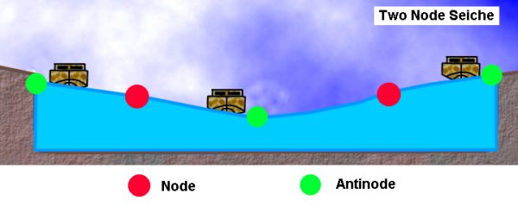
Although highly sophisticated tsunami warning systems exist along the Pacific coast, inland tsunamis have the potential to cause extreme damage to waterways and shoreline communities due to their infrequency and the lack of a warning system. Residences, businesses, and other resources along the Lake Roosevelt shoreline where these localized events might occur may be severely damaged by a series of high waves.
The Snake River corridor does not have a history of landslides that resulted in inland tsunamis, but due to the steep topography and continued development along the adjacent slopes, there is potential for a landslide initiating a wave that causes damage on the opposite shoreline. Inland tsunamis on Lake Roosevelt in northeastern Washington, which has similar topography and land and water uses, have exclusively been the result of landslides. Reports of these events suggest that only one wave hit the shoreline opposite of a landslide. The two major geologic parameters that affect the generation of a water wave from a landslide are the volume of the slide mass and the motion of the mass as it reaches the water.
Lake Roosevelt InlandTsunamis
Landslides into Lake Roosevelt generated numerous seiches (commonly recorded as tsunamis) from 1944 to 1953 after Grand Coulee Dam created the lake on the Columbia River. Most seiches on Lake Roosevelt have generated large waves (30 to 60 feet in height) that struck the opposite shore of the lake, with some waves observed miles from the source. At least seven seiches have been recorded on Lake Roosevelt since 1944, but only two reportedly caused damage.
February 23, 1951 – A 100,000 to 200,000 cubic yard landslide just north of Kettle Falls created a wave that picked up logs at the Harter Lumber Company Mill and flung them through the mill 10 feet above lake level.
October 13, 1952 – A landslide 98 miles upstream of Grand Coulee Dam created a wave that broke tugboats and barges loose from their moorings at the Lafferty Transportation Company six miles away. It also swept logs and other debris over a large area above lake level.

Volcano
The Cascade Range of the Pacific Northwest has more than a dozen potentially active volcanoes. Cascade volcanoes tend to erupt explosively, and on average two eruptions occur per century—the most recent were at Mount St. Helens, Washington (1980–86 and 2004–8), and Lassen Peak, California (1914–17). On May 18, 1980, after 2 months of earthquakes and minor eruptions, Mount St. Helens, Washington, exploded in one of the most devastating volcanic eruptions of the 20th century. Although less than 0.1 cubic mile of molten rock (magma) was erupted, 57 people died, and damage exceeded $1 billion. Fortunately, most people in the area were able to evacuate safely before the eruption because public officials had been alerted to the danger by U.S. Geological Survey (USGS) and other scientists. To help protect the Pacific Northwest’s rapidly expanding population, USGS scientists at the Cascades Volcano Observatory in Vancouver, Washington, monitor and assess the hazards posed by the region’s volcanoes.
There are no active volcanoes in southeastern Washington; however, Asotin, Columbia, and Garfield County communities could be directly affected by an eruption from any one of the Cascade volcanoes. During an eruption, such as the 1980 eruption of Mount St. Helens, southeastern Washington is not likely to be directly affected by lava flows, pyroclastic flows, landslides, or lahars; however, this region may be indirectly impacted due to damming of waterways, reduced air and water quality, acid rain, and ash fallout.
An explosive eruption blasts solid and molten rock fragments (tephra) and volcanic gases into the air with tremendous force. The largest rock fragments (bombs) usually fall back to the ground within 2 miles of the vent. Small fragments (less than about 0.1 inch across) of volcanic glass, minerals, and rock (ash) rise high into the air, forming a huge, billowing eruption column.
Eruption columns can grow rapidly and reach more than 12 miles above a volcano in less than 30 minutes, forming an eruption cloud. The volcanic ash in the cloud can pose a serious hazard to aviation. During the past 15 years, about 80 commercial jets have been damaged by inadvertently flying into ash clouds, and several have nearly crashed because of engine failure. Large eruption clouds can extend hundreds of miles downwind, resulting in ash fall over enormous areas; the wind carries the smallest ash particles the farthest. Ash from the May 18, 1980, eruption of Mount St. Helens, Washington, fell over an area of 22,000 square miles in the Western United States. Heavy ash fall can collapse buildings, and even minor ash fall can damage crops, electronics, and machinery.
Volcanoes emit gases during eruptions. Even when a volcano is not erupting, cracks in the ground allow gases to reach the surface through small openings called fumaroles. More than ninety percent of all gas emitted by volcanoes is water vapor (steam), most of which is heated ground water (underground water from rain fall and streams). Other common volcanic gases are carbon dioxide, sulfur dioxide, hydrogen sulfide, hydrogen, and fluorine. Sulfur dioxide gas can react with water droplets in the atmosphere to create acid rain, which causes corrosion and harms vegetation. Carbon dioxide is heavier than air and can be trapped in low areas in concentrations that are deadly to people and animals. Fluorine, which in high concentrations is toxic, can be adsorbed onto volcanic ash particles that later fall to the ground. The fluorine on the particles can poison livestock grazing on ash-coated grass and also contaminate domestic water supplies.

Volcanoes of the Cascades
The volcanoes of the Cascade Range, which stretches from northern California into British Columbia, have produced more than 100 eruptions, most of them explosive, in just the past few thousand years. However, individual Cascade volcanoes can lie dormant for many centuries between eruptions, and the great risk posed by volcanic activity in the region is therefore not always apparent.
When Cascade volcanoes do erupt, high-speed avalanches of hot ash and rock (pyroclastic flows), lava flows, and landslides can devastate areas 10 or more miles away; and huge mudflows of volcanic ash and debris, called lahars, can inundate valleys more than 50 miles downstream. Falling ash from explosive eruptions can disrupt human activities hundreds of miles downwind, and drifting clouds of fine ash can cause severe damage to jet aircraft even thousands of miles away. Erupting Cascade volcanoes are more prone than other U.S. volcanoes to explosive volcanic activity, resulting in pyroclastic flows. These are hot, often incandescent mixtures of volcanic fragments and gases that sweep along close to the ground at speeds up to 450 mph.
Because the population of the Pacific Northwest is rapidly expanding, the volcanoes of the Cascade Range in Washington, Oregon, and northern California are some of the most dangerous in the United States. Although Cascade volcanoes do not often erupt (on average, about two erupt each century), they can be dangerous because of their violently explosive behavior, their permanent snow and ice cover that can fuel large volcanic debris flows (lahars), and their proximity to various critical infrastructure, air routes, and populated areas in Washington, Oregon, and California.
Figure 4.10. Record of Cascade Range Volcanic Eruptions.
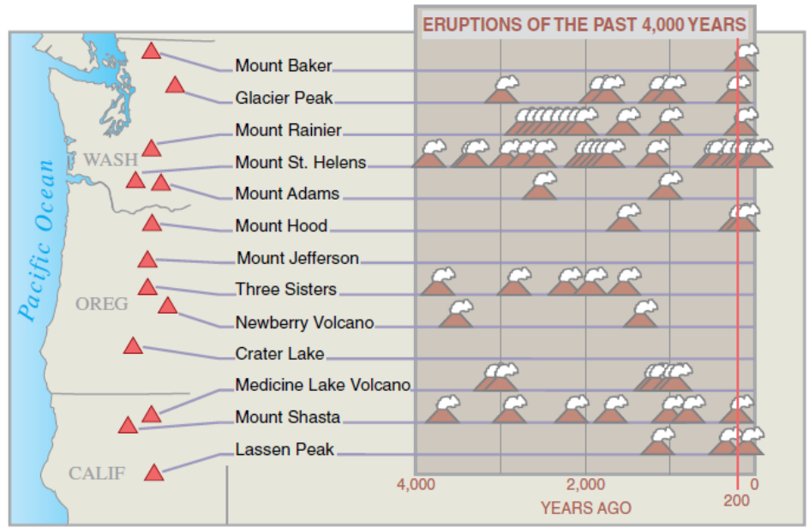
Of the 13 potentially active volcanoes in the Cascade Range, 11 have erupted in the past 4,000 years. More than 100 eruptions have occurred during that period, making the volcanoes of the Cascade Range some of the most hazardous in the U.S. Each eruption symbol in the diagram represents from one to several eruptions closely spaced in time at or near the named volcano.
Washington
Mount Baker erupted in the mid-1800s for the first time in several thousand years. Activity at steam vents (fumaroles) in Sherman Crater, near the volcano’s summit, increased in 1975 and is still vigorous, but there is no evidence that an eruption is imminent. Glacier Peak has erupted at least six times in the past 4,000 years. About 13,000 years ago, an especially powerful series of eruptions deposited volcanic ash at least as far away as Wyoming. Mount Rainier has produced at least ten eruptions and numerous lahars in the past 4,000 years. It is capped by more glacier ice than the rest of the Cascade volcanoes combined, and parts of Rainier’s steep slopes have been weakened by hot, acidic volcanic gases and water. These factors make this volcano especially prone to landslides and lahars. Mount St. Helens is the most frequently active volcano in the Cascades. During the past 4,000 years, it has produced many lahars and a wide variety of eruptive activity, from relatively quiet outflows of lava to explosive eruptions much larger than that of May 18, 1980. Mount Adams has produced few eruptions during the past several thousand years. This volcano’s most recent activity was a series of small eruptions about 1,000 years ago.
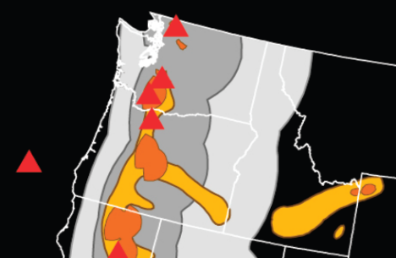
The red triangles are volcano locations. Dark orange areas have a higher volcanic hazard; light orange areas have a lower volcanic hazard. Dark gray areas have a higher ash fall hazard; light-gray areas have a lower ash fall hazard.
Oregon
Mount Hood last erupted about 200 years ago, producing pyroclastic flows, lahars, and a prominent lava dome (Crater Rock) near the volcano’s summit. Most recently, a series of steam blasts occurred between 1856 and 1865. Mount Jefferson last erupted more than 20,000 years ago. However, eruptions nearby have produced several lava flows and small volcanic cones in the past 10,000 years. Three Sisters Volcanic Center in central Oregon includes five large volcanoes—North Sister, Middle Sister, South Sister, Broken Top, and Mount Bachelor. About 2,000 years ago, eruptions occurred on South Sister, as well as from several small volcanoes north of North Sister. Since 1997, a broad area centered 3 miles west of South Sister has domed upward by more than 8 inches. Scientists think that this doming reflects the ongoing accumulation of magma at a depth of 3 to 4 miles. The outcome of this activity is uncertain, but there is no evidence that an eruption is imminent. The USGS and its partners have increased monitoring efforts in the area to detect any changes that might warrant more concern. Newberry Volcano, a broad shield covering more than 500 square miles, is capped by Newberry Crater, a large volcanic depression (caldera) 5 miles across. Its most recent eruption was about 1,300 years ago. Crater Lake occupies a 6-mile-wide caldera formed 7,700 years ago when the summit of an ancient volcano (referred to as Mount Mazama) collapsed during a huge explosive eruption. More than 10 cubic miles of magma was erupted, 10 times as much as in any other eruption in the Cascades during the past 10,000 years. Smaller eruptions ending about 5,000 years ago formed Wizard Island and several submerged cones and lava domes on the lake floor.

Reducing the Risk
After the 1980 eruption of Mount St. Helens, Congress provided increased funding that enabled the USGS to establish a volcano observatory for the Cascade Range. Located in Vancouver, Washington, the David A. Johnston Cascades Volcano Observatory (CVO) was named for a USGS scientist killed at a forward observation post by the May 18, 1980, eruption.
Scientists at CVO quickly recognized that it was not economically feasible to fully monitor all potentially active Cascade volcanoes. To address this and similar problems elsewhere in the United States and abroad, the USGS developed a suite of portable volcano-monitoring instruments—essentially, a portable volcano observatory. In the Pacific Northwest, when regional networks of earthquake sensors, operated in cooperation with the University of Washington’s Pacific Northwest Seismic Network, detect unusual seismic activity at a volcano, CVO staff will rapidly deploy this portable equipment to evaluate the hazard and, if needed, provide timely warnings to local officials and the public.
CVO also uses remote sensing as an early-detection tool. A technique called interferometric synthetic-aperture radar (InSAR) allows scientists to measure subtle movements of the ground surface, using radar images obtained by Earth-orbiting satellites. The current ground doming at Three Sisters was first detected using this technique.

Drought
Drought is defined as a prolonged period of dryness severe enough to reduce soil moisture, water levels, and snow levels below the minimum necessary for sustaining plant, animal and economic systems. In the past century, Washington State has experienced a number of drought cycles including several that lasted for more than a single season (1928-32, 1992-94, and 1996-97). The most severe droughts occurred in 1977 and 2001. The most recent drought affecting Southeastern Washington counties occurred in 2005, but was less severe than the 2001 cycle. Drought can have a widespread impact on the environment and the economy, depending on its severity, although it typically does not result in loss of life or damage to property.
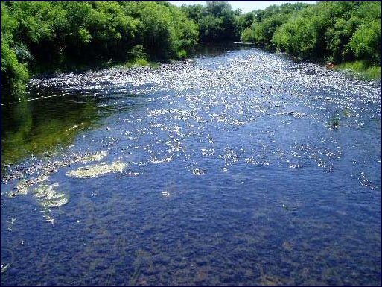
Touchet River at Cummins Road Bridge in Walla Walla County on June 30, 2005.
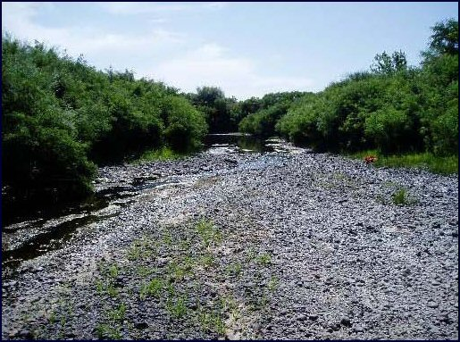
Touchet River at Cummins Road Bridge in Walla Walla County on July 21, 2005.
Unlike most states, Washington has a statutory definition of drought, consisting of two parts:
- An area has to be experiencing or projected to experience a water supply that is below 75 percent of normal.
- Water users within those areas will likely incur undue hardships as a result of the shortage.
On average, the nationwide annual economic impacts of drought – between $6 billion and $8 billion annually in the United States – are greater than the impacts of any other natural hazard. They occur primarily in the agriculture, transportation, recreation and tourism, forestry, and energy sectors. Social and environmental impacts are also significant, although it is difficult to put a precise cost on these impacts. A drought directly or indirectly affects all of the residents of Asotin, Columbia, and Garfield Counties. The National Drought Mitigation Center uses three categories to describe likely drought impacts:
- Agriculture – drought threatens crops that rely on natural precipitation
- Water Supply – drought threatens supplies of water for irrigated crops and for communities
- Fire Hazard – drought increases the threat of wildfire from dry conditions in forest and rangelands
Additionally, drought threatens the supply of electricity in Washington. Hydroelectric power plants generate approximately three quarters of the electricity produced in Washington State. When supplies of locally generated hydropower shrink because of drought, utilities seek other sources of electricity, which can drive up prices as well as reduce supply. Snowpack and water supply effects on Washington power supplies generally occur in the winter. Snow melt is captured throughout the spring and summer behind hydroelectric dams for release and generation during the peak demand winter period. Energy demand in the Pacific Northwest has decreased significantly since 2001, due in part to the closure of aluminum plants, and that load has not returned. Also, between 2001 and 2005, the region added significant amounts of non-hydropower generation. The decrease in demand, the increase in generating capacity, and the larger river flow reduces the potential impacts droughts will have on Washington’s energy supply.
Drought can also effect groundwater sources, but generally not as quickly as surface water supplies. However, groundwater supplies usually take longer to recover. Reduced precipitation during a drought means that groundwater supplies are not replenished at the normal rate. This can lead to a reduction in groundwater levels and problems such as reduced pumping capacity or wells going dry. Shallow wells are more susceptible than deep wells. Low ground and surface water supplies directly impact Southeastern Washington fisheries by reducing river and stream levels and thereby reducing potential habitat.
Agriculture is the industry most heavily affected by drought. Low water flow in the Snake River can present problems for wheat growers in Southeastern Washington since more than 80% of their crop is transported by barge. Lack of dredging combined with low river levels reduces the capacity for barge transportation down river from Lewiston, forcing Southeast Washington growers to use higher cost alternatives such as trucking and rail.
Drought indices assimilate thousands of bits of data on rainfall, snowpack, streamflow, and other water supply indicators into a comprehensible big picture. A drought index value is typically a single number, far more useful than raw data for decision making. The U.S. Drought Monitor is a synthesis of multiple indices and impacts that represents a consensus of federal and academic scientists.
Figure 4.11. U.S. Drought Monitor Map of Western Region.
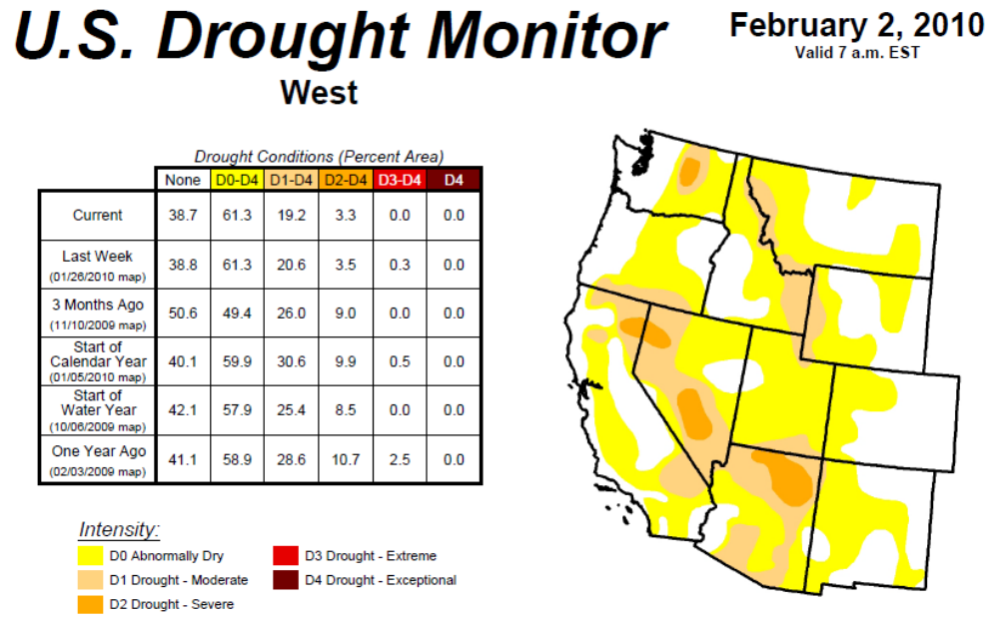
The major causes of droughts in Washington are either low snow accumulations from either low precipitation or warm winter temperatures; or by warm weather in the late winter-early spring that causes early melt of the snowpack. Most of the state’s annual precipitation occurs during the winter. Precipitation in the Blue Mountains is normally stored as snow that slowly melts during the spring and summer, maintaining stream and river flows. This is the primary source of water for irrigation and municipal use.
Figure 4.12. Precipitation Record 1890 – Present.
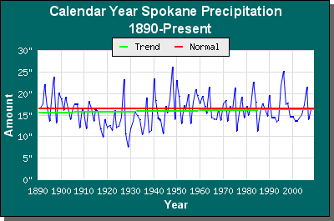
In 1965, W.C. Palmer developed an index to measure the departure of the moisture supply. Palmer based his index on the supply-and-demand concept of the water balance equation, taking into account more than just the precipitation deficit at specific locations. The objective of the Palmer Drought Severity Index (PDSI), as this index is now called, was to provide measurements of moisture conditions that were standardized so that comparisons using the index could be made between locations and between months. It is most effective measuring impacts sensitive to soil moisture conditions, such as agriculture.
At this time, reliable forecasts of drought are not attainable for temperate regions of the world more than a season in advance. However, based on a 100-year history with drought, the state as a whole can expect severe or extreme drought at least 5 percent of the time in the future, As the historical Palmer Drought Severity Index below indicates, between 1895-1995, Southeast Washington counties were in severe or extreme drought conditions 10-14.9% of the time. In 1985-95, Southeast Washington Counties were in severe or extreme drought conditions 20-30% of the time and in 1976-77, these counties were in severe or extreme drought conditions 30-40% of the time.
Figure 4.13. Palmer Drought Severity Index Map.
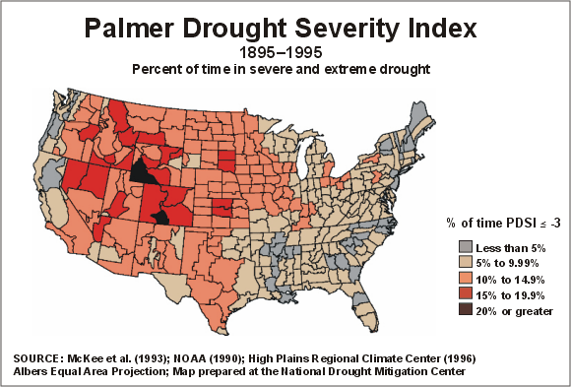

This page was intentionally left blank.

Chapter 5
Risk and Vulnerability Assessment
Chapter 5
Jurisdictional Risk and Vulnerability Assessment
IN THIS SECTION:
- Asotin County Annex
  - City of Asotin Annex
  - City of Clarkston Annex
  - Asotin County Fire District #1 Annex
- Columbia County Annex
  - City of Dayton Annex
  - Town of Starbuck Annex
  - Columbia County Fire District #1 Annex
  - Columbia County Fire District #3 Annex
  - Columbia Rural Electric Cooperative
- Garfield County Annex
  - City of Pomeroy
  - Garfield County Fire District #1
  - Garfield County Public Health District
  - Pomeroy Conservation District
  - Pomeroy School District #110
  - Garfield County Hospital
  - Port of Garfield

Chapter 5 – Jurisdictional Assessment

Jurisdictional Risk and Vulnerability Assessment
The Southeast Washington MHMP planning committees reviewed many of the natural and man-made hazards that have affected or pose a potential risk to people or property throughout the region. The committees agreed that the natural hazards identified in the Washington State Enhance Hazard Mitigation Plan had the greatest potential risk for in Columbia, Garfield, and Asotin Counties; thus, the hazards of flood, earthquake, landslide, severe weather, wildland fire, avalanche, inland tsunami, and drought were included in the risk assessment for each jurisdiction. The planning committee recognizes that there are additional hazards, particularly man-made hazards, which may also affect the planning area. These types of additional hazards will be reviewed for inclusion during the subsequent annual and 5-year evaluations of the MHMP.
As part of the risk and vulnerability assessment, each member of the planning committee was asked to fill out a critical infrastructure worksheet identifying and locating all structures, infrastructure, and culturally significant sites that the loss or damage of which would have a significant impact on a community. This exercise also included all communication, hazardous materials storage, transportation, and emergency response infrastructure. The list from each member was compiled and added to a GIS database. The critical infrastructure database was used to develop maps and address each type of hazard risk in each jurisdiction.
Furthermore, where available, existing parcel master listings have been converted to an accessible GIS database. This database allowed the planning committee to map every parcel within the county and city jurisdictions as well as assign an accurate assessed value of both land and improvements for each parcel. This data was combined with the hazard vulnerability models to develop the risk assessments and loss estimations for each jurisdiction.
In order to be eligible for project funds under the Flood Mitigation Assistance (FMA) program authorized by the National Flood Insurance Act of 1968, as amended, communities are required under 44 CFR 79.6(d)(1) to have a mitigation plan that addresses flood hazards. On October 31, 2007, FEMA published amendments to the 44 CFR Part 201 at 72 Federal Register 61720 to incorporate mitigation planning requirements for the FMA program, which combined the Local Mitigation Plan requirement for all hazard mitigation assistances programs under 44 CFR 201.6 to include the FMA as well as the HMGP, PDM, and SRL programs thus eliminating duplicative mitigation planning regulations. The purpose of the flood sections in the following annexes is to fulfill the requirements for both the FMA program and the Local Hazard Mitigation Plan.

Asotin County Annex
The Flood Mitigation Plan contained within this Multi – Hazard Mitigation Plan fulfills the requirements of a Flood Mitigation Plan as specified in 44 CFR 78.5 of the Federal Register describing the Flood Mitigation Assistance program. The purpose of this section is to prescribe actions, procedures, and requirements for administration of the Flood Mitigation Assistance (FMA) program, authorized by Sections 1366 and 1367 of the National Flood Insurance Act of 1968, 42 U.S.C. 4104c and 4104d. The goal of FMA is to assist state and local governments in funding cost-effective actions that reduce or eliminate the long term risk of flood damage to buildings, manufactured homes, and other insurable structures.

Flood
The three major drainages in Asotin County include the Snake River, which forms the County’s northern and eastern border; the Grand Ronde River in the remote southern extent of the County, and Asotin Creek, which drains a large section of the interior of the County. Asotin County is not considered to be one of the counties most at risk and vulnerable to flood in Washington according to the State of Washington Hazard Mitigation Plan. It is also not in the top percentage of Washington counties having a high frequency of floods causing damage. There are currently no repetitive loss properties in Asotin County. There have been 3 declared disasters resulting from flood events affecting Asotin County since 1980. The Snake River, the Grand Ronde River, and Asotin Creek flood every two to five years as a result of heavy rainfall, mild temperatures, and/or spring runoff.
Flooding does not typically occur on the Snake River due to flood control capacity of both upstream and downstream dams. The water level of Snake River reservoirs are monitored and highly regulated for the purposes of providing not only irrigation water to the surrounding agricultural developments and hydroelectric power, but also to provide flood control for communities along this major drainage. In the event of a major flood on the Snake River, State Highway 129 and the Snake River Road from Asotin to Rogersburg are the most vulnerable. Residents along these access roads would likely be isolated if either of these access routes were to become impassable.
The Grand Ronde River flows in an easterly direction on the south end of Asotin County to its confluence with the Snake River at Rogersburg. The Grand Ronde River is not heavily populated; thus the flood risk is primarily associated with the bridge crossing on State Route 129 and the Joseph Creek Road Bridge. There are 29 structures in the FEMA identified floodplain for the Grand Ronde River and its tributary, Joseph Creek.
Figure 5.1. Asotin County FEMA Flood Insurance Rate Map.
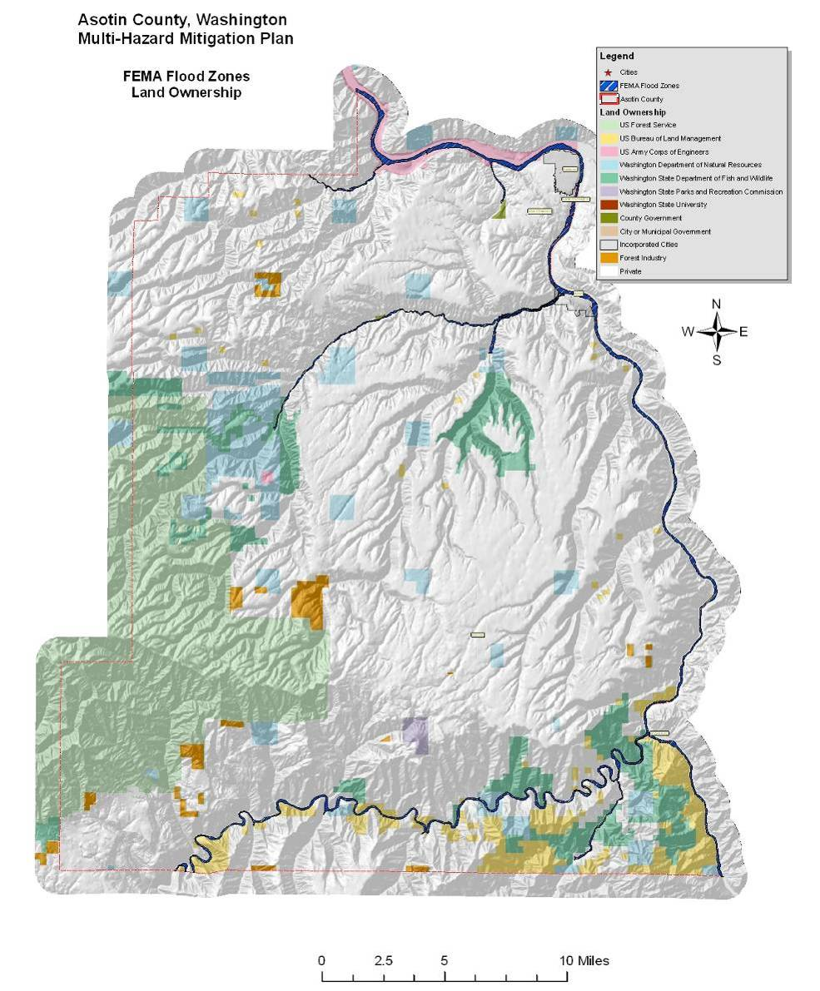
March 1963 - Flooding occurred in the counties of Columbia, Garfield, Grant, Whitman, and Spokane. Federal disaster number 146 was assigned for the event.
February 1996 - Heavy rains caused flooding in the counties of Adams, Asotin, Benton, Clark, Columbia, Cowlitz, Garfield, Grays Harbor, King, Kitsap, Kittitas, Klickitat, Lewis, Lincoln, Pierce, Skagit, Skamania, Snohomish, Spokane, Thurston, Wahkiakum, Walla Walla, Whitman, and Yakima and the Yakima Indian Reservation. Snowfall beginning January 26, 1996, followed by heavy rain in February, mild temperatures, and mountain snow melt caused severe flooding throughout the entire northwest. Three people died in Washington. Record flooding occurred on the Columbia, Snoqualmie, Cedar, Chehelis, Nisqually, Skookumchuck, Klickitat, Skokomish, Cowlitz, Yakima, Naches, Palouse, Walla Walla Rivers, and Latah Creek. During the 1996-97 winter storms, areas not prone to river flooding experienced surface water flooding due to high groundwater tables or inadequate urban storm sewer drainage systems. . Floods contaminated domestic water supplies, fouled septic systems, and inundated electrical and heating systems.
December 1996 thru January 1997 - Rain, ice, and snow caused flooding. Federal disaster number 1159 was assigned for counties of Adams, Asotin, Benton, Chelan, Clallam, Clark, Columbia, Cowlitz, Douglas, Ferry, Franklin, Garfield, Grant, Grays Harbor, Island, Jefferson, King, Kitsap, Kittitas, Klickitat, Lewis, Lincoln, Mason, Okanogan, Pacific, Pend Oreille, Pierce, San Juan, Skagit, Skamania, Snohomish, Spokane, Stevens, Thurston, Walla Walla, Whatcom, and Yakima.
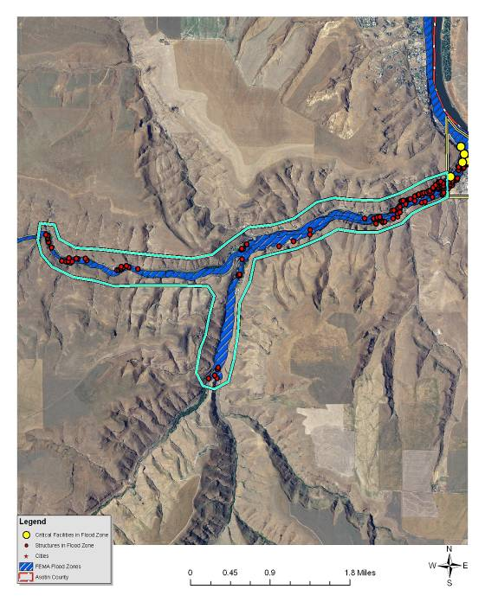
Structures and critical infrastructure in the Asotin Creek drainage of Asotin County.
Most of the structures in the FEMA-identified floodplain for all of Asotin County are located along Asotin Creek. Asotin Creek is a collector watershed for numerous tributaries in a large area originating in the Smoothing Iron and Hogback Ridge areas of the Umatilla National Forest. Some of these tributaries include George Creek, Pintler Creek, Kelly Creek Rockpile Creek, Charley Creek, Lick Creek, and Ayers Gulch. There are 113 structures located in the floodplain of Asotin Creek and its tributary, George Creek, outside of the city of Asotin. Asotin Creek is most heavily influenced by rain-on-snow events due to its large drainage area and relatively narrow channel; however, several flash floods have also been recorded.
A high level of sediment is prevalent during periods of runoff. This sediment tends to cause a deteriorating condition in channel beds through erosion and deposition. Natural obstructions to flood waters include trees, brush, and other vegetation along the stream banks in the floodplain area. Debris can plug culverts and accumulate on bridge abutments at several locations throughout the town. Several streets and road shoulders are prone to erosion during flood events. Many secondary routes are not paved, which results in gravel washing down-slope potentially clogging drainage systems or directing water to places that were not intended. Sedimentation and accumulated debris and vegetation are significantly increasing the flood risk associated with Asotin Creek. Debris jams during high water events have caused considerable flood damage to adjacent properties.
Following the 1996-97 and the 1999 flooding of Asotin Creek, there was found to be 18 abandoned vehicles in or alongside the creek bed. Asotin County, collaborating with the city of Asotin, the Department of Ecology, the Soil Conservation District, and local landowners, applied for and were awarded a grant to not only remove the cars, but also implement some stream bank protection measures at the Asotin City Park. Using the grant funds, all 18 vehicles were removed and disposed of and 4 J-hook vanes and some large woody debris was installed in Asotin Creek to slow stream flows near the Park. Additionally, new trees and shrubs were planted at the disturbed sites. Since Asotin Creek has been designated as a reserve for wild steelhead and salmon, this stream restoration project reduced stream bank degradation and improved water quality and fish spawning habitat while reducing the potential for future flooding due to stream flow obstructions.

Value of Resources at Risk
There are approximately 161 structures within the FEMA-identified floodplains (100- and 500-year) in unincorporated areas of Asotin County, yielding a total improvement value of $15.3 million. There are currently no repetitive loss properties in Asotin County. The average damage to structures was estimated based on the parcel’s location as either completely within or out of the flood zone. The estimated value of contents is ½ the value of the improvements equating to an additional $7.6 million in potential losses. In reality, the damages will most likely not be equally distributed between buildings based on building materials, building location, and flood location. However, these estimates provide a basic approximation.
Critical infrastructure located within the identified floodplain for the unincorporated areas of the county include U.S. Highway 12, the Southway Bridge, and the Grand Ronde Bridge at Joseph Creek.
Asotin County participates in the National Flood Insurance Program and has developed local ordinances to better regulate and direct development in flood plain areas. These local ordinances regulate planning, construction, operation, and maintenance of any works, structures, and improvements. Asotin County’s ordinances also help ensure that activities in the floodplain are properly planned, constructed, and maintained to avoid adversely influencing the stream or other body of water and the security of life, health, and property against damage by floodwater.
Participation in the National Flood Insurance Program (NFIP) and subsequent adoption of the Uniform Building Codes, or more stringent local building codes, provide basic guidelines to communities on how to regulate development. When a county participates in the NFIP it enables property owners in the county to insure against flood losses. By employing wise floodplain management, a participating county can protect its citizens against much of the devastating financial loss resulting from flood disasters. Careful local management of development in the floodplains results in construction practices that can reduce flood losses and the high costs associated with flood disasters to all levels of government.
Table 5.1. NFIP Policy Statistics As of 12/31/09 in Asotin County.
Community Name | Policies In-Force | Insurance In-Force | Written Premium In-Force | FIRM Effective Date | Floodplain Ordinance/ Manager | CRS Ranking
Asotin County (unincorporated) | 26 | $5,210,600 | $17,624 | 1/06/1988 | Yes/Yes | NA
Clarkston | - | - | - | - | No/No | NA
Asotin | 6 | $616,800 | 2,240 | 1/06/1988 | Yes/Yes | NA
An important part of being an NFIP community is the availability of low cost flood insurance for those homes and businesses within designated flood plains, or in areas that are subject to flooding, but that are not designated as Special Flood Hazard Areas.
Overall participation by individuals and business in the NFIP appears to be low. Potential reasons are:
- A lack of knowledge about the existence of the availability of low cost flood insurance.
- Home and business owners unaware of their vulnerability to flood events.
- Current cost of insurance is prohibitive.
The first two reasons can be addressed through public education. The third could be addressed by all communities in the county taking advantage of the Community Rating System (CRS). To encourage communities to go beyond the minimum requirements and further prevent and protect against flood damage, the NFIP established the Community Rating System (CRS). To qualify for CRS, communities can do things like make building codes more rigorous, maintain drainage systems, and inform residents of flood risk. In exchange for becoming more flood-ready, the CRS community's residents are offered discounted premium rates. Based on your community's CRS ratings, you can qualify for up to a 45% discount of your annual flood insurance premium.

Earthquake
Based on historical records, Asotin County has not experienced any seriously damaging earthquakes in recorded history. Several distant earthquakes produced intensities strong enough to be felt in southeastern Washington, but only two earthquakes epicenters, one in 1893 and another in 1936, were recorded for the region. Both of these earthquakes were rated as a VII on the Modified Mercalli intensity scale and produced only very slight property damages such as broken dishes and cracked plaster.
Communities in Asotin County can expect some structural failure of older multistory unreinforced masonry buildings as a result of even lower intensity earthquakes. Cornices, frieze, and other heavy decorative portions of these types of structures may fail. The potential impacts of a substantial earthquake event are highly variable. Many of the structures and infrastructure throughout the county may not incur any damages at all; however, damage to roads, bridges, unreinforced masonry, chimneys, foundations, water lines, and many other components are at risk. Fires can also be a secondary hazard to structures sustaining earthquake damage.
Because structural damage by earthquakes is typically not complete destruction, but rather tends to be subtle cracking or settling that undermines the stability of the structure. These types of repairs can be very costly. Additionally, changes to the water table or even the topography can significantly impact local municipal and private wells and could result in the loss of traditional land uses.
There is are no known fault lines in Asotin County. Peak ground acceleration (pga) in percent g is a measure of the ground motion, which decreases, the further you are from the earthquake. The USGS Shaking Hazard maps for the United States are based on current information about the rate at which earthquakes occur in different areas and on how far strong shaking extends from quake sources. Colors on the map show the levels of horizontal shaking that have a 1 in 10 chance of being exceeded in a 50-year period. Shaking is expressed as a percentage of “g” (g is the acceleration of a falling object due to gravity). This map is based on seismic activity and fault-slip rates and takes into account the frequency of occurrence of earthquakes of various magnitudes. Locally, this hazard may be greater than that shown, because site geology may amplify ground motions. As seen in Figure 5.2, much of Asotin County has a 10% chance of exceeding a 6-7% pga in the next 50 years. This probability trends downwards to a 5-6% pga along the northeastern edge of the County. Most of Asotin County’s population resides in the lower pga zone. No specific jurisdictions or special districts were identified as having differing issues or levels of risk associated with this hazard.
Figure 5.2. Regional Earthquake Probability Map.
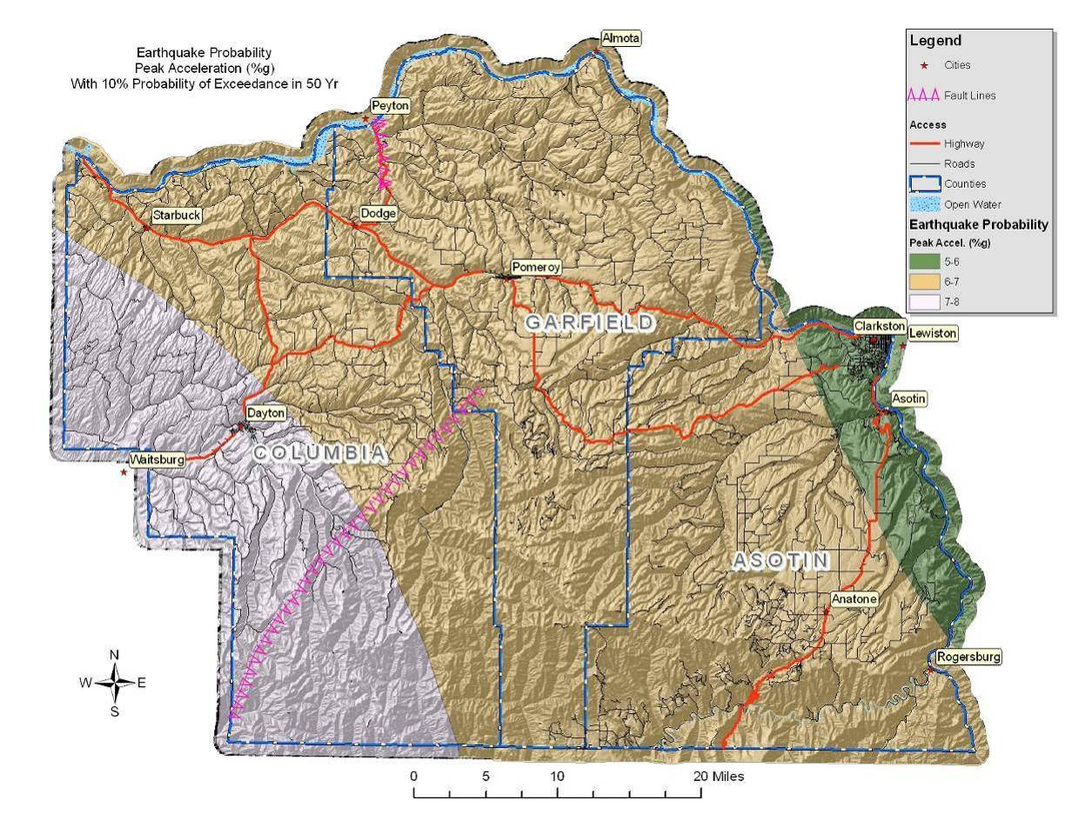
Past events suggest that an earthquake in the Asotin County area would cause little to no damage. Nonetheless, severity can increase in areas that have softer soils, such as unconsolidated sediments. Damage would be negligible in buildings of good design and construction; slight to moderate in well-built ordinary structures; and considerable in poorly built, old, or badly designed structures.

Value of Resources at Risk
Unreinforced masonry (URM) structures and unreinforced chimneys of homes will likely be damaged in the event of an earthquake. Damaged or collapsed chimneys could result in the secondary hazard of fire. Nonstructural damage caused by falling and swinging objects may be considerable after any magnitude earthquake. Damage to some older, more fragile bridges and land failure causing minor slides along roadways may isolate some residents.
The Lincoln Middle School, the Highland Elementary School, and the Asotin County Fire District #1 station located in the Clarkston Heights are likely unreinforced masonry buildings. The value of the schools is unknown. These are the only known publicly accessible unreinforced masonry structures within the unincorporated Asotin County. The number and value of unreinforced masonry homes or homes with masonry chimneys in Asotin County is unknown.

Landslide
To date, there is no recorded history of major landslides occurring in Asotin County. Nevertheless, there are some areas in Asotin County that have specific landslide concerns. Areas that are generally prone to landslides are:
- On existing landslides, old or recent
- On or at the base or top of slopes
- In or at the base of minor drainage hollows
- At the base or top of an old fill slope
- At the base or top of a steep cut slope
The majority of the landslide potential in Asotin County occurs in the more remote areas of the Umatilla National Forest and Grande Ronde drainage on the southern end of the County as well as in the upper reaches of the Asotin Creek drainage and along the Snake River. Most of the landslide damage potential occurs along the Snake River Road due to the location of numerous homes at the base of the steeper slope rising from the River and State Route 129. The probability of occurrence of major, high velocity landslide hazard events, including those caused by severe local storms, is moderate.
February 1996 – Stafford Act disaster assistance totaled $113 million and Small Business Administration disaster loans approved $61.2 million. The National Weather Service, Seattle Forecast Office considers this storm one of the top 10 weather events in Washington during the 20th Century. Near-record snowfall in January followed by warm, heavy rain, mild temperatures and snowmelt in February caused flooding, mudflows and landslides throughout the state. The storm caused three deaths, and 10 people were injured. Landslides damaged or destroyed nearly 8,000 homes, and closed traffic along major highways for several days. Damage from all causes throughout the Pacific Northwest was at least $800 million. The landslide that created the most significant impact blocked Interstate 5 and the state’s main north-south railroad tracks three miles north of Woodland, Cowlitz County. The initial slide on February 8 blocked northbound lanes of I-5; a second, larger slide covered all lanes of the freeway as well as the railroad tracks to the west. It took crews until February 19 to fully reopen the interstate. The highest concentration of landslides occurred at the northwest edge of the Blue Mountains near Walla Walla. The main areas affected were the Mill Creek, Blue Creek, Touchet, Tucannon, and Walla Walla drainages. Debris flows were most numerous on open, grassy hillsides. In the Mill Creek area, debris flows destroyed seven vehicles and five homes. Similar occurrences of flooding and landslides took place in 1931 and 1964.
The majority of the population has a low risk of landslides; however, homes and infrastructure located in or at the mouth of drainages have an elevated risk. Additionally, sections of the primary access routes are in moderate to high landslide prone areas. There is a moderate probability of small slides occurring on slopes ranging from 5-35%. This type of slide is common on the eyebrows of hills, especially where there has been soil disturbance. Generally, these low angle slides will have a low velocity and will not impact structures or infrastructure.
Soil factors that increase the potential for landslide are soils developed from parent materials high in schist and granite, and soils that are less permeable containing a resistive or hardpan layer. These soils tend to exhibit higher landslide potential under saturated conditions than do well drained soils. To determine the high-risk soils in Asotin County, the NRCS State Soils Geographic Database (STATSGO) layer was used to identify the location and characteristics of all soils in the County. The specific characteristics of each major soil type within the County were reviewed. According to this database, it was determined that the soils in Asotin County generally are not developed from schist and granitic parent materials, indicating that landslide potential is primarily due to factors associated with gravity and slope.
To portray areas of probable landslide risk due to slope related factors, slope models were used to identify areas of low, moderate and high risk. This analysis identified the low risk areas as slopes in the range of 20°-25° (36-46%), moderate as 26°-30° (48-60%) and high risk as slopes in the range of 31°-60° (60-173%). Slopes that exceeded 60° (173%) were considered low risk due to the fact that sliding most likely had already occurred relieving the area of the potential energy needed for a landslide. From the data layer created by this analysis, it is possible to depict areas of risk and its proximity to development and human activity. With additional reconnaissance, the areas of high risk were further defined by overlaying additional data points identifying actual slide locations, thus improving the resolution by specifically identifying the highest risk areas. This method of analysis is similar to a method developed by the Clearwater National Forest in north central Idaho.
Figure 5.3. Asotin County Landslide Prone Landscapes.
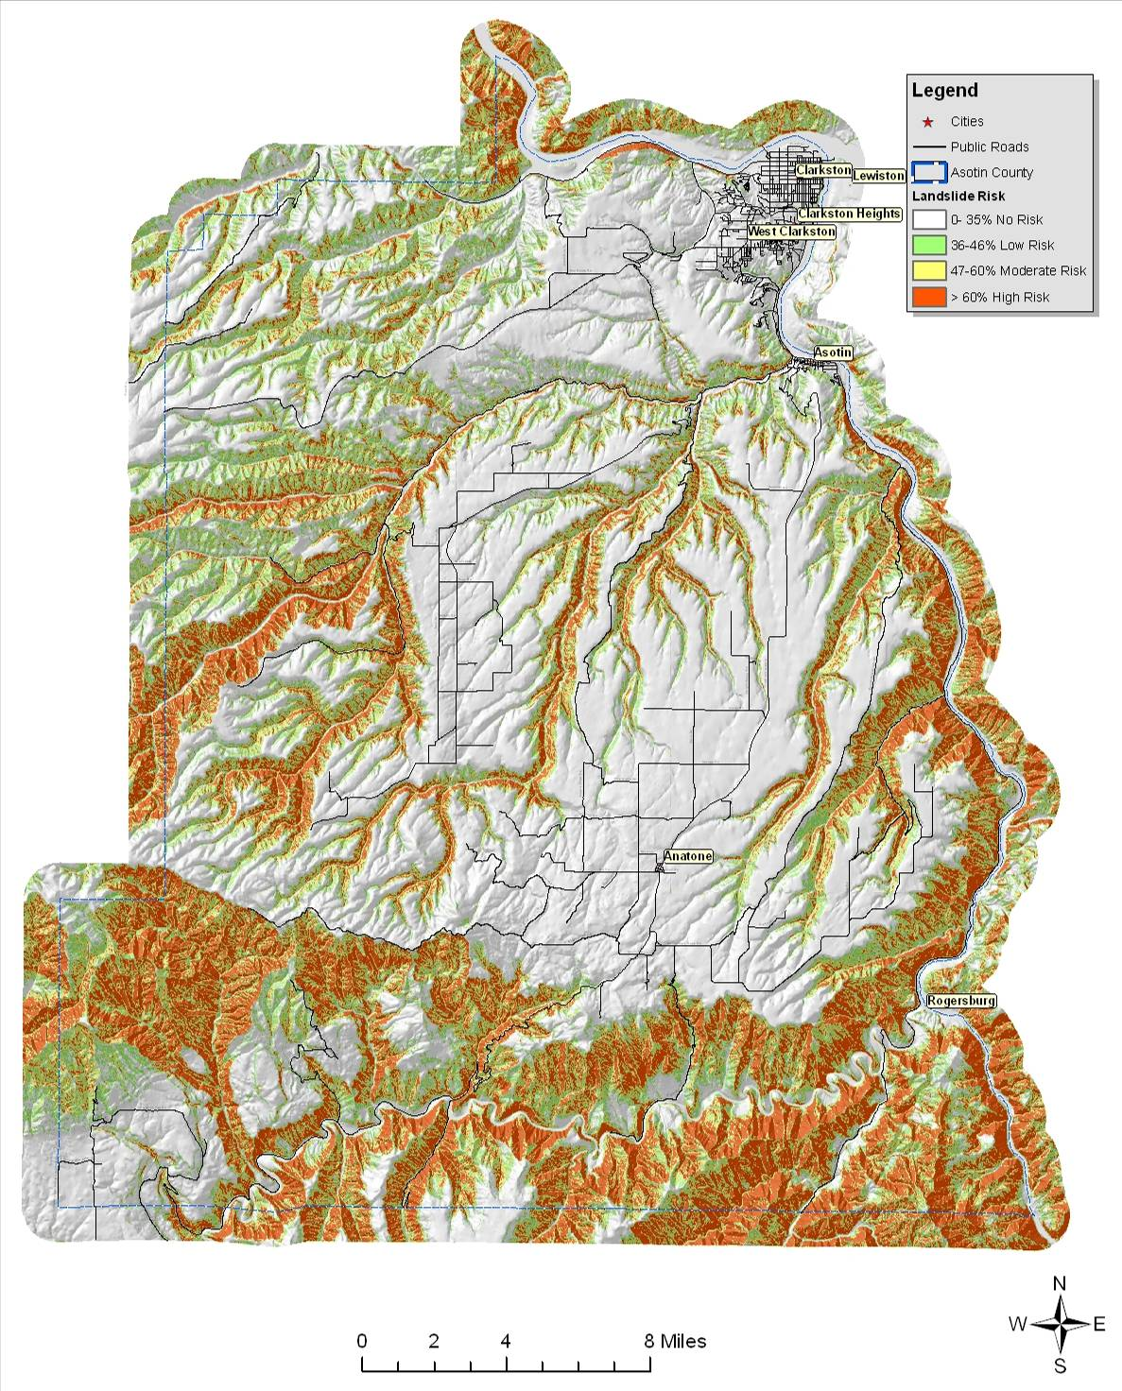
While a large portion of Asotin County is at high risk to landslides, most of this area occupies the rural mountainous regions. Home and business development in the County has been mainly on lands not at significant risk to landslides.
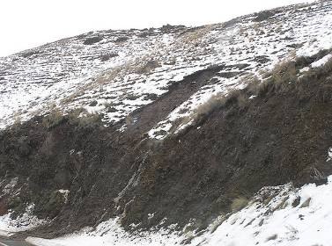
Much of the populated areas in Asotin County are at risk to flooding, which often results in damaging landslides. Flash floods typically carry large amounts of debris, silt, and rocks that are deposited in downstream floodplains. Additionally, soil saturation ensuing from prolonged periods of rain or flooding can lead to slope instability. Cut and fill slopes, even those well outside of the flood plain, are particularly at risk to slides and/or slumping as a result of soil saturation.
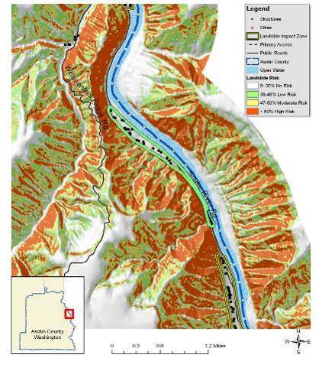
Ackerman Bar Landslide Impact Zone
Although it does not show up as a landslide prone area in the model, State Route 129 has a history (1998 and 2009) of small slides that temporarily block the road. State Route 129 from 13th Street to the Asotin city limits, from the city limits to the top of Asotin Hill (MP 33 to 36 and Clemans Road), and Rattlesnake Grade are sections of this road that are notorious for small slides, plugged culverts, and/or rolling rocks. These slides are typically caused by severe or long lasting storms that saturate the soil. Damage is usually limited to clogged ditches and culverts and the cost to remove debris from the roadway. The Washington State Department of Transportation has installed preventative measures at Swallows Rock on State Route 129 to prevent rocks from rolling onto the roadway. The basalt cliffs adjacent to the road continue to deposit rocks in the right-of-way, particularly during sustained rains. Critchfield Road near 22nd Street and Cherry Street in Asotin have also contributed to landslide damages on a few occasions. These areas are likely to continue depositing silt and other debris on the roadway during wet soil conditions.
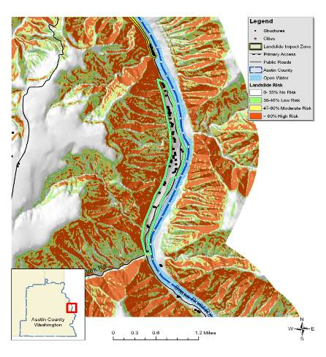
Grahams Landing Landslide Impact Zone
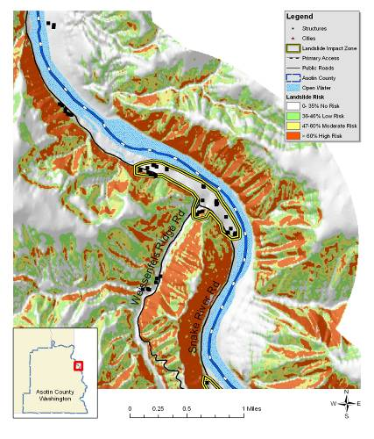
Ten Mile Landslide Impact Zone
The Ackerman Bar, Grahams Landing, Heller Bar, and Ten Mile Landslide Impact Zones encompass small population clusters on the Snake River Road paralleling the Snake River. The Silcott Landslide Impact Zone occurs at the mouth of Alpowa Creek on the Snake River along US Highway 12 on the northern end of the County. The Asotin Creek Landslide Impact Zone is located at the confluence of Asotin Creek and George Creek just upstream from the city of Asotin. In addition to the residences, these Impact Zones may affect the Snake River Road, Asotin Creek Road, and possibly a small section of US Highway 12.
Many of the slopes and hillsides in these impact zones are comprised by material deposited by past landslides. In fact, much of the lower slopes near the valley floors are alluvial fans created by sediment being carried downstream and deposited at the mouths of the numerous small drainages. The presence of this material indicates the historic occurrence of high-energy, short duration floods and debris flows in these chutes in response to severe climatic conditions, such as thunderstorms and rain-on-snow events. These events are historically infrequent, with recurrence cycles on the order of years to decades. However, they can result in significant damage to buildings and infrastructure, disrupt travel, reduce water quality, and jeopardize safety.
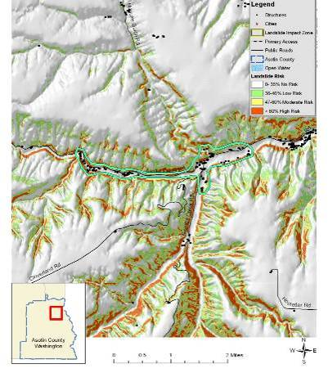
Asotin Creek Landslide Impact Zone
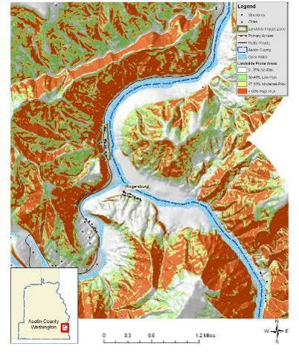
Heller Bar Landslide Impact Zone
The largest landslides typically occur where human development or disturbance has exposed landslide-prone sediments to steep topography. Today, initiation and reactivation of landslides is closely tied to unusual climatic events and land-use changes. Even small landslide activity on the upper slopes can transform into high-energy debris flows that endanger roads, buildings, and people below. Landslide debris is highly unstable when modified through natural variations in precipitation, artificial cuts, fills, and changes to surface drainage and ground water.
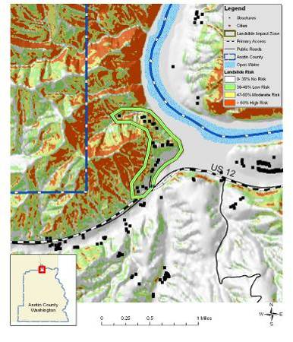
Silcott Landslide Impact Zone
Wildfires in theses impact zones could cause a domino effect of multiple hazards. Higher intensity fires not only remove most of the vegetation, but they also cause soils to become hydrophobic or water repellent for a period of time after the fire. This combination leads to unusually high runoff after rain showers or during the spring runoff season. As streams and rivers begin to reach and exceed flood stage, bank failures and channel migration are common. Road building and other soil disturbances tend to exacerbate this effect leading to even more severe land and soil slides.

Value of Resources at Risk
The cost of cleanup and repairs of roadways is difficult to estimate due to the variable circumstances with each incident including size of the slide, proximity to a State or County shop, and whether the slide occurred on the cut slope or the fill slope. Other factors that could affect the cost of the damage may include culverts, streams, and removal of debris. This type of information is impossible to anticipate; thus, no repair costs for damaged roadways have been estimated.
Table 5.2. Landslide Impact Zones in Asotin County.
Landslide Impact Zone | Number of Structures | Value of Structures at Risk
Ackerman Bar | 29 | $2,747,634
Asotin Creek | 96 | $9,095,616
Grahams Landing | 49 | $4,642,554
Heller Bar | 13 | $1,231,698
Silcott | 27 | $2,558,142
Ten Mile | 28 | $2,652,888
Total | 213 | $20,180,898
Slides in the identified impact zones are more likely to be larger and more damaging as weaknesses in the underlying rock formations give way. Although infrequent, this type of slide has the potential to not only block, but destroy road corridors, dam waterways, and demolish structures. The highest risk areas in these impact zones are typically at the higher elevations where slopes exceed 25% grade. There are numerous homes in each of these impact zones; however, for the most part, they are widely scattered. Thus, single slide events will not likely impact the entire population, but rather individual structures. Much of the Snake River Road, Asotin Creek Road, and West Lake Drive could be at risk from slides initiating in these impact zones.

Severe Weather
Severe weather in Asotin County ranges from the commonly occurring thunderstorms to hail, high winds, tornadoes, drought, dense fog, lightning, and snow storms.
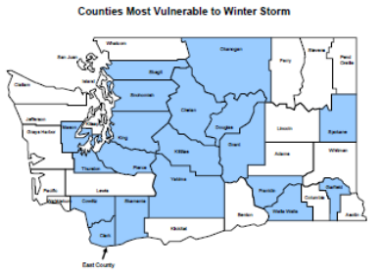
All of Asotin County is at risk to severe winter weather events and there is a high probability of their continued occurrence in this area. Due to topography and climatologic conditions, the higher mountainous areas are often the most exposed to the effects of these storms. Commonly, higher elevations in the County will receive snowfall, while the valley areas may not. Periodically though, individual storms can generate enough force to impact the entire County at one time. From high winds to ice storms to freezing temperatures, there are all types of winter storms that take place during the course of any given year. Winter conditions can change very rapidly. It is not uncommon to have a snowstorm at night with sunshine the next day. Winter storms with heavy snow, high winds, and/or extreme cold can have a considerable impact on Asotin County; however, most residents are well accustomed to the severe winter conditions in this part of Washington. Power outages and unplowed roads are a frequent occurrence throughout many parts of the County, but most residents are prepared to handle the temporary inconvenience.
Commonly, heavy snow accumulations are the cause of disruptions to normal commuting activities (delays and inability to plow roads and driveways). When coupled with extreme cold weather, severe winter storms have a detrimental impact on residents in Asotin County, particularly the senior population. Severe winter storms also have the potential to cause large losses among livestock and wildlife. Animal losses are usually the result of dehydration rather than cold or suffocation.
Snow loads on roofs, ice-slides off of roofs onto vehicles or other buildings, and damaged frozen pipes are also potential hazards associated with winter weather. These events represent a significant hazard to public health and safety, a substantial disruption of economic activity, and a constant threat to structures during the winter months. An average of at least two severe storms is anticipated each winter in Asotin County. Asotin County is not considered to be one of the counties most vulnerable to winter storms and blizzards in Washington according to the Washington State Hazard Mitigation Plan.
January 13, 1950 “The January 1950 Blizzard” - On this date, 21.4 inches of snow fell in Seattle, the second greatest 24-hour snowfall recorded. The snowfall was accompanied by 25-40 mph winds. The storm claimed 13 lives in the Puget Sound area. January had 18 days with high temperatures of 32 degrees or lower. The winter of 1949-50 was the coldest winter on record in Seattle, with an average temperature of 34.4 degrees. Eastern Washington, North Idaho, and parts of Oregon also were paralyzed by the snow – some lower-elevation snow depths reached nearly 50 inches and temperatures plunged into minus teens and twenties. Several dozen fatalities occurred.
1962 Columbus Day Wind Storm - The top weather event in Washington during the 20th Century, according to the National Weather Service, Seattle Forecast Office. This storm is the greatest windstorm to hit the Northwest since weather recordkeeping began in the 19th century, and called the “mother of all wind storms” in the 1900s. All windstorms in the Northwest are compared to this one. The Columbus Day Storm was the strongest widespread non-tropical windstorm to strike the continental U.S. during the 20th century, affecting an area from northern California to British Columbia. The storm claimed seven lives in Washington State; 46 died throughout the impacted region. One million homes lost power. More than 50,000 homes were damaged. Total property damage in the region was estimated at $235 million (1962 dollars). The storm blew down 15 billion board feet of timber worth $750 million (1962 dollars); this is more than three times the timber blown down by the May 1980 eruption of Mount St. Helens, and enough wood to replace every home in the state. Gusts of 88 miles per hour were recorded at Tacoma before power was lost to the recording stations.
February 1996 – Federal Disaster #1100. Stafford Act disaster assistance provided was $113 million. Small Business Administration disaster loans approved totaled $61.2 million. Heavy rainfall, mild temperatures and snowmelt caused flooding and mudslides in Adams, Asotin, Benton, Clark, Columbia, Cowlitz, Garfield, Grays Harbor, King, Kitsap, Kittitas, Klickitat, Lewis, Lincoln, Pierce, Skagit, Skamania, Snohomish, Spokane, Thurston, Wahkiakum, Walla Walla, Whitman and Yakima counties, and the Yakama Indian Reservation. This storm caused major flooding on rivers of western and southeast Washington. Mudslides occurred throughout the state. Three deaths, 10 people injured. Nearly 8,000 homes damaged or destroyed. Traffic flow both east and west, and north and south along major highways was shut down for several days. Damage throughout the Pacific Northwest estimated at $800 million.
December 1996 - January 1997 – Federal Disaster #1159. Stafford Act disaster assistance provided was $83 million. Small Business Administration loans approved totaled 31.7 million. Saturated ground combined with snow, freezing rain, rain, rapid warming and high winds within a five-day period produced flooding and landslides. Impacted counties – Adams, Asotin, Benton, Chelan, Clallam, Clark, Columbia, Cowlitz, Douglas, Ferry, Franklin, Garfield, Grant, Grays Harbor, Island, Jefferson, King, Kitsap, Kittitas, Klickitat, Lewis, Lincoln, Mason, Okanogan, Pacific, Pend Oreille, Pierce, San Juan, Skagit, Skamania, Snohomish, Spokane, Stevens, Thurston, Walla Walla, Whatcom, and Yakima. Twenty-four deaths; $140 million (est.) in insured losses; 250,000 people lost power. High winds and ice contributed to the repeated and extended power outages to rural power customers in Garfield, Asotin, and Columbia Counties. This storm also resulted in numerous rural residences being cutoff from any emergency service response for several days, due to drifting snow. The accumulations aggravated by rain, drifting snow, and ice in roof drains caused excessive weight and the collapse of structures.
1997 Tornadoes – There are 14 tornadoes on record for Washington in 1997. In May of that year, Tacoma experienced a small tornado that did an estimated $125,000 damage in a narrow swath across ten city blocks. Tornadoes also touched down north of Asotin County and east of Vancouver the same day. Tornadoes within this region are infrequent and touchdowns are not consistent or specific to any particular area within the region.
March 2, 2009 - President Obama declared that a major disaster exists in the State of Washington. This declaration made Public Assistance requested by the Governor available to State and eligible local governments and certain private nonprofit organizations on a cost-sharing basis for emergency work and the repair or replacement of facilities damaged by the severe winter storm and record and near record snow in Clallam, Clark, Columbia, Cowlitz, Garfield, Grays Harbor, Island, Jefferson, King, Klickitat, Lewis, Lincoln, Mason, Pacific, Pend Oreille, Skagit, Skamania, Snohomish, Spokane, Stevens, Thurston, Wahkiakum, Walla Walla, and Whatcom Counties. This declaration also made emergency protective measures (Category B), including snow removal assistance, under the Public Assistance program, requested by the Governor, available in Adams, Asotin, Benton, Chelan, Clallam, Columbia, Cowlitz, Franklin, Grays Harbor, Jefferson, King, Kittitas, Klickitat, Lewis, Mason, Pacific, Pierce, Skagit, Skamania, Snohomish, Spokane, Thurston, Wahkiakum, Walla Walla, Whatcom, Whitman, and Yakima for any continuous 48-hour period during or proximate to the incident period.
Due to their relative frequency and minimal severity, severe thunderstorms are not well documented in Asotin County. Their impacts are fairly limited and do not significantly affect the communities enough to declare a disaster. The secondary impacts of thunderstorms, floods, are emphasized within the flood chapter of this document. Areas most vulnerable to this type of storm are those subject to a strong southwesterly flow of moist, unstable air that generates strong, sometimes violent thunderstorms with one or more of the following characteristics: strong damaging winds, large hail, waterspouts, or tornados.
Hail can occur in any strong thunderstorm, which means hail is a threat everywhere. Hail is precipitation that is formed when updrafts in thunderstorms carry raindrops upward into extremely cold areas of the atmosphere. Large hail stones can fall at speeds faster than 100 miles per hour. Hail damage in Washington is very small in comparison with damage in areas of the central part of the United States. Often the hail that occurs does not grow to a size larger than one-half inch in diameter, and the areas affected are usually small. Quite often hail comes during early spring storms, when it is mostly of the small, soft variety with a limited damaging effect. Later, when crops are more mature and more susceptible to serious damage, hail occurs in widely scattered spots in connection with summer thunderstorms. The potential impacts of a severe hail storm in Asotin County include crop damage, downed power lines, downed or damaged trees, broken windows, roof damage, and vehicle damage. Hail storms can, in extreme cases, cause death by exposure. The most common direct impact from ice storms to people is traffic accidents. Over 85% of ice storm deaths nationwide are caused by traffic accidents. Hail storms also have the potential to cause losses among livestock. The highest potential damage from hail storms in Asotin County is the economic loss from crop damage. Even small hail can cause significant damage to young and tender plants and fruit. Trees can also be severely damaged by hail as was seen in the 1996 ice storm near Spokane, Washington.
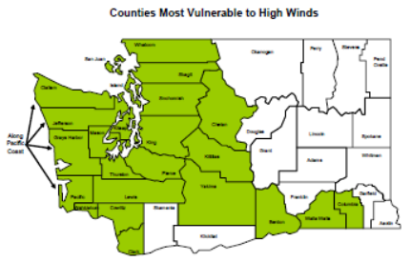
Windstorms are frequent in Asotin County and they have been known to cause substantial damage. Under most conditions, the County’s highest winds come from the south or southwest. Due to the abundance of agricultural development in Asotin County, crop damage due to high winds can have disastrous effects on the local economy. In the case of extremely high winds, some buildings may be damaged or destroyed. Wind damages will generally be categorized into four groups: 1) structure damage to roofs, 2) structure damage from falling trees, 3) damage from wind blown dust on sensitive receptors, or 4) wind driven wildfires. Structural injury from damaged roofs is not uncommon in Asotin County. Structural damage from falling trees is also relatively common. Many homeowners have planted ornamental trees for shade and windbreak protections. However, many of these trees are located near, and upwind of homes putting them at risk to falling trees which could cause substantial structural damage and potentially put lives at risk. Airborne particulate matter increases during high wind events. When this occurs, sensitive receptors including the elderly and those with asthma are at increased risk to complications. The National Weather Service defines high winds as sustained winds of 40 mph or gusts of 58 mph or greater, not caused by thunderstorms, expected to last for an hour or more. Areas most vulnerable to high winds are those affected by a strong pressure difference from deep storms originating over the Pacific Ocean; an outbreak of very cold, Arctic air originating over Canada; or air pressure differences between western and eastern Washington that primarily affect the Columbia River Gorge, Cascade Mountain passes, ridges and east slopes, and portions of the Columbia Basin. Asotin County is not considered to be one of the most vulnerable to high winds in Washington State according to the Washington State Hazard Mitigation Plan.
Asotin County and the entire region are at increased risk to wildfires during high wind events. Ignitions can occur from a variety of sources including downed power lines, lightning, or arson. Once ignited, only wildfire mitigation efforts around the community and scattered homes will assist firefighters in controlling a blaze. Details about wildfire mitigation are discussed in the wildland fire annexes of this Multi - Hazard Mitigation Plan.
A tornado is formed by the turbulent mixing of layers of air with contrasting temperature, moisture, density, and wind flow. This mixing accounts for most of the tornadoes occurring in April, May, and June, when cold, dry air from the north or northwest meets warm, moister air moving up from the south. If this scenario was to occur and a major tornado was to strike a populated area in Asotin County, damage could be widespread. Businesses could be forced to close for an extended period, and routine services such as telephone or power could be disrupted. The National Weather Service defines a tornado as a violently rotating column of air that contacts the ground; tornados usually develop from severe thunderstorms. Areas most vulnerable to tornado are those subject to severe thunderstorms or those with a recurrence rate of 5 percent or greater, meaning the County experiences one damaging severe thunderstorm event at least once every 20 years.
According to the Tornado Project and the National Weather Service, there have been no reports of tornadoes in Asotin County.

Value of Resources at Risk
It is difficult to estimate the cost of potential winter storm damages to structures and the economy in Asotin County. Damage to roofs by heavy snow accumulations depends on the moisture content of the snow and the structural characteristics of the buildings. In general, snow in this region tends to have low moisture content because of the low temperatures and arid environment. However, heavy snow is not uncommon. Frozen water pipes are the most common damage to residential and business structures. Older homes tend to be at a higher risk to frozen water pipes than newer ones. Snow plowing in Asotin County occurs from a variety of departments and agencies. The state highways are maintained by the State of Washington. Plowing of county roads is done by the Asotin County Public Works Department and the road departments of the individual cities. Private landowners are responsible for maintaining their own driveways or other private roads. Utility supplies are impacted during severe winter storms as power is lost on a regional basis. This has a two-fold impact on Asotin County residents as not only is power cut to homes and businesses, but primary heating is lost for many residents. Gas furnaces and wood stoves supplement electrical heating, but with wood heating the senior population is at a disadvantage. Emergency response to severe winter storms includes site visits by police or fire department personnel, opening of shelters, or assistance with shopping, medical attention, and communications. The economic losses caused by severe winter storms may frequently be greater than structural damages. Employees may not be able to travel to work for several days and businesses may not open. Damages are seen in the form of structural repair and loss of economic activity. Asotin County schools are occasionally closed during and right after a severe winter storm because of cold temperatures and snow covered roads.
Thunderstorms do occur within Washington affecting all counties, but usually are localized events. Their impacts are fairly limited and do not significantly affect the communities enough to declare a disaster. The loss potential from flooding that result from severe thunderstorms can be significant in Asotin County.
Although the financial impacts of hail can be substantial and extended, accurately quantifying these impacts is problematic. Hail typically causes direct losses to structures and other personal property as well as to the vast forestlands and extensive agricultural development in Asotin County. The most significant losses are most clearly seen in the agriculture sectors of the County’s economy. Potential losses to agriculture can be disastrous. They can also be very localized; thus, individual farmers can have significant losses, but the event may not drastically affect the economy of the County. Furthermore, crop damage from hail will also be different depending on the time of year and the type of crop. Most farmers carry insurance on their crops to help mitigate the potential financial loss resulting from a localized hail storm. Federal and state aid is available for County’s with declared hail disasters resulting in significant loss to local farmers as well as the regional economy. Homeowners in Asotin County rarely incur severe damage to structures (roofs); however, hail damage to vehicles is not uncommon. The damage to vehicles is difficult to estimate because the number of vehicles impacted by a specific ice storm is unknown. Additionally, most hail damage records are kept by various insurance agencies.
It is difficult to estimate potential losses in Asotin County due to windstorms and tornadoes. Construction throughout the County has been implemented in the presence of high wind events, and therefore, the community is at a higher level of preparedness to high wind events than many other areas experiencing lower average wind speeds.
We have estimated losses based on wind and tornado damage as follows:
- 3% of the buildings damaged causing 50% of value loss (loss could be from downed or damaged trees, damaged outbuildings, damaged fences/poles, damage to siding, damaged landscaping etc.)
- 5% of the buildings received damage to roof (requiring replacement of roof equaling $3,000)
Damages associated with sensitive receptor irritation have not been estimated. We have also not estimated the potential for a large scale wildfire event associated with high winds. Based on the data provided by the County, there are 9,543 total assessed improvements in Asotin County with a total value of approximately $904 million. Using the criteria outlined above an estimate of the impact of high winds on in the County has been made. The potential wind and tornado damage to all buildings is estimated at approximately $27 million. The estimated damage to roofs is approximately $1.4 million.
Power failure often accompanies severe storms. More rural parts of the County are sometimes better prepared to deal with power outages for a few days due to the frequent occurrence of such events; however, prolonged failure, especially during cold winter temperatures can have disastrous effects. All communities should be prepared to deal with power failures. Community shelters equipped with alternative power sources will help local residents stay warm and prepare food. A community-based system for monitoring and assisting elderly or disabled residents should also be developed. All households should maintain survival kits that include warm blankets, flashlights, extra batteries, nonperishable food items, and clean drinking water.

Wildland Fire
The Asotin County Community Wildfire Protection Plan provides a comprehensive analysis of the wildland fire risks and recommended protection and mitigation measures for all jurisdictions in Asotin County. The information in the “Wildland Fire” sections of this Asotin County Annex is excerpted from that more detailed document.
Vegetative structure and composition in Asotin County is closely related to elevation, aspect, and precipitation. Relatively mild and dry environments characterize the undulating topography of the region which transitions from the Snake River valley riparian plant communities to the rangeland ecosystems that characterize the vast majority of the land area in Asotin County. Forested communities extend this transition as elevations increases, soils change, and conditions favor forest tree species. Forests contain high fuel accumulations that have the potential to burn at moderate to high intensities. Highly variable topography coupled with dry, windy weather conditions typical of the region is likely to create extreme fire behavior.
The transition between developed agricultural land and timberlands occurs somewhat abruptly, usually along toe slopes or distinct property boundaries. At higher elevation mountainous regions, moisture becomes less limiting due to a combination of higher precipitation and reduced solar radiation. Vegetative patterns shift from forested communities dominated by ponderosa pine, western larch, grand fir, and Douglas-fir at the lower elevations to lodgepole pine and subalpine fir at the higher elevations. Engelmann spruce is found in moist draws and frost pockets. These forested conditions possess a greater quantity of both dead and down fuels as well as live fuels. Rates of fire spread tend to be lower than those in the grasslands; however, intensities can escalate dramatically, especially under the effect of slope and wind. These conditions can lead to control problems and potentially threaten lives, structures and other valued resources.
As elevation and aspect increase available moisture, forest composition transitions to moister habitat types. Increases in moisture keep forest fuels unavailable to burn for longer periods during the summer. This increases the time between fire events, resulting in varying degrees of fuel accumulation. When these fuels do become available to burn, they typically burn in a mosaic pattern at mid elevations, where accumulations of forest fuels result in either single or group tree torching, and in some instances, short crown fire runs. At the highest elevations, fire events are typically stand replacing, as years of accumulation fuel large, intense wildfires.
Insects and disease can cause widespread mortality of forest stands in a very short amount of time. Mountain pine beetle populations have continued to increase at epidemic levels throughout Washington State; however, mortality increases are most pronounced in Eastern Washington. Ponderosa pine and lodgepole pine seem to be the most affected species at all elevations in Asotin County. The occurrence of Ips beetles, Douglas-fir Bark-beetle, Douglas-fir Tussock Moth, and root disease have also been recorded in Eastern Washington (Washington State Department of Natural Resources 2006). Insects and disease often focus and cause the most mortality in forest stands that are overcrowded or otherwise stressed by drought, recent fires, or other factors. Large areas of dead trees are a significant fire hazard. Oftentimes, dry, dead needles hang on the killed trees for several years making them prime for a potential ignition and subsequent crown fire. Thinning overcrowded stands can help reduce stress on individual trees allowing them to better withstand insect attacks. Planting of appropriate species for the site and continual management can also help ward off future outbreaks.
Many lower elevation forested areas throughout Asotin County are highly valued for their scenic qualities as well as for their proximity to travel corridors. These attributes have led to increased recreational home development and residential home construction in and around forest fuel complexes. The juxtaposition of highly flammable forest types and rapid home development will continue to challenge management of wildland fires in the wildland-urban interface.
The slight to undulating topography and moisture availability across much of Asotin County facilitates extensive farming operations, especially from Anatone north. Agricultural fields infrequently serve to fuel a fire after curing; burning in much the same manner as consistent low grassy fuels. Fires in grass and rangeland fuel types tend to burn at relatively low intensities, with moderate flame lengths and only short-range spotting. Suppression resources are generally quite effective in such fuels. Homes and other improvements can be easily protected from the direct flame contact and radiant heat through adoption of precautionary measures around the structure. Although fires in these fuels may not present the same control problems as those associated with large, high intensity fires in timber fuel types, they can cause significant damage if precautionary measures have not taken place prior to a fire event. Wind driven fires in these short grass fuel types spread rapidly and can be difficult to control. During extreme drought and when pushed by high winds, fires in grassland fuel types can exhibit extreme rates of spread, thwarting suppression efforts.
A patch-work of dry ponderosa pine and Douglas-fir woodlands is located in the southwestern corner of the county. Forest stands in some parts of Asotin County have begun suffering from forest health issues. In addition, tree regeneration is resulting in multistoried conditions with abundant ladder fuels. During pre-settlement times, much of this area was characterized by low intensity fires due to the relatively light fuel loading, which mostly consisted of small diameter fuels. Frequent, low intensity fires generally kept stands open; free of fire intolerant species and promoted seral species such as ponderosa pine as well as larger diameter fire resistant Douglas-fir. In some areas, low intensity fires stimulated shrubs and grasses, maintaining vigorous browse and forage. The shrub layer could either inhibit or contribute to potential fire behavior, depending on weather and live fuel moisture conditions at the time of the burn.
The region southeast of Anatone is located at the top of a steep canyon dropping into the Grande Ronde River. A mosaic of rangeland and woodlands dominate the area culminating at the top of the canyon where woodlands are dominated by ponderosa pine and Douglas-fir. Many people have purchased small tracts of land in this location and built homes and cabins amongst the trees. Scenic vistas, rolling topography, and close juxtaposition to the national forest and Fields Spring State Park make this area desirable. However, the risk of catastrophic loss from wildfires in this location is significant. Fires igniting anywhere from the Grande Ronde River at the bottom of the canyon to any point up slope has the potential to grow rapidly and become very large by the time it crests the ridge near Anatone. Wildfire mitigation efforts in this area are a high priority.
Increased activities by pathogens will continue to increase levels of dead and down forest fuels, as host trees succumb to insect attack and stand level mortality increases. Overstocked, multi-layered stands and the abundance of ladder fuels lead to horizontal and vertical fuel continuity. These conditions, combined with an arid and often windy environment, can encourage the development of a stand replacing fire. These fires can burn with very high intensities and generate large flame lengths and fire brands that can be lofted long distances. Such fires present significant control problems for suppression resources, often developing into large, destructive wildland fires.
A probability that needs to be planned for is the likelihood of extended spot fires. Large fires may easily produce spot fires from ½ to 2 miles away from the main fire. How fire suppression forces respond to spot fires is largely dependent upon the fuels in which they ignite. Stands of timber that are managed for fire resilience are much less likely to sustain torching and crowning behavior that produces more spot fires. The objective of fuel reduction thinning is to change the fuels in a way that will moderate potential fire behavior. If fire intensity can be moderated by vegetation treatments, then ground and air firefighting resources can be much more effective.
Fire was once an integral function of the majority of ecosystems in southeastern Washington. The seasonal cycling of fire across the landscape was as regular as the July, August and September lightning storms plying across the canyons and mountains. Depending on the plant community composition, structural configuration, and buildup of plant biomass, fire resulted from ignitions with varying intensities and extent across the landscape. Shorter return intervals between fire events often resulted in less dramatic changes in plant composition. The fires burned from 1 to 47 years apart, with most at 5- to 20-year intervals. With infrequent return intervals, plant communities tended to burn more severely and be replaced by vegetation different in composition, structure, and age. Native plant communities in this region developed under the influence of fire, and adaptations to fire are evident at the species, community, and ecosystem levels. Fire history data (from fire scars and charcoal deposits) suggest fire has played an important role in shaping the vegetation in the Columbia Basin for thousands of years.
The Washington Department of Natural Resources database of wildfire ignitions includes ignition and extent data from 1978 through 2007 for wildfires responded to by the DNR. An analysis of the DNR reported wildfire ignitions in Asotin County reveals that during this period approximately 5,046 acres burned as a result of 79 wildfire ignitions. Lightning was resulted in the most number of ignitions as well as the highest number of acres burned.
Table 5.3. Summary of Asotin County Wildfire Ignitions from Washington DNR database.
Cause | Acres Burned | Percent | Number of Ignitions | Percent
Arson | 61 | 1% | 3 | 4%
Debris Burning | 983 | 19% | 9 | 11%
Lightning | 3,768 | 75% | 51 | 51%
Miscellaneous | 129 | 3% | 11 | 11%
Recreation | 105 | 2% | 4 | 4%
Smoking | 0 | 0% | 1 | 1%
Total | 5,046 | 100% | 79 | 100%
The U.S. Forest Service has maintained an extensive wildfire database for the period of 1970 – 2006 for fires responded to by the Forest Service. According to this database, lightning caused the most ignitions and resulted in the largest number of acres burned.
Table 5.4. Summary of Asotin County Wildfire Ignitions from U.S. Forest Service database.
Cause | Acres Burned | Percent | Number of Ignitions | Percent
Arson | 0 | 0% | 1 | 0%
Campfire | 33 | 1% | 55 | 20%
Debris Burning | 573 | 11% | 7 | 2%
Equipment | 146 | 3% | 8 | 3%
Lightning | 2,773 | 52% | 185 | 66%
Miscellaneous | 1,811 | 34% | 7 | 2%
Smoking | 7 | 0% | 18 | 6%
Total | 5,344 | 100% | 281 | 100%

Value of Resources at Risk
It is difficult to estimate potential losses in Asotin County due to wildland fire due to the unpredictability of wildfire behavior and the nature of ignition sources. It is impossible to forecast the path a wildfire will take and what type of assets and resources, manmade and ecological, will be at risk. Thus, no value estimates were made for this hazard.
Typically, structures located in forested areas without an adequate defensible space or fire resistant landscaping have the highest risk of loss. Nevertheless, homes and other structures located in the grasslands or agricultural regions are not without wildfire risk. Grass fires are often the most dangerous due to high rates of spread. Fires in this fuel type are considered somewhat easier to suppress given the right resources, but they can also be the most destructive.
Ignition potential is high throughout the County. Recreational areas, major roadways, debris burning, and agricultural equipment are typically the most likely human ignition sources. Lightning is also a common source of wildfires in Asotin County.
Asotin County is actively pursuing funds to help with wildland fire mitigation projects and public education programs. While mitigation efforts will significantly improve the probability of a structure’s survivability, no amount of mitigation will guarantee survival.

Avalanche
There have been no reported damages or lives lost due to an avalanche in Asotin County. The Blue Mountains in the southeast region of the County have a high propensity for avalanches; however, there are very few structures or infrastructure in these higher risk areas. Recreational activities such as skiing and snowmobiling have been increasing in these areas; thus, as these types of activities increase, so does the potential avalanche risk There are currently no avalanche mitigation programs occurring in Asotin County.

Value of Resources at Risk
Asotin County has no assets at significant risk of avalanches due to low snow accumulations in populated areas. The highest potential risk would likely be the result of a skier, snowboarder, snowmobiler, or other recreationist becoming trapped in an avalanche in the backcountry. These areas are generally difficult to access; thus, a rescue attempt may also be difficult.
There is a small possibility that an avalanche could cover a rural section of a Forest Service road, but this type of slide would not likely impact necessary travel routes. Actual damage to the road would likely be minimal.

Tsunami
The northern and eastern borders of Asotin County are formed by the Snake River. There is a low probability of landslides causing localized tsunamis in this vicinity.

Value of Resources at Risk
Due to population density and infrastructure along the Snake River, it is possible that an inland tsunami would cause significant damages within the County. Infrastructure including several major roadways, marinas, and businesses as well as homes along the waterfront may be damaged, but widespread losses are unlikely. It is also not probable that an inland tsunami would have a significant impact on any of the Snake River bridges near Clarkston.

Volcano
Asotin County is not directly at risk of experiencing a volcano; however, there is a high probability that ash and other particulates from an eruption in western Washington or Oregon would be carried to and deposited within the County. The Mount St. Helens eruption in 1980 deposited several inches of ash causing widespread damages to vehicles and other equipment in Asotin County. The airborne particulates can also cause respiratory problems for both people and animals. These affects are particularly notable for populations already dealing with respiratory illnesses. Local accounts of the 1980 eruption, did not indicate that the ash deposition adversely affected crops. In fact, some noted that the addition of volcanic ash increased the water retention properties of the soil.

Value of Resources at Risk
Asotin County has no assets at direct risk of being impacted by a volcanic eruption. However, the secondary effects of ash and airborne particulates may have varying degrees of negative effects within the County. Damages to property will likely be limited to vehicles and cleanup costs. Additionally, residents of Asotin County will be at risk to health problems associated with the respiratory effects of breathing airborne particulates.

Drought
Drought is a condition of climatic dryness that is severe enough to reduce soil moisture and water below the minimum necessary for sustaining plant, animal, and human life systems. The severity of drought is measured by the Palmer Index in a range of 4 (extremely wet) to -4 (extremely dry). The Palmer Index incorporates temperature, precipitation, evaporation and transpiration, runoff and soil moisture when designating the degree of drought.
Drought affects water levels for use by industry, agriculture and individual consumers. Water shortages affect fire fighting capabilities through reduced flows and pressures. Drought also affects power production. Much of Washington State’s power is produced by hydro-electric dams. When water levels drop, electric companies cannot produce enough power to meet demand and are forced to buy electricity from other sources. It is often difficult to recognize a drought before being in the middle of it. Droughts do not occur spontaneously, they evolve over time as certain conditions are met. Therefore, it is difficult to measure the losses and gains due to a drought.
Often times, drought is accompanied by extreme heat. When temperatures reach 90 degrees and above, people are vulnerable to sunstroke, heat cramps and heat exhaustion. Pets and livestock are also vulnerable to heat-related injuries. Crops can be vulnerable as well. In past Washington state droughts, wheat has been scorched, apples have sunburned and peeled and yields were significantly lessened.
The Washington State Legislature in 1989 gave permanent drought relief authority to the Department of Ecology and enabled them to issue orders declaring drought emergencies. Nearly all areas of the state are vulnerable to drought. In every drought, agriculture is adversely impacted, especially in non-irrigated areas such as dry land farms and rangelands. Droughts impact individuals (farm owners, tenants, and farm laborers), the agricultural industry, and other agriculture-related sectors.
Problems of domestic and municipal water supplies are historically corrected by building another reservoir, a larger pipeline, a new well, or some other facility. Short-term measures, such as using large capacity water tankers to supply domestic potable water, have also been used. As a result of droughts, agriculture uses new techniques. Federal and state governments play an active role in developing new water projects and soil conservation programs. RCW 43.83B.400 and Chapter 173-66 WAC pertain to drought relief.
Drought increases the danger of forest and wildland fires. Millions of board feet of timber have been lost. Loss of forests and trees increases erosion causing serious damage to aquatic life, irrigation, and power development by heavy silting of streams, reservoirs, and rivers. Low stream flows have created high temperatures, oxygen depletion, disease, and lack of spawning areas for our fish resources.
High quality agricultural soils exist in much of central and northern Asotin County. These areas of the county sustain dry land crops such as wheat that are dependent upon moisture through the winter and spring and dry arid conditions in the summer. While Asotin County does experience droughts, on the whole, they are mild and do not cause long term damage.

Value of Resources at Risk
The most direct impact of drought is economic rather than loss of life or immediate destruction of property. Droughts impact individuals, the agricultural industry, and other related sectors. Additionally, there is increased danger of wildland fires associated with most droughts. Millions of board feet of timber have been lost, and in many cases, erosion occurred which caused serious damage to aquatic life, irrigation, and power production by heavy silting of streams, reservoirs, and rivers.
The 2001 and 2005 drought years caused only minor damages. There were no threats to any critical facilities. Thus, a minor to moderate drought has a low probability of affecting the County’s economy directly.
In the event of an extended drought cycle, water shortages may lead to crop failures, or at the least, the necessity to plant lower value crops that are less water-dependent. The majority of the population is employed either directly by the agriculture industry or to a service industry dependent on agriculture. Crop losses resulting from extended droughts would likely be considered a disaster for Asotin County. Lower water levels may also affect the County’s ability to efficiently transport crops to available markets. Barging of goods on the Snake River could be reduced due to lower water levels.
Domestic and municipal water shortages are also likely to occur during an extended drought. Efforts to conserve water resources, including public education on conservation techniques, are encouraged by Asotin County during the summer months.

City of Asotin Annex

Flood
The city of Asotin is located at the confluence of Asotin Creek with the Snake River. The main Asotin Creek channel flows along the west side of Asotin affecting residential properties as well as several public facilities. The Snake River is located on the north side of Asotin. Flooding along the Snake River is uncommon due to existing upstream dams; however, there are a few structures including critical facilities located in the floodplain for this major waterway. Also, Asotin is accessed by State Highway 129 from Clarkston, which parallels the Snake River. Damage or undermining of this access route by Snake River floodwaters would effectively isolate Asotin. Alternative routes are available to the south; however, none would offer a direct route to Clarkston.
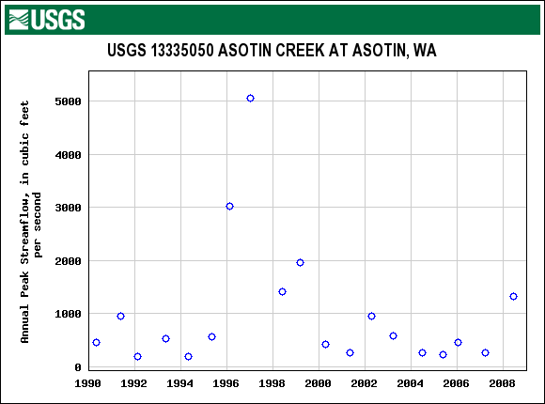
Stream flow histories in the form of gauging stations have been kept by the USGS since the 1920’s. By looking at the annual peak flow for several of the stations an indication of the size and relative frequency of flood events can be obtained (USGS 2010).
USGS. U.S. Geological Survey. U.S. Department of Interior. Peak Streamflow for the Nation. Available online at http://nwis.waterdata.usgs.gov/nwis/peak/?site_no=13344500&amp;. January 2010.
Asotin Creek drains approximately 325 square miles of Asotin and Garfield Counties. Asotin Creek is most heavily influenced by rain-on-snow events due to its large drainage area and relatively narrow channel; however, several flash floods have also been recorded. One significant flash flood struck Asotin Creek after a thunderstorm in May 1897, inflicting considerable damage, but causing no fatalities. A similar flash flood on Asotin Creek in June 1925 killed two young children, both members of the same family. A state highway department employee drowned in yet another flash flood in Dry Gulch, a tributary of Asotin Creek in 1976.
Sedimentation and accumulated debris and vegetation are significantly increasing the flood risk associated with Asotin Creek. Debris jams during high water events have caused considerable flood damage to adjacent properties. Most of the structures in the FEMA-identified floodplain for all of Asotin County are located along Asotin Creek.
Figure 5.4. City of Asotin FEMA Flood Insurance Rate Map.
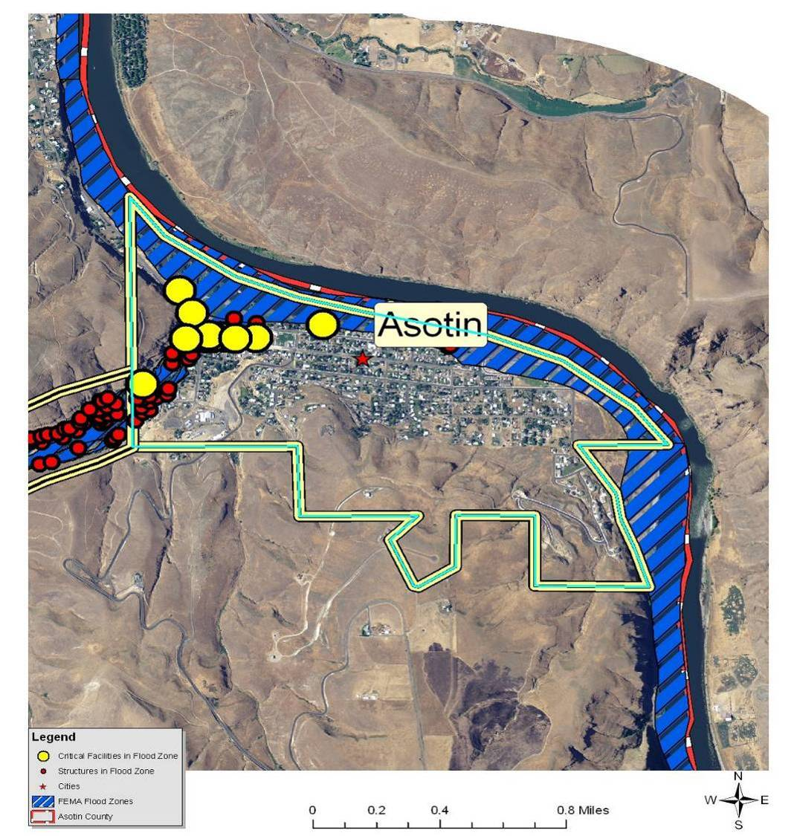
*Blue line does not necessarily represent the city limits boundary.
February 1996 - In 1996, the waters of Asotin Creek peaked on February 9th after a week of warm Pacific storm surges brought rain on snow covered frozen ground. This pattern was repeated the following winter with even higher flows coming on the first day of the New Year, 1997. The results included severe soil erosion from upland areas, numerous slope failures and extensive damage to roads, recreation trails, stream channels and property. The Department of Ecology granted the city of Asotin $160,000 following the floods in 1996 to restore the levee on Asotin Creek protecting at least 56 homes and an estimated $10 million in property.

Value of Resources at Risk
There are 43 structures within the FEMA-identified floodplains (100- and 500-year) in Asotin, yielding an estimated total improvement value of $4.1. The average damage to structures was estimated based on the structure’s location as either completely within or out of the flood zone. The estimated value of contents is ½ the value of the improvements equating to an additional $2 million in potential losses. In reality, the damages will most likely not be equally distributed between buildings based on building materials, building location, and flood location. However, these estimates provide a basic approximation. There are currently only 6 NFIP policies in Asotin.
Critical infrastructure located within the identified floodplain for Asotin includes the sewage treatment facility, the Asotin County Courthouse and Annex Building, city hall, the post office, the Sheriff’s office, water well #1, the State Highway 129 Bridge, the 2nd Street Bridge, the Costley Land Bridge, the school (also Red Cross shelter), and the fire station. Asotin recently built and overflow system at the sewage treatment facility to help mitigate the potential for damages and/or water contamination during a high water event.
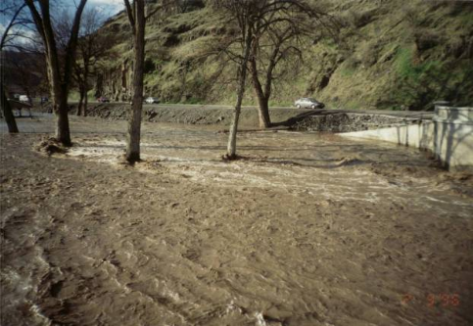
1997 Flooding in Asotin City Park.

Earthquake
There are no recorded occurrences of earthquakes significantly impacting the city of Asotin; however, some minimal shaking has been felt as a result of larger earthquakes elsewhere. The City has a 10% chance of exceeding a 5-6% pga in the next 50 years Asotin does not have any differing issues or levels of risk associated with this hazard than Asotin County as a whole.

Value of Resources at Risk
Unreinforced masonry (URM) structures and unreinforced chimneys of homes will likely be damaged in the event of an earthquake. There are several publicly accessible unreinforced masonry structures in Asotin in addition to the numerous homes and other buildings throughout the City with unreinforced chimneys. Damaged or collapsed chimneys could result in the secondary hazard of fire. Nonstructural damage caused by falling and swinging objects may be considerable after any magnitude earthquake. Damage to some older, more fragile bridges and land failure causing minor slides along roadways may isolate some residents.
In Asotin, many of the downtown structures on Second Street (6-7 buildings) are assumed to be unreinforced masonry including the Asotin County Courthouse and the fire station. .The number and value of unreinforced masonry homes or homes with masonry chimneys in Asotin is unknown, but estimated to include at least 20 buildings throughout the city.

Landslide
The city of Asotin has a very low probability of experiencing damaging landslides. Slopes in and around the community are generally less than 35%. While small, low angle slumps may occur on eyebrows of the surrounding hills, these will be infrequent and likely the result of water saturation or a major disturbance such as an earthquake or road construction. It is also probable that small slides will continue to occur on the cut and fill slopes of some roads. This type of slide is generally small with little permanent damage to the road or other infrastructure; however, there is some risk of traffic being delayed temporarily while road crews clear the debris and stabilize the bank.

Value of Resources at Risk
There are no structures directly at risk from landslides within the city of Asotin. Small slumps may occur along Highway 129, Asotin Creek Road, or other secondary roads. In many cases, this will cause temporary sediment delivery into nearby streams and plugged culverts. These types of events are cleaned up by county or city road departments with little complications. Road slumps are generally reported as regular maintenance; thus, there are few records associated with these events.

Severe Weather
The city of Asotin does not have any differing levels of risk associated with this hazard than Asotin County as a whole.

Value of Resources at Risk
It is difficult to estimate the cost of potential winter storm damages to structures and the economy in Asotin. Damage to roofs by heavy snow accumulations depends on the moisture content of the snow and the structural characteristics of the buildings. In general, heavy snow along the Snake River is uncommon due the higher valley temperatures and relatively arid environment. Frozen water pipes are the most common damage to residential and business structures. Older homes tend to be at a higher risk to frozen water pipes than newer ones. Snow plowing within the city limits is accomplished by the city’s maintenance department. Private landowners are responsible for maintaining their own driveways or other private roads. Utility supplies are impacted during severe winter storms as power is lost on a regional basis. This has a two-fold impact on residents as not only is power cut to homes and businesses, but primary heating is lost for many residents. Gas furnaces and wood stoves supplement electrical heating, but with wood heating the senior population is at a disadvantage. Emergency response to severe winter storms includes site visits by police or fire department personnel, opening of shelters, or assistance with shopping, medical attention, and communications. The economic losses caused by severe winter storms may frequently be greater than structural damages. Employees may not be able to travel to work for several days and businesses may not open. Damages are seen in the form of structural repair and loss of economic activity. Asotin County schools are occasionally closed during and right after a severe winter storm because of cold temperatures and snow covered roads.
Thunderstorms are not likely to be severe enough in Asotin to cause significant damages. However, the loss potential from flooding that results from severe thunderstorms could be significant.
Although the financial impacts of hail can be substantial and extended, accurately quantifying these impacts is problematic. Hail typically causes direct losses to structures and other personal property within Asotin. The most significant losses are most clearly seen in the agriculture sectors of the economy. Potential losses to agriculture can be disastrous. Crop damage from hail will also be different depending on the time of year and the type of crop. Most farmers carry insurance on their crops to help mitigate the potential financial loss resulting from a localized hail storm. Homeowners in Asotin rarely incur severe damage to structures (roofs); however, hail damage to vehicles is not uncommon. The damage to vehicles is difficult to estimate because the number of vehicles impacted by a specific ice storm is unknown. Additionally, most hail damage records are kept by various insurance agencies.
It is difficult to estimate potential losses in Asotin due to windstorms and tornadoes. Construction throughout the County has been implemented in the presence of high wind events, and therefore, the community is at a higher level of preparedness to high wind events than many other areas experiencing lower average wind speeds.
We have estimated losses based on wind and tornado damage as follows:
- 3% of the buildings damaged causing 50% of value loss (loss could be from downed or damaged trees, damaged outbuildings, damaged fences/poles, damage to siding, damaged landscaping etc.)
- 5% of the buildings received damage to roof (requiring replacement of roof equaling $3,000)
Damages associated with sensitive receptor irritation have not been estimated. We have also not estimated the potential for a large scale wildfire event associated with high winds. Based on the data provided by the County, there are 563 total structures in Asotin with a total value of approximately $53.3 million. Using the criteria outlined above an estimate of the impact of high winds on in the County has been made. The potential wind and tornado damage to all buildings is estimated at approximately $800,130. The estimated damage to roofs is approximately $84,450.
Power failure often accompanies severe storms. More rural parts of the County are sometimes better prepared to deal with power outages for a few days due to the frequent occurrence of such events; however, prolonged failure, especially during cold winter temperatures can have disastrous effects. All communities should be prepared to deal with power failures. Community shelters equipped with alternative power sources will help local residents stay warm and prepare food. A community-based system for monitoring and assisting elderly or disabled residents should also be developed. All households should maintain survival kits that include warm blankets, flashlights, extra batteries, nonperishable food items, and clean drinking water.

Wildland Fire
Asotin is located along the Snake River, upstream from its confluence with the Clearwater River and Clarkston. The city is bordered by the river to the north and east and rangeland to the west and south. Ornamental hardwoods and softwoods are scattered around homes with native hardwoods prolific along Asotin Creek. The city is clustered along Asotin Creek, the banks of the Snake River, and State Highway 129. There are also several subdivisions and scattered homes up the Asotin Creek drainage, but outside of the city limits.
The risk from structure loss due to a wildfire entering Asotin is moderate. Rangeland fuels surround this community. Fires in this fuel type have the potential to spread rapidly through the fine fuels, particularly when fanned by high winds. Scattered livestock grazing on the surrounding hillsides has drastically reduced fuel buildups; however, limited access points reduce response times and make suppression efforts difficult.
Asotin has a moderate risk of a wildfire threatening the city center; however, structure fires within the city have some potential to spread from one structure to another; either carried by radiant heat or spread through common vegetation between structures. This risk is lessened by the presence of an active fire protection district housed in Dayton.
One particular area of concern is located along the southern edge of the populated area, south of 4th Street. Here homes are located under ornamental trees with grasses and forbs growing around the structures. The area adjacent to the homes is a rangeland complex of vegetation located at the foot of the hill leading up to State Highway 129. The potential for an accidental human ignition is high. This hillside and subsequent fuels are constantly fanned by river influenced winds (upstream and downstream) and have the potential to move rapidly; thus, threatening homes. Historically, these areas were likely grazed, but this practice has been greatly reduced.
New homes are being built on the ridges surrounding Asotin. These homes are placed among the rangeland fuels with grasses and forbs intermixed with sagebrush. Very little fire protection is afforded as they are perched at or near the top of the ridges with often substandard access. Annual vegetation management is warranted in the areas to reduce the potential risk to life and property.
Access in and out of Asotin is provided by State Highway 129 running northwest-southeast, and by the Snake River Road beginning in Asotin and paralleling the river south to Rogersburg. Many smaller, graveled access routes tie into these two-lane roads. State Highway 129 from Asotin to Anatone begins by climbing a steep grade with numerous switchbacks in order to gain elevation to the upper plateau from the Snake River. This grade is the primary access route for travel between Asotin and Anatone. The Asotin Creek Road provides access to many homes, farms, and ranches in the Asotin Creek drainage as well as the Cloverland and Meyer Ridge areas.
The Asotin Water Department maintains two community water supply points (Well #1 and #2). One is located along the edge of the Snake River, the other is at the intersection of Meador Street and Cleveland Street. Power poles along road rights-of-way supply power to individual homes and businesses. Many poles are older with lines passing through ornamental trees.
New home construction, especially in the southeast corner of the city, is being built with underground power supplies and “firewise” construction principals. Where practiced and maintain, these techniques will serve to enhance the ability of these homes to survive the rangeland fires common in these areas.
The city of Asotin is protected by the Asotin Fire Department and has a good coverage of fire hydrants for homes in the city. The Asotin County Fire District #1 provides structural and wildland fire protection in the city and rural areas surrounding the city through an auto-aid agreement.
All of the private lands within the fire protection district have joint jurisdiction with the Washington Department of Natural Resources (DNR). Under joint jurisdiction, it is recognized that the fire district has primary responsibility for structure protection and the DNR will have primary responsibility for wildland fire suppression on state and private lands. The DNR provides wildfire protection during the fire season between April and October with varying degrees of available resources in the early spring and late autumn months. The U.S. Forest Service responds to all wildland fires on their jurisdiction and may also respond to wildland fires on private or state lands based on a closest forces, reciprocal agreement with the DNR when resources are available.
Asotin possesses many homes densely clustered into the city limits with many new homes being built along the perimeter of the city to the south. This change in housing density poses some challenges for the community’s wildfire protection. In terms fuels management for the established homes in Asotin, much of the focus should be on managing the grassland and sagebrush fuels along the southern edge of the city. A combination of field burning when conditions merit with long-term livestock grazing, would effectively lessen the range fire threat for those adjacent homes. Most of the mile long southern border of Asotin could effectively be treated in this manner.
The new construction, much of which is scattered beyond the southern edge of Asotin, warrants individual home site protection. In these cases, a combination of defensible space around the immediate 150 feet of the structure, coupled with access improvements, and firewise building material selection, will improve home’s survivability.

Value of Resources at Risk
It is difficult to estimate potential losses in Asotin from wildland fire due to the unpredictability of wildfire behavior and the nature of ignition sources. It is impossible to forecast the path a wildfire will take and what type of assets and resources, manmade and ecological, will be at risk. Thus, no value estimates were made for this hazard.
Typically, structures located in forested areas without an adequate defensible space or fire resistant landscaping have the highest risk of loss. Nevertheless, homes and other structures located in the grasslands or agricultural regions are not without wildfire risk. Grass fires are often the most dangerous due to high rates of spread. Fires in this fuel type are considered somewhat easier to suppress given the right resources, but they can also be the most destructive. Homes along the perimeter of the community would have the highest risk due to their adjacency to flashy fuels.

Avalanche
Although the Blue Mountains in southwestern Asotin County have a high probability of experiencing avalanches in remote areas, the city of Asotin will not be directly impacted by this type of localized event due to the lack of snow accumulations.

Value of Resources at Risk
The city of Asotin has no assets at risk to avalanches.

Tsunami
The city of Asotin is located along the Snake River; thus, there could be some potential impacts from an inland tsunami occurring in a location that caused large waves to break at Asotin. This type of event would likely be the result of a large landslide on the Idaho side of the River directly across from Asotin.

Value of Resources at Risk
Damage from an inland tsunami in the city of Asotin would be limited to infrastructure and recreational facilities within less than 100 feet of the Snake River shoreline. This may include some secondary access roads, the marina, beaches, and, in extreme cases, possibly the wastewater treatment facility. The wastewater treatment facility is protected by an elevated berm; thus, it is unknown what type of damage a large wave would cause. There are currently no residences or businesses at risk to inland tsunamis in Asotin.

Volcano
The city of Asotin does not have any differing levels of risk associated with this hazard than Asotin County as a whole.

Value of Resources at Risk
The city of Asotin has no assets at direct risk of being impacted by a volcanic eruption. However, the secondary effects of ash and airborne particulates may have varying degrees of negative effects. Damages to property will likely be limited to vehicles and cleanup costs. Additionally, residents of Asotin will be at risk to health problems associated with the respiratory effects of breathing airborne particulates.

Drought
The city of Asotin does not have any differing levels of risk associated with this hazard than Asotin County as a whole. However, the city does have its own policies concerning water conservation practices during the dry months. Additionally, the city may develop programs to deal with residents and businesses significantly impacted by drought if necessary.

Value of Resources at Risk
The city of Asotin has no assets directly at risk to drought; however, the economic impacts of a drought or a wildland fire caused by extended dry periods would have a great impact on the community. The majority of the population is employed either directly by the agriculture industry or to a service industry dependent on agriculture. Crop losses resulting from extended droughts would likely be considered a disaster for the community.

City of Clarkston Annex

Flood
Clarkston is located at the confluence of the Clearwater and Snake Rivers. Flooding does not typically occur on the Snake River, the northern and western borders of the County, due to flood control capacity of both upstream and downstream dams. The water level of Snake River reservoirs are monitored and highly regulated for the purposes of providing not only irrigation water to the surrounding agricultural developments and hydroelectric power, but also to provide flood control for communities along this major drainage. A major flood event on the Snake River may cause minimal damages in Clarkston; however, very few structures or infrastructure are located in the floodplain associated with this waterway. The U.S. Highway 12 Bridge connecting Clarkston with Lewiston and the Red Wolf Bridge on the north side of town could be impacted by debris and/or ice in the River causing jams or directly damaging the structures. This would cause serious traffic delays; however, it is unlikely that all of the Snake River bridges at Clarkston would be impassable.
Most of the structures in the floodplain are located in Dry Creek, a shallow draw, on the west side of Clarkston. This is a small waterway draining the foothills to the south and west of the City. Dry Creek is extremely prone to flash flooding as a result of localized thunderstorms. This type of event can occur rapidly, overwhelming the carrying capacity of the channel in a short time. The duration of this type of flooding tends to be a matter of hours and is usually associated with localized thunderstorms in which the ground cannot absorb moisture as quickly as it is coming down.
Dry Creek is also heavily impacted by rain-on-snow events. Warm rains falling on the snow pack result in a significantly increased rate of snowmelt. Often the melting occurs when the ground is frozen and the water cannot be absorbed fast enough, resulting in increased overland flows. Flood waters recede slowly as the weather events tend to last for several days. Homes in the Dry Creek area are accessed by Evans Road off of U.S. Highway 12. In the event that the stream damage or washes out Evans Road, the only remaining access routes would be Ben Johnson Road to the east or out the top on Peola Road.
Figure 5.5. City of Clarkston FEMA Flood Insurance Rate Map.
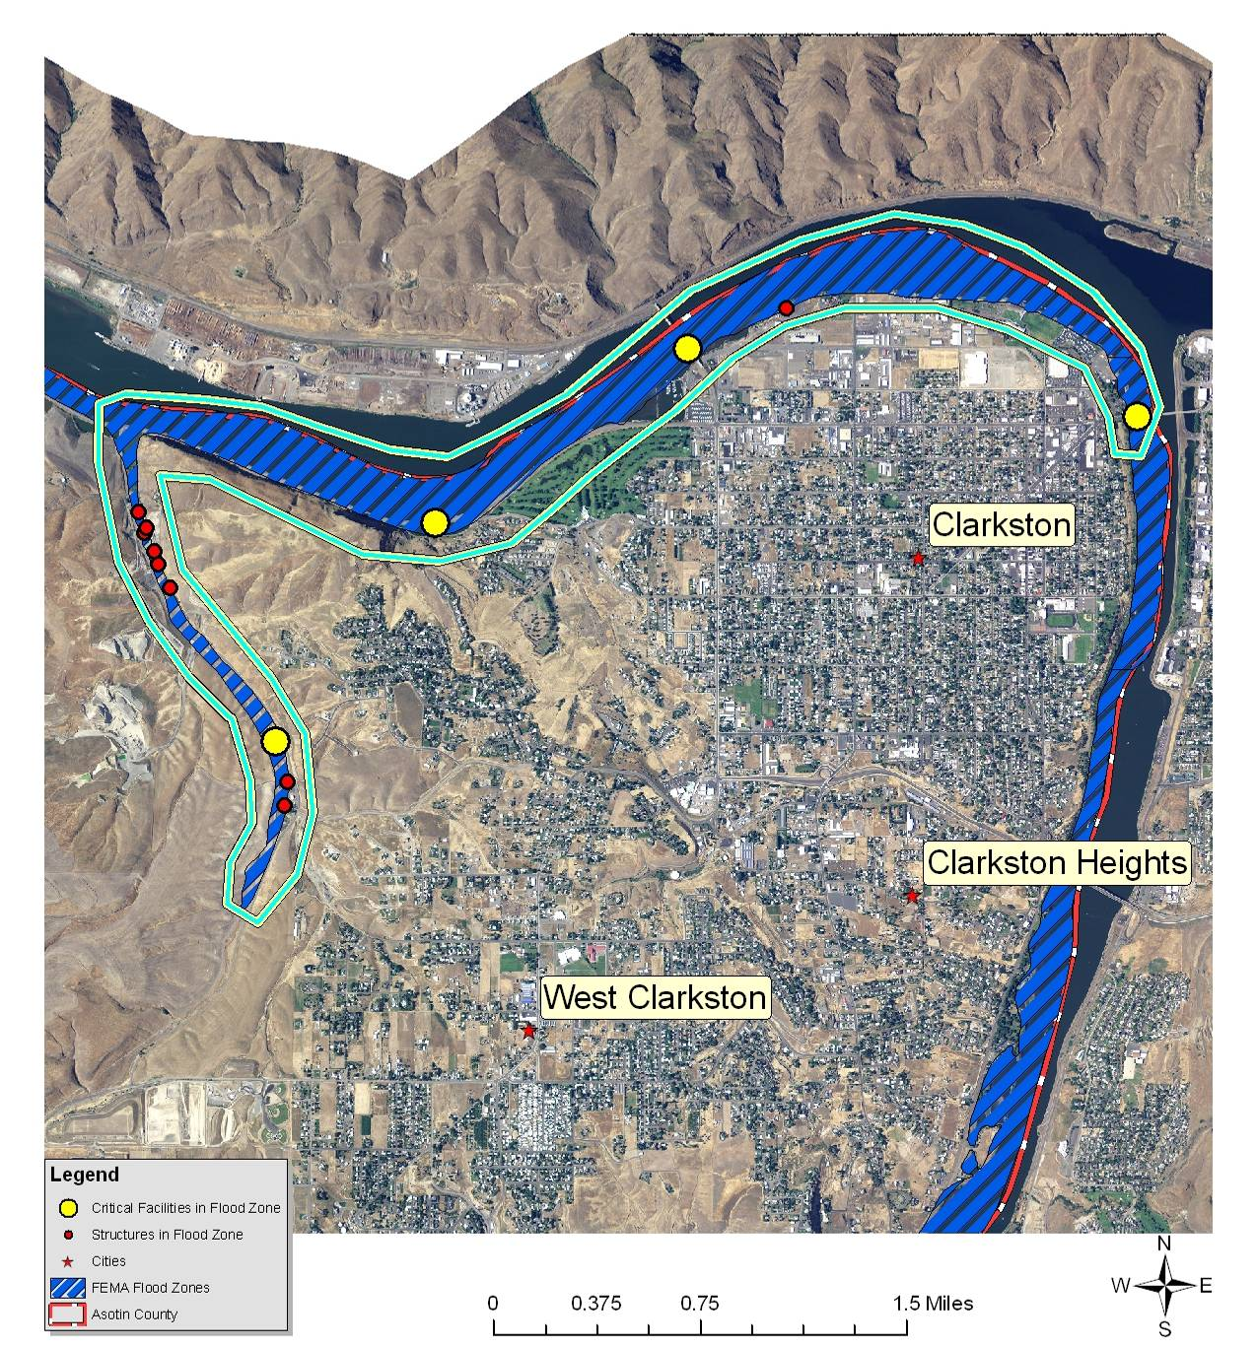
*Blue line does not necessarily represent the city limits boundary.

Value of Resources at Risk
There are 9 parcels within the FEMA-identified floodplains (100- and 500-year) in Clarkston, yielding an estimated total improvement value of over $850,000. The average damage to structures was estimated based on the parcel’s location as either completely within or out of the flood zone. The estimated value of contents is ½ the value of the improvements equating to an additional $426,000 in potential losses. In reality, the damages will most likely not be equally distributed between buildings based on building materials, building location, and flood location. However, these estimates provide a basic approximation. There are currently 0 NFIP policies in Clarkston.
Critical infrastructure located within the identified floodplain for Clarkston includes the U.S. Highway 12 Bridge, the Red Wolf Bridge (State Highway 193), and Asotin County Port.

Earthquake
There are no recorded occurrences of earthquakes significantly impacting the city of Clarkston; however, some minimal shaking has been felt as a result of larger earthquakes elsewhere. The City has a 10% chance of exceeding a 5-6% pga in the next 50 years. Clarkston does not have any differing issues or levels of risk associated with this hazard than Asotin County as a whole.

Value of Resources at Risk
Unreinforced masonry (URM) structures and unreinforced chimneys of homes will likely be damaged in the event of an earthquake. There are several publicly accessible unreinforced masonry structures in Clarkston in addition to the numerous homes and other buildings throughout the city with unreinforced chimneys. Damaged or collapsed chimneys could result in the secondary hazard of fire. Nonstructural damage caused by falling and swinging objects may be considerable after any magnitude earthquake. Damage to some older, more fragile bridges and land failure causing minor slides along roadways may isolate some residents.
In Clarkston, the Clarkston Hospital Complex, the Parkway School, Clarkston High School, Clarkston City Hall (includes fire station and police department), Asotin County Public Health, Clarkston Education Opportunity School, the U.S. Post Office, and Grantham Elementary School are assumed to be unreinforced masonry. These structures were built prior to the inclusion of articles for seismic stability in the Uniform Building Codes in 1972. The number and value of unreinforced masonry homes or homes with masonry chimneys in Clarkston is unknown, but estimated to include at least 500 buildings.

Landslide
The city of Clarkston has a very low probability of experiencing damaging landslides. Slopes in and around the community are generally less than 35%. While small, low angle slumps may occur on eyebrows of the surrounding rolling hills, these will be infrequent and likely the result of water saturation or a major disturbance such as an earthquake or road construction. It is also probable that small slides will continue to occur on the cut and fill slopes of some roads. This type of slide is generally small with little permanent damage to the road or other infrastructure; however, there is some risk of traffic being delayed temporarily while road crews clear the debris and stabilize the bank.

Value of Resources at Risk
There are no structures directly at risk from landslides within the city of Clarkston. Small slumps may occur along U.S. Highway 12, Highways 129 and 128, or other secondary roads. In many cases, this will cause temporary sediment delivery into nearby streams and plugged culverts. These types of events are cleaned up by county or city road departments with little complications. Road slumps are generally reported as regular maintenance; thus, there are few records associated with these events.

Severe Weather
The city of Clarkston does not have any differing levels of risk associated with this hazard than Asotin County as a whole.

Value of Resources at Risk
It is difficult to estimate the cost of potential winter storm damages to structures and the economy in Clarkston. Damage to roofs by heavy snow accumulations depends on the moisture content of the snow and the structural characteristics of the buildings. In general, heavy snow along the Snake River is uncommon due the higher valley temperatures and relatively arid environment. Frozen water pipes are the most common damage to residential and business structures. Older homes tend to be at a higher risk to frozen water pipes than newer ones. Snow plowing within the city limits is accomplished by the city’s public works department. Private landowners are responsible for maintaining their own driveways or other private roads. Utility supplies are impacted during severe winter storms as power is lost on a regional basis. This has a two-fold impact on residents as not only is power cut to homes and businesses, but primary heating is lost for many residents. Gas furnaces and wood stoves supplement electrical heating, but with wood heating the senior population is at a disadvantage. Emergency response to severe winter storms includes site visits by police or fire department personnel, opening of shelters, or assistance with shopping, medical attention, and communications. The economic losses caused by severe winter storms may frequently be greater than structural damages. Employees may not be able to travel to work for several days and businesses may not open. Damages are seen in the form of structural repair and loss of economic activity. Clarkston schools are occasionally closed during and right after a severe winter storm because of cold temperatures and snow covered roads.
Thunderstorms are not likely to be severe enough in Clarkston to cause significant damages. However, the loss potential from flooding that result from severe thunderstorms could be significant.
Although the financial impacts of hail can be substantial and extended, accurately quantifying these impacts is problematic. Hail typically causes direct losses to structures and other personal property within Clarkston. The most significant losses are most clearly seen in the agriculture sectors of the economy. Potential losses to agriculture can be disastrous. Crop damage from hail will also be different depending on the time of year and the type of crop. Most farmers carry insurance on their crops to help mitigate the potential financial loss resulting from a localized hail storm. Homeowners in Clarkston rarely incur severe damage to structures (roofs); however, hail damage to vehicles is not uncommon. The damage to vehicles is difficult to estimate because the number of vehicles impacted by a specific ice storm is unknown. Additionally, most hail damage records are kept by various insurance agencies.
It is difficult to estimate potential losses in Clarkston due to windstorms and tornadoes. Construction throughout the County has been implemented in the presence of high wind events, and therefore, the community is at a higher level of preparedness to high wind events than many other areas experiencing lower average wind speeds.
We have estimated losses based on wind and tornado damage as follows:
- 3% of the buildings damaged causing 50% of value loss (loss could be from downed or damaged trees, damaged outbuildings, damaged fences/poles, damage to siding, damaged landscaping etc.)
- 5% of the buildings received damage to roof (requiring replacement of roof equaling $3,000)
Damages associated with sensitive receptor irritation have not been estimated. We have also not estimated the potential for a large scale wildfire event associated with high winds. Based on the data provided by the County, there are 2,691 total structures in Clarkston with a total value of approximately $255 million. Using the criteria outlined above an estimate of the impact of high winds on in the County has been made. The potential wind and tornado damage to all buildings is estimated at approximately $3.8 million. The estimated damage to roofs is approximately $403,650.
Power failure often accompanies severe storms. More rural parts of the County are sometimes better prepared to deal with power outages for a few days due to the frequent occurrence of such events; however, prolonged failure, especially during cold winter temperatures can have disastrous effects. All communities should be prepared to deal with power failures. Community shelters equipped with alternative power sources will help local residents stay warm and prepare food. A community-based system for monitoring and assisting elderly or disabled residents should also be developed. All households should maintain survival kits that include warm blankets, flashlights, extra batteries, nonperishable food items, and clean drinking water.

Wildland Fire
Clarkston assessment area consists of the traditionally known incorporated city as well as the adjacent Clarkston Heights-Vineland area, West Clarkston, and the Clemens Addition south of Clarkston Heights, which is south of Clarkston. There is no noticeable break between the city limits and these developments; thus, for the purposes of this assessment, all of these areas will be considered together.
This area (Clarkston and Asotin) is the only example of High Density Urban WUI designation in the three county planning area. It is characterized by extremely high population densities, integrated structure fire services, and rangeland/agricultural fuels. The Snake River defines the eastern and northern boundary of the city. Lewiston, Idaho, is located due east of Clarkston on the opposite side of the river with a similar high density urban designation. These two cities comprise the largest metropolitan center in the region.
The risk from structure loss due to a wildfire entering the Clarkston area is minimal. The surrounding Snake River to the north and east (as well as the location of Lewiston to the east), dramatically reduces the risk from a wildfire moving in from these directions.
Rangeland fuels are present along the entire western and southern border of Clarkston. These fuels are primarily grasses and sagebrush all intermixed with agriculture fields. Most of the native vegetation is grazed by livestock. Numerous vacant lots and pasture are scattered throughout the Clarkston urban area, which could aid fire spread depending on management, fuel moisture, and weather. Steep terrain dominated by both native and nonnative grasses and weeds between home sites also poses a potential problem. This type of fuel is very flashy, but typically does not burn with the intensity of a forestland fuel complex. While these fuels do not generally threaten homes in the area, they could ignite debris and wood structures adjacent to the homes (e.g. firewood stacks, decks, stored lumber, or rubbish). In this manner, these scattered lots within the city limits and adjacent to homes can act as a fuse carrying wildfire from the rangeland to homes. The converse is also true, in that a structure fire can spread to adjacent rangeland fuels, which is then carried to neighboring structures or into the rangeland.
Identification of the vacant lots in the area which support rangeland fuels and are on steep slopes, especially those leading to homes perched on the top of ridges, is critical to reducing the wildfire risk in Clarkston.
There are many ornamental trees around homes and within parks maintained within the Clarkston urban area. These hardwoods and softwoods do not pose a substantial wildfire risk in that most are maintained in a green and lush condition for the majority of the fire season.
Clarkston has a low risk of wildfire threatening the city center; however, structure fires within the city have some potential to spread from one structure to another; either carried by radiant heat or spread through common vegetation between structures. This risk is lessened by the presence of an active fire department and fire protection district.
Access in and out of Clarkston is provided by Highway 12 running east-west. State Highway 183 provides access from the northern end of Clarkston across the Snake River (Red Wolf Crossing) to Whitman County. State Highway 129 (a.k.a. Snake River Road) parallels the Snake River from Clarkston to Asotin; however, this access point is primarily a means for residents in the southern locations to gain access north, as opposed to Clarkston residents escaping to the south. There are several options for access across the Snake River between Clarkston and Lewiston. Clarkston is a major regional transportation hub.
There are eight municipal water supply wells located within Clarkston. All of them supply community drinking water and are managed by the Public Utilities District #1 of Asotin County. One of them (well #4, Standby) is an emergency water supply source. The remaining wells are permanent.
Electricity supply to the city is from various locale linked to the hydroelectric grid of the region. In the oldest parts of the city, powerlines supply power to homes and businesses. New construction and new subdivisions in the area tend to have underground power supplies. The removal of the power poles and the hanging wires over the native vegetation is an exceptional improvement to the risk portfolio of the city.
The Clarkston Fire Department provides primarily structural fire protection within the city limits of Clarkston. The Asotin County Fire District #1 provides structural and wildland protection to unincorporated areas of Clarkston and the surrounding area (105 square miles). A complete system of fire hydrants is present throughout the city. Access challenges are present where steep driveways or inadequately built bridges are the only ingress/egress points. One way in, one way out streets accessing subdivisions or private homes, particularly in new construction areas, has become a safety issue for both residents and firefighters.
Because of the moderate level of risk in Clarkston, few potential mitigation activities are recommended at this time. The continued use of the surrounding landscape for active agricultural (not CRP) and livestock grazing will reduce fuel loading and; therefore, the potential fire risk.
In addition, the Asotin County Fire District #1 have so far been relatively successful at suppressing wildland fires. The continued support of these services by the community will improve their ability to fight fires effectively.

Value of Resources at Risk
It is difficult to estimate potential losses in Clarkston from wildland fire due to the unpredictability of wildfire behavior and the nature of ignition sources. It is impossible to forecast the path a wildfire will take and what type of assets and resources, manmade and ecological, will be at risk. Thus, no value estimates were made for this hazard.
Typically, structures located in forested areas without an adequate defensible space or fire resistant landscaping have the highest risk of loss. Nevertheless, homes and other structures located in the grasslands or agricultural regions are not without wildfire risk. Grass fires are often the most dangerous due to high rates of spread. Fires in this fuel type are considered somewhat easier to suppress given the right resources, but they can also be the most destructive. Homes along the perimeter of the community would have the highest risk due to their adjacency to flashy fuels.

Avalanche
Although the Blue Mountains in southwestern Asotin County has a high probability of experiencing avalanches in remote areas, the city of Clarkston will not be directly impacted by this type of localized event due to the lack of snow accumulation.

Value of Resources at Risk
The city of Clarkston has no assets at risk to avalanches.

Tsunami
The city of Clarkston is located along the Snake River; thus, there could be some potential impacts from an inland tsunami occurring in a location that caused large waves to break at Clarkston. This type of event would likely be the result of a large landslide on the Idaho or Washington side of the River directly across from Clarkston.

Value of Resources at Risk
Damage from an inland tsunami in the city of Clarkston would be limited to infrastructure, structures, and recreational facilities within less than 100 feet of the Snake River shoreline. This may include some secondary access roads, the marina, industrial businesses, and RV park, and public access areas. There are currently no residences at risk to inland tsunamis in Clarkston. It is unlikely that an inland tsunami would damage the Red Wolf Bridge, the Southway Bridge, or the US Highway 12 Bridge at Clarkston due to their height.

Volcano
The city of Clarkston does not have any differing levels of risk associated with this hazard than Asotin County as a whole.

Value of Resources at Risk
The city of Clarkston has no assets at direct risk of being impacted by a volcanic eruption. However, the secondary effects of ash and airborne particulates may have varying degrees of negative effects. Damages to property will likely be limited to vehicles and cleanup costs. Additionally, residents of Clarkston will be at risk to health problems associated with the respiratory effects of breathing airborne particulates.

Drought
The city of Clarkston does not have any differing levels of risk associated with this hazard than Asotin County as a whole. However, the city does have its own policies concerning water conservation practices during the dry months. Additionally, the city may develop programs to deal with residents and businesses significantly impacted by drought if necessary.

Value of Resources at Risk
The city of Clarkston has no assets directly at risk to drought; however, the economic impacts of a drought or a wildland fire caused by extended dry periods would have a great impact on the community. A large portion of the population is employed either directly by the agriculture industry or to a service industry dependent on agriculture. Crop losses resulting from extended droughts would likely be considered a disaster for the community.

Asotin County Fire District #1 Annex

Flood
The Fire District does not have any differing levels of risk associated with this hazard than Asotin County as a whole.

Value of Resources at Risk
The Asotin Fire District #1 station in the Clarkston Heights is not directly at risk to flood events; however, the District may provide emergency response capabilities and/or manpower for flood control measures.

Earthquake
There are no recorded occurrences of earthquakes significantly impacting Asotin County Fire District #1. The area covered by the District has a 10% chance of exceeding a 5-7% pga in the next 50 years. The Fire District does not have any differing issues or levels of risk associated with this hazard than Asotin County as a whole. However, in the event of a damaging earthquake, Fire District #1 would provide emergency response and search and rescue services.

Value of Resources at Risk
The Asotin Fire District #1 station in the Clarkston Heights is an unreinforced masonry structure. It is likely that this building would be damaged during a moderate to severe earthquake. The current value of the building is approximately $3.5 million plus an additional estimated content value of $1.75 million.

Landslide
The Fire District does not have any differing levels of risk associated with this hazard than Asotin County as a whole. However, in the event of a significant landslide, Fire District #1 may assist with any necessary evacuations or traffic accident responses.

Value of Resources at Risk
The Asotin Fire District #1 station in the Clarkston Heights is not at risk to landslides due to its location in a relatively flat, heavily developed area. The District has no other known assets or other resources at risk to landslides.

Severe Weather
The Fire District does not have any differing levels of risk associated with this hazard than Asotin County as a whole. However, in the event of significant severe weather events, Fire District #1 would assist with accident response, delivery of special aid if necessary, and search and rescue missions.

Value of Resources at Risk
The Asotin Fire District #1 station in the Clarkston Heights may be at risk to severe high wind events, hail damage, or significant snow accumulations. One room on the station has a flat roof, which may be susceptible to heavy snow accumulations or damage from standing water; however, the moderate weather in the Lewis and Clark Valley make this type of damage unlikely. The District has no other known assets or other resources at risk to severe weather events.

Wildland Fire
Asotin County Fire District #1 covers much of the north end of Asotin County. The District provides both structural and wildland fire protection in the unincorporated areas surrounding the cities of Clarkston and Asotin. All of the private lands within the fire protection district have joint jurisdiction with the Washington Department of Natural Resources (DNR). Under this joint jurisdiction, it is recognized that the fire district has primary responsibility for structure protection and the DNR will have primary responsibility for wildland fire suppression on state and private lands. The DNR provides wildfire protection during the fire season between April and October with varying degrees of available resources in the early spring and late autumn months.
The Fire District does not have any differing levels of risk associated with this hazard than Asotin County as a whole. However, in the event of a wildland fire, Fire District #1 would provide emergency response, protection, and search and rescue services.

Value of Resources at Risk
The Asotin Fire District #1 station in the Clarkston Heights is not at risk to wildland fire due to its location in an urban area. The District has no other known assets or other resources at risk to wildland fires.

Avalanche
The Fire District does not have any differing levels of risk associated with this hazard than Asotin County as a whole. However, in the event of a significant avalanche event, Fire District #1 may assist with any necessary evacuations or search and rescue operations.

Value of Resources at Risk
The Asotin Fire District #1 station in the Clarkston Heights is not at risk to avalanches due to its location in a relatively flat, heavily developed area. The District has no other known assets or other resources at risk to avalanches.

Tsunami
The Fire District does not have any differing levels of risk associated with this hazard than Asotin County as a whole. However, in the event of an inland tsunami, Fire District #1 may assist with any necessary evacuations or search and rescue operations.

Value of Resources at Risk
The Asotin Fire District #1 station in the Clarkston Heights is not at risk to tsunamis due to its location on high ground away from the Snake River channel. The District has no other known assets or other resources at risk to tsunamis.

Volcano
The Fire District does not have any differing levels of risk associated with this hazard than Asotin County as a whole. However, in the event of a volcanic eruption in western Washington or Oregon, Fire District #1 may assist with any necessary evacuations, medical responses, or traffic accidents.

Value of Resources at Risk
The Asotin Fire District #1 station in the Clarkston Heights is not have any direct risk to volcanoes; however, there may be damage to the structure and/or equipment caused by ash fallout.

Drought
The Fire District does not have any differing levels of risk associated with this hazard than Asotin County as a whole. However, in severe drought years, the District may have difficulty finding adequate water resources for wildland fire fighting purposes, particularly where drafting from ponds or streams is necessary.

Value of Resources at Risk
The Asotin Fire District #1 station in the Clarkston Heights does not have any direct risks to drought.

Columbia County Annex
The Flood Mitigation Plan contained within this Multi – Hazard Mitigation Plan fulfills the requirements of a Flood Mitigation Plan as specified in 44 CFR 78.5 of the Federal Register describing the Flood Mitigation Assistance program. The purpose of this section is to prescribe actions, procedures, and requirements for administration of the Flood Mitigation Assistance (FMA) program, authorized by Sections 1366 and 1367 of the National Flood Insurance Act of 1968, 42 U.S.C. 4104c and 4104d. The goal of FMA is to assist state and local governments in funding cost-effective actions that reduce or eliminate the long term risk of flood damage to buildings, manufactured homes, and other insurable structures.

Flood
The flood history record in Columbia County dates back to 1883. The major floods events in the Touchet and Tucannon River basins occurred in 1906, 1931, 1949, 1964, 1965, 1971, 1972, 1996, and 1997. High intensity rainfall, rain-on-snow and rain-on-frozen soil events have been prominent causes for flooding through the hydrologic record. Floods in Columbia County may occur at any time between November and June with flash floods from thunderstorms occurring during the summer months.
December 21, 1964 - Daytime temperatures rose to 52 degrees and the area received .82” of rain. On December 22nd, the temperature warmed to 58 degrees and 1.15 inches fell swelling the rivers to flood stage. By December 23rd, all of Columbia County was flooded as another .51” of rain fell and the daytime temperatures rose to 48 degrees. Most of the damage occurred in Dayton, east of the Main Street Bridge. Damage also occurred due to floodwaters eroding sections of the new levee constructed by the Corps of Engineers. Utility companies and the railroad estimated their damages at around $60,000.
Winter 1965 - Floodwaters again rose almost to 1964 levels due to similar weather patterns.
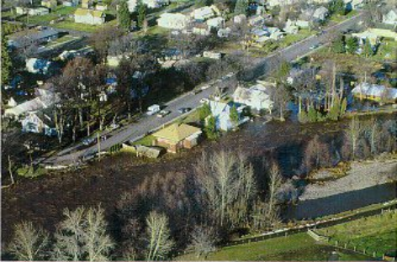
Downtown Dayton during 1996 Flood Event
February 6, 1996 - The weather was warm and wet after having 12-18” of snow on the ground in the Dayton area. The temperatures rose to 40 degrees and an ice jam formed on Patit Creek just east of the Third Street Bridge causing the stream to overflow its banks at 4th Street and Washington Street flowing west five blocks back into the Patit Creek channel. This flooded most sections of a 14-block area. By mid morning, water had backed up to the Highway 12 Bridge five blocks east of the ice jam. Crews removed the jam and waters receded. The temperatures stayed in the 30-degree range; with torrential rains at times swelling creek levels to flood stage. On February 9th, the approximately 500 residents on the lower end of town had to be evacuated. Only emergency vehicles and emergency workers were allowed access across the Main Street bridge. There were a total of 22 bridges left in bad repair or washed out completely. This event stranded 35 families for up to a week until temporary access was achieved. The flood damage repair costs exceeded 9.5 million dollars within Columbia County.
December 1996 thru January 1997 - Again in 1997 flooding occurred, but with streams cleared and bridges armored after the flood events earlier in 1996, the overall impact was reduced. The 1997 flood damage repair costs exceeded 3.3 million in Columbia County.
Columbia County is not considered to be one of the counties most at risk and vulnerable to flood in Washington according to the State of Washington Hazard Mitigation Plan. It is also not in the top percentage of Washington counties having a high frequency of floods causing damage. The Washington State Hazard Mitigation Plan does; however, report that Columbia County has 0 repetitive loss properties. Properties receiving two or more claim payments of more than $1,000 from the National Flood Insurance Program within any rolling 10-year period are considered repetitive loss properties by FEMA.
Columbia County contains portions of two major river drainages and four minor basins. Flooding does not typically occur on the Snake River, the northern border of the County, due to flood control capacity of both upstream and downstream dams. The water level of Snake River reservoirs are monitored and highly regulated for the purposes of providing not only irrigation water to the surrounding agricultural developments and hydroelectric power, but also to provide flood control for communities along this major drainage. In Columbia County, there are 13 structures located in the FEMA-identified Snake River floodplain.
Figure 5.6. Columbia County FEMA Flood Insurance Rate Map.
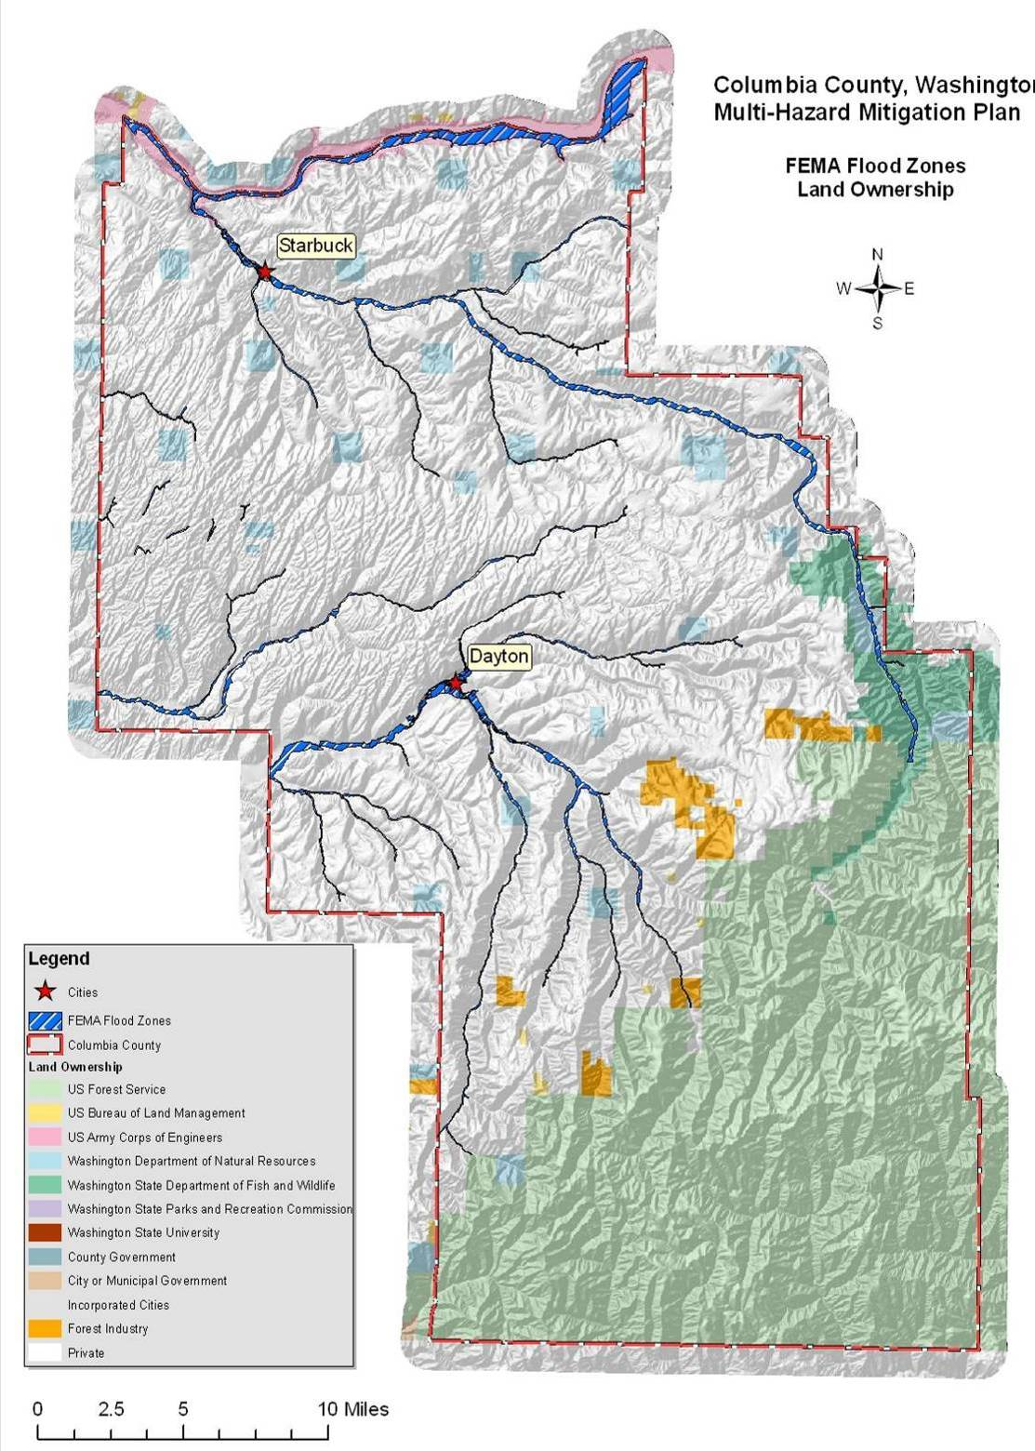
The Tucannon River basin starts in the southeastern portion of the county and drains into the Snake River at the northern border. Annual flash flooding is common in the Tucannon watershed. The upper reaches of the Tucannon River are also prone to flooding caused by rain-on-snow events. There are 94 structures located in the floodplain of the Tucannon River outside of the Town of Starbuck.
The Touchet River basin starts in the south and east portion of the county and runs through its midsection, then turns westward into Walla Walla County. The Touchet River watershed is prone to both flash flooding from localized weather events and riverine flooding in response primarily to rain-on-snow events. Between 1967 and 1996, gravel bars collected in the Touchet River channel near Dayton. This buildup of gravel and subsequent vegetative growth narrowed the channel and restricted the capacity of the stream. This, along with trees and other vegetation within the main channel, caused debris from both the north and south forks of the Touchet River to accumulate. These channel restrictions prevented the river from following its natural meandering course, which contributed to the intensity of the 1996 flood event. Outside of Dayton, there are 117 structures in the FEMA-identified floodplain of the Touchet River drainage.
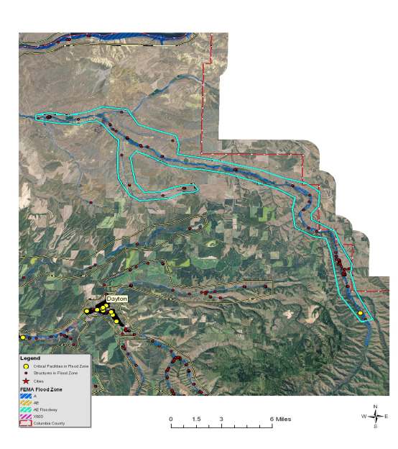
Structures and critical infrastructure in the Tucannon River drainage of Columbia County.
The Whetstone/Sorghum basin starts in the eastern and middle part of the county and empties into the Touchet River at Prescott. This watershed does not typically experience flash flooding due to mild elevational differences. Although the Whetstone/Sorghum basin did flood during the 1997 event, records show that this watershed is not highly prone to riverine flooding. There are 31 structures located in the Whetstone/Sorghum drainage FEMA-identified floodplain.
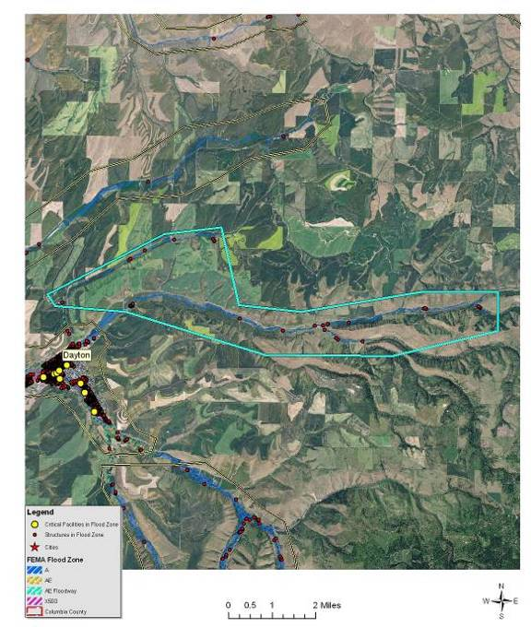
Structures and critical infrastructure in the Patit Creek drainage of Columbia County.
The Patit Creek basin, which is part of the Touchet River drainage, starts in the eastern portion of the county and runs predominantly westward. Patit Creek is extremely prone to flash flooding, particularly through Dayton, where the channel is restricted. During the 1996 and 1997 flood events, Patit Creek overtopped the channel at restricted areas between 1st and 2nd Streets, at the Patit Creek Bridge, at the 90-degree turn upstream of the Patit Creek Bridge, and at the area between the Patit Street and the Front Street Bridges in Dayton. There are 31 structures in the Patit Creek FEMA-identified floodplain outside of Dayton.
The Ayre basin area is west of the Town of Starbuck and drains north near Ayre Junction. Riverine and flash flooding has occurred in the Ayre watershed; however, neither type of event is common due to generally low flows.
The Waitsburg basin is on the southwesterly edge of Columbia County and drains into Coppi Creek in Walla Walla County south of the community of Waitsburg. This watershed does not typically experience flash flooding due mild elevational differences. Although the Waitsburg basin did incur minor damages during the 1997 flood event, records show that this watershed is not highly prone to riverine flooding.
The last basin is the Wenaha, which is located in the wilderness area on the southernmost tip of Columbia County. Due to the lack of population and potential impacts, little data is available for the Wenaha basin.
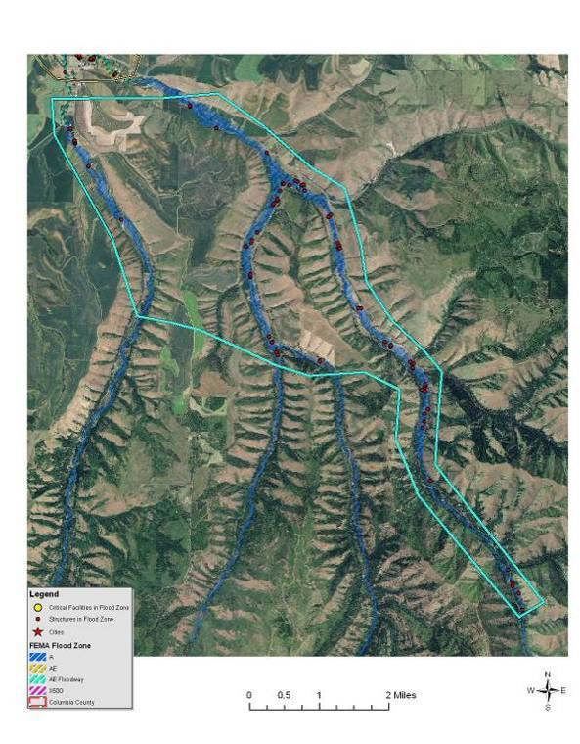 | 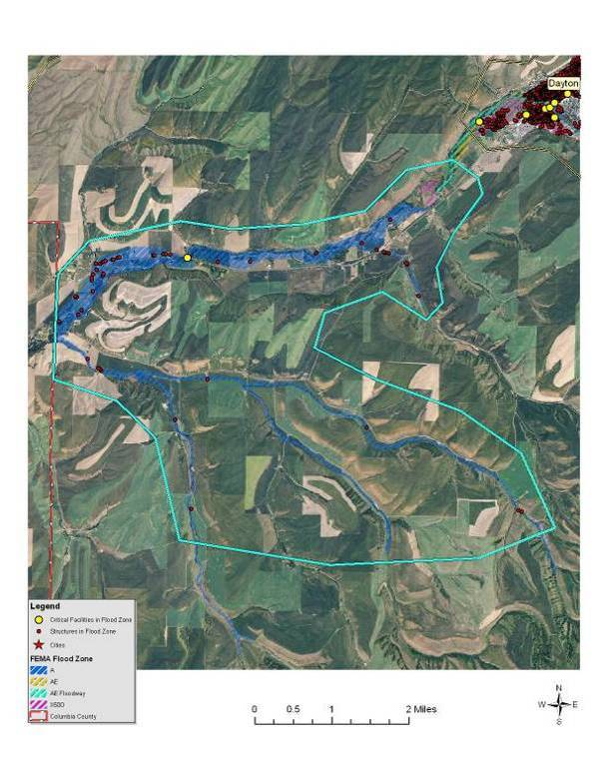
Structures in the East and South Forks of the Touchet River in Columbia County. | Structures and critical infrastructure in the Touchet River drainage west of Dayton in Columbia County.

Value of Resources at Risk
There are approximately 286 parcels within the FEMA-identified floodplains (100- and 500-year) in unincorporated areas of Columbia County, yielding a total improvement value of $19.9 million. According to Columbia County Emergency Management, there are currently no repetitive loss properties within Columbia County. The average damage to structures was estimated based on the parcel’s location as either completely within or out of the flood zone. The estimated value of contents is ½ the value of the improvements equating to an additional $9.9 million in potential losses. In reality, the damages will most likely not be equally distributed between buildings based on building materials, building location, and flood location. However, these estimates provide a basic approximation.
Critical infrastructure located within the identified floodplain for the unincorporated includes the Touchet River Bridge west of Dayton, the Patit Creek Bridge east of Dayton, the Tucannon Fish Hatchery, and the water well at the Tucannon Fish Hatchery.
Participation in the National Flood Insurance Program (NFIP) and subsequent adoption of the Uniform Building Codes, or more stringent local building codes, provide basic guidelines to communities on how to regulate development. When a county participates in the NFIP it enables property owners in the county to insure against flood losses. By employing wise floodplain management, a participating county can protect its citizens against much of the devastating financial loss resulting from flood disasters. Careful local management of development in the floodplains results in construction practices that can reduce flood losses and the high costs associated with flood disasters to all levels of government.
Table 5.5. NFIP Policy Statistics as of 12/31/09 in Columbia County
Community Name | Policies In-Force | Insurance In-Force | Written Premium In-Force | FIRM Effective Date | Floodplain Ordinance/ Manager | CRS Ranking
Columbia County (unincorporated) | 38 | $5,774,400 | $22,865 | 7/19/2000 | Yes/Yes | NA
Dayton | 59 | $7,019,700 | $20,676 | 7/19/2000 | Yes/Yes | NA
Starbuck | 9 | $855,800 | $7,235 | 7/19/2000 | Yes/Yes | NA
An important part of being an NFIP community is the availability of low cost flood insurance for those homes and businesses within designated flood plains, or in areas that are subject to flooding, but that are not designated as Special Flood Hazard Areas.
Overall participation by individuals and business in the NFIP appears to be low relative to the number of structures within the floodplain. Potential reasons are:
- A lack of knowledge about the existence of the availability of low cost flood insurance.
- Home and business owners unaware of their vulnerability to flood events.
- Current cost of insurance is prohibitive.
The first two reasons can be addressed through public education. The third could be addressed by all communities in the county taking advantage of the Community Rating System (CRS). To encourage communities to go beyond the minimum requirements and further prevent and protect against flood damage, the NFIP established the Community Rating System (CRS). To qualify for CRS, communities can do things like make building codes more rigorous, maintain drainage systems, and inform residents of flood risk. In exchange for becoming more flood-ready, the CRS community's residents are offered discounted premium rates. Based on your community's CRS ratings, you can qualify for up to a 45% discount of your annual flood insurance premium.

Earthquake
Based on historical records, Columbia County has not experienced any seriously damaging earthquakes in recorded history. Several distant earthquakes produced intensities strong enough to be felt in southeastern Washington, but only two earthquakes epicenters, one in 1893 and another in 1936, were recorded for the region. Both of these earthquakes were rated as a VII on the Modified Mercalli intensity scale and produced only very slight property damages such as broken dishes and cracked plaster.
Communities in Columbia County can expect some structural failure of older multistory unreinforced masonry buildings as a result of even lower intensity earthquakes. Cornices, frieze, and other heavy decorative portions of these types of structures may fail. The potential impacts of a substantial earthquake event are highly variable. Many of the structures and infrastructure throughout the county may not incur any damages at all; however, damage to roads, bridges, unreinforced masonry, chimneys, foundations, water lines, and many other components are at risk. Fires can also be a secondary hazard to structures sustaining earthquake damage.
Because structural damage by earthquakes is typically not complete destruction, but rather tends to be subtle cracking or settling that undermines the stability of the structure. These types of repairs can be very costly. Additionally, changes to the water table or even the topography can significantly impact local municipal and private wells and could result in the loss of traditional land uses.
There is only one known fault line in Columbia County. This fault runs from the southwestern corner in a northeastward direction into Garfield County and is not currently active. Peak ground acceleration (pga) in percent g is a measure of the ground motion, which decreases, the further you are from the earthquake. The USGS Shaking Hazard maps for the United States are based on current information about the rate at which earthquakes occur in different areas and on how far strong shaking extends from quake sources. Colors on the map show the levels of horizontal shaking that have a 1 in 10 chance of being exceeded in a 50-year period. Shaking is expressed as a percentage of “g” (g is the acceleration of a falling object due to gravity). This map is based on seismic activity and fault-slip rates and takes into account the frequency of occurrence of earthquakes of various magnitudes. Locally, this hazard may be greater than that shown, because site geology may amplify ground motions. As seen in Figure 5.7, much of northeastern half of Columbia County has 10% chance of exceeding a 6-7% pga in the next 50 years. This probability trends upwards to a 7-8% pga on the southwestern half of the County. No specific jurisdictions or special districts were identified as having differing issues or levels of risk associated with this hazard.
Figure 5.7. Regional Earthquake Probability Map.
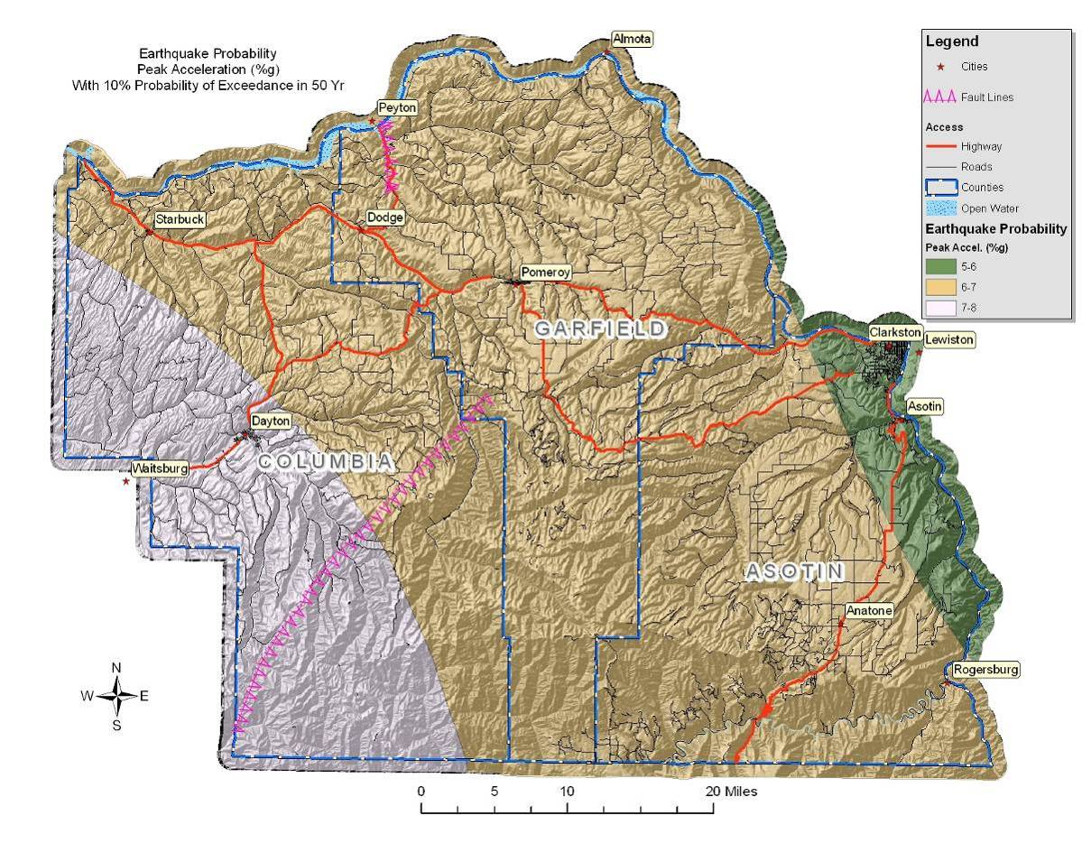
Past events suggest that an earthquake in the Columbia County area would cause little to no damage. Nonetheless, severity can increase in areas that have softer soils, such as unconsolidated sediments. Damage would be negligible in buildings of good design and construction; slight to moderate in well-built ordinary structures; and considerable in poorly built, old, or badly designed structures.

Value of Resources at Risk
Unreinforced masonry (URM) structures and unreinforced chimneys of homes will likely be damaged in the event of an earthquake. Damaged or collapsed chimneys could result in the secondary hazard of fire. Nonstructural damage caused by falling and swinging objects may be considerable after any magnitude earthquake. Damage to some older, more fragile bridges and land failure causing minor slides along roadways may isolate some residents.
There are no known publicly accessible unreinforced masonry structures within the unincorporated Columbia County. The number and value of unreinforced masonry homes or homes with masonry chimneys is unknown.

Landslide
To date, there is no recorded history of major landslides occurring in Columbia County. Nevertheless, there are some areas in Columbia County that have specific landslide concerns. Areas that are generally prone to landslides are:
- On existing landslides, old or recent
- On or at the base or top of slopes
- In or at the base of minor drainage hollows
- At the base or top of an old fill slope
- At the base or top of a steep cut slope
The majority of the landslide potential in Columbia County occurs in the more remote areas of the Blues Mountains on the southern end of the County. Most of the landslide damage potential occurs along the Touchet River drainage in the front country due to the location of numerous homes and roadways at the base of the steeper slopes rising out of the river beds. The probability of occurrence of major, high velocity landslide hazard events, including those caused by severe local storms, is low.
February 1996 – Stafford Act disaster assistance totalled $113 million and Small Business Administration disaster loans approved $61.2 million. The National Weather Service, Seattle Forecast Office considers this storm one of the top 10 weather events in Washington during the 20th Century. Near-record snowfall in January followed by warm, heavy rain, mild temperatures and snowmelt in February caused flooding, mudflows and landslides throughout the state. The storm caused three deaths, and 10 people were injured. Landslides damaged or destroyed nearly 8,000 homes, and closed traffic along major highways for several days. Damage from all causes throughout the Pacific Northwest was at least $800 million. The landslide that created the most significant impact blocked Interstate 5 and the state’s main north-south railroad tracks three miles north of Woodland, Cowlitz County. The initial slide on February 8 blocked northbound lanes of I-5; a second, larger slide covered all lanes of the freeway as well as the railroad tracks to the west. It took crews until February 19 to fully reopen the interstate. The highest concentration of landslides occurred at the northwest edge of the Blue Mountains near Walla Walla. The main areas affected were the Mill Creek, Blue Creek, Touchet, Tucannon, and Walla Walla drainages. Debris flows were most numerous on open, grassy hillsides. In the Mill Creek area, debris flows destroyed seven vehicles and five homes. Similar occurrences of flooding and landslides took place in 1931 and 1964.
The majority of the populated areas and infrastructure in Columbia County occurs in the rolling hills of the Columbia Basin. There is a moderate probability of small slides occurring on slopes ranging from 5-35%. This type of slide is common on the eyebrows of hills, especially where there has been soil disturbance. Generally, these low angle slides will have a low velocity and will not impact structures or infrastructure.
Soil factors that increase the potential for landslide are soils developed from parent materials high in schist and granite, and soils that are less permeable containing a resistive or hardpan layer. These soils tend to exhibit higher landslide potential under saturated conditions than do well drained soils. To determine the high-risk soils in Columbia County, the NRCS State Soils Geographic Database (STATSGO) layer was used to identify the location and characteristics of all soils in the County. The specific characteristics of each major soil type within the County were reviewed. According to this database, it was determined that the soils in Columbia County generally are not developed from schist and granitic parent materials, indicating that landslide potential is primarily due to factors associated with gravity and slope.
To portray areas of probable landslide risk due to slope related factors, slope models were used to identify areas of low, moderate and high risk. This analysis identified the low risk areas as slopes in the range of 20°-25° (36-46%), moderate as 26°-30° (48-60%) and high risk as slopes in the range of 31°-60° (60-173%). Slopes that exceeded 60° (173%) were considered low risk due to the fact that sliding most likely had already occurred relieving the area of the potential energy needed for a landslide. From the data layer created by this analysis, it is possible to depict areas of risk and its proximity to development and human activity. With additional reconnaissance, the areas of high risk were further defined by overlaying additional data points identifying actual slide locations, thus improving the resolution by specifically identifying the highest risk areas. This method of analysis is similar to a method developed by the Clearwater National Forest in north central Idaho.
Figure 5.8. Columbia County Landslide Prone Landscapes Map.
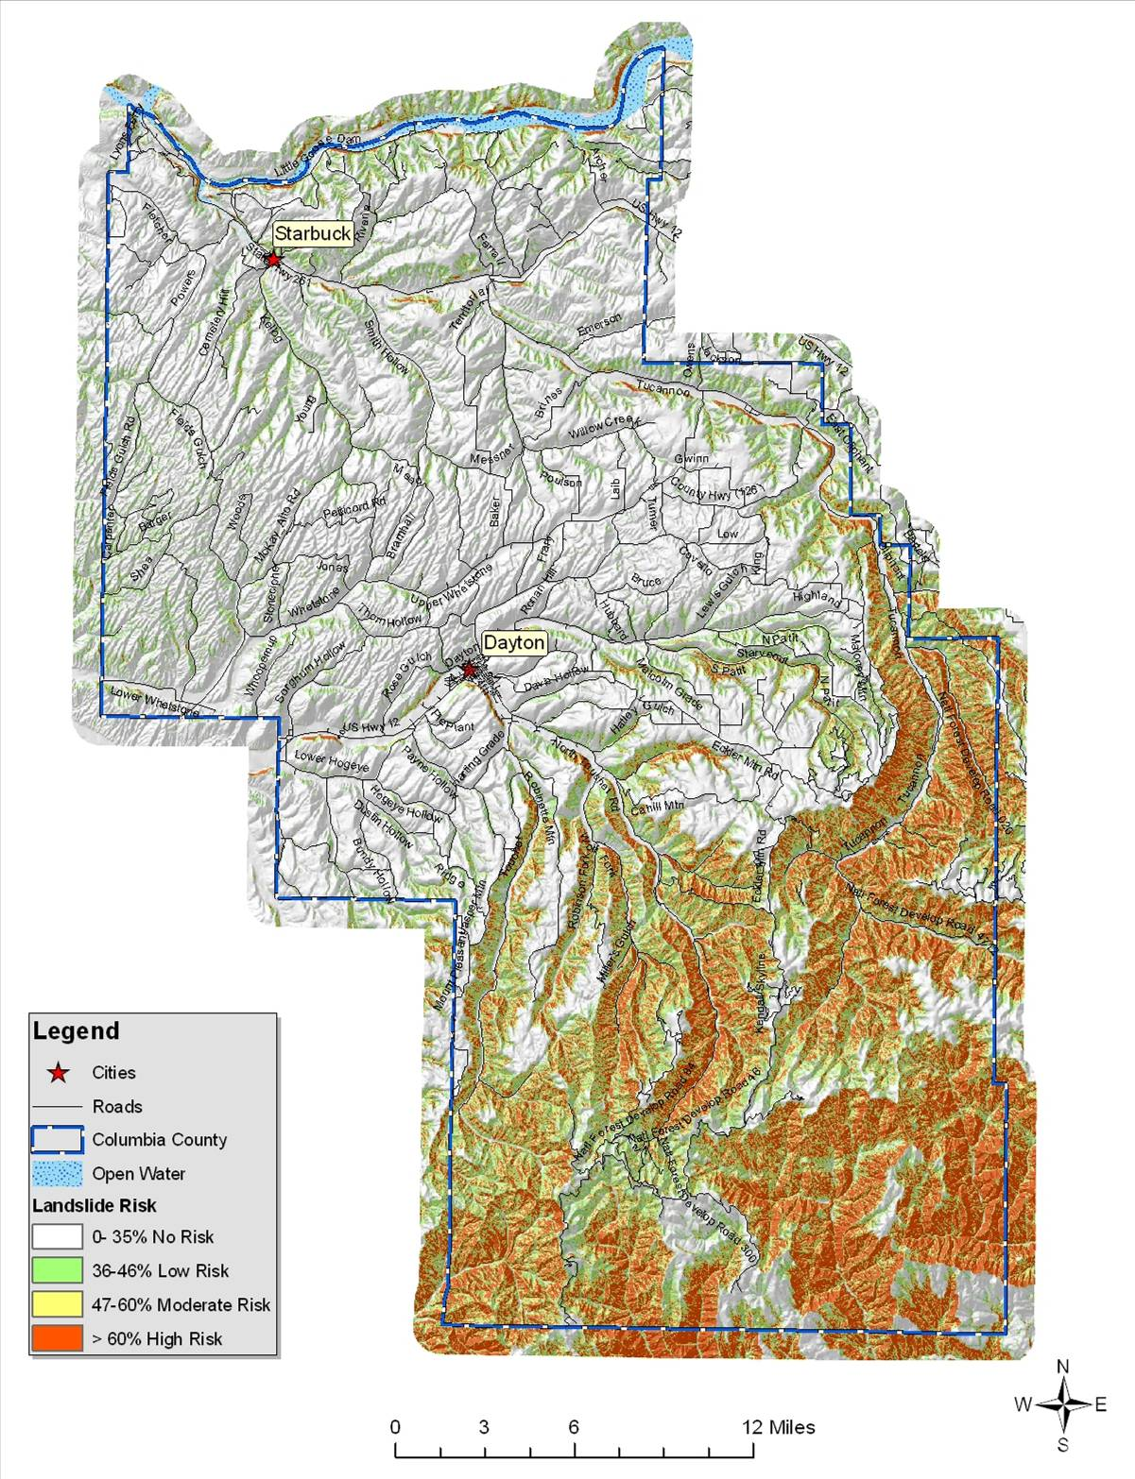
While a large portion of Columbia County is at high risk to landslides, most of this area occupies the rural mountainous regions. Home and business development in the County has been mainly on lands not at significant risk to landslides.
Much of the populated areas in Columbia County are at risk to flooding, which often results in damaging landslides. Flash floods typically carry large amounts of debris, silt, and rocks that are deposited in downstream floodplains. Additionally, soil saturation ensuing from prolonged periods of rain or flooding can lead to slope instability. Cut and fill slopes, even those well outside of the flood plain, are particularly at risk to slides and/or slumping as a result of soil saturation.
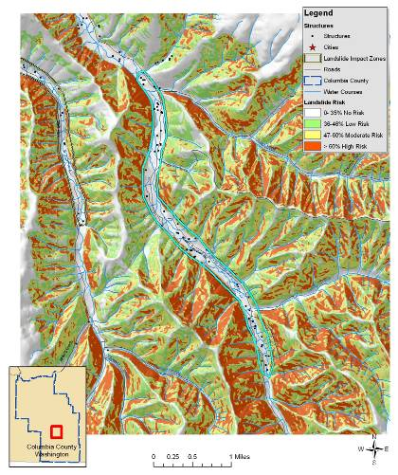
North Touchet Landslide Impact Zone
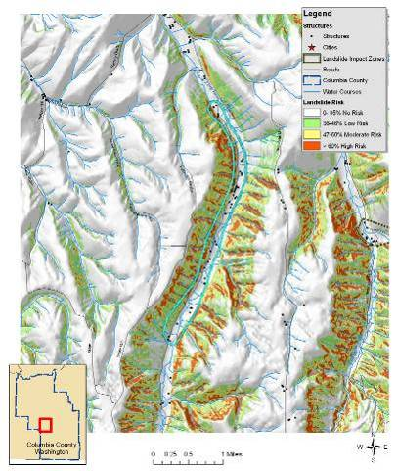
South Touchet Landslide Impact Zone
The North Touchet, South Touchet, and Wolf Fork Landslide Impact Zone encompass small population clusters in the Touchet River watershed. The Tucannon Landlside Impact Zone occurs near the eastern border of the county in a populated valley created by the Tucannon River. In addition to the residences, these Impact Zones may affect the North Touchet Road, South Touchet Road, the Wolf Fork Road, and the Tucannon Road.
Many of the slopes and hillsides in these impact zones are comprised by material deposited by past landslides. In fact, much of the lower slopes near the valley floors are alluvial fans created by sediment being carried downstream and deposited at the mouths of the numerous small drainages. The presence of this material indicates the historic occurrence of high-energy, short duration floods and debris flows in these chutes in response to severe climatic conditions, such as thunderstorms and rain-on-snow events. These events are historically infrequent, with recurrence cycles on the order of years to decades. However, they can result in significant damage to buildings and infrastructure, disrupt travel, reduce water quality, and jeopardize safety.
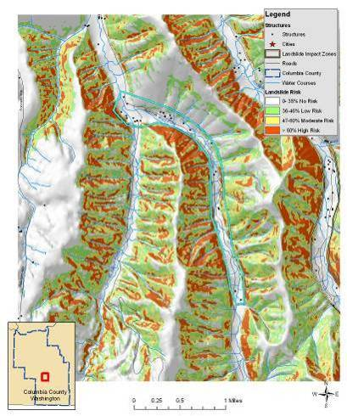
Wolf Fork Landslide Impact Zone
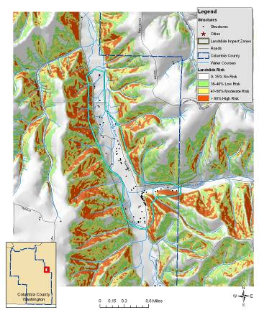
Tucannon Landslide Impact Zone
The largest landslides typically occur where human development or disturbance has exposed landslide-prone sediments to steep topography. Today, initiation and reactivation of landslides is closely tied to unusual climatic events and land-use changes. Even small landslide activity on the upper slopes can transform into high-energy debris flows that endanger roads, buildings, and people below. Landslide debris is highly unstable when modified through natural variations in precipitation, artificial cuts, fills, and changes to surface drainage and ground water.
Wildfires in theses impact zones could cause a domino effect of multiple hazards. Higher intensity fires not only remove most of the vegetation, but they also cause soils to become hydrophobic or water repellent for a period of time after the fire. This combination leads to unusually high runoff after rain showers or during the spring runoff season. As streams and rivers begin to reach and exceed flood stage, bank failures and channel migration are common. Road building and other soil disturbances tend to exacerbate this effect leading to even more severe land and soil slides.

Value of Resources at Risk
The cost of cleanup and repairs of roadways is difficult to estimate due to the variable circumstances with each incident including size of the slide, proximity to a State or County shop, and whether the slide occurred on the cut slope or the fill slope. Other factors that could affect the cost of the damage may include culverts, streams, and removal of debris. This type of information is impossible to anticipate; thus, no repair costs for damaged roadways have been estimated.
Table 5.6. Landslide Impact Zones in Columbia County.
Landslide Impact Zone | Number of Structures | Value of Structures at Risk
North Touchet | 56 | $3,897,600
South Touchet | 38 | $2,644,800
Upper Tucannon | 77 | $5,359,200
Wolf Fork | 24 | $1,670,400
Total | 195 | $13,572,000
Slides in the identified impact zones are more likely to be larger and more damaging as weaknesses in the underlying rock formations give way. Although infrequent, this type of slide has the potential to not only block, but destroy road corridors, dam waterways, and demolish structures. The highest risk areas in these impact zones are typically at the higher elevations where slopes exceed 25% grade. There are numerous homes in each of these impact zones; however, for the most part, they are widely scattered. Thus, single slide events will not likely impact the entire population, but rather individual structures. Much of the North Touchet Road, South Touchet Road, and Wolf Fork Road as well as sections of the Tucannon Road, could be at risk from slides initiating in these impact zones.

Severe Weather
Severe weather in Columbia County ranges from the commonly occurring thunderstorms to hail, tornadoes, high winds, drought, dense fog, lightning, and snow storms.
All of Columbia County is at risk to severe winter weather events and there is a high probability of their continued occurrence in this area. Due to topography and climatologic conditions, the higher mountainous areas are often the most exposed to the effects of these storms. Normally the mountainous terrain and the north/south orientation of the Cascades tend to isolate severe storms into localized areas of the County. For example, higher elevations will receive snowfall, while the valley areas may not. Periodically though, individual storms can generate enough force to impact the entire County at one time. From high winds to ice storms to freezing temperatures, there are all types of winter storms that take place during the course of any given year. Winter conditions can change very rapidly. It is not uncommon to have a snowstorm at night with sunshine the next day. Winter storms with heavy snow, high winds, and/or extreme cold can have a considerable impact on Columbia County; however, most residents are well accustomed to the severe winter conditions in this part of Washington. Power outages and unplowed roads are a frequent occurrence throughout many parts of the County, but most residents are prepared to handle the temporary inconvenience.
Commonly, heavy snow accumulations are the cause of disruptions to normal commuting activities (delays and inability to plow roads and driveways). When coupled with extreme cold weather, severe winter storms have a detrimental impact on residents in Columbia County, particularly the senior population. Severe winter storms also have the potential to cause large losses among livestock and wildlife. Animal losses are usually the result of dehydration rather than cold or suffocation.
Snow loads on roofs, ice-slides off of roofs onto vehicles or other buildings, and damaged frozen pipes are also potential hazards associated with winter weather. These events represent a significant hazard to public health and safety, a substantial disruption of economic activity, and a constant threat to structures during the winter months. An average of at least two severe storms is anticipated each winter in Columbia County. Columbia County is not considered to be one of the counties most vulnerable to winter storms and blizzards in Washington according to the Washington State Hazard Mitigation Plan.
January 13, 1950 “The January 1950 Blizzard” - On this date, 21.4 inches of snow fell in Seattle, the second greatest 24-hour snowfall recorded. The snowfall was accompanied by 25-40 mph winds. The storm claimed 13 lives in the Puget Sound area. January had 18 days with high temperatures of 32 degrees or lower. The winter of 1949-50 was the coldest winter on record in Seattle, with an average temperature of 34.4 degrees. Eastern Washington, North Idaho, and parts of Oregon also were paralyzed by the snow – some lower-elevation snow depths reached nearly 50 inches and temperatures plunged into minus teens and twenties. Several dozen fatalities occurred.
1962 Columbus Day Wind Storm - The top weather event in Washington during the 20th Century, according to the National Weather Service, Seattle Forecast Office. This storm is the greatest windstorm to hit the Northwest since weather recordkeeping began in the 19th century, and called the “mother of all wind storms” in the 1900s. All windstorms in the Northwest are compared to this one. The Columbus Day Storm was the strongest widespread non-tropical windstorm to strike the continental U.S. during the 20th century, affecting an area from northern California to British Columbia. The storm claimed seven lives in Washington State; 46 died throughout the impacted region. One million homes lost power. More than 50,000 homes were damaged. Total property damage in the region was estimated at $235 million (1962 dollars). The storm blew down 15 billion board feet of timber worth $750 million (1962 dollars); this is more than three times the timber blown down by the May 1980 eruption of Mount St. Helens, and enough wood to replace every home in the state. Gusts of 88 miles per hour were recorded at Tacoma before power was lost to the recording stations.
February 1996 – Federal Disaster #1100. Stafford Act disaster assistance provided was $113 million. Small Business Administration disaster loans approved totaled $61.2 million. Heavy rainfall, mild temperatures and snowmelt caused flooding and mudslides in Adams, Asotin, Benton, Clark, Columbia, Cowlitz, Garfield, Grays Harbor, King, Kitsap, Kittitas, Klickitat, Lewis, Lincoln, Pierce, Skagit, Skamania, Snohomish, Spokane, Thurston, Wahkiakum, Walla Walla, Whitman and Yakima counties, and the Yakama Indian Reservation. This storm caused major flooding on rivers of western and southeast Washington. Mudslides occurred throughout the state. Three deaths, 10 people injured. Nearly 8,000 homes damaged or destroyed. Traffic flow both east and west, and north and south along major highways was shut down for several days. Damage throughout the Pacific Northwest estimated at $800 million.
December 1996 - January 1997 – Federal Disaster #1159. Stafford Act disaster assistance provided was $83 million. Small Business Administration loans approved totaled 31.7 million. Saturated ground combined with snow, freezing rain, rain, rapid warming and high winds within a five-day period produced flooding and landslides. Impacted counties – Adams, Asotin, Benton, Chelan, Clallam, Clark, Columbia, Cowlitz, Douglas, Ferry, Franklin, Garfield, Grant, Grays Harbor, Island, Jefferson, King, Kitsap, Kittitas, Klickitat, Lewis, Lincoln, Mason, Okanogan, Pacific, Pend Oreille, Pierce, San Juan, Skagit, Skamania, Snohomish, Spokane, Stevens, Thurston, Walla Walla, Whatcom, and Yakima. Twenty-four deaths; $140 million (est.) in insured losses; 250,000 people lost power. High winds and ice contributed to the repeated and extended power outages to rural power customers in Garfield, Asotin, and Columbia Counties. This storm also resulted in numerous rural residences being cutoff from any emergency service response for several days, due to drifting snow. The accumulations aggravated by rain, drifting snow, and ice in roof drains caused excessive weight and the collapse of structures.
March 2, 2009 - President Obama declared that a major disaster exists in the State of Washington. This declaration made Public Assistance requested by the Governor available to State and eligible local governments and certain private nonprofit organizations on a cost-sharing basis for emergency work and the repair or replacement of facilities damaged by the severe winter storm and record and near record snow in Clallam, Clark, Columbia, Cowlitz, Garfield, Grays Harbor, Island, Jefferson, King, Klickitat, Lewis, Lincoln, Mason, Pacific, Pend Oreille, Skagit, Skamania, Snohomish, Spokane, Stevens, Thurston, Wahkiakum, Walla Walla, and Whatcom Counties. This declaration also made emergency protective measures (Category B), including snow removal assistance, under the Public Assistance program, requested by the Governor, available in Adams, Asotin, Benton, Chelan, Clallam, Columbia, Cowlitz, Franklin, Grays Harbor, Jefferson, King, Kittitas, Klickitat, Lewis, Mason, Pacific, Pierce, Skagit, Skamania, Snohomish, Spokane, Thurston, Wahkiakum, Walla Walla, Whatcom, Whitman, and Yakima for any continuous 48-hour period during or proximate to the incident period. Columbia County reported $8.38 per capita impact from this event.
Due to their relative frequency and minimal severity, severe thunderstorms are not well documented in Columbia County. Their impacts are fairly limited and do not significantly affect the communities enough to declare a disaster. The secondary impacts of thunderstorms, floods, are emphasized within the flood chapter of this document. Columbia County is considered to be one of the counties most vulnerable to severe thunderstorms according to the Washington State Hazard Mitigation Plan. Areas most vulnerable to this type of storm are those subject to a strong southwesterly flow of moist, unstable air that generates strong, sometimes violent thunderstorms with one or more of the following characteristics: strong damaging winds, large hail, waterspouts, or tornados.
Hail can occur in any strong thunderstorm, which means hail is a threat everywhere. Hail is precipitation that is formed when updrafts in thunderstorms carry raindrops upward into extremely cold areas of the atmosphere. Large hail stones can fall at speeds faster than 100 miles per hour. Hail damage in Washington is very small in comparison with damage in areas of the central part of the United States. Often the hail that occurs does not grow to a size larger than one-half inch in diameter, and the areas affected are usually small. Quite often hail comes during early spring storms, when it is mostly of the small, soft variety with a limited damaging effect. Later, when crops are more mature and more susceptible to serious damage, hail occurs in widely scattered spots in connection with summer thunderstorms. The potential impacts of a severe hail storm in Columbia County include crop damage, downed power lines, downed or damaged trees, broken windows, roof damage, and vehicle damage. Hail storms can, in extreme cases, cause death by exposure. The most common direct impact from ice storms to people is traffic accidents. Over 85% of ice storm deaths nationwide are caused by traffic accidents. Hail storms also have the potential to cause losses among livestock. The highest potential damage from hail storms in Columbia County is the economic loss from crop damage. Even small hail can cause significant damage to young and tender plants and fruit. Trees can also be severely damaged by hail as was seen in the 1996 ice storm near Spokane, Washington.
Windstorms are frequent in Columbia County and they have been known to cause substantial damage. Under most conditions, the County’s highest winds come from the south or southwest. Due to the abundance of agricultural development in Columbia County, crop damage due to high winds can have disastrous effects on the local economy. In the case of extremely high winds, some buildings may be damaged or destroyed. Wind damages will generally be categorized into four groups: 1) structure damage to roofs, 2) structure damage from falling trees, 3) damage from wind blown dust on sensitive receptors, or 4) wind driven wildfires. Structural injury from damaged roofs is not uncommon in Columbia County. Structural damage from falling trees is also relatively common. Many homeowners have planted ornamental trees for shade and windbreak protections. However, many of these trees are located near, and upwind of homes putting them at risk to falling trees which could cause substantial structural damage and potentially put lives at risk. Airborne particulate matter increases during high wind events. When this occurs, sensitive receptors including the elderly and those with asthma are at increased risk to complications. The National Weather Service defines high winds as sustained winds of 40 mph or gusts of 58 mph or greater, not caused by thunderstorms, expected to last for an hour or more. Areas most vulnerable to high winds are those affected by a strong pressure difference from deep storms originating over the Pacific Ocean; an outbreak of very cold, Arctic air originating over Canada; or air pressure differences between western and eastern Washington that primarily affect the Columbia River Gorge, Cascade Mountain passes, ridges and east slopes, and portions of the Columbia Basin. Columbia County is considered to be one of the most vulnerable to high winds in Washington State according to the Washington State Hazard Mitigation Plan.
Columbia County and the entire region are at increased risk to wildfires during high wind events. Ignitions can occur from a variety of sources including downed power lines, lightning, or arson. Once ignited, only wildfire mitigation efforts around the community and scattered homes will assist firefighters in controlling a blaze. Details about wildfire mitigation are discussed in the wildland fire annexes of this Multi - Hazard Mitigation Plan.
A tornado is formed by the turbulent mixing of layers of air with contrasting temperature, moisture, density, and wind flow. This mixing accounts for most of the tornadoes occurring in April, May, and June, when cold, dry air from the north or northwest meets warm, moister air moving up from the south. If this scenario was to occur and a major tornado was to strike a populated area in Columbia County, damage could be widespread. Businesses could be forced to close for an extended period, and routine services such as telephone or power could be disrupted. The National Weather Service defines a tornado as a violently rotating column of air that contacts the ground; tornados usually develop from severe thunderstorms. Areas most vulnerable to tornado are those subject to severe thunderstorms or those with a recurrence rate of 5 percent or greater, meaning the County experiences one damaging severe thunderstorm event at least once every 20 years.
According to the Tornado Project, there have only been two tornadoes reported for Columbia County between 1880 and 2000. An F2 tornado occurred in March of 1966 and a an F1 tornado touched down in January of 2000.

Value of Resources at Risk
It is difficult to estimate the cost of potential winter storm damages to structures and the economy in Columbia County. Damage to roofs by heavy snow accumulations depends on the moisture content of the snow and the structural characteristics of the buildings. In general, snow in this region tends to have low moisture content because of the low temperatures and arid environment. However, heavy snow is not uncommon. Frozen water pipes are the most common damage to residential and business structures. Older homes tend to be at a higher risk to frozen water pipes than newer ones. Snow plowing in Columbia County occurs from a variety of departments and agencies. The state highways are maintained by the State of Washington. Plowing of county roads is done by the Columbia County Public Works Department and the road departments of the individual cities. Private landowners are responsible for maintaining their own driveways or other private roads. Utility supplies are impacted during severe winter storms as power is lost on a regional basis. This has a two-fold impact on Columbia County residents as not only is power cut to homes and businesses, but primary heating is lost for many residents. Gas furnaces and wood stoves supplement electrical heating, but with wood heating the senior population is at a disadvantage. Emergency response to severe winter storms includes site visits by police or fire department personnel, opening of shelters, or assistance with shopping, medical attention, and communications. The economic losses caused by severe winter storms may frequently be greater than structural damages. Employees may not be able to travel to work for several days and businesses may not open. Damages are seen in the form of structural repair and loss of economic activity. Columbia County schools are occasionally closed during and right after a severe winter storm because of cold temperatures and snow covered roads.
Thunderstorms do occur within Washington affecting all counties, but usually are localized events. Their impacts are fairly limited and do not significantly affect the communities enough to declare a disaster. The loss potential from flooding that results from severe thunderstorms can be significant in Columbia County.
Although the financial impacts of hail can be substantial and extended, accurately quantifying these impacts is problematic. Hail typically causes direct losses to structures and other personal property as well as to the vast forestlands and extensive agricultural development in Columbia County. The most significant losses are most clearly seen in the agriculture sectors of the County’s economy. Potential losses to agriculture can be disastrous. They can also be very localized; thus, individual farmers can have significant losses, but the event may not drastically affect the economy of the County. Furthermore, crop damage from hail will also be different depending on the time of year and the type of crop. Most farmers carry insurance on their crops to help mitigate the potential financial loss resulting from a localized hail storm. Federal and state aid is available for County’s with declared hail disasters resulting in significant loss to local farmers as well as the regional economy. Homeowners in Columbia County rarely incur severe damage to structures (roofs); however, hail damage to vehicles is not uncommon. The damage to vehicles is difficult to estimate because the number of vehicles impacted by a specific ice storm is unknown. Additionally, most hail damage records are kept by various insurance agencies.
It is difficult to estimate potential losses in Columbia County due to windstorms and tornadoes. Construction throughout the County has been implemented in the presence of high wind events, and therefore, the community is at a higher level of preparedness to high wind events than many other areas experiencing lower average wind speeds.
We have estimated losses based on wind and tornado damage as follows:
- 3% of the buildings damaged causing 50% of value loss (loss could be from downed or damaged trees, damaged outbuildings, damaged fences/poles, damage to siding, damaged landscaping etc.)
- 5% of the buildings received damage to roof (requiring replacement of roof equaling $3,000)
Damages associated with sensitive receptor irritation have not been estimated. We have also not estimated the potential for a large scale wildfire event associated with high winds. Based on the data provided by the County, there are 3,911 total structures in Columbia County with a total value of approximately $272 million. Using the criteria outlined above an estimate of the impact of high winds on in the County has been made. The potential wind and tornado damage to all structures is estimated at approximately $4.1 million. The estimated damage to roofs is approximately $586,650.
Power failure often accompanies severe storms. More rural parts of the County are sometimes better prepared to deal with power outages for a few days; however, prolonged failure, especially during cold winter temperatures can have disastrous effects. All communities should be prepared to deal with power failures. Community shelters equipped with alternative power sources will help local residents stay warm and prepare food. A community-based system for monitoring and assisting elderly or disabled residents should also be developed. Generally, the utility companies maintain a list of the special needs populations that may be at risk during an extended power outage. All households should maintain survival kits that include warm blankets, flashlights, extra batteries, nonperishable food items, and clean drinking water.

Wildland Fire
The Columbia County Community Wildfire Protection Plan provides a comprehensive analysis of the wildland fire risks and recommended protection and mitigation measures for all jurisdictions in Columbia County. The information in the “Wildland Fire” sections of this Columbia County Annex is excerpted from that more detailed document.
Vegetative structure and composition in Columbia County is closely related to elevation, aspect, and precipitation. Relatively mild and dry environments characterize the undulating topography of the region which transitions from the Snake River valley riparian plant communities to the rangeland ecosystems that characterize the vast majority of the land area in Columbia County. Forested communities extend this transition as elevation increases, soils change, and conditions favor forest tree species. Forests contain high fuel accumulations that have the potential to burn at moderate to high intensities. Highly variable topography coupled with dry, windy weather conditions typical of the region is likely to create extreme fire behavior.
The transition between developed agricultural land and timberlands occurs somewhat abruptly, usually along toe slopes or distinct property boundaries. At higher elevation mountainous regions, moisture becomes less limiting due to a combination of higher precipitation and reduced solar radiation. Vegetative patterns shift from forested communities dominated by ponderosa pine, western larch, grand fir, and Douglas-fir at the lower elevations to lodgepole pine and subalpine fir at the higher elevations. Engelmann spruce is found in moist draws and frost pockets. These forested conditions possess a greater quantity of both dead and down fuels as well as live fuels. Rates of fire spread tend to be lower than those in the grasslands; however, intensities can escalate dramatically, especially under the effect of slope and wind. These conditions can lead to control problems and potentially threaten lives, structures and other valued resources.
As elevation and aspect increase available moisture, forest composition transitions to moister habitat types. Increases in moisture keep forest fuels unavailable to burn for longer periods during the summer. This increases the time between fire events, resulting in varying degrees of fuel accumulation. When these fuels do become available to burn, they typically burn in a mosaic pattern at mid elevations, where accumulations of forest fuels result in either single or group tree torching, and in some instances, short crown fire runs. At the highest elevations, fire events are typically stand replacing, as years of accumulation fuel large, intense wildfires.
Insects and disease can cause widespread mortality of forest stands in a very short amount of time. Mountain pine beetle populations have continued to increase at epidemic levels throughout Washington State; however, mortality increases are most pronounced in Eastern Washington. Ponderosa pine and lodgepole pine seem to be the most affected species at all elevations in Columbia County. The occurrence of ips beetles, Douglas-fir bark-beetle, Douglas-fir tussock moth, and root disease have also been recorded in Eastern Washington (Washington State Department of Natural Resources 2006). Insects and disease often focus and cause the most mortality in forest stands that are overcrowded or otherwise stressed by drought, recent fires, or other factors. Large areas of dead trees are a significant fire hazard. Oftentimes, dry, dead needles hang on the killed trees for several years making them prime for a potential ignition and subsequent crown fire. Thinning overcrowded stands can help reduce stress on individual trees allowing them to better withstand insect attacks. Planting of appropriate species for the site and continual management can also help ward off future outbreaks.
Many lower elevation forested areas throughout Columbia County are highly valued for their scenic qualities as well as for their proximity to travel corridors. These attributes have led to increased recreational home development and residential home construction in and around forest fuel complexes. The juxtaposition of highly flammable forest types and rapid home development will continue to challenge management of wildland fires in the wildland-urban interface.
The slight to undulating topography and moisture availability across much of Columbia County facilitates extensive farming operations. Agricultural fields infrequently serve to fuel a fire after curing; burning in much the same manner as consistent low grassy fuels. Fires in grass and rangeland fuel types tend to burn at relatively low intensities, with moderate flame lengths and only short-range spotting. Suppression resources are generally quite effective in such fuels. Homes and other improvements can be easily protected from the direct flame contact and radiant heat through adoption of precautionary measures around the structure. Although fires in these fuels may not present the same control problems as those associated with large, high intensity fires in timber fuel types, they can cause significant damage if precautionary measures have not taken place prior to a fire event. Wind driven fires in these short grass fuel types spread rapidly and can be difficult to control. During extreme drought and pushed by high winds, fires in grassland fuel types can exhibit extreme rates of spread, thwarting suppression efforts.
The Tucannon and Touchet River drainages are a patch-work of dry ponderosa pine and Douglas-fir woodlands that, in many areas, have began suffering from forest health issues. In addition, tree regeneration is resulting in multistoried conditions with abundant ladder fuels. During pre-settlement times, much of Columbia County was characterized by low intensity fires due to the relatively light fuel loading, which mostly consisted of small diameter fuels. Frequent, low intensity fires generally kept stands open; free of fire intolerant species and promoted seral species such as ponderosa pine as well as larger diameter fire resistant Douglas-fir. In some areas, low intensity fires stimulated shrubs and grasses, maintaining vigorous browse and forage. The shrub layer could either inhibit or contribute to potential fire behavior, depending on weather and live fuel moisture conditions at the time of the burn.
In general, natural fires in the Tucannon and Touchet River drainages start high in elevation and move downhill. As fires move down in elevation, they encounter drier and flashier fuels in the lower elevations. Rolling embers and spot fires are a common method of downhill fire spread. Spot fires ignited on slopes trigger uphill runs that throw more spot fires, expanding the downward fire progression. Modifying fuels to reduce the likelihood of torching and crowning trees will in turn reduce the likelihood of spot fires. Human caused fires, on the other hand tend to ignite at the bottom of the draws, near the abundant recreational and development sites and then spread rapidly uphill.
Increased activities by pathogens will continue to increase levels of dead and down fuel, as host trees succumb to insect attack and stand level mortality increases. Overstocked, multi-layered stands and the abundance of ladder fuels lead to horizontal and vertical fuel continuity. These conditions, combined with an arid and often windy environment, can encourage the development of a stand replacing fire. These fires can burn with very high intensities and generate large flame lengths and fire brands that can be lofted long distances. Such fires present significant control problems for suppression resources, often developing into large, destructive wildland fires.
A probability that needs to be planned for is the likelihood of extended spot fires. Large fires may easily produce spot fires from ½ to 2 miles away from the main fire. How fire suppression forces respond to spot fires is largely dependent upon the fuels in which they ignite. Stands of timber that are managed for fire resilience are much less likely to sustain torching and crowning behavior that produces more spot fires. The objective of fuel reduction thinning is to change the fuels in a way that will moderate potential fire behavior. If fire intensity can be moderated by vegetation treatments, then ground and air firefighting resources can be much more effective.
Fire was once an integral function of the majority of ecosystems in southeastern Washington. The seasonal cycling of fire across the landscape was as regular as the July, August and September lightning storms plying across the canyons and mountains. Depending on the plant community composition, structural configuration, and buildup of plant biomass, fire resulted from ignitions with varying intensities and extent across the landscape. Shorter return intervals between fire events often resulted in less dramatic changes in plant composition. The fires burned from 1 to 47 years apart, with most at 5- to 20-year intervals. With infrequent return intervals, plant communities tended to burn more severely and be replaced by vegetation different in composition, structure, and age. Native plant communities in this region developed under the influence of fire, and adaptations to fire are evident at the species, community, and ecosystem levels. Fire history data (from fire scars and charcoal deposits) suggest fire has played an important role in shaping the vegetation in the Columbia Basin for thousands of years.
Detailed records of fire ignitions and extents have been compiled by the larger land management agencies in Columbia County including the Washington Department of Natural Resources and United States Forest Service. Using this data on past fire extents and fire ignition data, the occurrence of wildland fires in the region of Columbia County has been evaluated. The Washington Department of Natural Resources database of wildfire ignitions includes ignition and extent data from 1978 through 2007 for wildfires responded to by the DNR. An analysis of the DNR reported wildfire ignitions in Columbia County reveals that during this period approximately 52,898 acres burned as a result of 108 wildfire ignitions. The data is somewhat skewed due to the School Fire, which burned approximately 52,000 acres in 2005. This was a huge fire event for Columbia and neighboring Garfield County. This database shows that normally lightning results in the most ignitions as well as the highest number of acres burned. The Columbia Complex Fire, which burned 109,402 acres in 2006, also significantly impacted Columbia County; however, data for this fire is not included in the DNR’s database.
Table 5.7. Summary of ignitions from Washington DNR database.
Cause | Acres Burned | Percent | Number of Ignitions | Percent
Arson | 0 | 0% | 1 | 1%
Children | 10 | 0% | 1 | 1%
Debris Burning | 199 | 0% | 16 | 15%
Lightning | 204 | 0% | 43 | 40%
Logging | 4 | 0% | 3 | 3%
Miscellaneous | 52,465 | 99% | 13 | 12%
Recreation | 15 | 0% | 31 | 29%
Total | 52,898 | 100% | 108 | 100%
The U.S. Forest Service has maintained an extensive wildfire database for the period of 1970 – 2006 for fires responded to by the Forest Service. As with the DNR database, the Forest Service’s statistics are skewed by the 2005 School Fire. However, lightning still results in the highest number of ignitions and usually the greatest number of acres burned. Equipment, debris burning, and campfires have also caused a significant number of acres to burn. Campfires are also the second highest cause of ignitions. The Forest Service’s database also does not show the Columbia Complex Fire in 2006, which was started by lightning.
Table 5.8. Summary of ignitions from U.S. Forest Service database.
Cause | Acres Burned | Percent | Number of Ignitions | Percent
Arson | 0 | 0% | 1 | 0%
Campfire | 190 | 0% | 178 | 28%
Debris Burning | 152 | 0% | 14 | 2%
Equipment | 204 | 0% | 7 | 1%
Lightning | 306 | 1% | 402 | 64%
Miscellaneous | 52,155 | 98% | 15 | 2%
Smoking | 81 | 0% | 16 | 3%
Total | 53,088 | 100% | 633 | 100%
Both databases show that the highest fire risk for both number of ignitions and acres burned is lightning by a significant majority. Debris burning, equipment (both logging and farming), and campfires also result in numerous ignitions and acres burned each year. This data demonstrates that the aggressive initial attack policy employed by both wildfire agencies and local fire agencies keeps most fires from growing over one acre in size.

Value of Resources at Risk
It is difficult to estimate potential losses in Columbia County due to wildland fire due to the unpredictability of wildfire behavior and the nature of ignition sources. It is impossible to forecast the path a wildfire will take and what type of assets and resources, manmade and ecological, will be at risk. Thus, no value estimates were made for this hazard.
Typically, structures located in forested areas without an adequate defensible space or fire resistant landscaping have the highest risk of loss. Nevertheless, homes and other structures located in the grasslands or agricultural regions are not without wildfire risk. Grass fires are often the most dangerous due to high rates of spread. Fires in this fuel type are considered somewhat easier to suppress given the right resources, but they can also be the most destructive.
Ignition potential is high throughout the County. Recreational areas, major roadways, debris burning, and agricultural equipment are typically the most likely human ignition sources. Lightning is also a common source (64%) of wildfires in Columbia County.
Columbia County is actively pursuing funds to help with wildland fire mitigation projects and public education programs. While mitigation efforts will significantly improve the probability of a structure’s survivability, no amount of mitigation will guarantee survival.

Avalanche
There have been no reported damages or lives lost due to an avalanche in Columbia County. The Blue Mountains in the southern part of the County have a high propensity for avalanches; however, there are very few structures or infrastructure in these higher risk areas. Recreational activities such as skiing and snowmobiling have been increasing in these areas; thus, as these types of activities increase, so does the potential avalanche risk. The area surrounding the Bluewood ski hill in south central Columbia County has the highest risk of avalanches and potential loss of life. Since this North Touchet Road accessing Bluewood is kept open during the winter, there are more recreational users in the area. It is common for avalanches to be triggered by disturbances caused by recreators. There are currently no avalanche mitigation programs occurring in Columbia County.

Value of Resources at Risk
Columbia County has no assets at significant risk of avalanches due to low snow accumulations in populated areas. The highest potential risk would likely be the result of a skier, snowboarder, snowmobiler, or other recreationist becoming trapped in an avalanche in the backcountry or near Bluewood. These areas are generally difficult to access; thus, a rescue attempt would also be difficult.
There is a small possibility that an avalanche could cover a rural section of a County or Forest Service road, particularly the North Touchet Road due to its regular use during the winter months. Actual damage to the road would likely be minimal; however, costs would be incurred for crews to clear the debris.

Tsunami
The northern border of Columbia County is formed by the Snake River. There is a low probability of landslides causing localized tsunamis in this vicinity.

Value of Resources at Risk
Due to the very low population density and the lack of infrastructure along the Snake River, it is unlikely that an inland tsunami would cause significant damages within the County. Individual crops, structures, or docks may be damaged, but widespread losses are unlikely. It is also not highly probable that an inland tsunami would have a significant impact on the Lyon’s Ferry Bridge, JOSO Rail Bridge, or Little Goose Dam.

Volcano
Columbia County is not directly at risk of experiencing a volcano; however, there is a high probability that ash and other particulates from an eruption in western Washington or Oregon would be carried to and deposited within the County. The Mount St. Helens eruption in 1980 deposited several inches of ash causing widespread damages to vehicles and other equipment in Columbia County. The airborne particulates can also cause respiratory problems for both people and animals. These affects are particularly notable for populations already dealing with respiratory illnesses. Local accounts of the 1980 eruption, did not indicate that the ash deposition adversely affected crops. In fact, some noted that the addition of volcanic ash increased the water retention properties of the soil.

Value of Resources at Risk
Columbia County has no assets at direct risk of being impacted by a volcanic eruption. However, the secondary effects of ash and airborne particulates may have varying degrees of negative effects within the County. Damages to property will likely be limited to vehicles and cleanup costs. Additionally, residents of Columbia County will be at risk to health problems associated with the respiratory effects of breathing airborne particulates.

Drought
Drought is a condition of climatic dryness that is severe enough to reduce soil moisture and water below the minimum necessary for sustaining plant, animal, and human life systems. The severity of drought is measured by the Palmer Index in a range of 4 (extremely wet) to -4 (extremely dry). The Palmer Index incorporates temperature, precipitation, evaporation and transpiration, runoff and soil moisture when designating the degree of drought.
Drought affects water levels for use by industry, agriculture and individual consumers. Water shortages affect fire fighting capabilities through reduced flows and pressures. Drought also affects power production. Much of Washington State’s power is produced by hydro-electric dams. When water levels drop, electric companies cannot produce enough power to meet demand and are forced to buy electricity from other sources. It is often difficult to recognize a drought before being in the middle of it. Droughts do not occur spontaneously, they evolve over time as certain conditions are met. Therefore, it is difficult to measure the losses and gains due to a drought.
Often times, drought is accompanied by extreme heat. When temperatures reach 90 degrees and above, people are vulnerable to sunstroke, heat cramps and heat exhaustion. Pets and livestock are also vulnerable to heat-related injuries. Crops can be vulnerable as well. In past Washington state droughts, wheat has been scorched, apples have sunburned and peeled and yields were significantly lessened.
The Washington State Legislature in 1989 gave permanent drought relief authority to the Department of Ecology and enabled them to issue orders declaring drought emergencies. Nearly all areas of the state are vulnerable to drought. In every drought, agriculture is adversely impacted, especially in non-irrigated areas such as dry land farms and rangelands. Droughts impact individuals (farm owners, tenants, and farm laborers), the agricultural industry, and other agriculture-related sectors.
Problems of domestic and municipal water supplies are historically corrected by building another reservoir, a larger pipeline, a new well, or some other facility. Short-term measures, such as using large capacity water tankers to supply domestic potable water, have also been used. As a result of droughts, agriculture uses new techniques. Federal and state governments play an active role in developing new water projects and soil conservation programs. RCW 43.83B.400 and Chapter 173-66 WAC pertain to drought relief.
Drought increases the danger of forest and wildland fires. Millions of board feet of timber have been lost. Loss of forests and trees increases erosion causing serious damage to aquatic life, irrigation, and power development by heavy silting of streams, reservoirs, and rivers. Low stream flows have created high temperatures, oxygen depletion, disease, and lack of spawning areas for our fish resources.
High quality agricultural soils exist in much of central and northern Columbia County. These areas of the county sustain dry land crops such as wheat that are dependent upon moisture through the winter and spring and dry arid conditions in the summer. While Columbia County does experience droughts, on the whole, they are mild and do not cause long term damage.

Value of Resources at Risk
The most direct impact of drought is economic rather than loss of life or immediate destruction of property. Droughts impact individuals, the agricultural industry, and other related sectors. Additionally, there is increased danger of wildland fires associated with most droughts. Millions of board feet of timber have been lost, and in many cases, erosion occurred which caused serious damage to aquatic life, irrigation, and power production by heavy silting of streams, reservoirs, and rivers.
The 2001 and 2005 drought years caused only minor damages. There were no threats to any critical facilities. Thus, a minor to moderate drought has a low probability of affecting the County’s economy directly.
In the event of an extended drought cycle, water shortages may lead to crop failures, or at the least, the necessity to plant lower value crops that are less water-dependent. The majority of the population is employed either directly by the agriculture industry or to a service industry dependent on agriculture. Crop losses resulting from extended droughts would likely be considered a disaster for Columbia County. Lower water levels may also affect the County’s ability to efficiently transport crops to available markets. Barging of goods on the Snake River could be reduced due to lower water levels.
Domestic and municipal water shortages are also likely to occur during an extended drought. Efforts to conserve water resources, including public education on conservation techniques, are encouraged by Columbia County during the summer months.

City of Dayton Annex

Flood
The city of Dayton is located at the confluence of the Patit Creek with the main Touchet River channel. U.S. Highway 12 crosses Patit Creek on the north end of town, travels through downtown Dayton, then crosses the Touchet River near the southern extent of the City. Most of Dayton’s residential areas lie along both banks of Patit Creek and on the east of the Touchet River. The downtown district is vulnerable to flooding from both waterways. Figure 5.9 below shows the FEMA-identified 100-year (A, AE, and AE floodway) and 500-year (X500) in Dayton.
February 1996 - Floodwaters from the Touchet River and Patit Creek inundated the northside of Dayton. Patit Creek reached floodstage on February 7th flooding 5 city blocks and at least 110 homes. Later that afternoon, the Touchet River began to rise and by February 8th, Highway 12 between Dayton and Waitsburg was impassable. When the Touchet River began to overtop the Main Street Bridge, trees and other debris in the channel broke one of the city’s two water mains attached to the underside of the Bridge. About a mile downstream, the Dayton sewage treatment plant shut down sending thousands of gallons or raw sewage into the river. Bridges were washed out on the North and South Fork Touchet Roads, the Wolf Fork Road, and the Patit Road. Citizens, including many students, spent hours filling and placing sandbags along the river and creek banks in and around Dayton.
As previously discussed, both the Touchet River and Patit Creek are extremely prone to flash flooding from localized weather events. This situation is exacerbated at Dayton due to channel restrictions. Rain-on-snow events occur when significant snow pack exists in the upper reaches of the watershed. Warm rains result in a significantly increased rate of snowmelt. Often this melting occurs while the ground is frozen and the water cannot be absorbed into the soil, resulting in increased overland flows. Flood waters recede slowly as rain-on-snow weather events tend to last for several days. Low velocity flooding occurs in several of the nearby tributaries almost annually during the spring runoff period. The main tributaries that empty into the Touchet River within or near Dayton include Patit Creek, the North Fork Touchet River, South Fork Touchet River, Wolf Fork, and Robinson Fork. Mustard Hollow, Davis Hollow, Crall Hollow, Hatley Gulch, and Rodgers Gulch also contribute to the Touchet River.
There is currently an U.S. Army Corps of Engineers levee along the northeast bank of the Touchet River to protect the town against flood waters. After the 1996 flood event, the Corp of Engineers was required to repair sections of the structure. They have also since modified a section of the levee just below the confluence of the Touchet River and Patit Creek. A local Levee Roundtable group helps maintain the levee to the Corps standards. Recently, there have been some concerns regarding vegetation along the levee. Vegetation may undermine the structural integrity of the levee; however, removal of the vegetation may reduce the quality of fish habitat.
Figure 5.9. City of Dayton FEMA Flood Insurance Rate Map.
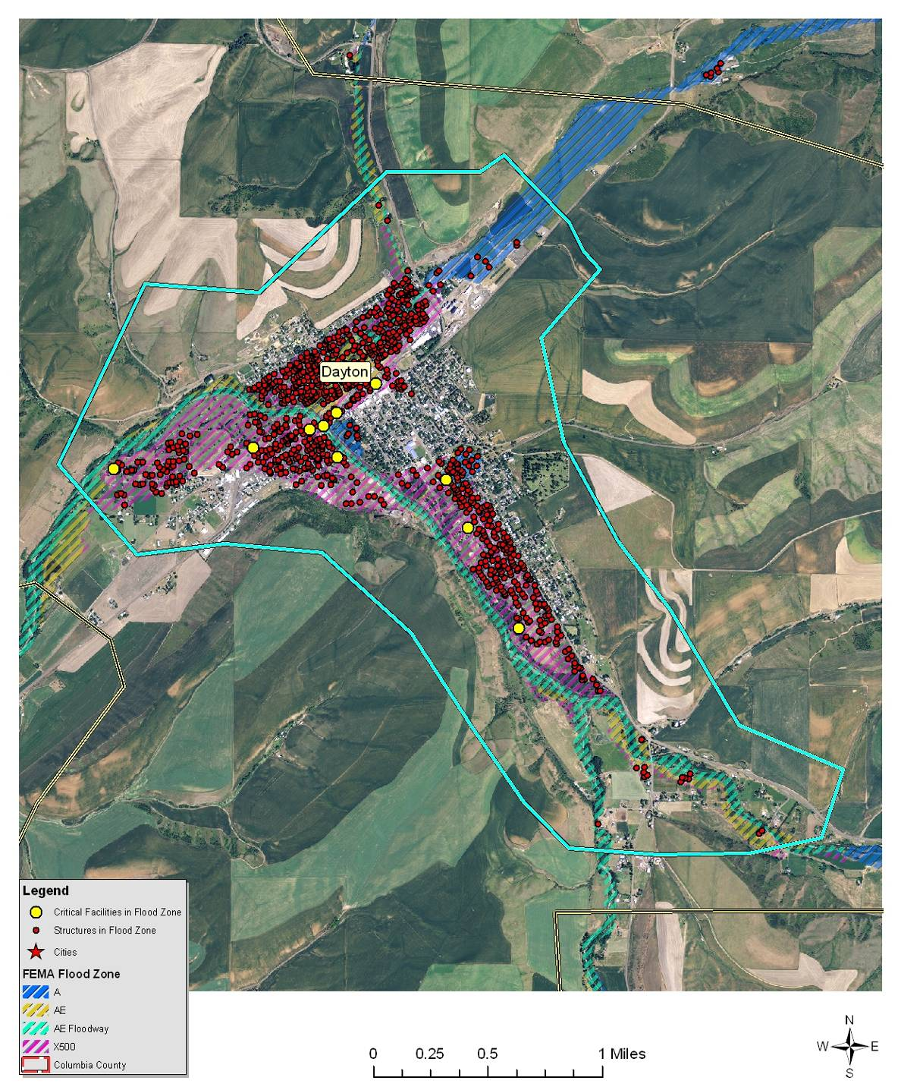
*Blue line does not necessarily represent the city limits boundary.
Rural residences, ranches, farms, and roadways located near these smaller waterways may be at significant flood risk. The onset of flooding in the smaller drainages can range from extremely slow to very fast. This variability depends on the cause of flooding and other factors such as rainfall intensity, the areas receiving the rain, temperature, and the condition of the soil. Floods that occur quickly are usually caused by thunderstorms, while floods that occur more slowly are often the result of moderate, but prolonged rainfall, snowmelt, or a combination of both. In the case of intense rainfall immediately above developed areas, the onset of flooding may occur in a matter of minutes.
The major impacts from flooding in Dayton are the restricted use of several streets including Highway 12, commercial, and residential areas. There are numerous bridge and culvert crossings over both the Touchet River and several of the tributaries throughout their extents within the City and the surrounding area.
A high level of sediment is prevalent during periods of intense runoff. This sediment tends to cause a deteriorating condition in streambeds and channels through deposition. Natural obstructions to flood waters include trees, brush, and other vegetation along the stream banks in the floodplain area. Considerable debris is allowed to accumulate in these channels, plugging culverts and bridges at several locations throughout the county.

Value of Resources at Risk
There are 874 parcels within the FEMA-identified floodplains (100- and 500-year) in Dayton, yielding an estimated total improvement value of $60.8 million. The average damage to structures was estimated based on the parcel’s location as either completely within or out of the flood zone. The estimated value of contents is ½ the value of the improvements equating to an additional $30.4 million in potential losses. In reality, the damages will most likely not be equally distributed between buildings based on building materials, building location, and flood location. However, these estimates provide a basic approximation. There are currently only 59 NFIP policies (6.7% of at-risk properties) in Dayton. There are 3 repetitive loss properties in Dayton resulting from the 1996-1997 flood events. The total home value for all 3 properties is $200,000. The total payment for these properties was $47,000.
Critical infrastructure located within the identified floodplain for Dayton includes two water wells, the sewage treatment facility, the Columbia County Courthouse (also Sheriff’s Office), Dayton General Hospital, Blue Mountain Counseling, Columbia County offices (Public Works, Emergency Management, the Columbia County Fire District #3 station, Dayton Public Works shop, Columbia REA office, AT&T cell tower, two main Touchet River bridges, and the Dayton High School which is also the designated Red Cross shelter.

Earthquake
There are no recorded occurrences of earthquakes significantly impacting the city of Dayton; however, some minimal shaking has been felt as a result of larger earthquakes elsewhere. The City has 10% chance of exceeding a 7-8% pga in the next 50 years (see Figure 5.7). Dayton does not have any differing issues or levels of risk associated with this hazard than Columbia County as a whole.

Value of Resources At Risk
Unreinforced masonry (URM) structures and unreinforced chimneys of homes will likely be damaged in the event of an earthquake. There are several publicly accessible unreinforced masonry structures in Dayton in addition to the numerous homes and other buildings throughout the City with unreinforced chimneys. Damaged or collapsed chimneys could result in the secondary hazard of fire. Nonstructural damage caused by falling and swinging objects may be considerable after any magnitude earthquake. Damage to some older, more fragile bridges and land failure causing minor slides along roadways may isolate some residents.
In Dayton, nearly all of the downtown structures are assumed to be unreinforced masonry including the County Courthouse, city hall, the hospital, Blue Mountain Counseling, and the High School. These structures were built prior to the inclusion of articles for seismic stability in the Uniform Building Codes in 1972. The number and value of unreinforced masonry homes or homes with masonry chimneys in Dayton is unknown, but estimated to include at least 125 buildings.

Landslide
The city of Dayton has a very low probability of experiencing damaging landslides. Slopes in and around the community are generally less than 35%. While small, low angle slumps may occur on eyebrows of the surrounding rolling hills, these will be infrequent and likely the result of water saturation or a major disturbance such as an earthquake or road construction. It is also probable that small slides will continue to occur on the cut and fill slopes of some roads. This type of slide is generally small with little permanent damage to the road or other infrastructure; however, there is some risk of traffic being delayed temporarily while road crews clear the debris and stabilize the bank.

Value of Resources at Risk
There are no structures directly at risk from landslides within the city of Dayton. Small slumps may occur along U.S. Highway 12, North Touchet Road, or other secondary roads. In many cases, this will cause temporary sediment delivery into nearby streams and plugged culverts. These types of events are cleaned up by county or city road departments with little complications. Road slumps are generally reported as regular maintenance; thus, there are few records associated with these events.

Severe Weather
The city of Dayton does not have any differing levels of risk associated with this hazard than Columbia County as a whole.

Value of Resources at Risk
It is difficult to estimate the cost of potential winter storm damages to structures and the economy in Dayton. Damage to roofs by heavy snow accumulations depends on the moisture content of the snow and the structural characteristics of the buildings. In general, snow in this region tends to have low moisture content because of the low temperatures and arid environment. However, heavy snow is not uncommon. Frozen water pipes are the most common damage to residential and business structures. Older homes tend to be at a higher risk to frozen water pipes than newer ones. Snow plowing in within the city limits is accomplished by the city’s public works department. Private landowners are responsible for maintaining their own driveways or other private roads. Utility supplies are impacted during severe winter storms as power is lost on a regional basis. This has a two-fold impact on residents as not only is power cut to homes and businesses, but primary heating is lost for many residents. Gas furnaces and wood stoves supplement electrical heating, but with wood heating the senior population is at a disadvantage. Emergency response to severe winter storms includes site visits by police or fire department personnel, opening of shelters, or assistance with shopping, medical attention, and communications. The economic losses caused by severe winter storms may frequently be greater than structural damages. Employees may not be able to travel to work for several days and businesses may not open. Damages are seen in the form of structural repair and loss of economic activity. Columbia County schools are occasionally closed during and right after a severe winter storm because of cold temperatures and snow covered roads.
Thunderstorms are not likely to be severe enough in Dayton to cause significant damages. However, the loss potential from flooding that results from severe thunderstorms could be significant.
Although the financial impacts of hail can be substantial and extended, accurately quantifying these impacts is problematic. Hail typically causes direct losses to structures and other personal property within Dayton. The most significant losses are most clearly seen in the agriculture sectors of the economy. Potential losses to agriculture can be disastrous. Crop damage from hail will also be different depending on the time of year and the type of crop. Most farmers carry insurance on their crops to help mitigate the potential financial loss resulting from a localized hail storm. Homeowners in Dayton rarely incur severe damage to structures (roofs); however, hail damage to vehicles is not uncommon. The damage to vehicles is difficult to estimate because the number of vehicles impacted by a specific ice storm is unknown. Additionally, most hail damage records are kept by various insurance agencies.
It is difficult to estimate potential losses in Dayton due to windstorms and tornadoes. Construction throughout the County has been implemented in the presence of high wind events, and therefore, the community is at a higher level of preparedness to high wind events than many other areas experiencing lower average wind speeds.
We have estimated losses based on wind and tornado damage as follows:
- 3% of the buildings damaged causing 50% of value loss (loss could be from downed or damaged trees, damaged outbuildings, damaged fences/poles, damage to siding, damaged landscaping etc.)
- 5% of the buildings received damage to roof (requiring replacement of roof equaling $3,000)
Damages associated with sensitive receptor irritation have not been estimated. We have also not estimated the potential for a large scale wildfire event associated with high winds. Based on the data provided by the County, there are 1,372 total structures in Dayton with a total value of approximately $95.5 million. Using the criteria outlined above an estimate of the impact of high winds on in the County has been made. The potential wind and tornado damage to all buildings is estimated at approximately $1.4 million. The estimated damage to roofs is approximately $205,800.
Power failure often accompanies severe storms. More rural parts of the County are sometimes better prepared to deal with power outages for a few days due to the frequent occurrence of such events; however, prolonged failure, especially during cold winter temperatures can have disastrous effects. All communities should be prepared to deal with power failures. Community shelters equipped with alternative power sources will help local residents stay warm and prepare food. A community-based system for monitoring and assisting elderly or disabled residents should also be developed. All households should maintain survival kits that include warm blankets, flashlights, extra batteries, nonperishable food items, and clean drinking water.

Wildland Fire
Dayton is located at the confluence of the Touchet River and Patit Creek. The region is surrounded by agricultural fields with a combination of hardwoods and ornamental softwood tree species around homes. The city is clustered along Highway 12 with many homes extending southward in the direction of Baileysburg.
The risk from structure loss due to a wildfire entering the Dayton area is minimal. The only fuels exhibiting some level of risk are located along the southern bench of the city where steep slopes are dominated by native shrub vegetation. During the fire season, these fuels could ignite and be difficult to control. However, the fuels are bounded on the top of the hill by agricultural crops, which may be at less risk. A few structures are along the toe of the slope have an increased risk due to the proximity of fuels.
Another area of concern is the northeast corner of the city where homes give way to native rangeland. Grasses and forbs dominate this area with evidence indicating the presence of livestock grazing. Responsible grazing practices generally lessen the risk of wildfire by reducing the buildup of fine fuels.
Dayton has a low risk of wildfire threatening the city center; however, structure fires within the city have some potential to spread from one structure to another; either carried by radiant heat or spread through common vegetation between structures. This risk is lessened by the presence of an active fire protection district housed in Dayton.
The primary access into Dayton is provided by U.S. Highway 12, a major intra-county route. There are also several other secondary travel corridors accessing rural areas and population clusters surrounding Dayton such as North Touchet Road, Patit Creek Road, Mustard Hollow Road, and several others. Many of these secondary access corridors are paved, but most are graveled, two-lane routes.
A city water system is available for residents of Dayton. Residents in the more rural areas typically rely on personal well systems for their water resources. The main power lines supplying Columbia County pass about four miles south of Dayton with an east-west orientation. Most residents are served by numerous smaller distribution lines.
In addition, the Columbia County Fire District #3 provides both structural and wildland protection to a large coverage area including Dayton and the surrounding area. A complete system of fire hydrants is present in the city.
All of the private lands within the fire protection district have joint jurisdiction with the Washington Department of Natural Resources (DNR). Under joint jurisdiction, it is recognized that the fire district has primary responsibility for structure protection and the DNR will have primary responsibility for wildland fire suppression on state and private lands. The DNR provides wildfire protection during the fire season between April and October with varying degrees of available resources in the early spring and late autumn months. The U.S. Forest Service responds to all wildland fires on their jurisdiction and may also respond to wildland fires on private or state lands based on a closest forces, reciprocal agreement with the DNR when resources are available.
Because of the moderate level of risk in Dayton, few potential mitigation activities are recommended at this time. The continued use of the surrounding landscape for active agricultural (not CRP) and livestock grazing will reduce fuel loading and the potential fire risk.
In addition, the Columbia County Fire Districts have so far been relatively successful at suppressing wildland fires. The continued support of these services by the community will improve their ability to fight fires effectively.

Value of Resources at Risk
It is difficult to estimate potential losses in Dayton from wildland fire due to the unpredictability of wildfire behavior and the nature of ignition sources. It is impossible to forecast the path a wildfire will take and what type of assets and resources, manmade and ecological, will be at risk. Thus, no value estimates were made for this hazard.
Typically, structures located in forested areas without an adequate defensible space or fire resistant landscaping have the highest risk of loss. Nevertheless, homes and other structures located in the grasslands or agricultural regions are not without wildfire risk. Grass fires are often the most dangerous due to high rates of spread. Fires in this fuel type are considered somewhat easier to suppress given the right resources, but they can also be the most destructive. Homes along the perimeter of the community would have the highest risk due to their adjacency to wildland fuels.

Avalanche
Although the Blue Mountains in southern Columbia County has a high probability of experiencing avalanches in remote areas, the city of Dayton will not be directly impacted by this type of localized event.

Value of Resources at Risk
The city of Dayton has no assets at risk to avalanches.

Tsunami
Although Columbia County’s northern border has some low probability risk of being impact by an inland tsunami on the Snake River, the city of Dayton will not be directly impacted by this type of localized event.

Value of Resources at Risk
The city of Dayton has no assets at risk to inland tsunamis.

Volcano
The city of Dayton does not have any differing levels of risk associated with this hazard than Columbia County as a whole.

Value of Resources at Risk
The city of Dayton has no assets at direct risk of being impacted by a volcanic eruption. However, the secondary effects of ash and airborne particulates may have varying degrees of negative effects. Damages to property will likely be limited to vehicles and cleanup costs. Additionally, residents of Dayton will be at risk to health problems associated with the respiratory effects of breathing airborne particulates.

Drought
The city of Dayton does not have any differing levels of risk associated with this hazard than Columbia County as a whole. However, the city does have its own policies concerning water conservation practices during the dry months. Additionally, the city may develop programs to deal with residents and businesses significantly impacted by drought if necessary.

Value of Resources at Risk
The city of Dayton has no assets directly at risk to drought; however, the economic impacts of a drought or a wildland fire caused by extended dry periods would have a great impact on the community. The majority of the population is employed either directly by the agriculture industry or to a service industry dependent on agriculture. Crop losses resulting from extended droughts would likely be considered a disaster for the community.

Town of Starbuck Annex

Flood
Starbuck is located at the confluence of Kellogg Creek with the Tucannon River. The townsite sits between State Highway 261 along its north end and the Tucannon River along its southern boundary. The Kellogg Creek drainage flows into the River from the south. Historically, the only major disasters in Starbuck were caused by flooding. The most recent notable flood events occurred in 1964-1965 and 1996. Over the past 30 years, gravel bars have collected in the river channel within the town limits and vegetation has built up. The gravel bars and vegetation in the channel catch debris from the entire Tucannon River watershed, causing restricted flows and reduced channel capacity.
February 1996 - During the flooding of 1996, a debris jam immediately downstream of the levee diverted water into the lower end of town causing major flooding. A citywide sandbagging effort limited the damage to three homes. Additionally, flood damage claims were caused by groundwater pooling. In response to this, the Town has adopted and enforces FEMA recommendations that the base elevation of all new construction is one foot above the high water mark. During the flood event of 1996, the Tucannon River also left the banks on the upper end of Starbuck where a large portion of homes are located, but was held in place by a setback levee which extends from the School to the abandoned Union Pacific Railroad berm. During this event the setback basin, which is level farm ground, received several inches of silt deposit. It is the goal of the Town to seek funding to enhance this setback levee.
The upper and lower ends of Town are divided into two flood protection regions by the abandoned Union Pacific Railroad berm. The portions of Starbuck vulnerable to flooding by the Tucannon River are the areas of the community adjacent to the river including Pataha Street on the upper end of town and First Street and sections of Laurens Street, Baxter Street, and West Second Street on the lower end of town.
Figure 5.10. Town of Starbuck FEMA Flood Insurance Rate Map.
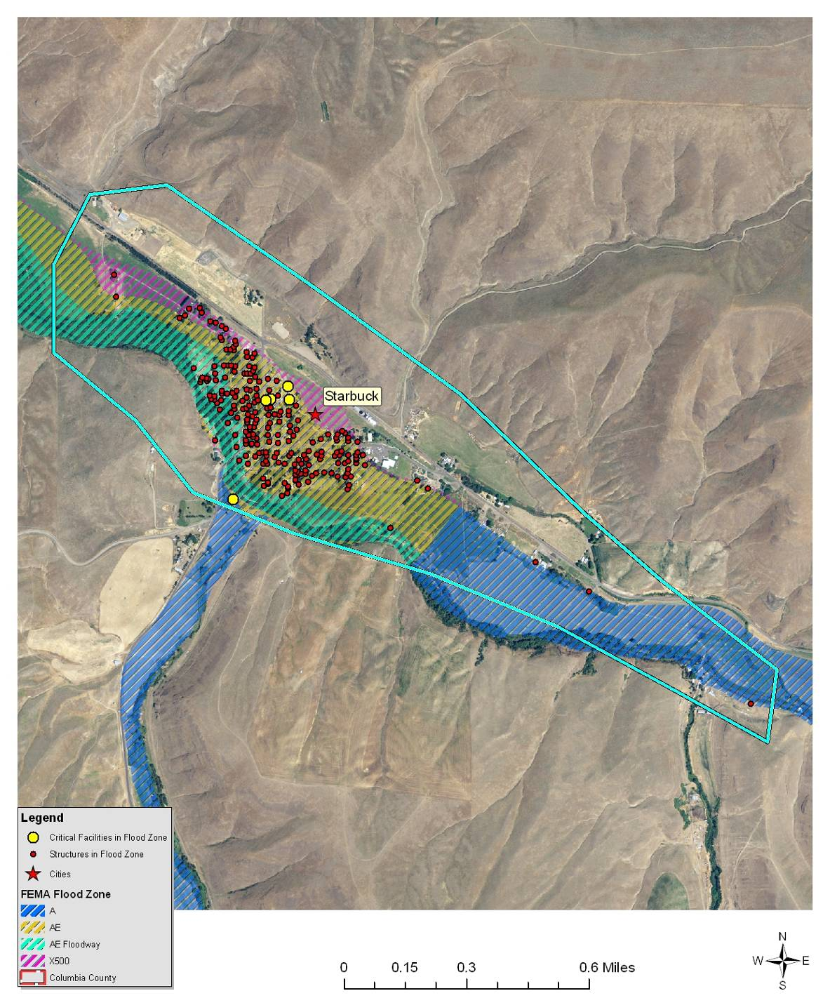
*Blue line does not necessarily represent the city limits boundary.
The levee system is located to the north of the Tucannon River and extends 750 feet above and 1,000 feet below the Kellogg Hollow Bridge and was built during the high water events of 1964 and 1965 through a cooperative effort between the Town of Starbuck, US Army Corps of Engineers (USACE), and the State of Washington. It is owned and maintained by the Town of Starbuck. The Tucannon River levee protects an estimated 81 homes, 6 businesses, the Town of Starbuck historical district, and $3.5 million in property. The southern bank of the Tucannon River is comprised of primarily sandy loam soils that support a natural habitat of mature alder. These areas are lower in elevation than the top of the levee and provide a delta region for excess water flow. The most confined section of the channel is located along the southern bank and is a basalt bluff extending along about 200 feet of levee.
According to the US Geological Survey (USGS), a 100-year flood volume for Starbuck would be approximately 11,000 cubic feet per second. The Town of Starbuck has determined that some regions of the levee system would not contain flows during a 100-year flood event. One solution to this issue is to place setback berms adjacent to areas with insufficient flow capacity. Starbuck has a variation of 17 degrees in elevation. This hydraulic condition allows water to drain fairly efficiently; thus, a relatively small setback berm would contain water and allow drainage preventing further flood damage outside of the limits of the current levee system. This was evidenced during the flood of 1996 when sandbags along the narrower portions of the levee allowed adequate drainage when a portion of the levee failed adjacent to Second Street. An after-action study of the 1996 flood event by the USACE, identified the potential for a setback berm’s success in preventing further flood damage.
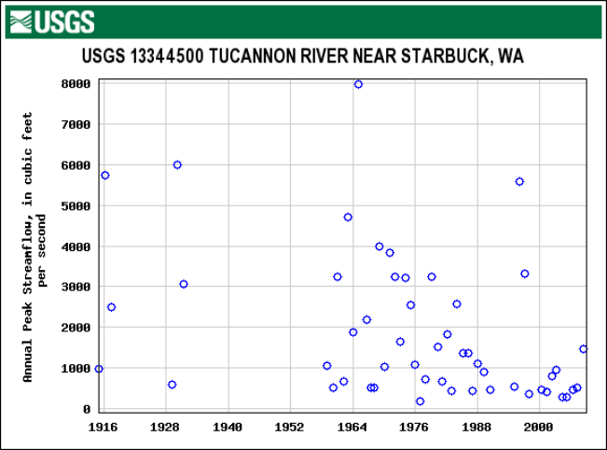
Stream flow histories in the form of gauging stations have been kept by the USGS since the 1920’s. By looking at the annual peak flow for several of the stations an indication of the size and relative frequency of flood events can be obtained (USGS 2010). Estimated flood volumes for the 1996 event were 7,500 cubic feet per second and were 8,000 cubic feet per second during the 1964 event. The estimated 100-year flood volume is 10,800 cubic feet per second.
USGS. U.S. Geological Survey. U.S. Department of Interior. Peak Streamflow for the Nation. Available online at http://nwis.waterdata.usgs.gov/nwis/peak/?site_no=13344500&amp;. January 2010.
After the flood of 1996, the Town of Starbuck tried to get funding from the USACE and FEMA to improve the levee system. Starbuck was advised that money was no longer available to channel the River with levees. Instead, the USACE did a study of what it would cost to purchase the floodway properties and construct a setback levee. This suggestion was not pursued because of an enormous outcry of opposition from the community, a lack of funding, and a poor debt to value ratio. The town council invested about $10,000 into reconstructing a failing section of the levee and placing diversion weirs into the River where flow direction was jeopardizing levee integrity.
Following the changes in levee enforcement mandated by the National Association of Flood Safety Management Agencies (NAFSMA) as a result of the devastation caused by Hurricane Katrina in 2007, the Starbuck levee failed the USACE inspection because of trees and fencing on the levee structure. This has made Starbuck ineligible for Public Law 84-99 funding from the USACE for levee repair. Pending development of vegetation variance standards, Starbuck has opted to comply with USACE standards for levee maintenance. This action was approved by NOAA Fisheries.
The bridge spanning the Tucannon River on Kellogg Hollow Road at Starbuck was built after the 1964 flood event and is supported on a steel frame. The center pier is located within the Tucannon River at the center of the bridge. This pier can catch wood and other debris and may cause blockages during high water events. The Kellogg Hollow Road is a primary access for Starbuck and is rated as second in Columbia County for commerce as it handles thousands of tons of wheat being transported to the grain barging terminal on the Snake River. To mitigate future flooding hazards, the Town of Starbuck suggests that Columbia County prioritize replacement of the Kellogg Hollow Bridge.

Value of Resources at Risk
There are 221 parcels within the FEMA-identified floodplains (100- and 500-year) in Starbuck, yielding an estimated total improvement value of $15.4 million. The average damage to structures was estimated based on the parcel’s location as either completely within or out of the flood zone. The estimated value of contents is ½ the value of the improvements equating to an additional $7.7 million in potential losses. In reality, the damages will most likely not be equally distributed between buildings based on building materials, building location, and flood location. However, these estimates provide a basic approximation. There are currently only 9 NFIP policies (4% of at-risk properties) in Starbuck, none of which are currently considered repetitive loss properties.
Critical infrastructure located within the identified floodplain for Starbuck includes city hall, the city water building and new city well, the old city well, the current Columbia County Fire District #1 emergency response station and the location for the new Fire District #1 station, the federal post office, the community solid waste collection system, electrical utilities, and three major arterial streets that connect the county road system to Washington State Highway 261.

Earthquake
There are no recorded occurrences of earthquakes significantly impacting the town of Starbuck; however, some minimal shaking has been felt as a result of larger earthquakes elsewhere. The Town has a 10% chance of exceeding a 6-7% pga in the next 50 years. Starbuck does not have any differing issues or levels of risk associated with this hazard than Columbia County as a whole.

Value of Resources at Risk
Unreinforced masonry (URM) structures and unreinforced chimneys of homes will likely be damaged in the event of an earthquake. There are several publicly accessible unreinforced masonry structures in Starbuck in addition to the numerous homes and other buildings throughout the Town with unreinforced chimneys. Damaged or collapsed chimneys could result in the secondary hazard of fire. Nonstructural damage caused by falling and swinging objects may be considerable after any magnitude earthquake. Damage to some older, more fragile bridges and land failure causing minor slides along roadways may isolate some residents.
In Starbuck, there are at least 7 publicly accessible structures constructed with unreinforced masonry including city hall, the old school building, the jail, the water treatment facility, the Zink Building, the Nelson Garage, the Rebecca Hall, Fire District #1 station, and Darver Tackle. The number and value of unreinforced masonry homes or homes with masonry chimneys in Starbuck is unknown.

Landslide
The town of Starbuck has a very low probability of experiencing damaging landslides. Slopes in and around the community are generally less than 35%. While small, low angle slumps may occur on eyebrows of the surrounding rolling hills, these will be infrequent and likely the result of water saturation or a major disturbance such as an earthquake or road construction. It is also probable that small slides will continue to occur on the cut and fill slopes of some roads. This type of slide is generally small with little permanent damage to the road or other infrastructure; however, there is some risk of traffic being delayed temporarily while road crews clear the debris and stabilize the bank.

Value of Resources at Risk
There are no structures directly at risk from landslides within the town of Starbuck. Small slumps may occur along Highway 261, Kellogg Hollow Road, or other secondary roads. In many cases, this will cause temporary sediment delivery into nearby streams and plugged culverts. These types of events are cleaned up by county or city road departments with little complications. Road slumps are generally reported as regular maintenance; thus, there are few records associated with these events.

Severe Weather
The town of Starbuck does not have any differing levels of risk associated with this hazard than Columbia County as a whole.

Value of Resources at Risk
It is difficult to estimate the cost of potential winter storm damages to structures and the economy in Starbuck. Damage to roofs by heavy snow accumulations depends on the moisture content of the snow and the structural characteristics of the buildings. In general, snow in this region tends to have low moisture content because of the low temperatures and arid environment. However, heavy snow is not uncommon. Frozen water pipes are the most common damage to residential and business structures. Older homes tend to be at a higher risk to frozen water pipes than newer ones. Private landowners are responsible for maintaining their own driveways, sidewalks, or other private roads. Utility supplies are impacted during severe winter storms as power is lost on a regional basis. This has a two-fold impact on residents as not only is power cut to homes and businesses, but primary heating is lost for many residents. Gas furnaces and wood stoves supplement electrical heating, but with wood heating the senior population is at a disadvantage. Emergency response to severe winter storms includes site visits by police or fire department personnel, opening of shelters, or assistance with shopping, medical attention, and communications. The economic losses caused by severe winter storms may frequently be greater than structural damages. Employees may not be able to travel to work for several days and businesses may not open. Damages are seen in the form of structural repair and loss of economic activity. Columbia County schools are occasionally closed during and right after a severe winter storm because of cold temperatures and travel hazards created by snow and ice covered roads.
Thunderstorms are not likely to be severe enough in Starbuck to cause significant damages. However, the loss potential from flooding that result from severe thunderstorms could be significant. Many summer fires are also caused by thunderstorms.
Although the financial impacts of hail can be substantial and extended, accurately quantifying these impacts is problematic. Hail typically causes direct losses to structures and other personal property within Starbuck. The most significant losses are most clearly seen in the agriculture sectors of the economy. Potential losses to agriculture can be disastrous. Crop damage from hail will also be different depending on the time of year and the type of crop. Most farmers carry insurance on their crops to help mitigate the potential financial loss resulting from a localized hail storm. Homeowners in Starbuck rarely incur severe damage to structures (roofs); however, hail damage to vehicles is not uncommon. The damage to vehicles is difficult to estimate because the number of vehicles impacted by a specific ice storm is unknown. Additionally, most hail damage records are kept by various insurance agencies.
It is difficult to estimate potential losses in Starbuck due to windstorms and tornadoes. Construction throughout the County has been implemented in the presence of high wind events, and therefore, the community is at a higher level of preparedness to high wind events than many other areas experiencing lower average wind speeds.
We have estimated losses based on wind and tornado damage as follows:
- 3% of the buildings damaged causing 50% of value loss (loss could be from downed or damaged trees, damaged outbuildings, damaged fences/poles, damage to siding, damaged landscaping etc.)
- 5% of the buildings received damage to roof (requiring replacement of roof equaling $3,000)
Damages associated with sensitive receptor irritation have not been estimated. We have also not estimated the potential for a large scale wildfire event associated with high winds. Based on the data provided by the County, there are 236 total structures in Starbuck with a total value of approximately $16.4 million. Using the criteria outlined above an estimate of the impact of high winds on in the County has been made. The potential wind and tornado damage to all buildings is estimated at approximately $246,384. The estimated damage to roofs is approximately $35,400.
Power failure often accompanies severe storms. More rural parts of the County are sometimes better prepared to deal with power outages for a few days due to the frequent occurrence of such events; however, prolonged failure, especially during cold winter temperatures can have disastrous effects. All communities should be prepared to deal with power failures. Community shelters equipped with alternative power sources will help local residents stay warm and prepare food. A community-based system for monitoring and assisting elderly or disabled residents has been identified in the Starbuck Evacuation Plan. All households should maintain survival kits that include warm blankets, flashlights, extra batteries, nonperishable food items, and clean drinking water.

Wildland Fire
Starbuck is located along the Tucannon River, upstream from its confluence with the Snake River. The region is surrounded by rangeland and agricultural fields with ornamental hardwood species around homes and native hardwoods along the Tucannon River. The city is clustered along State Highway 261 with most homes on the south side of the highway.
The risk from structure loss due to a wildfire in the Starbuck area is moderate. Rangeland fuels surround this community. Range fires have the potential to spread rapidly through the grasses, forbs, and sagebrush of the region. When fanned by high winds, these fires can move rapidly and exhibit large flame lengths. However, the intense livestock grazing on most of these lands has a significant mitigative effect. The fuels are minimal and would provide only spotty advancement of a range fire. In addition, the presence of available access routes improves firefighters’ quick suppression ability.
Starbuck is at low risk to a wildfire encroaching on the city from the surrounding rangelands. However, structural fires igniting in the city have a potential to spread from one structure to another; either carried by radiant heat or as a fire carried through common vegetation. One mitigation goal is to encourage biofuel reduction by providing residents with a place to dispose of unwanted yard waste.
Access in and out of Starbuck is provided by State Highway 261 running northwest-southeast. Many smaller, graveled and paved access routes tie into this two-lane highway.
A treated municipal water supply is available for residents within Starbuck from Well #1 (old well) and well #2 (new well). Both are managed by the town of Starbuck and are located near the Tucannon River.
The Columbia County Fire District #1 provides structural and wildland protection to a large coverage area surrounding Starbuck. All of the private lands within the fire protection district have joint jurisdiction with the Washington Department of Natural Resources (DNR). Under joint jurisdiction, it is recognized that the fire district has primary responsibility for structure protection and the DNR will have primary responsibility for wildland fire suppression on state and private lands. The DNR provides wildfire protection during the fire season between April and October with varying degrees of available resources in the early spring and late autumn months.
Because of the lower level of risk in Starbuck, few potential mitigation activities are recommended at this time. The continued use of the surrounding landscape for active agricultural (not CRP) and livestock grazing will reduce fuel loading and; therefore, the potential fire risk.
In addition, the Columbia County Fire Districts are successful at suppressing most grassland fires. The continued support of these services by the community will improve their ability to fight fires effectively.

Value of Resources at Risk
It is difficult to estimate potential losses in Starbuck from wildland fire due to the unpredictability of wildfire behavior and the nature of ignition sources. It is impossible to forecast the path a wildfire will take and what type of assets and resources, manmade and ecological, will be at risk. Losses within the Starbuck from wildfire should be extremely low since the Town is bordered by the Tucannon River to the south, Highway 261 to the north, and irrigated pasture land to the east and west of the city limits. Thus, no value estimates were made for this hazard.
Homes and other structures located in the grasslands or agricultural regions have considerable wildfire risk. Grass fires are often the most dangerous due to high rates of spread. Fires in this fuel type are considered somewhat easier to suppress given the right resources, but they can also be the most destructive. Homes along the perimeter of the community would have the highest risk due to their adjacency to flashy fuels.

Avalanche
Although the Blue Mountains in southern Columbia County have a high probability of experiencing avalanches in remote areas, the town of Starbuck will not be directly impacted by this type of localized event.

Value of Resources at Risk
The town of Starbuck has no assets at risk to avalanches.

Tsunami
Although Columbia County’s northern border has some low probability risk of being impact by an inland tsunami on the Snake River, the town of Starbuck will not be directly impacted by this type of localized event.

Value of Resources at Risk
The town of Starbuck has no assets at risk to inland tsunamis.

Volcano
The town of Starbuck does not have any differing levels of risk associated with this hazard than Columbia County as a whole.

Value of Resources at Risk
The town of Starbuck has no assets at direct risk of being impacted by a volcanic eruption. However, the secondary effects of ash and airborne particulates may have varying degrees of negative effects. Damages to property will likely be limited to vehicles and cleanup costs. Additionally, residents of Starbuck will be at risk to health problems associated with the respiratory effects of breathing airborne particulates.

Drought
The town of Starbuck does not have any differing levels of risk associated with this hazard than Columbia County as a whole. Additionally, the town is developing programs to encourage residents to conserve water, in compliance with the recently imposed Washington State water use rule.

Value of Resources at Risk
The town of Starbuck has no assets directly at risk to drought; however, the economic impacts of a drought or a wildland fire caused by extended dry periods would have a great impact on the community. The majority of the population is employed either directly by the agriculture industry or to a service industry dependent on agriculture. Crop losses resulting from extended droughts would likely be considered a disaster for the community.

Columbia Rural Electric Association Annex

Flood
The Columbia Rural Electric Associations’ (CREA) main office is located within the Touchet River floodplain in Dayton. The building is located along Main Street/Highway 12 about 1 block northeast of the Touchet River Bridge. In the event of a flood at the Dayton office building, operations can continue from the Columbia REA Walla Walla Service Center located in Walla Walla. The flooding of the Dayton Office would not directly interrupt the power supplied to the members served in Columbia County.
Distribution lines located near drainages can be adversely affected by flooding conditions. Every attempt is made to minimize this possibility when constructing new lines. However, rivers change channels over time and this can cause damage to the distribution lines during times of flooding. This can lead to power outages that can affect many services until repairs can be made.

Value of Resources at Risk
It would be difficult to determine the value of all the distribution system that may be at risk due to flooding. However, the cost to replace a single pole can vary from $ 2000 to $6000 each depending on the size and type of structure. The amount of damage caused to the distribution system will be dependent on the location and severity of the flooding.

Earthquake
There are no recorded occurrences of earthquakes significantly impacting the CREA. The area covered by the CREA has a 10% chance of exceeding a 6-8% pga in the next 50 years. CREA does not have any differing levels of risk associated with this hazard than Columbia County as a whole. However, in the event of a damaging earthquake, the REA may incur mild to moderate damages to their distribution infrastructure potentially causing power outages throughout the area.

Value of Resources at Risk
The CREA has no known assets or other resources directly at risk to earthquakes.

Landslide
The CREA does not have any differing levels of risk associated with this hazard than Columbia County as a whole. However, in the event of a significant landslide, REA distribution lines may be at risk depending on location. A severe landslide could disrupt power supply by knocking down or damaging poles but would likely be localized.

Value of Resources at Risk
The CREA power infrastructure in Columbia County has a moderate risk of being affected by landslides. The amount of damage caused to the distribution system will be dependent on the location and severity of the slide.

Severe Weather
The CREA power distribution infrastructure has significant risk to severe weather events in Columbia County. The power lines are exposed to all types of weather including storms, high winds, hail, tornadoes, ice, and snow. High winds and ice accumulation on the lines typically have the highest frequency of occurrence and therefore the highest risk of damage. The probability of these types of weather events continuing to occur in Columbia County is very high. CREA has not experienced any damages due to tornadoes.

Value of Resources at Risk
Power outages in Columbia County due to severe weather events can occur and are, for the most part, very short term in duration. Columbia REA crews often repair damaged lines and restore power within a matter of hours. Outages are usually limited to certain areas rather than affecting the entire county or even a whole community at any one time. Nevertheless, the cost of equipment and crews required to repair damages and the loss of revenue due to deactivation of the line can cost CREA as much as an estimated $15,000 to $20,000 per day. Local businesses served by CREA could also be impacted as a result of the loss of power. An extended outage will also have a significant impact on special needs populations as well as those dependent on electricity for heating (in the winter) and preparing food.

Wildland Fire
The CREA’s power distribution system is spread across much of Columbia County. The CREA regularly checks the fuel buildup beneath and surrounding the power line corridors through a vegetation removal and trimming program in an effort to reduce the risk of an accidental ignition originating with the line. This type of ignition can occur in eastern Washington due to the nature of the fuel complexes.
There is a potential for arcing to occur in power lines due to heavy particulates from wildland fires. However, this is usually only a problem for higher transmission line voltages. At this time, CREA does not have any lines in Columbia County that are operated at transmission line voltages.

Value of Resources at Risk
The value of the CREA power distribution system in Columbia County is approximately $11,700,000. Additionally, the equipment and crews required to repair damages and the loss of power due to deactivation of the line can l cost the REA an estimated $ 15,000 to $20,000 per day. Local businesses served by CREA can also be impacted as a result of the loss of power.

Avalanche
Although the Blue Mountains in southern Columbia County have a high probability of experiencing avalanches in remote areas, the Columbia Rural Electric Cooperative will not be directly impacted by this type of localized event.

Value of Resources at Risk
The Columbia Rural Electric Cooperative has no assets at risk to avalanches.

Tsunami
Although Columbia County’s northern border has some low probability risk of being impact by an inland tsunami on the Snake River, the Columbia Rural Electric Cooperative will not be directly impacted by this type of localized event.

Value of Resources at Risk
The Columbia Rural Electric Cooperative has no assets at risk to inland tsunamis.

Volcano
Columbia REA does not have any differing levels of risk associated with this hazard than Columbia County as a whole. However, in the event of a volcanic eruption in western Washington or Oregon, ash fallout may cause arcing on the distribution lines that could lead to power outages. Ash fallout can contaminate substation insulators and buss and they must be cleaned. Additionally, the ash may cause damage to utility vehicles and may be hazardous to the health of crews working on the lines.

Value of Resources at Risk
The Columbia REA infrastructure in Columbia County may be at risk to damage from the ash fallout caused by an eruption in western Washington or Oregon. The value of Columbia REA power distribution system in Columbia County is approximately $11,700,000. Additionally, the equipment and crews required to repair damages and the loss of power due to deactivation of the line may cost the REA an estimated $ 15,000-$20,000 per day. Local businesses served by Columbia REA could also be impacted as a result of the loss of power.

Drought
The REA does not have any differing levels of risk associated with this hazard than Columbia County as a whole.

Value of Resources at Risk
The Columbia REA does not have any direct risks to drought.

Columbia County Fire District #1 Annex

Flood
Both the location of the old Columbia County Fire District #1 station and the lot for the new station are within the floodplain of the Tucannon River in Starbuck. In the event of a large flood event, it is likely that the District’s station will incur damages as well as be limited in its emergency response capabilities. However, the main Tucannon River channel runs along the western edge of the town; thus, it is unlikely that accessibility for emergency response would be an issue for the District. The Tucannon River Bridge on Kellogg Hollow Road would likely become impassable during a large flood event, thereby limiting the District’s access to residents in the rural area south and west of town. Alternative routes to these areas are available (Fletcher Road and Tucker Road); however, these routes would significantly increase response times and may also be affected by floodwaters.

Value of Resources at Risk
Columbia County Fire District #1’s main station is located in the Tucannon River floodplain. The value of the structure itself is estimated at $30,000. The contents of the structure including all of the emergency response apparatus and other equipment are valued at approximately $80,000.

Earthquake
There are no recorded occurrences of earthquakes significantly impacting Columbia County Fire District #1. The area covered by the District has a 10% chance of exceeding a 6-7% pga in the next 50 years. The Fire District does not have any differing levels of risk associated with this hazard than Columbia County as a whole. However, in the event of a damaging earthquake, Fire District #1 would provide emergency response and search and rescue services.

Value of Resources at Risk
Columbia County Fire District #1 has no known assets or other resources at risk to earthquakes.

Landslide
The Fire District does not have any differing levels of risk associated with this hazard than Columbia County as a whole. However, in the event of a significant landslide, Fire District #1 may assist with any necessary evacuations or traffic accident responses.

Value of Resources at Risk
The Columbia County Fire District #1 station in the Starbuck is not at risk to landslides due to its location in a relatively flat, developed area. The District has no other known assets or other resources at risk to landslides.

Severe Weather
The Fire District does not have any differing levels of risk associated with this hazard than Columbia County as a whole. However, in the event of significant severe weather events, Fire District #1 would assist with accident response, delivery of special aid if necessary, and search and rescue missions.

Value of Resources at Risk
The Columbia County Fire District #1 station in the Starbuck may be at risk to severe high wind events, hail damage, or significant snow accumulations. The District has no other known assets or other resources at risk to severe weather events.

Wildland Fire
Columbia County Fire District #1 covers much of the north end of Columbia County. The District provides both structural and wildland fire protection in the town of Starbuck as well as the surrounding rural areas. All of the private lands within the fire protection district have joint jurisdiction with the Washington Department of Natural Resources (DNR). Under this joint jurisdiction, it is recognized that the fire district has primary responsibility for structure protection and the DNR will have primary responsibility for wildland fire suppression on state and private lands. The DNR provides wildfire protection during the fire season between April and October with varying degrees of available resources in the early spring and late autumn months.
The Fire District does not have any differing levels of risk associated with this hazard than Columbia County as a whole. However, in the event of a wildland fire, Fire District #1 would provide emergency response, protection, and search and rescue services.

Value of Resources at Risk
The Columbia County Fire District #1 station in Starbuck is not at risk to wildland fire due to its location in a developed area. The District has no other known assets or other resources at risk to wildland fires.

Avalanche
Although the Blue Mountains in southern Columbia County has a high probability of experiencing avalanches in remote areas, the Fire District will not be directly impacted by this type of localized event. However, in the event of a significant avalanche event, Fire District #1 may assist with any necessary evacuations or search and rescue operations.

Value of Resources at Risk
Columbia County Fire District #1 is not at risk to avalanches due to its location in a relatively flat, developed area. The District has no other known assets or other resources at risk to avalanches.

Tsunami
Although Columbia County’s northern border has some low probability risk of being impact by an inland tsunami on the Snake River, the Fire District will not be directly impacted by this type of localized event. However, it is likely that Fire District #1 would be involved in any emergency response required including search and rescue.

Value of Resources at Risk
Columbia County Fire District #1 has no assets at risk to inland tsunamis.

Volcano
The Fire District does not have any differing levels of risk associated with this hazard than Columbia County as a whole. However, in the event of a volcanic eruption in western Washington or Oregon, Fire District #1 may assist with any necessary evacuations, medical responses, or traffic accidents.

Value of Resources at Risk
The Columbia County Fire District #1 station in Starbuck does not have any direct risk to volcanoes; however, there may be damage to the structure and/or equipment caused by ash fallout.

Drought
The Fire District does not have any differing levels of risk associated with this hazard than Columbia County as a whole. However, in severe drought years, the District may have difficulty finding adequate water resources for wildland fire fighting purposes, particularly where drafting from ponds or streams is necessary.

Value of Resources at Risk
The Columbia County Fire District #1 station in Starbuck does not have any direct risks to drought.

Columbia County Fire District #3 Annex

Flood
The Columbia County Fire District #3 station in Dayton is located within the floodplain of the Touchet River. The station is on Main Street less than 100 yards southwest of the Touchet River Bridge. In the event of a very large flood event, it is likely that the station will incur damages as well as be limited in its emergency response capabilities. The District station in Dayton was not inundated with flood waters during the 1996 100 year flood; thus, the probability of the station being damaged by floodwaters is very low.
If the Touchet River Bridge in Dayton is compromised by floodwaters, access to the majority of the town, including the downtown area and most of the residential neighborhoods, would be cut off from the fire station. Due to this issue, it is District policy to move half of the station’s equipment and resources to the east side of the bridge during flood warnings.

Value of Resources at Risk
Columbia County Fire District #3’s main station is located in the Touchet River floodplain. The value of the structure itself is estimated at $3 million. The contents of the structure including all of the emergency response apparatus and other equipment are valued at approximately an additional $3 million.

Earthquake
There are no recorded occurrences of earthquakes significantly impacting Columbia County Fire District #3. The area covered by the District has a 10% chance of exceeding a 6-8% pga in the next 50 years. The Fire District does not have any differing levels of risk associated with this hazard than Columbia County as a whole. However, in the event of a damaging earthquake, Fire District #3 would provide emergency response and search and rescue services.

Value of Resources at Risk
Columbia County Fire District #3 has no known assets or other resources at risk to earthquakes.

Landslide
The Fire District does not have any differing levels of risk associated with this hazard than Columbia County as a whole. However, in the event of a significant landslide, Fire District #3 may assist with any necessary evacuations or traffic accident responses.

Value of Resources at Risk
The Columbia County Fire District #3 station in Dayton is not at risk to landslides due to its location in a relatively flat, heavily developed area. The District has no other known assets or other resources at risk to landslides.

Severe Weather
The Fire District does not have any differing levels of risk associated with this hazard than Columbia County as a whole. However, in the event of significant severe weather events, Fire District #3 would assist with accident response, delivery of special aid if necessary, and search and rescue missions.

Value of Resources at Risk
The Columbia County Fire District #3 station in the Dayton may be at risk to severe high wind events, hail damage, or significant snow accumulations. The District has no other known assets or other resources at risk to severe weather events.

Wildland Fire
Columbia County Fire District #3 covers much of the southwestern portion of the County. The District provides both structural and wildland fire protection in the city of Dayton as well as the surrounding rural areas through an auto-aid agreement. All of the private lands within the fire protection district have joint jurisdiction with the Washington Department of Natural Resources (DNR). Under this joint jurisdiction, it is recognized that the fire district has primary responsibility for structure protection and the DNR will have primary responsibility for wildland fire suppression on state and private lands. The DNR provides wildfire protection during the fire season between April and October with varying degrees of available resources in the early spring and late autumn months.
The Fire District does not have any differing levels of risk associated with this hazard than Columbia County as a whole. However, in the event of a wildland fire, Fire District #3 would provide emergency response, protection, and search and rescue services.

Value of Resources at Risk
The Columbia County Fire District #3 station in Dayton is not at risk to wildland fire due to its location in an urban area. The District has no other known assets or other resources at risk to wildland fires.

Avalanche
Although the Blue Mountains in southern Columbia County has a high probability of experiencing avalanches in remote areas, Columbia County Fire District #3 will not be directly impacted by this type of localized event. However, in the event of a significant avalanche event, Fire District #3 may assist with any necessary evacuations or search and rescue operations.

Value of Resources at Risk
The Columbia County Fire District #3 in Dayton is not at risk to avalanches due to its location in a relatively flat, heavily developed area. The District has no other known assets or other resources at risk to avalanches.

Tsunami
Although Columbia County’s northern border has some low probability risk of being impact by an inland tsunami on the Snake River, the potentially impacted area is outside of Columbia County Fire District #3’s jurisdiction. Fire District #3 would not be directly impacted by an inland tsunami; however, the District would likely be involved in any rescue or clean-up efforts that were required through their mutual aid agreement with Columbia County Fire District #1.

Value of Resources at Risk
Columbia County Fire District #3 has no assets at risk to inland tsunamis.

Volcano
The Fire District does not have any differing levels of risk associated with this hazard than Columbia County as a whole. However, in the event of a volcanic eruption in western Washington or Oregon, Fire District #3 may assist with any necessary evacuations, medical responses, or traffic accidents.

Value of Resources at Risk
The Columbia County Fire District #3 station in Dayton does not have any direct risk to volcanoes; however, there may be damage to the structure and/or equipment caused by ash fallout.

Drought
The Fire District does not have any differing levels of risk associated with this hazard than Columbia County as a whole. However, in severe drought years, the District may have difficulty finding adequate water resources for wildland fire fighting purposes, particularly where drafting from ponds or streams is necessary.

Value of Resources at Risk
The Columbia County Fire District #3 station in Dayton does not have any direct risks to drought.

Garfield County Annex
The Flood Mitigation Plan contained within this Multi – Hazard Mitigation Plan fulfills the requirements of a Flood Mitigation Plan as specified in 44 CFR 78.5 of the Federal Register describing the Flood Mitigation Assistance program. The purpose of this section is to prescribe actions, procedures, and requirements for administration of the Flood Mitigation Assistance (FMA) program, authorized by Sections 1366 and 1367 of the National Flood Insurance Act of 1968, 42 U.S.C. 4104c and 4104d. The goal of FMA is to assist state and local governments in funding cost-effective actions that reduce or eliminate the long term risk of flood damage to buildings, manufactured homes, and other insurable structures.

Flood
Pataha Creek is the principal tributary to the Tucannon River and is often considered as a separate water body. Draining an area of 183 square miles, Pataha Creek generally flows westward from its headwaters near Stentz Spring in the Blue Mountains (5,647 ft) to its confluence with the Tucannon River (748 feet) near Delaney in Columbia County. Primary tributaries to Pataha Creek include Bihmaier Gulch, Sweeney Gulch, and Tatman Gulch. Average annual precipitation is approximately 16 inches per year. While this does not lend to particularly large flows, warm rains following a period of accumulating snow have resulted in damaging floods in 1950, 1964, 1966, 1971, and 1996. The main channel of Pataha Creek parallels U.S. Highway 12 through most of Garfield County creating what is known as the Pataha Valley. Nearly all of Garfield County’s population resides in the Pataha Valley either within the city of Pomeroy or in the Pataha community. Currently, there are approximately 48 structures within the FEMA-identified floodplain in Pataha. There are an additional 16 structures in the Pataha Creek floodplain upstream of the Pataha Valley and another 28 structures in the floodplain west of the Pomeroy.
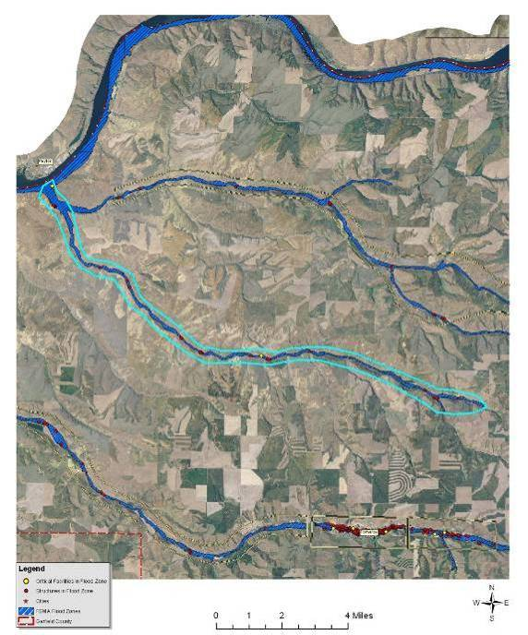
Structures and critical infrastructure in the Deadman Creek and Meadow Creek drainages of Garfield County.
Flooding does not typically occur on the Snake River due to flood control capacity of both upstream and downstream dams. The water level of Snake River reservoirs are monitored and highly regulated for the purposes of providing not only irrigation water to the surrounding agricultural developments and hydroelectric power, but also to provide flood control for communities along this major drainage. In the event of a major flood on the Snake River, State Highway 127 at Central Ferry and Lower Granite Dam are the most vulnerable. There are 23 residences and other structures near Lower Granite Dam in Garfield County within the FEMA-identified floodplain for the Snake River.
Several other waterways in Garfield County flood every two to five years including Deadman Creek, Meadow Creek, and Alpowa Creek. Flooding on streams in Garfield County occurs as a result of periods with heavy rainfall, mild temperatures melting the snow pack, Chinook winds, and severe thunderstorms. Streams in Garfield County are also prone to flash flooding. Thunderstorms, steep topography, alluvial fans, dry or frozen ground, and light vegetation, tends to increase overland water flow.
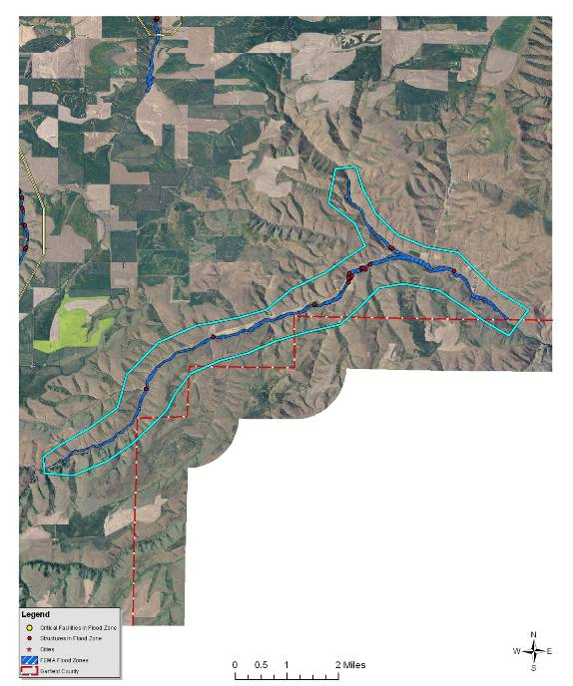
Structures and critical infrastructure in the Alpowa Creek drainage of Garfield County.
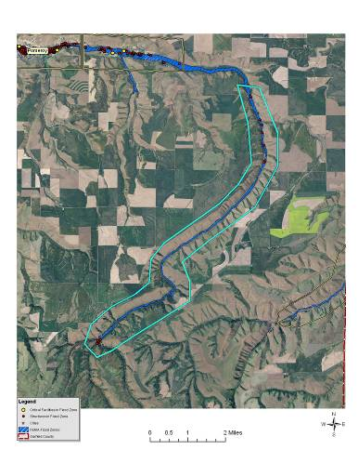 | 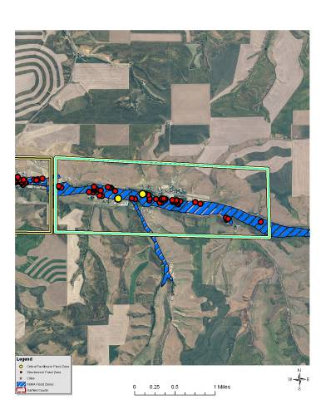 | 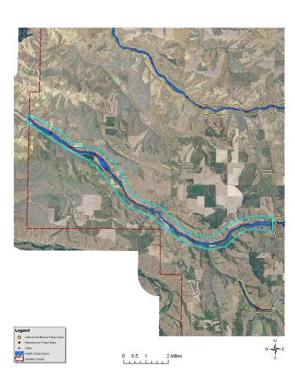
Structures in the upper reaches of Pataha Creek in Garfield County. | Structures in the community of Pataha in Garfield County. | Structures along Pataha Creek west of Pomeroy in Garfield County.

Both the Deadman Creek and Meadow Creek drain the northern half of the county and flow directly into the Snake River at an inlet near Central Ferry. Due to the lack of significant topography as well as population in this area, flooding on these waterways typically results in the floodwaters occupying their natural floodplain at low depths. Damage from flood events in this area is generally minor; however, there are approximately 30 structures in the FEMA-identified Meadow Creek floodplain and 33 structures in the Deadman Creek floodplain (north and south forks).
Alpowa Creek drains much of the eastern edge of Garfield County. This waterway flows out of the Darland Ridge area near Columbia Center in a northeasterly direction. then parallels U.S. Highway 12 before emptying into the Lower Granite Lake on the Snake River near Silcott in Asotin County. Alpowa Creek is prone to flooding as a result of rain-on-snow events and normal spring runoff. This watershed is also likely to flash flood due to a constricted channel, relatively steep topography, and limited streamside vegetation. There are currently about 17 structures in the FEMA-identified floodplain for Alpowa Creek in Garfield County. These structures are primarily located in the upper reaches of the drainage.
March 1963 – Flooding occurred in Columbia, Garfield, Grant, Whitman and Spokane Counties.
1971 - The 1971 flood event inundated Pomeroy and several other widely dispersed areas throughout the County resulting in over a half million dollars in damage.
February 6, 1996 – Heavy rains caused flooding in the counties of Adams, Asotin, Benton, Clark, Columbia, Cowlitz, Garfield, Grays Harbor, King, Kitsap, Kittitas, Klickitat, Lewis, Lincoln, Pierce, Skagit, Skamania, Snohomish, Spokane, Thurston, Wahkiakum, Walla Walla, Whitman, and Yakima and the Yakima Indian Reservation. Snowfall began on January 26, 1996 followed by heavy rain in February. Mild temperatures and mountain snow melt caused severe flooding throughout the entire northwest. Three people died in Washington. Snow closed Interstate 90 at Snoqualmie Pass. Mudslides and flooding closed Interstate 5 in Lewis County.
December 1996 thru January 1997 - Again in 1997 flooding occurred, but with streams cleared and bridges armored after the flood events earlier in 1996, the overall impact was reduced. During the 1996-97 winter storms, areas not prone to stream flooding experienced surface water flooding due to high groundwater tables in floodplain areas or inadequate storm sewer drainage systems. Floods contaminated domestic water supplies, fouled septic systems, and inundated electrical and heating systems. Fire-fighting access was restricted, leaving homes vulnerable to fire.
Garfield County is not considered to be one of the counties most at risk and vulnerable to flood in Washington according to the State of Washington Hazard Mitigation Plan. It is also not in the top percentage of Washington counties having a high frequency of floods causing damage and does not currently report any repetitive loss properties. Properties receiving two or more claim payments of more than $1,000 from the National Flood Insurance Program within any rolling 10-year period are considered repetitive loss properties by FEMA.
Figure 5.11. Garfield County FEMA Flood Insurance Rate Map.
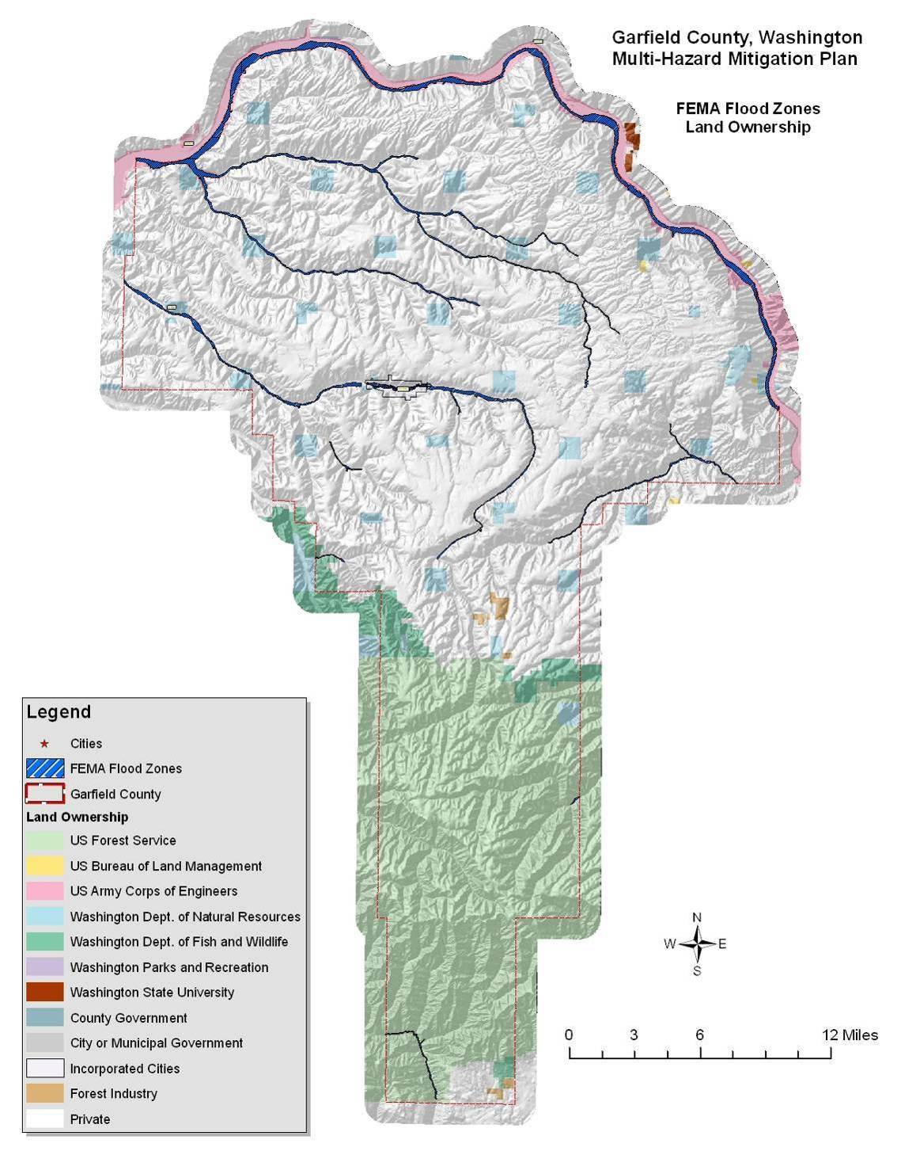

Value of Resources at Risk
There are approximately 200 parcels within the FEMA-identified floodplains (100- and 500-year) in unincorporated areas of Garfield County, yielding a total improvement value of $13.9 million. There are currently no repetitive loss properties in Garfield County. The average damage to structures was estimated based on the parcel’s location as either completely within or out of the flood zone. The estimated value of contents is ½ the value of the improvements equating to an additional $7 million in potential losses. In reality, the damages will most likely not be equally distributed between buildings based on building materials, building location, and flood location. However, these estimates provide a basic approximation.
Critical infrastructure located within the identified floodplain for the unincorporated areas of the County includes the Central Ferry Bridge, Lower Granite Dam, two electrical substations (one at Lower Granite Dam and one at Weimer Gulch and Meadow Creek), Butler Spring, and the water well near the Fairgrounds.
Participation in the National Flood Insurance Program (NFIP) and subsequent adoption of the Uniform Building Codes, or more stringent local building codes, provide basic guidelines to communities on how to regulate development. When a county participates in the NFIP it enables property owners in the county to insure against flood losses. By employing wise floodplain management, a participating county can protect its citizens against much of the devastating financial loss resulting from flood disasters. Careful local management of development in the floodplains results in construction practices that can reduce flood losses and the high costs associated with flood disasters to all levels of government.
Table 5.9. NFIP Policy Statistics As of 12/31/09 in Garfield County.
Community Name | Policies In-Force | Insurance In-Force | Written Premium In-Force | FIRM Effective Date | Floodplain Ordinance/ Manager | CRS Ranking
Garfield County (unincorporated) | 9 | $271,000 | 2,422 | 11/15/1977 | No/Yes | NA
Pomeroy | 58 | 5,369,600 | $44,363 | 9/30/1993 | Yes/Yes | NA
An important part of being an NFIP community is the availability of low cost flood insurance for those homes and businesses within designated flood plains, or in areas that are subject to flooding, but that are not designated as Special Flood Hazard Areas.
Overall participation by individuals and business in the NFIP appears to be low. Potential reasons are:
- A lack of knowledge about the existence of the availability of low cost flood insurance.
- Home and business owners unaware of their vulnerability to flood events.
- Current cost of insurance is prohibitive.
The first two reasons can be addressed through public education. The third could be addressed by all communities in the county taking advantage of the Community Rating System (CRS). To encourage communities to go beyond the minimum requirements and further prevent and protect against flood damage, the NFIP established the Community Rating System (CRS). To qualify for CRS, communities can do things like make building codes more rigorous, maintain drainage systems, and inform residents of flood risk. In exchange for becoming more flood-ready, the CRS community's residents are offered discounted premium rates. Based on your community's CRS ratings, you can qualify for up to a 45% discount of your annual flood insurance premium.

Earthquake
Based on historical records, Garfield County has not experienced any seriously damaging earthquakes in recorded history. Several distant earthquakes produced intensities strong enough to be felt in southeastern Washington, but only two earthquakes epicenters, one in 1893 and another in 1936, were recorded for the region. Both of these earthquakes were rated as a VII on the Modified Mercalli intensity scale and produced only very slight property damages such as broken dishes and cracked plaster.
Garfield County can expect some structural failure of older multistory unreinforced masonry buildings as a result of even lower intensity earthquakes. Cornices, frieze, and other heavy decorative portions of these types of structures may fail. The potential impacts of a substantial earthquake event are highly variable. Many of the structures and infrastructure throughout the county may not incur any damages at all; however, damage to roads, bridges, unreinforced masonry, chimneys, foundations, water lines, and many other components are at risk. Fires can also be a secondary hazard to structures sustaining earthquake damage.
Because structural damage by earthquakes is typically not complete destruction, but rather tends to be subtle cracking or settling that undermines the stability of the structure. These types of repairs can be very costly. Additionally, changes to the water table or even the topography can significantly impact local municipal and private wells and could result in the loss of traditional land uses.
There are two fault lines in Garfield County. One is a short segment located near Dodge and running due north to the Snake River. The other begins south of Pomeroy and runs in a southwestern direction into Columbia County. Neither of these faults is currently active. As seen in Figure 5.12, Garfield County has a 10% chance of exceeding a 6-7% pga in the next 50 years. No specific jurisdictions or special districts were identified as having differing issues or levels of risk associated with this hazard.
Figure 5.12. Regional Earthquake Probability Map.
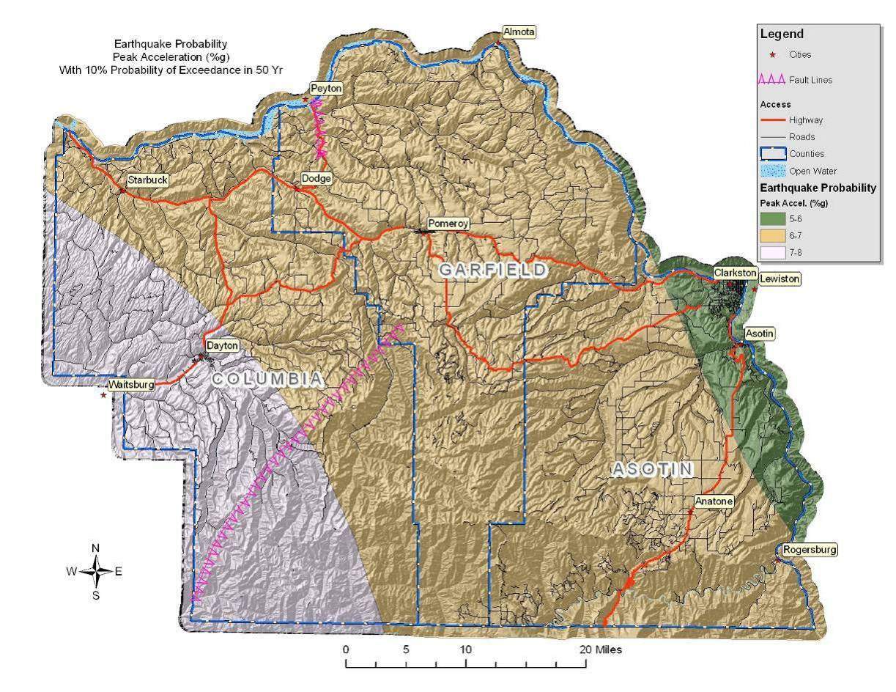
Past events suggest that an earthquake in the Garfield County area would cause little to no damage. Nonetheless, severity can increase in areas that have softer soils, such as unconsolidated sediments. Damage would be negligible in buildings of good design and construction; slight to moderate in well-built ordinary structures; and considerable in poorly built, old, or badly designed structures.

Value of Resources at Risk
Unreinforced masonry (URM) structures and unreinforced chimneys of homes will likely be damaged in the event of an earthquake. Damaged or collapsed chimneys could result in the secondary hazard of fire. Nonstructural damage caused by falling and swinging objects may be considerable after any magnitude earthquake. Damage to some older, more fragile bridges and land failure causing minor slides along roadways may isolate some residents.
There are no known publicly accessible unreinforced masonry buildings in the unincorporated areas of Garfield County. The number and value of unreinforced masonry homes or homes with masonry chimneys throughout Garfield County is unknown.

Landslide
To date, there is no recorded history of major landslides occurring in Garfield County. Nevertheless, there are some areas in Columbia County that have specific landslide concerns. Areas that are generally prone to landslides are:
- On existing landslides, old or recent
- On or at the base or top of slopes
- In or at the base of minor drainage hollows
- At the base or top of an old fill slope
- At the base or top of a steep cut slope
The majority of the landslide potential in Garfield County occurs in the more remote areas of the Blue Mountains on the southern end of the County as well as along some sections of the Snake River. Most of the landslide damage potential due to development occurs in east Pomeroy and a small populated area near Lower Granite Dam. The probability of occurrence of major, high velocity landslide hazard events, including those caused by severe local storms, is low.
February 1996 – Stafford Act disaster assistance totalled $113 million and Small Business Administration disaster loans approved $61.2 million. The National Weather Service, Seattle Forecast Office considers this storm one of the top 10 weather events in Washington during the 20th Century. Near-record snowfall in January followed by warm, heavy rain, mild temperatures and snowmelt in February caused flooding, mudflows and landslides throughout the state. The storm caused three deaths, and 10 people were injured. Landslides damaged or destroyed nearly 8,000 homes, and closed traffic along major highways for several days. Damage from all causes throughout the Pacific Northwest was at least $800 million. The landslide that created the most significant impact blocked Interstate 5 and the state’s main north-south railroad tracks three miles north of Woodland, Cowlitz County. The initial slide on February 8 blocked northbound lanes of I-5; a second, larger slide covered all lanes of the freeway as well as the railroad tracks to the west. It took crews until February 19 to fully reopen the interstate. The highest concentration of landslides occurred at the northwest edge of the Blue Mountains near Walla Walla. The main areas affected were the Mill Creek, Blue Creek, Touchet, Tucannon, and Walla Walla drainages. Debris flows were most numerous on open, grassy hillsides. In the Mill Creek area, debris flows destroyed seven vehicles and five homes. Similar occurrences of flooding and landslides took place in 1931 and 1964.
The only major populated areas and infrastructure in Garfield County occurs in the rolling hills of the Columbia Basin. There is a moderate probability of small slides occurring on slopes ranging from 5-35%. This type of slide is common on the eyebrows of hills, especially where there has been soil disturbance. Generally, these low angle slides will have a low velocity and will not impact structures or infrastructure.
Soil factors that increase the potential for landslide are soils developed from parent materials high in schist and granite, and soils that are less permeable containing a resistive or hardpan layer. These soils tend to exhibit higher landslide potential under saturated conditions than do well drained soils. To determine the high-risk soils in Garfield County, the NRCS State Soils Geographic Database (STATSGO) layer was used to identify the location and characteristics of all soils in the County. The specific characteristics of each major soil type within the County were reviewed. According to this database, it was determined that the soils in Garfield County generally are not developed from schist and granitic parent materials, indicating that landslide potential is primarily due to factors associated with gravity and slope.
To portray areas of probable landslide risk due to slope related factors, slope models were used to identify areas of low, moderate and high risk. This analysis identified the low risk areas as slopes in the range of 20°-25° (36-46%), moderate as 26°-30° (48-60%) and high risk as slopes in the range of 31°-60° (60-173%). Slopes that exceeded 60° (173%) were considered low risk due to the fact that sliding most likely had already occurred relieving the area of the potential energy needed for a landslide. From the data layer created by this analysis, it is possible to depict areas of risk and its proximity to development and human activity. With additional reconnaissance, the areas of high risk were further defined by overlaying additional data points identifying actual slide locations, thus improving the resolution by specifically identifying the highest risk areas. This method of analysis is similar to a method developed by the Clearwater National Forest in north central Idaho.
Figure 5.13. Garfield County Landslide Prone Landscapes.
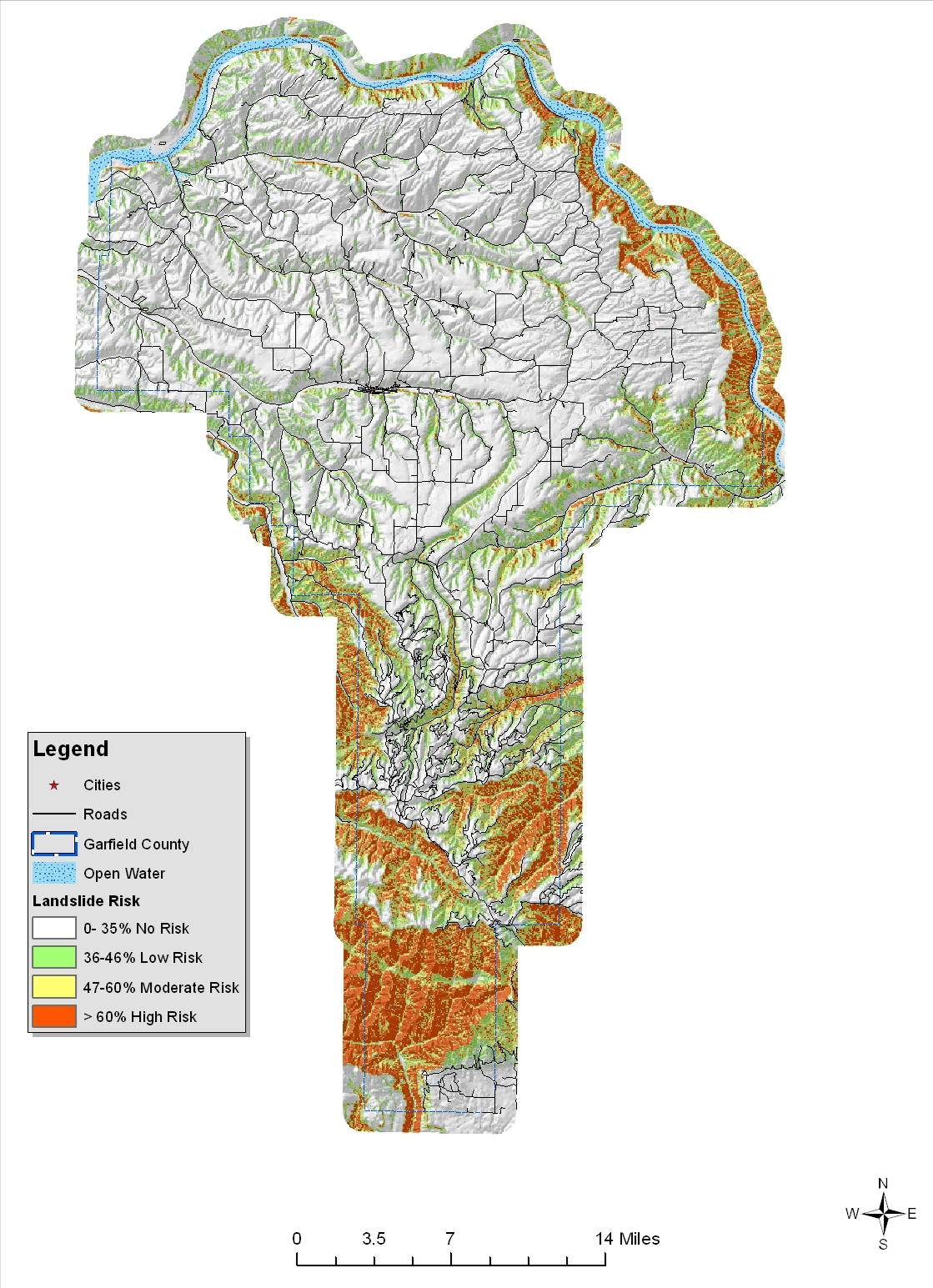
While a large portion of Garfield County is at high risk to landslides, most of this area occupies the most remote mountainous regions. Home and business development in the County has been mainly on lands not at significant risk to landslides.
Much of the populated areas in Garfield County are at risk to flooding, which often results in damaging landslides. Flash floods typically carry large amounts of debris, silt, and rocks that are deposited in downstream floodplains. Additionally, soil saturation ensuing from prolonged periods of rain or flooding can lead to slope instability. Cut and fill slopes, even those well outside of the flood plain, are particularly at risk to slides and/or slumping as a result of soil saturation.
The Lower Granite Landslide Impact Zone encompasses a small population cluster along the Snake River just upstream of Lower Granite Dam on the northern border of the County. In addition to the residences, this Impact Zone may affect the Wawawai Grade.
The slopes in this impact zone are comprised by material deposited by past landslides. In fact, much of the lower slopes near the valley floors are alluvial fans created by sediment being carried downstream and deposited at the mouths of the several small drainages in that area. The presence of this material indicates the historic occurrence of high-energy, short duration floods and debris flows in these chutes in response to severe climatic conditions, such as thunderstorms and rain-on-snow events. These events are historically infrequent, with recurrence cycles on the order of years to decades. However, they can result in significant damage to buildings and infrastructure, disrupt travel, reduce water quality, and jeopardize safety.
The largest landslides typically occur where human development or disturbance has exposed landslide-prone sediments to steep topography. Today, initiation and reactivation of landslides is closely tied to unusual climatic events and land-use changes. Even small landslide activity on the upper slopes can transform into high-energy debris flows that endanger roads, buildings, and people below. Landslide debris is highly unstable when modified through natural variations in precipitation, artificial cuts, fills, and changes to surface drainage and ground water.
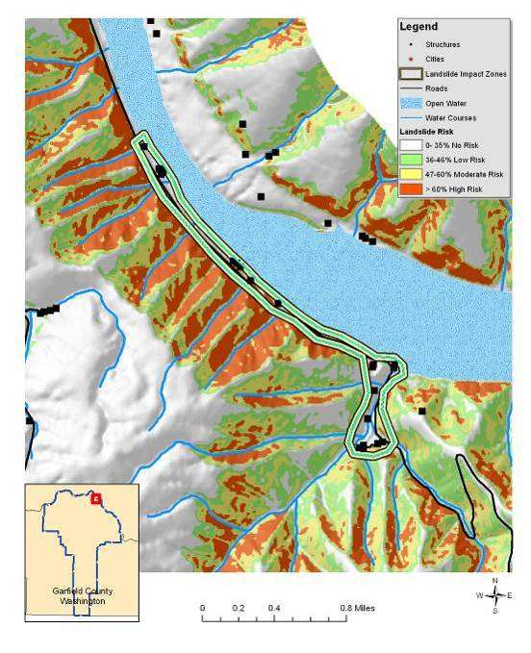
Lower Granite Landslide Impact Zone
The primary slope stability problem is associated with the sediments within and along the boundary of the Snake River. The occurrence of new landslides and the reactivation of old landslides increased dramatically with the filling of reservoirs behind the Lower Granite Dam. Drawdowns for flood control and power generation also trigger new landslides and/or reactivate and extend old ones. With landslide activity relatively common along hundreds of miles of shoreline, one hazard in such a setting is water waves generated byfast-moving landslide masses.
Wildfires in this impact zone could cause a domino effect of multiple hazards. Higher intensity fires not only remove most of the vegetation, but they also cause soils to become hydrophobic or water repellent for a period of time after the fire. This combination leads to unusually high runoff after rain showers or during the spring runoff season. As streams and rivers begin to reach and exceed flood stage, bank failures and channel migration are common. Road building and other soil disturbances tend to exacerbate this effect leading to even more severe land and soil slides.

Value of Resources at Risk
The cost of cleanup and repairs of roadways is difficult to estimate due to the variable circumstances with each incident including size of the slide, proximity to a State or County shop, and whether the slide occurred on the cut slope or the fill slope. Other factors that could affect the cost of the damage may include culverts, streams, and removal of debris. This type of information is impossible to anticipate; thus, no repair costs for damaged roadways have been estimated.
There are currently 22 structures located in the Lower Granite Landslide Impact Zone with a total estimated value of approximately $1.5 million.
Slides in this impact zone are more likely to be larger and more damaging as weaknesses in the underlying rock formations give way. Although infrequent, this type of slide has the potential to not only block, but destroy road corridors, dam waterways, and demolish structures. There are numerous homes in this impact zone; however, for the most part, they are widely scattered. Thus, single slide events will not likely impact the entire population, but rather individual structures. Much of the Wawawai Grade through this area, could be at risk from slides.

Severe Weather
Severe weather in Garfield County ranges from the commonly occurring thunderstorms to hail, tornadoes, high winds, drought, dense fog, lightning, and snow storms.
All of Garfield County is at risk to severe winter weather events and there is a high probability of their continued occurrence in this area. Due to topography and climatologic conditions, the higher mountainous areas are often the most exposed to the effects of these storms. Normally the mountainous terrain and the north/south orientation of the Cascades tend to isolate severe storms into localized areas of the County. For example, higher elevations will receive snowfall, while the valley areas may not. Periodically though, individual storms can generate enough force to impact the entire County at one time. From high winds to ice storms to freezing temperatures, there are all types of winter storms that take place during the course of any given year. Winter conditions can change very rapidly. It is not uncommon to have a snowstorm at night with sunshine the next day. Winter storms with heavy snow, high winds, and/or extreme cold can have a considerable impact on Garfield County; however, most residents are well accustomed to the severe winter conditions in this part of Washington. Power outages and unplowed roads are a frequent occurrence throughout many parts of the County, but most residents are prepared to handle the temporary inconvenience.
Commonly, heavy snow accumulations are the cause of disruptions to normal commuting activities (delays and inability to plow roads and driveways). When coupled with extreme cold weather, severe winter storms have a detrimental impact on residents in Garfield County, particularly the senior population. Severe winter storms also have the potential to cause large losses among livestock and wildlife. Animal losses are usually the result of dehydration rather than cold or suffocation.
Snow loads on roofs, ice-slides off of roofs onto vehicles or other buildings, and damaged frozen pipes are also potential hazards associated with winter weather. These events represent a significant hazard to public health and safety, a substantial disruption of economic activity, and a constant threat to structures during the winter months. An average of at least two severe storms is anticipated each winter in Garfield County. Garfield County is considered to be one of the counties most vulnerable to winter storms and blizzards in Washington according to the Washington State Hazard Mitigation Plan.
January 13, 1950 “The January 1950 Blizzard” - On this date, 21.4 inches of snow fell in Seattle, the second greatest 24-hour snowfall recorded. The snowfall was accompanied by 25-40 mph winds. The storm claimed 13 lives in the Puget Sound area. January had 18 days with high temperatures of 32 degrees or lower. The winter of 1949-50 was the coldest winter on record in Seattle, with an average temperature of 34.4 degrees. Eastern Washington, North Idaho, and parts of Oregon also were paralyzed by the snow – some lower-elevation snow depths reached nearly 50 inches and temperatures plunged into minus teens and twenties. Several dozen fatalities occurred.
1962 Columbus Day Wind Storm - The top weather event in Washington during the 20th Century, according to the National Weather Service, Seattle Forecast Office. This storm is the greatest windstorm to hit the Northwest since weather recordkeeping began in the 19th century, and called the “mother of all wind storms” in the 1900s. All windstorms in the Northwest are compared to this one. The Columbus Day Storm was the strongest widespread non-tropical windstorm to strike the continental U.S. during the 20th century, affecting an area from northern California to British Columbia. The storm claimed seven lives in Washington State; 46 died throughout the impacted region. One million homes lost power. More than 50,000 homes were damaged. Total property damage in the region was estimated at $235 million (1962 dollars). The storm blew down 15 billion board feet of timber worth $750 million (1962 dollars); this is more than three times the timber blown down by the May 1980 eruption of Mount St. Helens, and enough wood to replace every home in the state. Gusts of 88 miles per hour were recorded at Tacoma before power was lost to the recording stations.
February 1996 – Federal Disaster #1100. Stafford Act disaster assistance provided was $113 million. Small Business Administration disaster loans approved totaled $61.2 million. Heavy rainfall, mild temperatures and snowmelt caused flooding and mudslides in Adams, Asotin, Benton, Clark, Columbia, Cowlitz, Garfield, Grays Harbor, King, Kitsap, Kittitas, Klickitat, Lewis, Lincoln, Pierce, Skagit, Skamania, Snohomish, Spokane, Thurston, Wahkiakum, Walla Walla, Whitman and Yakima counties, and the Yakama Indian Reservation. This storm caused major flooding on rivers of western and southeast Washington. Mudslides occurred throughout the state. Three deaths, 10 people injured. Nearly 8,000 homes damaged or destroyed. Traffic flow both east and west, and north and south along major highways was shut down for several days. An avalanche closed Interstate 90 at Snoqualmie Pass. Mudslides in Cowlitz County and flooding in Lewis County closed Interstate 5. Damage throughout the Pacific Northwest estimated at $800 million.
December 1996 - January 1997 – Federal Disaster #1159. Stafford Act disaster assistance provided was $83 million. Small Business Administration loans approved totaled 31.7 million. Saturated ground combined with snow, freezing rain, rain, rapid warming and high winds within a five-day period produced flooding and landslides. Impacted counties – Adams, Asotin, Benton, Chelan, Clallam, Clark, Columbia, Cowlitz, Douglas, Ferry, Franklin, Garfield, Grant, Grays Harbor, Island, Jefferson, King, Kitsap, Kittitas, Klickitat, Lewis, Lincoln, Mason, Okanogan, Pacific, Pend Oreille, Pierce, San Juan, Skagit, Skamania, Snohomish, Spokane, Stevens, Thurston, Walla Walla, Whatcom, and Yakima. Twenty-four deaths; $140 million (est.) in insured losses; 250,000 people lost power. More than 130 landslides between Seattle and Everett, primarily along shorelines. Interstate 90 at Snoqualmie Pass was closed due to avalanche. High winds and ice contributed to the repeated and extended power outages to rural power customers in Garfield, Asotin, and Columbia Counties. This storm also resulted in numerous rural residences being cutoff from any emergency service response for several days, due to drifting snow. The accumulations aggravated by rain, drifting snow, and ice in roof drains caused excessive weight and the collapse of structures.
1997 Tornadoes – There are 14 tornadoes on record for Washington in 1997. In May of that year, Tacoma experienced a small tornado that did an estimated $125,000 damage in a narrow swath across ten city blocks. Tornadoes also touched down north of Asotin County and east of Vancouver the same day. Tornadoes within this region are infrequent and touchdowns are not consistent or specific to any particular area within the region.
December 14-15 2006 Windstorm - Federal Disaster # 1682. The most powerful windstorm since the Inauguration Day Storm of 1993 slammed into Washington State with 90 MPH winds on the Coast, gusts up to 70 MPH in the Puget Sound basin, and peak winds well over 100 MPH along the Cascade Crest. Up to 1.5 million residents were without power for up to 11 days. The storm resulted in 15 deaths (including 8 from carbon monoxide poisoning). Governor Gregoire proclaimed an emergency for all 39 Counties. Total damages are still being tallied but will exceed 50 million dollars.
March 2, 2009 - President Obama declared that a major disaster exists in the State of Washington. This declaration made Public Assistance requested by the Governor available to State and eligible local governments and certain private nonprofit organizations on a cost-sharing basis for emergency work and the repair or replacement of facilities damaged by the severe winter storm and record and near record snow in Clallam, Clark, Columbia, Cowlitz, Garfield, Grays Harbor, Island, Jefferson, King, Klickitat, Lewis, Lincoln, Mason, Pacific, Pend Oreille, Skagit, Skamania, Snohomish, Spokane, Stevens, Thurston, Wahkiakum, Walla Walla, and Whatcom Counties. This declaration also made emergency protective measures (Category B), including snow removal assistance, under the Public Assistance program, requested by the Governor, available in Adams, Asotin, Benton, Chelan, Clallam, Columbia, Cowlitz, Franklin, Grays Harbor, Jefferson, King, Kittitas, Klickitat, Lewis, Mason, Pacific, Pierce, Skagit, Skamania, Snohomish, Spokane, Thurston, Wahkiakum, Walla Walla, Whatcom, Whitman, and Yakima for any continuous 48-hour period during or proximate to the incident period. Finally, this declaration made Hazard Mitigation Grant Program assistance requested by the Governor available for hazard mitigation measures statewide. Garfield County reported $154.71 per capita impact from this event, which was by far the highest in the State (statewide average countywide per capita was $3.28).
Due to their relative frequency and minimal severity, severe thunderstorms are not well documented in Garfield County. Their impacts are fairly limited and do not significantly affect the communities enough to declare a disaster. The secondary impacts of thunderstorms, floods, are emphasized within the flood chapter of this document. Garfield County is considered to be one of the counties most vulnerable to severe thunderstorms according to the Washington State Hazard Mitigation Plan. Areas most vulnerable to this type of storm are those subject to a strong southwesterly flow of moist, unstable air that generates strong, sometimes violent thunderstorms with one or more of the following characteristics: strong damaging winds, large hail, waterspouts, or tornados.
Hail can occur in any strong thunderstorm, which means hail is a threat everywhere. Hail is precipitation that is formed when updrafts in thunderstorms carry raindrops upward into extremely cold areas of the atmosphere. Large hail stones can fall at speeds faster than 100 miles per hour. Hail damage in Washington is very small in comparison with damage in areas of the central part of the United States. Often the hail that occurs does not grow to a size larger than one-half inch in diameter, and the areas affected are usually small. Quite often hail comes during early spring storms, when it is mostly of the small, soft variety with a limited damaging effect. Later, when crops are more mature and more susceptible to serious damage, hail occurs in widely scattered spots in connection with summer thunderstorms. The potential impacts of a severe hail storm in Garfield County include crop damage, downed power lines, downed or damaged trees, broken windows, roof damage, and vehicle damage. Hail storms can, in extreme cases, cause death by exposure. The most common direct impact from ice storms to people is traffic accidents. Over 85% of ice storm deaths nationwide are caused by traffic accidents. Hail storms also have the potential to cause losses among livestock. The highest potential damage from hail storms in Garfield County is the economic loss from crop damage. Even small hail can cause significant damage to young and tender plants and fruit. Trees can also be severely damaged by hail as was seen in the 1996 ice storm near Spokane, Washington.
Windstorms are frequent in Garfield County and they have been known to cause substantial damage. Under most conditions, the County’s highest winds come from the south or southwest. Due to the abundance of agricultural development in Columbia County, crop damage due to high winds can have disastrous effects on the local economy. In the case of extremely high winds, some buildings may be damaged or destroyed. Wind damages will generally be categorized into four groups: 1) structure damage to roofs, 2) structure damage from falling trees, 3) damage from wind blown dust on sensitive receptors, or 4) wind driven wildfires. Structural injury from damaged roofs is not uncommon in Garfield County. Structural damage from falling trees is also relatively common. Many homeowners have planted ornamental trees for shade and windbreak protections. However, many of these trees are located near, and upwind of homes putting them at risk to falling trees which could cause substantial structural damage and potentially put lives at risk. Airborne particulate matter increases during high wind events. When this occurs, sensitive receptors including the elderly and those with asthma are at increased risk to complications. The National Weather Service defines high winds as sustained winds of 40 mph or gusts of 58 mph or greater, not caused by thunderstorms, expected to last for an hour or more. Areas most vulnerable to high winds are those affected by a strong pressure difference from deep storms originating over the Pacific Ocean; an outbreak of very cold, Arctic air originating over Canada; or air pressure differences between western and eastern Washington that primarily affect the Columbia River Gorge, Cascade Mountain passes, ridges and east slopes, and portions of the Columbia Basin. Garfield County is not considered to be one of the most vulnerable to high winds in Washington State according to the Washington State Hazard Mitigation Plan.
Garfield County and the entire region are at increased risk to wildfires during high wind events. Ignitions can occur from a variety of sources including downed power lines, lightning, or arson. Once ignited, only wildfire mitigation efforts around the community and scattered homes will assist firefighters in controlling a blaze. Details about wildfire mitigation are discussed in the wildland fire annexes of this Multi - Hazard Mitigation Plan.
A tornado is formed by the turbulent mixing of layers of air with contrasting temperature, moisture, density, and wind flow. This mixing accounts for most of the tornadoes occurring in April, May, and June, when cold, dry air from the north or northwest meets warm, moister air moving up from the south. If this scenario was to occur and a major tornado was to strike a populated area in Garfield County, damage could be widespread. Businesses could be forced to close for an extended period, and routine services such as telephone or power could be disrupted. The National Weather Service defines a tornado as a violently rotating column of air that contacts the ground; tornados usually develop from severe thunderstorms. Areas most vulnerable to tornado are those subject to severe thunderstorms or those with a recurrence rate of 5 percent or greater, meaning the County experiences one damaging severe thunderstorm event at least once every 20 years.
According to the Tornado Project and the National Weather Service there has been no tornadoes reported for Garfield County between 1880 and 2009.

Value of Resources at Risk
It is difficult to estimate the cost of potential winter storm damages to structures and the economy in Garfield County. Damage to roofs by heavy snow accumulations depends on the moisture content of the snow and the structural characteristics of the buildings. In general, snow in this region tends to have low moisture content because of the low temperatures and arid environment. However, heavy snow is not uncommon. Frozen water pipes are the most common damage to residential and business structures. Older homes tend to be at a higher risk to frozen water pipes than newer ones. Snow plowing in Garfield County occurs from a variety of departments and agencies. The state highways are maintained by the State of Washington. Plowing of county roads is done by the Columbia County Public Works Department and the city of Pomeroy road department. Private landowners are responsible for maintaining their own driveways or other private roads. Utility supplies are impacted during severe winter storms as power is lost on a regional basis. This has a two-fold impact on Garfield County residents as not only is power cut to homes and businesses, but primary heating is lost for many residents. Gas furnaces and wood stoves supplement electrical heating, but with wood heating the senior population is at a disadvantage. Emergency response to severe winter storms includes site visits by police or fire department personnel, opening of shelters, or assistance with shopping, medical attention, and communications. The economic losses caused by severe winter storms may frequently be greater than structural damages. Employees may not be able to travel to work for several days and businesses may not open. Damages are seen in the form of structural repair and loss of economic activity. Garfield County schools are occasionally closed during and right after a severe winter storm because of cold temperatures and snow covered roads.
Thunderstorms do occur within Washington affecting all counties, but usually are localized events. Their impacts are fairly limited and do not significantly affect the communities enough to declare a disaster. The loss potential from flooding that results from severe thunderstorms can be significant in Garfield County.
Although the financial impacts of hail can be substantial and extended, accurately quantifying these impacts is problematic. Hail typically causes direct losses to structures and other personal property as well as to the vast forestlands and extensive agricultural development in Garfield County. The most significant losses are most clearly seen in the agriculture sectors of the County’s economy. Potential losses to agriculture can be disastrous. They can also be very localized; thus, individual farmers can have significant losses, but the event may not drastically affect the economy of the County. Furthermore, crop damage from hail will also be different depending on the time of year and the type of crop. Most farmers carry insurance on their crops to help mitigate the potential financial loss resulting from a localized hail storm. Federal and state aid is available for County’s with declared hail disasters resulting in significant loss to local farmers as well as the regional economy. Homeowners in Garfield County rarely incur severe damage to structures (roofs); however, hail damage to vehicles is not uncommon. The damage to vehicles is difficult to estimate because the number of vehicles impacted by a specific ice storm is unknown. Additionally, most hail damage records are kept by various insurance agencies.
It is difficult to estimate potential losses in Garfield County due to windstorms and tornadoes. Construction throughout the County has been implemented in the presence of high wind events, and therefore, the community is at a higher level of preparedness to high wind events than many other areas experiencing lower average wind speeds.
We have estimated losses based on wind and tornado damage as follows:
- 3% of the buildings damaged causing 50% of value loss (loss could be from downed or damaged trees, damaged outbuildings, damaged fences/poles, damage to siding, damaged landscaping etc.)
- 5% of the buildings received damage to roof (requiring replacement of roof equaling $3,000)
Damages associated with sensitive receptor irritation have not been estimated. We have also not estimated the potential for a large scale wildfire event associated with high winds. Based on the data provided by the County, there are 1,703 total assessed improvements in Garfield County with a total value of approximately $118 million. Using the criteria outlined above an estimate of the impact of high winds on in the County has been made. The potential wind and tornado damage to all buildings is estimated at approximately $1.8 million. The estimated damage to roofs is approximately $255,450.
Power failure often accompanies severe storms. More rural parts of the County are sometimes better prepared to deal with power outages for a few days due to the frequent occurrence of such events; however, prolonged failure, especially during cold winter temperatures can have disastrous effects. All communities should be prepared to deal with power failures. Community shelters equipped with alternative power sources will help local residents stay warm and prepare food. A community-based system for monitoring and assisting elderly or disabled residents should also be developed. All households should maintain survival kits that include warm blankets, flashlights, extra batteries, nonperishable food items, and clean drinking water.

Wildland Fire
The Garfield County Community Wildfire Protection Plan provides a comprehensive analysis of the wildland fire risks and recommended protection and mitigation measures for all jurisdictions in Garfield County. The information in the “Wildland Fire” sections of this Garfield County Annex is excerpted from that more detailed document.
Vegetative structure and composition in Garfield County is closely related to elevation, aspect, and precipitation. Relatively mild and dry environments characterize the undulating topography of the region which transitions from the Snake River valley riparian plant communities to the rangeland ecosystems that characterize the vast majority of the land area in Garfield County. Forested communities extend this transition as elevations increases, soils change, and conditions favor forest tree species. Forests contain high fuel accumulations that have the potential to burn at moderate to high intensities. Highly variable topography coupled with dry, windy weather conditions typical of the region is likely to create extreme fire behavior.
The transition between developed agricultural land and timberlands occurs somewhat abruptly, usually along toe slopes or distinct property boundaries. At higher elevation mountainous regions, moisture becomes less limiting due to a combination of higher precipitation and reduced solar radiation. Vegetative patterns shift from forested communities dominated by ponderosa pine, western larch, grand fir, and Douglas-fir at the lower elevations to lodgepole pine and subalpine fir at the higher elevations. Engelmann spruce is found in moist draws and frost pockets. These forested conditions possess a greater quantity of both dead and down fuels as well as live fuels. Rates of fire spread tend to be lower than those in the grasslands; however, intensities can escalate dramatically, especially under the effect of slope and wind. These conditions can lead to control problems and potentially threaten lives, structures and other valued resources.
As elevation and aspect increase available moisture, forest composition transitions to moister habitat types. Increases in moisture keep forest fuels unavailable to burn for longer periods during the summer. This increases the time between fire events, resulting in varying degrees of fuel accumulation. When these fuels do become available to burn, they typically burn in a mosaic pattern at mid elevations, where accumulations of forest fuels result in either single or group tree torching, and in some instances, short crown fire runs. At the highest elevations, fire events are typically stand replacing, as years of accumulation fuel large, intense wildfires.
Insects and disease can cause widespread mortality of forest stands in a very short amount of time. Mountain pine beetle populations have continued to increase at epidemic levels throughout Washington State; however, mortality increases are most pronounced in Eastern Washington. Ponderosa pine and lodgepole pine seem to be the most affected species at all elevations in Garfield County. The occurrence of ips beetles, Douglas-fir bark-beetle, Douglas-fir tussock moth, and root disease have also been recorded in Eastern Washington (Washington State Department of Natural Resources 2006). Insects and disease often focus and cause the most mortality in forest stands that are overcrowded or otherwise stressed by drought, recent fires, or other factors. Large areas of dead trees are a significant fire hazard. Oftentimes, dry, dead needles hang on the killed trees for several years making them prime for a potential ignition and subsequent crown fire. Thinning overcrowded stands can help reduce stress on individual trees allowing them to better withstand insect attacks. Planting of appropriate species for the site and continual management can also help ward off future outbreaks.
Many lower elevation forested areas throughout Garfield County are highly valued for their scenic qualities as well as for their proximity to forest travel corridors. These attributes have led to increased recreational home development and residential home construction in and around forest fuel complexes. The juxtaposition of highly flammable forest types and rapid home development will continue to challenge the ability to manage wildland fires in the wildland-urban interface.
The slight to undulating topography and moisture availability across much of Garfield County facilitates extensive farming operations, especially in the northern half of the county. Agricultural fields infrequently serve to fuel a fire after curing; burning in much the same manner as consistent low grassy fuels. Fires in grass and rangeland fuel types tend to burn at relatively low intensities, with moderate flame lengths and only short-range spotting. Suppression resources are generally quite effective in such fuels. Homes and other improvements can be easily protected from the direct flame contact and radiant heat through adoption of precautionary measures around the structure. Although fires in these fuels may not present the same control problems as those associated with large, high intensity fires in timber fuel types, they can cause significant damage if precautionary measures have not taken place prior to a fire event. Wind driven fires in these short grass fuel types spread rapidly and can be difficult to control. During extreme drought and when pushed by high winds, fires in grassland fuel types can exhibit extreme rates of spread, thwarting suppression efforts.
The Umatilla National Forest boundary is located approximately twelve miles south of Pomeroy. This area is a patch-work of dry ponderosa pine and Douglas-fir woodlands that, in many areas, have begun suffering from forest health issues. In addition, tree regeneration is resulting in multistoried conditions with abundant ladder fuels. During pre-settlement times, much of this area was characterized by low intensity fires due to the relatively light fuel loading, which mostly consisted of small diameter stems. Frequent, low intensity fires generally kept stands open; free of fire intolerant species and maintained seral species such as ponderosa pine as well as larger diameter fire resistant Douglas-fir. In some areas, low intensity fires stimulated shrubs and grasses, maintaining vigorous browse and forage. The shrub layer could either inhibit or contribute to potential fire behavior, depending on weather and live fuel moisture conditions at the time of the burn.
Increased activities by pathogens will continue to increase levels of dead and down forest fuels, as host trees succumb to insect attack and stand level mortality increases. Overstocked, multi-layered stands and the abundance of ladder fuels lead to horizontal and vertical fuel continuity. These conditions, combined with an arid and often windy environment, can encourage the development of a stand replacing fire. These fires can burn with very high intensities and generate large flame lengths and fire brands that can be lofted long distances. Such fires present significant control problems for suppression resources, often developing into large, destructive wildland fires.
A probability that needs to be planned for is the likelihood of extended spot fires. Large fires may easily produce spot fires from ½ to 2 miles away from the main fire. How fire suppression forces respond to spot fires is largely dependent upon the fuels in which they ignite. Stands of timber that are managed for fire resilience are much less likely to sustain torching and crowning behavior that produces more spot fires. The objective of fuel reduction thinning is to change the fuels in a way that will moderate potential fire behavior. If fire intensity can be moderated by vegetation treatments, then ground and air firefighting resources can be much more effective.
Fire was once an integral function of the majority of ecosystems in southeastern Washington. The seasonal cycling of fire across the landscape was as regular as the July, August and September lightning storms plying across the canyons and mountains. Depending on the plant community composition, structural configuration, and buildup of plant biomass, fire resulted from ignitions with varying intensities and extent across the landscape. Shorter return intervals between fire events often resulted in less dramatic changes in plant composition. The fires burned from 1 to 47 years apart, with most at 5- to 20-year intervals. With infrequent return intervals, plant communities tended to burn more severely and be replaced by vegetation different in composition, structure, and age. Native plant communities in this region developed under the influence of fire, and adaptations to fire are evident at the species, community, and ecosystem levels. Fire history data (from fire scars and charcoal deposits) suggest fire has played an important role in shaping the vegetation in the Columbia Basin for thousands of years.
The Washington Department of Natural Resources database of wildfire ignitions includes ignition and extent data from 1977 through 2006 for wildfires responded to by the DNR; however, statistics for several years and known fires are missing. An analysis of the DNR reported wildfire ignitions in Garfield County reveals that during this period approximately only 391 acres burned as a result of 31 wildfire ignitions. This database does not show the School Fire, which burned approximately 52,000 acres in 2005. This was a huge fire event for Garfield County and was started by a tree falling on a power line. This database shows that normally lightning results in the most ignitions as well as the highest number of acres burned.
Table 5.10. Summary of Garfield County Wildfire Ignitions from Washington DNR database.
Cause | Acres Burned | Percent | Number of Ignitions | Percent
Debris Burning | 0 | 0% | 3 | 10%
Lightning | 261 | 67% | 22 | 71%
Logging | 3 | 1% | 1 | 3%
Miscellaneous | 125 | 32% | 3 | 10%
Recreation | 2 | 1% | 2 | 6%
Total | 391 | 100% | 31 | 100%
The U.S. Forest Service has maintained an extensive wildfire database for the period of 1970 – 2006 for fires responded to by the Forest Service. As with the DNR database, the Forest Service’s statistics do not have data for the 2005 School Fire. However, lightning still results in the highest number of ignitions and the greatest number of acres burned. Equipment, debris burning, and campfires have also caused a significant number of acres to burn. Campfires are also the second highest cause of ignitions.
Table 5.11. Summary of Garfield County Ignitions from U.S. Forest Service database.
Cause | Acres Burned | Percent | Number of Ignitions | Percent
Arson | 1 | 0% | 6 | 1%
Campfire | 74 | 10% | 111 | 24%
Debris Burning | 186 | 25% | 11 | 2%
Equipment | 212 | 29% | 9 | 2%
Lightning | 243 | 33% | 307 | 65%
Miscellaneous | 20 | 3% | 11 | 2%
Smoking | 4 | 1% | 14 | 3%
Total | 740 | 100% | 469 | 100%
Both databases show that the highest fire risk for both number of ignitions and acres burned is lightning by a significant majority. Debris burning, equipment (both logging and farming), and campfires also result in numerous ignitions and acres burned each year. This data demonstrates that the aggressive initial attack policy employed by both wildfire agencies and local fire agencies keeps most fires from growing over one acre in size.

Value of Resources at Risk
It is difficult to estimate potential losses in Garfield County from wildland fire due to the unpredictability of wildfire behavior and the nature of ignition sources. It is impossible to forecast the path a wildfire will take and what type of assets and resources, manmade and ecological, will be at risk. Thus, no value estimates were made for this hazard. It is unlikely that the entire county would be threaten by a single fire; however, it is possible that several small fires (lightning strikes) could escape initial attack efforts and cause crews to fight fires on several fronts at once. Under the influence of wind and/or high temperatures/low humidity, multiple fires could burn together within a few days.
Typically, structures located in forested areas without inadequate defensible space or fire resistant landscaping have the highest risk of loss. Nevertheless, homes and other structures located in the grasslands or agricultural regions are not without wildfire risk. Grass fires are often the most dangerous due to high rates of spread. Fires in this fuel type are considered somewhat easier to suppress given the right resources, but they can also be the most destructive.
Ignition potential is high throughout the County. Recreational areas, major roadways, debris burning, and agricultural equipment are typically the most likely human ignition sources. Lightning is also a common source of wildfires in Garfield County.
Garfield County is actively pursuing funds to help with wildland fire mitigation projects and public education programs. While mitigation efforts will significantly improve the probability of a structure’s survivability, no amount of mitigation will guarantee survival.

Avalanche
There have been no reported damages or lives lost due to an avalanche in Garfield County. The only reported occurrence was in 1932 when a small avalanche covered the railroad tracks on the south side of Pomeroy. This event did require crews to shovel off the tracks, but no other damages were reported. The Blue Mountains in the southern part of the County have a high propensity for avalanches; however, there are very few structures or infrastructure in these higher risk areas. Recreational activities such as skiing and snowmobiling are increasing in some of these areas; thus, as more people frequent the area during the winter, the higher the risk. There are currently no avalanche mitigation programs occurring in Garfield County.

Value of Resources at Risk
Garfield County has no assets at significant risk of avalanches due to low snow accumulations in populated areas. The highest potential risk would likely be the result of a skier, snowboarder, snowmobiler, or other recreationist becoming trapped in an avalanche. These areas are generally difficult to access; thus, a rescue attempt may also be difficult.
There is a small possibility that an avalanche could cover a rural section of a County or Forest Service road; however, this type of road is not likely critical to daily travel; thus the damages would likely be minimal.

Tsunami
The northern border of Garfield County is formed by the Snake River. There is a low probability of landslides causing localized tsunamis in this vicinity. There have been no damages reported from this type of occurrence along the Snake River.

Value of Resources at Risk
Due to the very low population density and the lack of infrastructure along the Snake River, it is unlikely that an inland tsunami would cause significant damages within the County. Individual crops, structures, or docks may be damaged, but widespread losses are unlikely. It is also not highly probable that an inland tsunami would have a significant impact on Lower Granite Dam.

Volcano
Garfield County is not directly at risk of experiencing a volcano; however, there is a high probability that ash and other particulates from an eruption in western Washington or Oregon would be carried to and deposited within the County. The Mount St. Helens eruption in 1980 deposited several inches of ash causing widespread damages to vehicles and other equipment in Garfield County. The airborne particulates can also cause respiratory problems for both people and animals. These affects are particularly notable for populations already dealing with respiratory illnesses. Local accounts of the 1980 eruption, did not indicate that the ash deposition adversely affected crops. In fact, some noted that the addition of volcanic ash increased the water retention properties of the soil.

Value of Resources at Risk
Garfield County has no assets at direct risk of being impacted by a volcanic eruption. However, the secondary effects of ash and airborne particulates may have varying degrees of negative effects within the County. Damages to property will likely be limited to vehicles and cleanup costs. Additionally, residents of Garfield County will be at risk to health problems associated with the respiratory effects of breathing airborne particulates.

Drought
Drought is a condition of climatic dryness that is severe enough to reduce soil moisture and water below the minimum necessary for sustaining plant, animal, and human life systems. The severity of drought is measured by the Palmer Index in a range of 4 (extremely wet) to -4 (extremely dry). The Palmer Index incorporates temperature, precipitation, evaporation and transpiration, runoff and soil moisture when designating the degree of drought.
Drought affects water levels for use by industry, agriculture and individual consumers. Water shortages affect fire fighting capabilities through reduced flows and pressures. Drought also affects power production. Much of Washington State’s power is produced by hydro-electric dams. When water levels drop, electric companies cannot produce enough power to meet demand and are forced to buy electricity from other sources. It is often difficult to recognize a drought before being in the middle of it. Droughts do not occur spontaneously, they evolve over time as certain conditions are met. Therefore, it is difficult to measure the losses and gains due to a drought.
Often times, drought is accompanied by extreme heat. When temperatures reach 90 degrees and above, people are vulnerable to sunstroke, heat cramps and heat exhaustion. Pets and livestock are also vulnerable to heat-related injuries. Crops can be vulnerable as well. In past Washington state droughts, wheat has been scorched, apples have sunburned and peeled and yields were significantly lessened.
The Washington State Legislature in 1989 gave permanent drought relief authority to the Department of Ecology and enabled them to issue orders declaring drought emergencies. Nearly all areas of the state are vulnerable to drought. In every drought, agriculture is adversely impacted, especially in non-irrigated areas such as dry land farms and rangelands. Droughts impact individuals (farm owners, tenants, and farm laborers), the agricultural industry, and other agriculture-related sectors.
Problems of domestic and municipal water supplies are historically corrected by building another reservoir, a larger pipeline, a new well, or some other facility. Short-term measures, such as using large capacity water tankers to supply domestic potable water, have also been used. As a result of droughts, agriculture uses new techniques. Federal and state governments play an active role in developing new water projects and soil conservation programs. RCW 43.83B.400 and Chapter 173-66 WAC pertain to drought relief.
Drought increases the danger of forest and wildland fires. Millions of board feet of timber have been lost. Loss of forests and trees increases erosion causing serious damage to aquatic life, irrigation, and power development by heavy silting of streams, reservoirs, and rivers. Low stream flows have created high temperatures, oxygen depletion, disease, and lack of spawning areas for our fish resources.
High quality agricultural soils exist in much of central and northern Garfield County. These areas of the county sustain dry land crops such as wheat that are dependent upon moisture through the winter and spring and dry arid conditions in the summer. While Garfield County does experience droughts, on the whole, they are mild and do not cause long term damage.

Value of Resources at Risk
The most direct impact of drought is economic rather than loss of life or immediate destruction of property. Droughts impact individuals, the agricultural industry, and other related sectors. Additionally, there is increased danger of wildland fires associated with most droughts. Millions of board feet of timber have been lost, and in many cases, erosion occurred which caused serious damage to aquatic life, irrigation, and power production by heavy silting of streams, reservoirs, and rivers.
The 2001 and 2005 drought years caused only minor damages. There were no threats to any critical facilities. Thus, a minor to moderate drought has a low probability of affecting the County’s economy directly.
In the event of an extended drought cycle, water shortages may lead to crop failures, or at the least, the necessity to plant lower value crops that are less water-dependent. The majority of the population is employed either directly by the agriculture industry or to a service industry dependent on agriculture. Crop losses resulting from extended droughts would likely be considered a disaster for Garfield County. Lower water levels may also affect the County’s ability to efficiently transport crops to available markets. Barging of goods on the Snake River could be reduced due to lower water levels.
Domestic and municipal water shortages are also likely to occur during an extended drought. Efforts to conserve water resources, including public education on conservation techniques, are encouraged by Garfield County during the summer months.

City of Pomeroy Annex

Flood
The main channel of Pataha Creek runs directly through the city of Pomeroy on the south side of U.S. Highway 12; primarily between Columbia Street and Pataha Street. Within Pomeroy, flooding is generally limited to large rain-on-snow events such as occurred in 1996 due to the relatively deep stream bed and flood control measures. Flash floods along this stretch of the watershed are not likely to cause significant damage. Nevertheless, debris blockages often occur along Pataha Creek near the trailer park, 9th Street, and 8th Street as well as on 20th and 21st Streets. Debris or ice tends to get caught at bridge abuments causing the channel to become constricted and floodwaters to back up. The city of Pomeroy and Garfield County are aware of the trouble spots and frequently check the channel for blockages that could cause flooding.
Benjamin Gulch is a small tributary of Pataha Creek that joins the main channel from the south at Pomeroy. Benjamin Gulch is prone to both high runoff events and flash flooding. Flash flooding may also occur due to runoff in the much smaller Heaton Gulch, Pomeroy Hill, and Dutch Flat drainages, which also flow into Pataha Creek at Pomeroy. These drainages are normally dry, but due to steep topography and a lack of larger vegetation, flash flooding as a result of a localized storm could have serious impacts on people and structures at the mouth of these draws.
Pomeroy’s municipal water system is supplied by several wells in the area. Flooding as well as several other hazards and numerous potential non-point sources could cause contamination of the water supply or affect the capacity of the system. All of the homes and businesses in Pomeroy and the Pataha area are fed by the municipal system; thus, the impact of these events could affect the majority of the population including the hospital and schools.
Figure 5.14. City of Pomeroy FEMA Flood Insurance Rate Map.
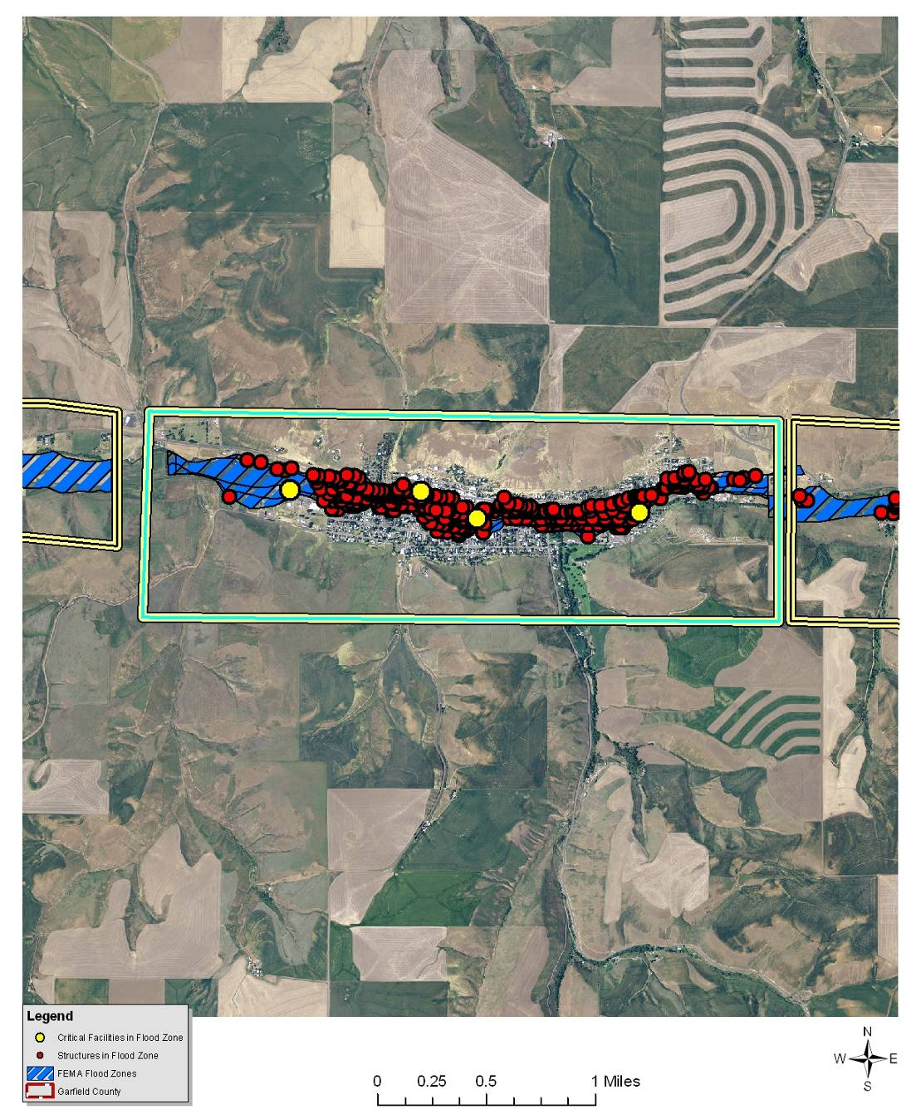
*Blue line does not necessarily represent the city limits boundary.

Value of Resources at Risk
There are approximately 330 parcels within the FEMA-identified floodplains (100- and 500-year) in Pomeroy, yielding a total improvement value of $23 million. The average damage to structures was estimated based on the parcel’s location as either completely within or out of the flood zone. The estimated value of contents is ½ the value of the improvements equating to an additional $11.5 million in potential losses. In reality, the damages will most likely not be equally distributed between buildings based on building materials, building location, and flood location. However, these estimates provide a basic approximation.
Critical infrastructure located within the identified floodplain for Pomeroy includes the City shop, Pomeroy Elementary and High Schools, the Senior Center (also a community shelter), the municipal water system, and the sewer treatment facility. The sewer treatment facility is located on the west end of Pomeroy on the south side of Pataha Creek. The facility is technically located in the floodplain; however, the city has elevated the infrastructure to a height that is not likely to be damaged by normal flood events.

Earthquake
There are no recorded occurrences of earthquakes significantly impacting the city of Pomeroy; however, some minimal shaking has been felt as a result of larger earthquakes elsewhere. Pomeroy has 10% chance of exceeding a 6-7% pga in the next 50 years and does not have any differing issues or levels of risk associated with this hazard than Garfield County as a whole.

Value of Resources at Risk
Unreinforced masonry (URM) structures and unreinforced chimneys of homes will likely be damaged in the event of an earthquake. There are several publicly accessible unreinforced masonry structures in Pomeroy in addition to the numerous homes and other buildings throughout the City with unreinforced chimneys. Damaged or collapsed chimneys could result in the secondary hazard of fire. Nonstructural damage caused by falling and swinging objects may be considerable after any magnitude earthquake. Damage to some older, more fragile bridges and land failure causing minor slides along roadways may isolate some residents.
In Pomeroy, nearly all of the downtown Historic District structures (estimated at 61 structures) are likely unreinforced masonry. Additionally, the Garfield County Courthouse, City Hall, Garfield County Memorial Hospital, the Pomeroy School, the Methodist Church, and the Catholic Church are public buildings constructed of unreinforced masonry. The number and value of unreinforced masonry homes or homes with masonry chimneys in Pomeroy is unknown.
Figure 5.15. City of Pomeroy Historic District.
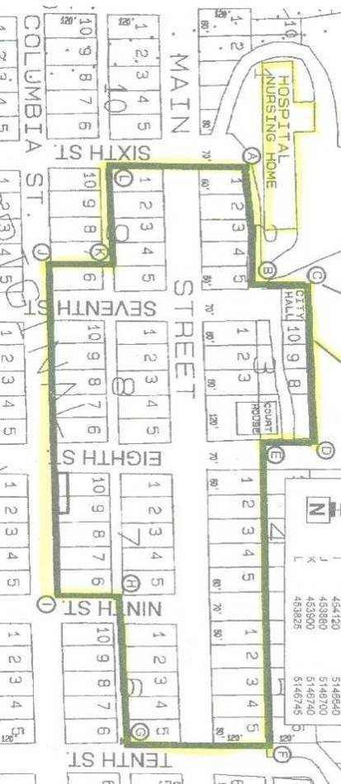

Landslide
To date, there is no recorded history of major landslides occurring in Pomeroy. Nevertheless, there is at least one area that has some specific landslide concerns. Areas that are generally prone to landslides are:
- On existing landslides, old or recent
- On or at the base or top of slopes
- In or at the base of minor drainage hollows
- At the base or top of an old fill slope
- At the base or top of a steep cut slope
Soil factors that increase the potential for landslide are soils developed from parent materials high in schist and granite, and soils that are less permeable containing a resistive or hardpan layer. These soils tend to exhibit higher landslide potential under saturated conditions than do well drained soils. To identify the high-risk soils in Garfield County, the NRCS State Soils Geographic Database (STATSGO) layer was used to identify the location and characteristics of all soils in the County. The specific characteristics of each major soil type within the County were reviewed. According to this database, soils in Garfield County are not highly prone to landslides; thus, slope angle was the major contributing factor for slide potential.
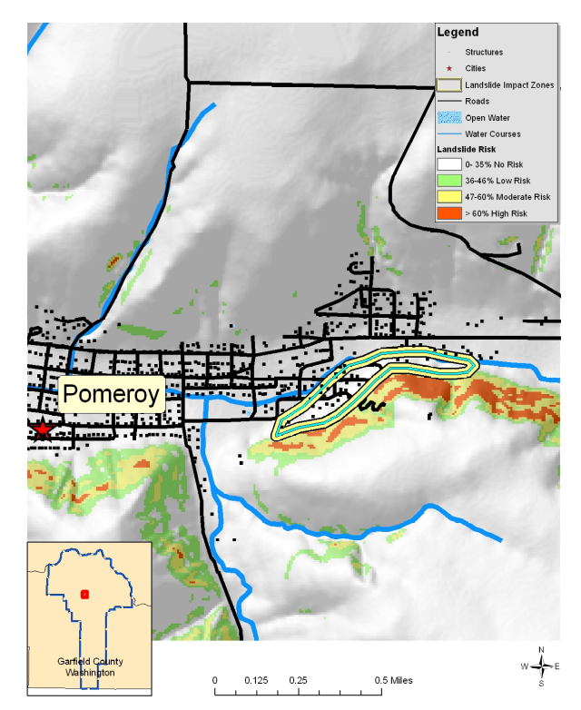
Pomeroy Impact Zone
To portray areas of probable landslide risk due to slope related factors, slope models were used to identify areas of low, moderate and high risk. This analysis identified the low risk areas as slopes in the range of 20°-25° (36-46%), moderate as 26°-30° (48-60%) and high risk as slopes in the range of 31°-60° (60-173%). Slopes that exceeded 60° (173%) were considered low risk due to the fact that sliding most likely had already occurred relieving the area of the potential energy needed for a landslide. From the coverage created by these two methods it is possible to depict areas of risk and their proximity to development and human activity. With additional reconnaissance, the areas of high risk were further defined by overlaying additional data points identifying actual slide locations, thus improving the resolution by specifically identifying the highest risk areas. This method of analysis is similar to a method developed by the Clearwater National Forest in north central Idaho.
The majority of the landslide potential occurs on the southeastern edge of Pomeroy. The slope rising above the structures in this area is relatively steep and the housing development and road building along the toeslope may have decreased the stability of the soil. Additionally, Pataha Creek flows along the base of this slope. In some areas, undermining of the stream bank during floods or even natural migration of the channel could lead to slope instability. The probability of a slide within this impact zone is moderate.
Flash floods typically carry large amounts of debris, silt, and rocks that are deposited in downstream floodplains. Pomeroy Hill and structures out the mouth of this small drainage may be at risk to mud and debris flows resulting from flash flood events. Soil saturation ensuing from prolonged periods of rain or flooding can lead to slope instability. Cut and fill slopes, even those well outside of the flood plain, are particularly at risk to slides and/or slumping as a result of soil saturation.
Wildfires in this impact zone could cause a domino effect of multiple hazards. Higher intensity fires not only remove most of the vegetation, but they also cause soils to become hydrophobic or water repellent for a period of time after the fire. This combination leads to unusually high runoff after rain showers or during the spring runoff season. As streams and rivers begin to reach and exceed flood stage, bank failures and channel migration are common. Road building and other soil disturbances tend to exacerbate this effect leading to even more severe land and soil slides.

Value of Resources at Risk
The cost of cleanup and repairs of roadways is difficult to estimate due to the variable circumstances with each incident including size of the slide and whether the slide occurred on the cut slope or the fill slope. Other factors that could affect the cost of the damage may include culverts, streams, and removal of debris. This type of information is impossible to anticipate; thus, no repair costs for damaged roadways have been estimated.
There are currently 26 structures located in the Pomeroy Impact Zone with a total estimated value of approximately $1.8 million. It is likely that single slide events will not likely impact the entire population, but rather individual structures.
Slides in this impact zone are more likely to be larger and more damaging as weaknesses in the underlying rock formations give way. Although infrequent, this type of slide has the potential to not only block, but destroy road corridors, dam Pataha Creek, and demolish structures.

Severe Weather
The city of Pomeroy does not have any differing levels of risk associated with this hazard than Garfield County as a whole.

Value of Resources at Risk
It is difficult to estimate the cost of potential winter storm damages to structures and the economy in Pomeroy. Damage to roofs by heavy snow accumulations depends on the moisture content of the snow and the structural characteristics of the buildings. In general, snow in this region tends to have low moisture content because of the low temperatures and arid environment. However, heavy snow is not uncommon. Frozen water pipes are the most common damage to residential and business structures. Older homes tend to be at a higher risk to frozen water pipes than newer ones. Snow plowing within the city limits is accomplished by the city’s maintenance crew. Private landowners are responsible for maintaining their own driveways or other private roads. Utility supplies are impacted during severe winter storms as power is lost on a regional basis. This has a two-fold impact on residents as not only is power cut to homes and businesses, but primary heating is lost for many residents. Gas furnaces and wood stoves supplement electrical heating, but with wood heating the senior population is at a disadvantage. Emergency response to severe winter storms includes site visits by police or fire department personnel, opening of shelters, or assistance with shopping, medical attention, and communications. The economic losses caused by severe winter storms may frequently be greater than structural damages. Employees may not be able to travel to work for several days and businesses may not open. Damages are seen in the form of structural repair and loss of economic activity. Pomeroy schools are occasionally closed during and right after a severe winter storm because of cold temperatures and snow covered roads.
Thunderstorms are not likely to be severe enough in Pomeroy to cause significant damages. However, the loss potential from flooding that result from severe thunderstorms could be significant.
Although the financial impacts of hail can be substantial and extended, accurately quantifying these impacts is problematic. Hail typically causes direct losses to structures and other personal property within Pomeroy. The most significant losses are most clearly seen in the agriculture sectors of the economy. Potential losses to agriculture can be disastrous. Crop damage from hail will also be different depending on the time of year and the type of crop. Most farmers carry insurance on their crops to help mitigate the potential financial loss resulting from a localized hail storm. Homeowners in Pomeroy rarely incur severe damage to structures (roofs); however, hail damage to vehicles is not uncommon. The damage to vehicles is difficult to estimate because the number of vehicles impacted by a specific ice storm is unknown. Additionally, most hail damage records are kept by various insurance agencies.
It is difficult to estimate potential losses in Pomeroy due to windstorms and tornadoes. Construction throughout the County has been implemented in the presence of high wind events, and therefore, the community is at a higher level of preparedness to high wind events than many other areas experiencing lower average wind speeds.
We have estimated losses based on wind and tornado damage as follows:
- 3% of the buildings damaged causing 50% of value loss (loss could be from downed or damaged trees, damaged outbuildings, damaged fences/poles, damage to siding, damaged landscaping etc.)
- 5% of the buildings received damage to roof (requiring replacement of roof equaling $3,000)
Damages associated with sensitive receptor irritation have not been estimated. We have also not estimated the potential for a large scale wildfire event associated with high winds. Based on the data provided by the County, there are 990 total assessed buildings in Pomeroy with a total value of approximately $68.9 million. Using the criteria outlined above an estimate of the impact of high winds on in the County has been made. The potential wind and tornado damage to all buildings is estimated at approximately $1 million. The estimated damage to roofs is approximately $148,500.
Power failure often accompanies severe storms. More rural parts of the County are sometimes better prepared to deal with power outages for a few days due to the frequent occurrence of such events; however, prolonged failure, especially during cold winter temperatures can have disastrous effects. All communities should be prepared to deal with power failures. Community shelters equipped with alternative power sources will help local residents stay warm and prepare food. A community-based system for monitoring and assisting elderly or disabled residents should also be developed. All households should maintain survival kits that include warm blankets, flashlights, extra batteries, nonperishable food items, and clean drinking water.

Wildland Fire
Garfield County possesses only one incorporated city, Pomeroy. It is located in the geographic center of the county and is surrounded by native rangelands on moderate to steep slopes and abundant agricultural fields where terrain permits. Pomeroy is the population center of the County as well as the County Seat. It is located along U.S. Highway 12.
The risk from structure loss due to a wildfire entering Pomeroy is moderate. Range fires and agricultural fires have the potential to spread long distances when fanned by high winds.
Rangeland fuels are present along the entire northern and southern border of Pomeroy. These fuels are primarily grass, cheatgrass, and sagebrush intermixed with agriculture fields. Most of the native vegetation in this intermix area is grazed by livestock. Undeveloped sites and vacant lots adjacent to the city pose a potential wildfire threat due to the accumulation of grass fuels unmanaged by the owner. This fuel type is very flashy, but typically does not burn with the intensity of a forestland fuel complex. While these fuels do not generally threaten homes in the area, they could ignite debris and wood structures adjacent to the homes (e.g. firewood stacks, decks, stored lumber, or rubbish). In this manner, these scattered lots within the city limits and adjacent to homes can act as a fuse carrying wildfire from the rangeland to homes. The converse is also true, in that a structure fire can spread to adjacent rangeland fuels, which is then carried to neighboring structures or into the rangeland.
Identification of the vacant lots in the area which support rangeland fuels and are on steep slopes, especially those leading to homes perched on the top of ridges, is critical to reducing the wildfire risk in Pomeroy.
There are many ornamental trees around homes and within parks maintained within Pomeroy. These hardwoods and softwoods do not pose a substantial wildfire risk in that most are maintained in a green and lush condition for the majority of the fire season.
Pomeroy is at moderate risk to a wildfire threatening the city; however, structure fires within the city have some potential to spread from one structure to another; either carried by radiant heat or spread through common vegetation between structures. This risk is lessened by the presence of an active fire protection district.
The Garfield County Fire District #1 provides both structural and wildland fire protection to all of Garfield County. A complete system of fire hydrants is present in the city. Access by fire protection apparatus is generally adequate within the city; however, there are ingress/egress issues in some areas of the unincorporated county such as unrated bridges, steep or narrow driveways, and high risk fuels abutting the roadway.
All of the private lands in Garfield County have joint jurisdiction with the Washington Department of Natural Resources (DNR). Under joint jurisdiction, it is recognized that the fire district has primary responsibility for structure protection and the DNR will have primary responsibility for wildland fire suppression on state and private lands. The DNR provides wildfire protection during fire season between April and October with varying degrees of available resources in the early spring and late autumn months. U.S. Forest Service responds to all wildland fires on their jurisdiction and may also respond to wildland fires on private or state lands based on a closest forces, reciprocal agreement with the DNR when resources are available.

Value of Resources at Risk
It is difficult to estimate potential losses in Pomeroy from wildland fire due to the unpredictability of wildfire behavior and the nature of ignition sources. It is impossible to forecast the path a wildfire will take and what type of assets and resources, manmade and ecological, will be at risk. Thus, no value estimates were made for this hazard.
Typically, structures located in forested areas without an adequate defensible space or fire resistant landscaping have the highest risk of loss. Nevertheless, homes and other structures located in the grasslands or agricultural regions are not without wildfire risk. Grass fires are often the most dangerous due to high rates of spread. Fires in this fuel type are considered somewhat easier to suppress given the right resources, but they can also be the most destructive. Homes along the perimeter of the community would have the highest risk due to their adjacency to wildland fuels.

Avalanche
The city of Pomeroy has very little risk of experiencing an avalanche. The Blue Mountains in southern Garfield County have a high probability of experiencing avalanches in remote areas, however, the city of Pomeroy will not be directly impacted by this type of localized event.
Winter 1932 - In 1932, a small avalanche occurred on the south side of Pomeroy covering the railroad tracks. This slide did not causing any recorded damages.

Value of Resources at Risk
As the 1932 event demonstrates, there is a small possibility of an occurrence; however, there are currently no structures or infrastructure that would be impacted.

Tsunami
Although Garfield County’s northern border has some low probability risk of being impact by an inland tsunami on the Snake River, the city of Pomeroy will not be directly impacted by this type of localized event.

Volcano
The city of Pomeroy does not have any differing levels of risk associated with this hazard than Garfield County as a whole.

Value of Resources at Risk
The city of Pomeroy has no assets at direct risk of being impacted by a volcanic eruption. However, the secondary effects of ash and airborne particulates may have varying degrees of negative effects. Damages to property will likely be limited to vehicles and cleanup costs. Additionally, residents of Pomeroy will be at risk to health problems associated with the respiratory effects of breathing airborne particulates.

Drought
The city of Pomeroy does not have any differing levels of risk associated with this hazard than Garfield County as a whole. However, the city does have its own policies concerning water conservation practices during the dry months. Additionally, the city may develop programs to deal with residents and businesses significantly impacted by drought if necessary.

Value of Resources at Risk
The city of Pomeroy has no assets directly at risk to drought; however, the economic impacts of a drought or a wildland fire caused by extended dry periods would have a great impact on the community. The majority of the population is employed either directly by the agriculture industry or to a service industry dependent on agriculture. Crop losses resulting from extended droughts would likely be considered a disaster for the community.

Garfield County Fire District #1 Annex

Flood
The Fire District is not located in the FEMA-identified floodplain; thus, does not have any differing levels of risk associated with this hazard than Garfield County as a whole. However, a flash flood on Pomeroy Hill and any resulting mudflows could impact the fire station. This type of event could also hinder the District’s response capabilities due to floodwaters or debris blocking the access points.

Value of Resources at Risk
The Garfield County Fire District #1 station in Pomeroy has a small chance of being impacted by flash flooding. The station is valued at $200,000 with an additional $750,000 worth of contents. The ambulance garage is valued at approximately $80,000 with an additional $280,000 worth of contents. During a typically flood event along Pataha Creek, the District provides emergency response capabilities and/or manpower for flood control measures such as sandbagging.

Earthquake
There are no recorded occurrences of earthquakes significantly impacting Garfield County Fire District #1. The area covered by the District has a 10% chance of exceeding a 6-7% pga in the next 50 years and does not have any differing issues or levels of risk associated with this hazard than Garfield County as a whole. However, in the event of a damaging earthquake, Fire District #1 would provide emergency response and search and rescue services.

Value of Resources at Risk
The Garfield County Fire District #1 station in Pomeroy was built with concrete blocks in the 1950s; thus, it is likely an unreinforced masonry structure. The station is valued at $200,000 with an additional $750,000 worth of contents. The ambulance garage is a wood frame structure dating to the 1980s and has a low probability of incurring damage during an earthquake. However, the rock wall near the ambulance bay could be susceptible to shaking damages; possibly toppling into the ambulance garage. The ambulance garage is valued at approximately $80,000 with an additional $280,000 worth of contents.

Landslide
The Fire District does not have any differing levels of risk associated with this hazard than Garfield County as a whole. However, in the event of a significant landslide, Fire District #1 may assist with any necessary evacuations or traffic accident responses.

Value of Resources at Risk
The Garfield County Fire District #1 station in Pomeroy is not at risk to landslides due to its location in a relatively flat, heavily developed area. The District has no other known assets or other resources at risk to landslides.

Severe Weather
The Fire District does not have any differing levels of risk associated with this hazard than Garfield County as a whole. However, in the event of significant severe weather events, Fire District #1 would assist with accident response, delivery of special aid if necessary, and search and rescue missions.

Value of Resources at Risk
The Garfield County Fire District #1 station in the Pomeroy may be at risk to severe high wind events, hail damage, or significant snow accumulations. The District has no other known assets or other resources at risk to severe weather events.

Wildland Fire
Garfield County Fire District #1 covers all of Garfield County. The District provides both structural and wildland fire protection in the city of Pomeroy as well as the surrounding rural areas through an auto-aid agreement. All of the private lands within the fire protection district have joint jurisdiction with the Washington Department of Natural Resources (DNR). Under this joint jurisdiction, it is recognized that the fire district has primary responsibility for structure protection and the DNR will have primary responsibility for wildland fire suppression on state and private lands. The DNR provides wildfire protection during the fire season between April and October with varying degrees of available resources in the early spring and late autumn months.
The Fire District does not have any differing levels of risk associated with this hazard than Garfield County as a whole. However, in the event of a wildland fire, Fire District #1 would provide emergency response, protection, and search and rescue services.

Value of Resources at Risk
The Garfield County Fire District #1 station in Pomeroy is not at risk to wildland fire due to its location in an urban area. The District has no other known assets or other resources at risk to wildland fires.

Avalanche
Although the Blue Mountains in southern Garfield County has a high probability of experiencing avalanches in remote areas, Garfield County Fire District #1 will not be directly impacted by this type of localized event. However, in the event of a significant avalanche event, Fire District #1 may assist with any necessary evacuations or search and rescue operations.

Value of Resources at Risk
The Garfield County Fire District #1 in Pomeroy is not at risk to avalanches due to its location in a relatively flat, heavily developed area. The District has no other known assets or other resources at risk to avalanches.

Tsunami
Although Garfield County’s northern border has some low probability risk of being impact by an inland tsunami on the Snake River, the Fire District will not be directly impacted by this type of localized event. However, it is likely that Fire District #1 would be involved in any emergency response required including search and rescue.

Value of Resources at Risk
Garfield County Fire District #1 has no assets at risk to inland tsunamis.

Volcano
The Fire District does not have any differing levels of risk associated with this hazard than Garfield County as a whole. However, in the event of a volcanic eruption in western Washington or Oregon, Fire District #1 may assist with any necessary evacuations, medical responses, or traffic accidents.

Value of Resources at Risk
The Garfield County Fire District #1 station in Pomeroy does not have any direct risk to volcanoes; however, there may be damage to the structure and/or equipment caused by ash fallout.

Drought
The Fire District does not have any differing levels of risk associated with this hazard than Garfield County as a whole. However, in severe drought years, the District may have difficulty finding adequate water resources for wildland fire fighting purposes, particularly where drafting from ponds or streams is necessary.

Value of Resources at Risk
The Garfield County Fire District #1 station in Pomeroy does not have any direct risks to drought.

Pomeroy Conservation District Annex

Flood
The Pomeroy Conservation District office is located in downtown Pomeroy. The facility as well as assets owned by the District are not located in a floodplain. Nevertheless, the Conservation District is involved with many area landowners on flood diversion and erosion mitigation projects on a regular basis. Garfield County is an agriculturally-based community; thus, protecting crops, structures, and other property from the affects of flooding and erosion as a result of runoff, is a primary objective for the Conservation District.

Value of Resources at Risk
The Pomeroy Conservation District facility in Pomeroy is not in the floodplain. The District has no direct risk of flood damage.

Earthquake
There are no recorded occurrences of earthquakes significantly impacting the Pomeroy Conservation District. The area covered by the District has a 10% chance of exceeding a 6-7% pga in the next 50 years and does not have any differing issues or levels of risk associated with this hazard than Garfield County as a whole.

Value of Resources at Risk
The building occupied by the Pomeroy Conservation District was built in the 1960s and is likely unreinforced masonry. The building is valued at $350,000 with an additional $100,000 worth of contents.

Landslide
The Conservation District does not have any differing levels of risk associated with this hazard than Garfield County as a whole. However, the District may be involved in any cleanup efforts and slope stabilization projects following a landslide event in the County.

Value of Resources at Risk
Due to its location in a relatively flat area within the city of Pomeroy, the Conservation District office has a very low risk of being directly impacted by a landslide.

Severe Weather
The Conservation District does not have any differing levels of risk associated with this hazard than Garfield County as a whole.

Value of Resources at Risk
The Conservation District office in the Pomeroy may be at risk to severe high wind events, hail damage, or significant snow accumulations. The building has a flat roof that has a tendency to leak if the drain plugs with debris causing snow or rain to accumulate. The District has no other known assets or other resources at risk to severe weather events.

Wildland Fire
The Conservation District does not have any differing levels of risk associated with this hazard than Garfield County as a whole. However, the District would be heavily involved in rehabilitation and erosion control following a wildland fire.

Value of Resources at Risk
Due to its location within the city of Pomeroy, the Conservation District office has a very low risk of being directly impacted by wildland fire.

Avalanche
Although the Blue Mountains in southern Garfield County have a high probability of experiencing avalanches in remote areas, the Pomeroy Conservation District will not be directly impacted by this type of localized event.

Value of Resources at Risk
The Conservation District office in Pomeroy is not at risk to avalanches due to its location in a relatively flat, heavily developed area. The District has no other known assets or other resources at risk to avalanches.

Tsunami
Although Garfield County’s northern border has some low probability risk of being impact by an inland tsunami on the Snake River, the Conservation District will not be directly impacted by this type of localized event.

Value of Resources at Risk
The Pomeroy Conservation District has no assets at risk to inland tsunamis.

Volcano
The Conservation District does not have any differing levels of risk associated with this hazard than Garfield County as a whole. However, in the event of a volcanic eruption in western Washington or Oregon, the District may assist with any necessary cleanup efforts, particularly if local farmers and ranches require technical assistance.

Value of Resources at Risk
The Conservation District office in Pomeroy does not have any direct risk to volcanoes; however, there may be damage to the structure and/or equipment caused by ash fallout.

Drought
The Conservation District does not have any differing levels of risk associated with this hazard than Garfield County as a whole. However, in severe drought years, the District will assist local farmers and ranches with enrollment and participation in drought relief programs. The District also assists residents with cost share practices such as drilling wells, installing storage tanks or troughs, and pasture management that may lessen their risk of being impacted by drought conditions.

Value of Resources at Risk
The Conservation District office in Pomeroy does not have any direct risks to drought.

Pomeroy School District No. 110 Annex

Flood
The Pomeroy School District No. 110 campus straddles Pataha Creek between South 10th Street and South 12th Street in Pomeroy. The Elementary School sits on the north side of the creek and the High School is located on the south side of Pataha Creek. Both structures are included in the FEMA-identified floodplain. Pataha Street runs between the two structures with the creek on the north side of the roadway.
The Pataha Creek channel is well-developed along this stretch; thus, it is unlikely that even very high water events would cause major flooding onto the School grounds. However, there is a high potential for debris to cause a blockage at the bridge on South 10th Street, which is located just off the southwest corner of the Elementary School. Restricted flow during a high water event could cause floodwaters to back up and eventually exceed the channel’s capacity. The Elementary School yard and ball fields and the High School parking lot would likely be inundated prior to floodwaters reaching the structures. Additionally, flooding and/or blockages occurring upstream could also have serious impacts on the School.

Value of Resources at Risk
In the event of a large flood event that temporarily closed either one or both of the Schools, children would likely be sent to the Catholic School or the Fairgrounds to continue regular classes. Replacement of the existing School District No. 110 structures would cost an estimated 18.5 million.

Earthquake
There are no recorded occurrences of earthquakes significantly impacting Pomeroy School District No. 110. The area covered by the District has a 10% chance of exceeding a 6-7% pga in the next 50 years. The Pomeroy High School is located on soils that have been proven unstable for construction purposes as evidenced by the settling and sinking that is currently causing structural damages to the facility. Even a minor earthquake could exacerbate this situation.
In the event of a damaging earthquake during school hours, the School District would also be responsible for the safety of over 400 children. Since both of the School structures are unreinforced masonry, sheltering at this facility is not an option.

Value of Resources at Risk
The Pomeroy schools are older, unreinforced masonry structures. It is likely that structural damage resulting from an earthquake would close the school due to safety issues until repairs or reconstruction could occur. This would cause the District to either set up temporary facilities and/or transport children to schools outside the District, either of which would result in considerable costs and hardships to constituents. Replacement of the existing School District No. 110 structures would cost an estimated 18.5 million.

Landslide
The School District’s facilities are located in downtown Pomeroy and are not at risk to landslides. Slumps and/or cave-ins along the stream banks of Pataha Creek on school property are possible, particularly during a high water event. This type of slump may cause loss of usable property as well as sediment delivery into the stream.

Value of Resources at Risk
Due to its location in a relatively flat area within the city of Pomeroy, the Pomeroy School District’s facilities have a very low risk of being directly impacted by a landslide. A slump or cave-in within the stream channel would not impact any school structures directly; however, the school may be involved in any necessary bank stabilization projects. It may also be necessary to fence off the slide area.

Severe Weather
The School District does not have any differing levels of risk associated with this hazard than Garfield County as a whole.

Value of Resources at Risk
The School District buildings in Pomeroy may be at risk to severe high wind events, hail damage, or significant snow accumulations. The District has no other known assets or other resources at risk to severe weather events.

Wildland Fire
The School District does not have any differing levels of risk associated with this hazard than Garfield County as a whole. However, the District may be impacted by smoke causing delays or closure of the schools. Much of the high-risk fire season occurs during the District’s summer break.

Value of Resources at Risk
Due to its location within the city of Pomeroy, the School District office has a very low risk of being directly impacted by wildland fire.

Avalanche
Although the Blue Mountains in southern Garfield County have a high probability of experiencing avalanches in remote areas, the Pomeroy School District will not be directly impacted by this type of localized event.

Value of Resources at Risk
The School District facilities in Pomeroy are not at risk to avalanches due to its location in a relatively flat, heavily developed area. The District has no other known assets or other resources at risk to avalanches.

Tsunami
Although Garfield County’s northern border has some low probability risk of being impact by an inland tsunami on the Snake River, the School District will not be directly impacted by this type of localized event.

Value of Resources at Risk
The Pomeroy School District has no assets at risk to inland tsunamis.

Volcano
The School District does not have any differing levels of risk associated with this hazard than Garfield County as a whole. However, in the event of a volcanic eruption in western Washington or Oregon, the District may be shut down due to the respiratory effects of ash.

Value of Resources at Risk
The School District office in Pomeroy does not have any direct risk to volcanoes; however, there may be damage to the structure and/or equipment caused by ash fallout. There may also be some cleanup required before children could be allowed to return to school.

Drought
The School District does not have any differing levels of risk associated with this hazard than Garfield County as a whole. However, the schools may partner with the city of Pomeroy and others to deliver water conservation education programs.

Value of Resources at Risk
The School District facilities in Pomeroy do not have any direct risks to drought.

Garfield County Public Health District Annex

Flood
The Garfield County Public Health District office is located at the Pomeroy Elementary School, which is within the FEMA-identified floodplain of Pataha Creek. Public Health would have the same vulnerabilities to flooding as the School District. In addition, the Public Health office would be responsible for preventing and/or responding to contamination of the city’s water supply. The municipal water system is primarily fed by springs; thus, it is vulnerable to contamination from numerous non-point sources. The District is also responsible for any illnesses (gastroenteritis type diseases) that are directly linked to a flood event, such as West Nile.

Value of Resources at Risk
In the event of a large flood event that temporarily closed the Elementary School, Public Health would close its office and vacate to another location. The Public Health District does not own any facilities at risk to floods; however, their equipment, files, and other assets may be damaged.

Earthquake
There are no recorded occurrences of earthquakes significantly impacting Garfield County Public Health District. The area covered by the District has a 10% chance of exceeding a 6-7% pga in the next 50 years and does not have any differing issues or levels of risk associated with this hazard than Garfield County as a whole. However, in the event of a damaging earthquake, the Garfield County Health District may have difficulty communicating with other departments and agencies in Pomeroy and Garfield County due to a lack of integration with their system.

Value of Resources at Risk
The Public Health office is located at the Pomeroy Elementary School, which is an unreinforced masonry structure. However, the structure is owned by the School District; thus, the Public Health District is not responsible for damages or upgrades to the facility.

Landslide
Public Health’s office in the Elementary School is located in downtown Pomeroy and is not at risk to landslides. Slumps and/or cave-ins along the stream banks of Pataha Creek on school property are possible, particularly during a high water event. This type of slump may cause loss of usable property as well as sediment delivery into the stream.

Value of Resources at Risk
The Public Health District does not have any facilities or assets at risk to landslides.

Severe Weather
The Public Health District does not have any differing levels of risk associated with this hazard than Garfield County as a whole. Garfield County Emergency Management would act as the lead agency during a weather-related hazard event and the Public Health District would respond as a supporting agency.

Value of Resources at Risk
Public Health’s office in the Elementary School may be at risk to severe high wind events, hail damage, or significant snow accumulations. However, the structure is owned by the School District; thus, the Public Health District is not responsible for damages or upgrades to the facility. The District has no other known assets or other resources at risk to severe weather events.

Wildland Fire
The Public Health District does not have any differing levels of risk associated with this hazard than Garfield County as a whole.

Value of Resources at Risk
Due to its location within the city of Pomeroy, the Public Health office has a very low risk of being directly impacted by wildland fire.

Avalanche
Although the Blue Mountains in southern Garfield County have a high probability of experiencing avalanches in remote areas, the Public Health District will not be directly impacted by this type of localized event.

Value of Resources at Risk
The Public Health District office at the Elementary School is not at risk to avalanches due to its location in a relatively flat, heavily developed area. The District has no other known assets or other resources at risk to avalanches.

Tsunami
Although Garfield County’s northern border has some low probability risk of being impact by an inland tsunami on the Snake River, the Public Health District will not be directly impacted by this type of localized event.

Value of Resources at Risk
The Public Health District has no assets at risk to inland tsunamis.

Volcano
The School District does not have any differing levels of risk associated with this hazard than Garfield County as a whole. However, in the event of a volcanic eruption in western Washington or Oregon, the District would be involved with educating and treating any illnesses or side-effects caused by ash inhalation.

Value of Resources at Risk
The Public Health District office does not have any direct risk to volcanoes; however, there may be damage to the Elementary School structure caused by ash fallout. However, the structure is owned by the School District; thus, the Public Health District is not responsible for damages or upgrades to the facility.

Drought
The Public Health District does not have any differing levels of risk associated with this hazard than Garfield County as a whole. However, the District may partner with the School District and others to deliver water conservation education programs.

Value of Resources at Risk
The Public Health District office does not have any direct risks to drought.

Port of Garfield Annex

Flood
The Port of Garfield office and warehouse is located in downtown Pomeroy and within the floodplain of Pataha Creek. The warehouse and part of the back portion of the office is rented to Dye Seed Ranch as a storage facility for 50 pound bags of grass seed. When the facility is full, nearly 6 million pounds of seed are stored at this location. It is likely that both structures as well as the seed and other contents would incur severe damages or even total loss during a severe flood event.

Value of Resources at Risk
The Port of Garfield office facility is valued at $1.4 million with its contents estimated value at $700,000 (half of the structure value). The warehouse facility rented by Dye Seed Ranch has an approximate value of $500,000. The value of the stored grass seed at maximum in each facility is approximately $3 million.
Dye Seed Ranch is a major employer in Garfield County. Loss of the Port’s storage facility and/or loss of the stored seed would have a significant economic impact to the community.

Earthquake
There are no recorded occurrences of earthquakes significantly impacting the Port of Garfield. The Port is located in an area that has a 10% chance of exceeding a 6-7% pga in the next 50 years and does not have any differing issues or levels of risk associated with this hazard than Garfield County as a whole.

Value of Resources at Risk
The main Port of Garfield administration building is an unreinforced masonry valued at approximately $ 1.4 million. Structural damage to this building would likely result in temporary, or possibly permanent due to the age of the buildings, closure due to safety hazards. Additionally, major structural damage may result in the loss of the Port’s records as well as Dye Seed Ranch’s stored seed.

Landslide
The Port of Garfield’s facility is located in a flat area in west Pomeroy and is not at risk to landslides.

Value of Resources at Risk
The Port of Garfield does not have any facilities or assets at risk to landslides.

Severe Weather
The Port of Garfield does not have any differing levels of risk associated with this hazard than Garfield County as a whole. The Port of Garfield has a 15,000 square foot facility that is rented to Dye Seed Ranch. Dye Seed Ranch stores up to 3,000,000 pounds of grass seed in the building. For years the roof has been deteriorating and has incurred massive wind and rain damage.
In 2007, a wind storm lifted the roof completely off of Building #2B and threw it onto Building #2 causing significant damages. The holes left in Building #2 after this event continue to leak.
Table 5.12. Port of Garfield Recorded Severe Weather Damages.
Building #3 (Warehouse)
Date | Amount of Damage
1993 | $1,000
1995 | $2,972
2006 | $3,605
2007 | $325
2007 | $6,127
2008 | 7,800
2010 | $301
Total | $21,230
Building #2 (Office/Warehouse)
Date | Amount of Damage
2007 | $6,452
2009 | $2,055
Total | $8,507
Building #2B (Warehouse)
Date | Amount of Damage
2007 | $26,552.50

Value of Resources at Risk
The Port of Garfield facilities in Pomeroy may be at risk to severe high wind events, hail damage, or significant snow accumulations. These structures have incurred significant weather-related damages on numerous occasions in the last 20 years. The Port of Garfield office facility is valued at $1.4 million with its contents valued at an estimated $700,000. The warehouse facility has an approximate value of $500,000. The seed stored by Dye Seed Ranch at the Port is highly susceptible to water damages.

Wildland Fire
The Port of Garfield does not have any differing levels of risk associated with this hazard than Garfield County as a whole.

Value of Resources at Risk
Due to its location within the city of Pomeroy, the Port facility has a very low risk of being directly impacted by wildland fire.

Avalanche
Although the Blue Mountains in southern Garfield County have a high probability of experiencing avalanches in remote areas, the Port of Garfield will not be directly impacted by this type of localized event.

Value of Resources at Risk
The Port of Garfield is not at risk to avalanches due to its location in a relatively flat, heavily developed area. The District has no other known assets or other resources at risk to avalanches.

Tsunami
Although Garfield County’s northern border has some low probability risk of being impact by an inland tsunami on the Snake River, the Port of Garfield’s facilities will not be directly impacted by this type of localized event. An inland tsunami along the Snake River may affect river commerce by damaging docking locations as well as possibly changing channel locations, which will temporarily impact the Port and the regional economy.

Value of Resources at Risk
The Port of Garfield has no assets at risk to inland tsunamis.

Volcano
The Port of Garfield does not have any differing levels of risk associated with this hazard than Garfield County as a whole.

Value of Resources at Risk
The Port of Garfield facility does not have any direct risk to volcanoes; however, there may be damage to the structures and cleanup costs caused by ash fallout.

Drought
The Port of Garfield does not have any differing levels of risk associated with this hazard than Garfield County as a whole. However, the Port would be drastically affected by low water levels that impact commerce on the Snake River. The Pomeroy Grain Growers at the Port of Garfield site at Central Ferry ships approximately 10 million bushels of grain a year. Any slow down or blockage of this transportation route would be disastrous to the Pomeroy Grain Growers.

Value of Resources at Risk
The Port of Garfield does not have any direct risks to drought.

Garfield County Hospital District Annex
One of the most important functions of emergency response for the Hospital District is its Incident Command Policy. In order to further enhance their emergency capabilities, the Hospital District is working on developing and implementing a “Ladder Approach” to its incident command response training. The Hospital is developing a standard for the routine update of the incident command policies and procedures, training, and disaster drills. Training will include orientation to the Emergency Response Manual, monthly drills with short in-services involving the different codes. After all employees are trained, there will be quarterly “table top” exercises for individual’s roles in a scenario. Then, yearly facility-wide exercises will be implemented with walk-through scenarios.

Flood
Garfield County Memorial Hospital is located in Pomeroy on the north side of town. The hospital facilities including the ambulance garage, Medstar landing pad, and long-term care home are outside of any floodplains. In the event of a flood on Pataha Creek or even the occasional flash flood in Heaton Gulch about 200 yards to the west, Memorial Hospital would not be impacted directly. Nevertheless, the hospital may see an increase in injuries as a result of flood events. In addition, the hospital facilities are dependent on Pomeroy’s municipal water system. A flood event may impact or contaminate the community’s water supply.
During normal operations, the Hospital has approximately 10 available beds. An additional 37 beds are available at the long-term care facility. Relocating individuals from either of these facilities as a result of a flood or other hazard event would be very difficult.

Value of Resources at Risk
Memorial Hospital has no known assets or other resources at direct risk to flooding.

Earthquake
There are no recorded occurrences of earthquakes significantly impacting the Garfield County Hospital District. The area covered by the District has a 10% chance of exceeding a 6-7% pga in the next 50 years and does not have any differing issues or levels of risk associated with this hazard than Garfield County as a whole. However, in the event of a damaging earthquake, Garfield County Memorial Hospital would likely experience an influx of injuries resulting from the quake. In the event that the Hospital structure or associated equipment was damaged, patients would require transport to other nearby medical facilities. Longer wait times may lead to more serious injuries or even deaths.

Value of Resources At Risk
Garfield County Memorial Hospital is an unreinforced masonry structure valued at approximately $1 million . Significant damage to the building would likely result in closure of the hospital due to safety issues until repairs could be made. Additionally, structural damage may, in turn, cause damage or complete loss of much of the medical equipment within the building due to collapses or contamination.

Landslide
Memorial Hospital is located on the northwest corner of Pomeroy at the base of a low-angle slope. This area did not show a moderate or high risk in the Landslide Prone Landscapes model; however, there is some potential for slumps in this area. The development along the base of this slope be contributing to some instability of the soils. During a severe storm, saturation of these soils may lead to small-scale slumps that deliver mud and other debris into the Hospital parking lot or roadways. In extreme events, slide debris could reach the Hospital structure. The probability of this type of event is extremely low.

Value of Resources at Risk
The Memorial Hospital structure as well as surrounding parking and travel ways may have a limited risk of experiencing a small slide originating on the slope to the north of facility. It is unlikely that there would be significant damages to the Hospital; however, there would be cleanup costs associated with a slide event.

Severe Weather
The Garfield County Hospital does not have any differing levels of risk associated with this hazard than Garfield County as a whole. However, any injuries, including traffic accidents, resulting from severe storms would likely be treated at the hospital.

Value of Resources at Risk
Garfield County Memorial Hospital will not likely incur major structural damages from severe weather events; however, damage to roofing, windows, or other structural components could result in closure of the hospital due to safety issues until repairs could be made. Additionally, structural damage may, in turn, cause damage or complete loss of much of the medical equipment within the building due to collapses or contamination.

Wildland Fire
Memorial Hospital does not have any differing levels of risk associated with this hazard than Garfield County as a whole. However, any injuries resulting from a wildfire would likely be treated at the hospital including smoke inhalation and heat exhaustion.

Value of Resources at Risk
Due to its location within the city of Pomeroy, the Hospital facility has a very low risk of being directly impacted by wildland fire.

Avalanche
Although the Blue Mountains in southern Garfield County have a high probability of experiencing avalanches in remote areas, Memorial Hospital is not at risk to this type of localized event. Theoretically, snow could slide from the slope just north of the Hospital facility; however, due to the south aspect of the slope and typically low snow accumulation in Pomeroy, this is very unlikely.

Value of Resources at Risk
Memorial Hospital is not at risk to avalanches due to its location in Pomeroy. The District has no other known assets or other resources at risk to avalanches.

Tsunami
Although Garfield County’s northern border has some low probability risk of being impact by an inland tsunami on the Snake River, the Garfield County Hospital District has no assets in the potentially impacted area. Nevertheless, any injuries resulting from a tsunami event, would be routed to the District’s medical facilities in Pomeroy.

Value of Resources at Risk
Memorial Hospital has no assets at risk to inland tsunamis.

Volcano
Memorial Hospital does not have any differing levels of risk associated with this hazard than Garfield County as a whole. However, any injuries resulting from a volcano, including the respiratory effects caused by ash inhalation, would likely be treated at the hospital.

Value of Resources at Risk
The Memorial Hospital facility does not have any direct risk to volcanoes; however, there may be damage to the structures and cleanup costs associated with the ash fallout.

Drought
Memorial Hospital does not have any differing levels of risk associated with this hazard than Garfield County as a whole.

Value of Resources at Risk
Memorial Hospital does not have any direct risks to drought.

Regional Issues Annex
Due to their adjacency as well as topographical and economical commonalities between Asotin, Garfield, and Columbia Counties, there are several planning and mitigation issues that are common to the region as a whole. All of these issues are addressed at the jurisdictional level, but the planning committee involved wanted to iterate that they are aware of the more regional scope of many of the issues and that each County has an ally and ready partnership opportunity when discussing potential solutions.
The following is a brief explanation of some known regional issues.

Levee Certification and Maintenance
Both Asotin and Columbia Counties have flood control levees constructed and certified by the U.S. Army Corps of Engineers. Over the last decade, the communities charged with the maintenance of these levees have had difficulty implementing the various requirements from different agencies as well as varying priorities among agencies. For example; FEMA, who must accredit a certified levee before it will modify its flood maps, has based its certification standards on the Corp of Engineers levee construction standards, which will soon include a proposed change to vegetation standards. These changing standards may result in levees being decertified and subsequently being shown as not providing any mitigation on FEMA’s flood maps, resulting in increased insurance premiums for an entire community.
Additionally, several populations of salmon in Washington State are listed species under the Endangered Species Act (ESA). As a result of this listing, levee operators in the impacted Washington river basins must comply with the ESA, which in most cases means vegetation that provides shade to cool the water temperature must be planted on a levee. Levees required to be in compliance with the ESA could simultaneously be in conflict with proposed Corps vegetation standards. This could also result in levees being decertified or not being accredited if the FEMA standards are not met.
Municipalities are caught in the middle of conflicting guidance from the many Federal agencies that have policies regarding levee regulation. This confusion may leave communities exposed to legal action or unnecessarily vulnerable to flooding.

Wildland Fire
All three counties in Southeast Washington have been repeatedly and significantly impacted by wildland fire in the last decade. This activity has resulted in numerous meetings and agreements being made regarding firefighting policies at all levels of government, availability of resources, agency/department responsibilities, training, mutual aid, etc. to the benefit of improved firefighting capability and support. Wildfire is a known threat in southeast Washington and is being planned for and dealt with as effectively as possible. Unfortunately, the counties are heavily impacted by changes in state and federal budgets. Reduced or reallocated budgets not only affects the availability and responsiveness of suppression resources across all ownerships, but it also affects regional, county, and community-level mitigation efforts as many of these programs are at least partially dependent on state and/or federal support.

Drought
Drought affects most of southeast Washington equally and can be particularly difficult for the agricultural sector of the economy. Unfortunately, there is very little the counties or their communities can do to mitigate the risk. Numerous programs are already in place to help alleviate the effects of drought and educate residents on water conservation practices.

Severe Weather
Severe weather also affects the region relatively equally and there is likewise very little people can do to avoid the risk. However, the residents and governments of southeast Washington are prepared to handle to affects of severe weather occurrences, and it most cases, are only impact for short periods at a time. One vulnerability shared by all three counties is the electrical system. Power lines are especially susceptible to the effects of storms and other forms of severe weather. Nevertheless, the power companies in the area maintain excellent response and repair teams.

Expansion of Windmill Power Generation
Over the last 10 years, certain areas in southeast Washington have been targeted as ideal sites for windmill power generation. Power generated at these sites is delivered to the Bonneville Power Administration substation in Garfield County where it enters the main power grid. So far, the counties have not experienced any additional hazard issues associated with the windmills; however, it is added infrastructure and a high profile asset to be protected.

Snake River Commerce
The Snake River borders all three counties in southeastern Washington and is a major transportation route for agricultural and other commerce in the area. Low flows, reservoir draw downs, lock shutdowns, and other factors affecting the water level or access to the River can have a very significant impact on the regional economy. Even short term delays in river exports will force producers to find other, more costly, modes of transporting goods and/or result in lost markets or revenues due to timing issues.

Limited Financial Base
All three counties in southeast Washington are primarily low population, rural areas with the exception of Clarkston in Asotin County. Local governments are constantly dealing with the lack of funding for necessary community projects, maintenance, and delivery of basic services due to a small tax base. Because of their dependence on outside grants and other funding sources for many special projects, administrators spend a significant portion of their time seeking out funding opportunities.

This page was intentionally left blank.

Chapter 6
Mitigation Strategy
Mitigation Strategy
Chapter 6
IN THIS SECTION:
- Asotin County Annex
- Columbia County Annex
- Garfield County Annex

Chapter 6 – Mitigation Strategy

Administration and Implementation of Action Items
Critical to the implementation of this Multi - Hazard Mitigation Plan will be the identification of, and implementation of, an integrated schedule of action items targeted at achieving an elimination of lives lost and reduction in structures destroyed, infrastructure compromised, and unique ecosystems damaged that serve to sustain the way-of-life and economy of Southeast Washington. Since there are many management agencies and thousands of private landowners in this area, it is reasonable to expect that differing schedules of adoption will be made and varying degrees of compliance will be observed across all ownerships.
Asotin, Columbia, and Garfield Counties and the incorporated cities, encourage the philosophy of instilling disaster resistance in normal day-to-day operations. By implementing plan activities through existing programs and resources, the cost of mitigation is often a small portion of the overall cost of a project’s design or program. Through their resolution of adoption as well as their participation on the planning committees, each jurisdiction is aware of, and committed to incorporating the risk assessments and mitigation strategies contained herein. It is anticipated that the research, local knowledge, and documentation of hazard conditions coalesced in this document will serve as a tool for decision-makers as new policies, plans, and projects are evaluated.
All risk assessments were made based on the conditions existing during 2009-2010, thus, the recommendations in this section have been made in light of those conditions. However, the components of risk and the preparedness of the Counties’ resources are not static. It will be necessary to fine-tune this Plan’s recommendations annually to adjust for changes in the components of risk, population density changes, infrastructure modifications, and other factors.

Prioritization of Action Items
The prioritization process includes a special emphasis on benefit-cost analysis review. The process will reflect that a key component in funding decision is a determination that the project will provide an equivalent or more in benefits over the life of the project when compared with the costs. Projects will be administered by respective Counties and local jurisdictions with overall coordination provided by the County Emergency Managers.
County Commissioners and the elected officials of all jurisdictions have evaluated opportunities and established their own unique priorities to accomplish mitigation activities where existing funds and resources are available and there is community interest in implementing mitigation measures. If no federal funding is used in these situations, the prioritization process may be less formal. Often the types of projects that each county can afford to do on their own are in relation to improved codes and standards, department planning and preparedness, and education. These types of projects may not meet the traditional project model, selection criteria, and benefit-cost model. Each county will use this Multi-Hazard Mitigation Plan as guidance when considering pre-disaster mitigation proposals brought before the Board of Commissioners by department heads, city officials, fire districts, and local civic groups.
When federal or state funding is available for hazard mitigation, there are usually requirements that establish a rigorous benefit-cost analysis as a guiding criterion in establishing project priorities. The southeast Washington counties understand the basic federal grant program criteria which will drive the identification, selection, and funding of the most competitive and worthy mitigation projects. FEMA’s three grant programs (the Hazard Mitigation Grant Program, the Flood Mitigation Assistance, and Pre-Disaster Mitigation program) that offer federal mitigation funding to state and local governments all include the benefit-cost and repetitive loss selection criteria.
The prioritization of new projects and deletion of completed projects will occur annually and be facilitated by each county’s emergency manager and the joint planning committee. All mitigation activities, recommendations, and action items mentioned in this document are dependent on available funding and staffing.

Prioritization Scheme
All of the action item and project recommendations made in this MHMP were prioritized by the planning committee using one of two prioritization schemes. Most of the jurisdictions met with their represented governing bodies and prioritized their own list of projects and mitigation measures through a group discussion and voting process referred to as Scheme One. Columbia County, the city of Dayton, and the town of Starbuck prioritized their own projects and mitigation measures using a numerical scoring system referred to as Scheme Two. Prioritization Scheme Two is made up of nine scoring criteria for non-planning projects and four criteria for planning-related projects.

Scheme One
Each jurisdiction using Prioritization Scheme One chose to rank their mitigation strategy recommendations through a group discussion, informal benefit/cost review, and voting process. Projects in these sections are rated on a “High”, “Moderate”, or “Low” scale.

Scheme Two
A numerical scoring system is used to prioritize projects. This prioritization serves as a guide for the counties when developing mitigation activities. This project prioritization scheme has been designed to rank projects on a case by case basis. In many cases, a very good project in a lower priority category could outrank a mediocre project in a higher priority. The County mitigation program does not want to restrict funding to only those projects that meet the high priorities because what may be a high priority for a specific community may not be a high priority at the County level. Regardless, the project may be just what the community needs to mitigate disaster. The flexibility to fund a variety of diverse projects based on varying reasons and criteria is a necessity for a functional mitigation program at the regional, county, and community level.
To implement this case by case concept, a more detailed process for evaluating and prioritizing projects has been developed. Any type of project, whether county or site specific, will be prioritized in this more formal manner. To prioritize projects, a general scoring system has been developed. This prioritization scheme has been used in statewide all hazard mitigations plans. These factors range from benefit-cost ratios, to details on the hazard being mitigated, to environmental impacts.
Since planning projects are somewhat different than non-planning projects when it comes to reviewing them, different criteria will be considered, depending on the type of project.
The factors for the non-planning projects include:
- Benefit/Cost
- Population Benefit
- Property Benefit
- Economic Benefit
- Project Feasibility (environmentally, politically, socially)
- Hazard Magnitude/Frequency
- Potential for repetitive loss reduction
- Potential to mitigate hazards to future development
- Potential project effectiveness and sustainability
The factors for the planning projects include:
- Benefit/Cost
- Vulnerability of the community or communities
- Potential for repetitive loss reduction
- Potential to mitigate hazards to future development
Since some factors are considered more critical than others, two ranking scales have been developed. A scale of 1-10, 10 being the best, has been used for cost, population benefit, property benefit, economic benefit, and vulnerability of the community. Project feasibility, hazard magnitude/frequency, potential for repetitive loss reduction, potential to mitigate hazards to future development, and potential project effectiveness and sustainability are all rated on a 1-5 scale, with 5 being the best. The highest possible score for a non-planning project is 65 and for a planning project is 30.
The guidelines for each category are as follows:
Benefit / Cost (BC)
The analysis process will include summaries as appropriate for each project as well as benefit / cost analysis results. Projects with a negative BC analysis result will be ranked as a 0. Projects with a positive BC analysis will receive a score equal to the projects BC analysis results divided by 30. Therefore a project with a BC ratio of 150:1 would receive 5 points, a project with a BC ratio of 300:1 (or higher) would receive the maximum points of 10.
FEMA Requirement §201.4(c)(4)(iii) details criteria for prioritizing communities and local jurisdictions that would receive planning and project grants under available funding programs, which should include consideration for communities with the highest risks, repetitive loss properties, and most intense development pressures. Further, the requirement states that for non-planning grants, a principal criterion for prioritizing grants shall be the extent to which benefits are maximized according to a BC review of proposed projects and their associated costs. For many of the initiatives identified in this plan, the County may seek financial assistance under FEMA’s HMGP or PDM programs. Both of these programs require detailed BC analysis as part of the FEMA award process. Participating jurisdictions in Southeast Washington are committed to implementing mitigation strategies with benefits that exceed costs. For projects which do not require financial assistance from grant programs that require this type of analysis, the Counties reserve the right to define “benefits” according to parameters that would otherwise be considered subjective, while still meeting the needs and goals of the plan.
Population Benefit
Population benefit relates to the ability of the project to prevent the loss of life or injuries. A ranking of 10 has the potential to impact the entire population. A ranking of 5 has the potential to impact 50% of the population, and a ranking of 1 will impact approximately 10% of the population. In some cases, a project may not directly provide population benefits, but may lead to actions that do, such as in the case of a study. Those projects will not receive as high of a rating as one that directly effects the population, but should not be considered to have no population benefit.
Property Benefit
Property benefit relates to the prevention of physical losses to structures, infrastructure, and personal property. These losses can be attributed to potential dollar losses. Similar to cost, a ranking of 10 has the potential to save $400,000,000 or more in losses. Property benefit of less than $400,000,000 will receive a score of the benefit divided by $400,000,000, times 10. Therefore, a property benefit of $80,000,000 would receive a score of 2 ([80,000,000÷400,000,000] x 10 = 2). In some cases, a project may not directly provide property benefits, but may lead to actions that do, such as in the case of a study. Those projects will not receive as high of a rating as one that directly effects property, but should not be considered to have no property benefit.
Economic Benefit
Economic benefit is related to the savings from mitigation to the economy. This benefit includes reduction of losses in revenues, jobs, and facility shut downs. Since this benefit can be difficult to evaluate, a ranking of 10 would prevent a total economic collapse, a ranking of 5 could prevent losses to about half the economy, and a ranking of 1 would not prevent any economic losses. In some cases, a project may not directly provide economic benefits, but may lead to actions that do, such as in the case of a study. Those projects will not receive as high of a rating as one that directly affects the economy, but should not be considered to have no economic benefit.
Vulnerability of the Community
For planning projects, the vulnerability of the community is considered. A community that has a high vulnerability with respect to other jurisdictions to the hazard or hazards being studied or planned for will receive a higher score. To promote planning participation by the smaller or less vulnerable communities in the state, the score will be based on the other communities being considered for planning grants. A community that is the most vulnerable will receive a score of 10, and one that is the least, a score of 1.
Project Feasibility (Environmentally, Politically & Socially)
Project feasibility relates to the likelihood that such a project could be completed. Projects with low feasibility would include projects with significant environmental concerns or public opposition. A project with high feasibility has public and political support without environmental concerns. Those projects with very high feasibility would receive a ranking of 5 and those with very low would receive a ranking of 1.
Hazard Magnitude/Frequency
The hazard magnitude/frequency rating is a combination of the recurrence period and magnitude of a hazard. The severity of the hazard being mitigated and the frequency of that event must both be considered. For example, a project mitigating a 10-year event that causes significant damage would receive a higher rating than one that mitigates a 500-year event that causes minimal damage. For a ranking of 5, the project mitigates a high frequency, high magnitude event. A 1 ranking is for a low frequency, low magnitude event. Note that only the damages being mitigated should be considered here, not the entire losses from that event.
Potential for repetitive loss reduction
Those projects that mitigate repetitive losses receive priority consideration here. Common sense dictates that losses that occur frequently will continue to do so until the hazard is mitigated. Projects that will reduce losses that have occurred more than three times receive a rating of 5. Those that do not address repetitive losses receive a rating of 1.
Potential to mitigate hazards to future development
Proposed actions that can have a direct impact on the vulnerability of future development are given additional consideration. If hazards can be mitigated on the onset of the development, the County will be less vulnerable in the future. Projects that will have a significant effect on all future development receive a rating of 5. Those that do not affect development should receive a rating of 1.
Potential project effectiveness and sustainability
Two important aspects of all projects are effectiveness and sustainability. For a project to be worthwhile, it needs to be effective and actually mitigate the hazard. A project that is questionable in its effectiveness will score lower in this category. Sustainability is the ability for the project to be maintained. Can the project sustain itself after grant funding is spent? Is maintenance required? If so, are or will the resources be in place to maintain the project. An action that is highly effective and sustainable will receive a ranking of 5. A project with effectiveness that is highly questionable and not easily sustained should receive a ranking of 1.
Final ranking
Upon ranking a project in each of these categories, a total score can be derived by adding together each of the scores. The project can then be ranked high, medium, or low based on the thresholds of:
Project Ranking Priority Score Non-Planning Projects
- High 40-65
- Moderate 25-39
- Low 1-24
Project Ranking Priority Score Planning Projects
- High 18-30
- Moderate 12-17
- Low 1-11

This page was intentionally left blank.

Jurisdictional Mitigation Strategies

Asotin County Annex
Table 6.1. Asotin County Mitigation Strategies.
Hazard | Action Item | Goals Addressed | Responsible Departments or Organizations | Projected Completion Year
General | Install Reverse 911 system countywide. | Goal #4 | Asotin County | Ongoing
  Priority Ranking: Low
 | Enhance microwave communication system countywide. | Goal #4 | Asotin County | Ongoing
  Priority Ranking: High
 | Establish GIS capabilities for Asotin County including software, training, and development of a parcel master listing. | Goal #4 | Asotin County | Ongoing
  Priority Ranking: Moderate
 | Obtain funding to build a new Fire District #1 station in the Clarkston Heights to include space for training exercises and to house the Asotin County Emergency Operations Center. | Goal #1 | Partnership: Asotin County Fire District #1 and Asotin County | 2015-2020
  Priority Ranking: Moderate
 | Obtain funding for a generator to serve as an alternate power source for public water and sewer systems. | Goal #4 | Asotin County Emergency Management | Ongoing
  Priority Ranking: Moderate
 | Develop an emergency response and evacuation plan specifically for the special needs populations throughout the County including a location database. | Goal #3 | Partnership: Asotin County and Asotin County Fire District #1 | Ongoing
  Priority Ranking: Moderate
 | Develop a Comprehensive Watershed Assessment for the tributaries of the Snake River in southeastern Washington to assist with integrating local priorities for maintaining critical infrastructure along waterways and improving salmon and other fisheries habitats. | Goal #2 and 4 | Partnership: Columbia County, Garfield, Asotin County, Port of Clarkston, Port of Wilman, US Army Corps of Engineers, and the Snake River Salmon Recovery Project | Ongoing
  Priority Ranking: Moderate
 | Develop a system for identifying and tracking hazardous material transport through the County. | Goal #5 | Asotin County Emergency Management | 2 years
  Priority Ranking: Moderate
Flood | Update FEMA Flood Insurance Study and Flood Insurance Rate Maps, especially outside of city limits. | Goal #2 | Asotin County Emergency Management | 5 years
  Priority Ranking: Moderate
Wildland Fire | Continue to work on action items and proposed projects identified in the Asotin County Community Wildfire Protection Plan. | Goal #4 | Partnership: CWPP stakeholders | Ongoing
  Priority Ranking: Moderate

City of Asotin
Table 6.2. City of Asotin Mitigation Strategies.
Hazard | Action Item | Goals Addressed | Responsible Departments or Organizations | Projected Completion Year
General | Evaluate strategies to re-establish the Asotin Marina as a serviceable access point for community evacuation and search & rescue uses. | Goal #2 | City of Asotin | 1 year
  Priority Ranking: High
 | Obtain funding for a generator to serve as an alternate power source for city hall, the fire department, and water pump stations. | Goal #1 | City of Asotin | 1 year
  Priority Ranking: High
 | Remodel or rebuild the Asotin Fire Department station to include space for training and to serve as potential community shelter. | Goal #1 | City of Asotin | 3 years
  Priority Ranking: Moderate
Earthquake | Seismically retrofit the Asotin Fire Department station. | Goal #1 | City of Asotin | 3 years
  Priority Ranking: Low
Flood | Install control structures to protect the sewer lagoons from flood waters. | Goal #3 | Partnership: City of Asotin and US Army Corps of Engineers | Ongoing
  Priority Ranking: Low
 | Evaluate options for reducing the vulnerability of the water treatment plant and pump stations. | Goal #3 | City Engineer | 2 years
  Priority Ranking: Low
 | Obtain funding to improve the city’s water storage tanks to prevent flooding caused by faulty equipment associated with the tanks or landslides. | Goal #3 | City of Asotin | 5 years
  Priority Ranking: Moderate
 | Evaluate strategies to improve functionality of the dike along Asotin Creek. | Goal #3 | Partnership: City of Asotin and US Army Corps of Engineers | Ongoing
  Priority Ranking: Moderate
 | Encourage homeowners along Asotin Creek to participate in the national flood insurance program. | Goal #3 | City of Asotin | Ongoing
  Priority Ranking: Low
 | Relocate residents that have been repeatedly damaged by flood events along Asotin Creek. | Goal #3 | City of Asotin and Asotin County Emergency Management | Ongoing
  Priority Ranking: Low
Wildland Fire | Continue to work on action items and proposed projects identified in the Asotin County Community Wildfire Protection Plan. | Goal #1 | Partnership: CWPP stakeholders | Ongoing
  Priority Ranking: High

City of Clarkston
Table 6.3. City of Clarkston Mitigation Strategies.
Hazard | Action Item | Goals Addressed | Responsible Departments or Organizations | Projected Completion Year
General | Continue to improve GIS capabilities for Clarkston including software, training, and development of a parcel master listing. | Goal # 5 | City of Clarkston Public Works | Ongoing
  Priority Ranking: Low
 | Continue remodel of public safety building to create a “campus” including the expansion of the fire station. | Goal #1 and 5 | City of Clarkston Public Works | 5 years
  Priority Ranking: Moderate
 | Continue with Phase II of the project to address the quality of water being released into the Snake River (stormwater program already in place). | Goal #3 and 5 | City of Clarkston Public Works and Washington Department of Ecology | 2 years
  Priority Ranking: High
 | Obtain funding for updating and upgrading the Clarkston wastewater treatment plant. | Goal #5 | City of Clarkston Public Works | 3 years
  Priority Ranking: High
Severe Weather | Continue to improve stormwater drainage throughout the city including curbs, gutters, and sidewalks. | Goal #2, 4, and 5 | City of Clarkston Public Works | Ongoing
  Priority Ranking: Moderate
Flood | Work on the adoption of a floodplain ordinance and enroll the city in the National Flood Insurance Program. | Goal #2, 4, 3, and 5 | City of Clarkston Public Works | 2 years
  Priority Ranking: High
Wildland Fire | Continue to work on action items and proposed projects identified in the Asotin County Community Wildfire Protection Plan. | Goal #1, 2, 3, and 5 | Partnership: CWPP stakeholders | Ongoing
  Priority Ranking: Low

This page was intentionally left blank.

Asotin County Fire District #1
Table 6.4. Asotin County Fire District #1 Mitigation Strategies.
Hazard | Action Item | Priority Ranking  Goals Addressed | Responsible Departments or Organizations | Projected Completion Year
General | Obtain funding to build a new station in the Clarkston Heights to include space for training exercises and to house the Asotin County Emergency Operations Center. | Goal #1 and 3 | Partnership: Asotin County Fire District #1 and Asotin County | 5-10 years
  Priority Ranking: High
 | Develop a program that will lead to better firefighter retention and recruitment into the District. | Goal #2 and 6 | Asotin County Fire District #1 | 2 years
  Priority Ranking: Moderate
 | Identify and obtain funding to fulfill mandatory equipment and personal protective equipment upgrades. | Goal #1 and 3 | Asotin County Fire District #1 | 2 years
  Priority Ranking: High
Wildland Fire | Continue to work on action items and proposed projects identified in the Asotin County Community Wildfire Protection Plan. | Goal #1, 2, 4, 5, 6, and 7 | Partnership: CWPP stakeholders | Ongoing
  Priority Ranking: Moderate

This page was intentionally left blank.

Columbia County Annex
Table 6.5. Columbia County Mitigation Strategies.
Hazard | Action Item | Goals Addressed | Responsible Departments or Organizations | Projected Completion Year
General | Develop a Comprehensive Watershed Assessment for the tributaries of the Snake River in southeastern Washington to assist with integrating local priorities for maintaining critical infrastructure along waterways and improving salmon and other fisheries habitats. | Goal #2 and 8 | Partnership: Columbia County and the Snake River Salmon Recovery Project | 6 months
  Priority Ranking: Moderate
 | Develop a HAZUS-MH five step risk assessment data report for Columbia County including the City of Dayton and the Town of Starbuck. | Goal #2 and 8 | Columbia County Public Works and Emergency Management | 2 years
  Priority Ranking: High
 | Upgrade existing communications system to ensure Countywide communication for fire districts, law enforcement, and public works. | Goal #2 and 8 | Partnership: Columbia County Emergency Management, Columbia County Public Works, Law Enforcement, Columbia County Fire Districts | Ongoing
  Priority Ranking: High
Flood | Protect critical emergency facilities by insuring facilities have adequate flood proofing supplies. | Goal #3,4, and 8 | Partnership: Columbia County Public Works, Law Enforcement, and Columbia County Fire Districts | Ongoing
  Priority Ranking: High
 | Upgrade Rose Gulch Road and Lower Weinhard Road to current standards to allow these roads to function as alternative emergency routes in the event the Main Street Bridge is damaged by floodwaters. | Goal #1 and 8 | Columbia County Public Works | 6 years
  Priority Ranking: High
 | Repair and stabilize areas where continued stream bank erosion jeopardizes county bridges and the stability of other critical infrastructure during high water events. | Goal #1, 3, 4, and 8 | Columbia County Public Works | Ongoing
  Priority Ranking: High
 | Continue to limit new development in 100-year floodplain in accordance with the comprehensive flood management plan. | Goal #1, 3, 4, and 8 | Columbia County Planning and Building | Ongoing
  Priority Ranking: High
 | Elevate, relocate, or acquire homes and businesses in the 100-year floodplain. | Goal #3, 4, and 8 | Columbia County Emergency Management and Planning and Building | Ongoing
  Priority Ranking: Low
 | Remove vegetation along County-maintained levees to the requirements of the U.S. Corps of Engineers “Levee Owner’s Manual for non-Federal Flood Control Works.” | Goal #3, 4, and 8 | Columbia County Public Works | Ongoing
  Priority Ranking: High
 | Encourage homeowner flood proofing for structures susceptible to flood damage. | Goal #3, 4, and 8 | Columbia County Emergency Management and Planning and Building | Ongoing
  Priority Ranking: High
 | Relocate fencing along County-maintained levees to facilitate inspection of the landward levee slope. | Goal #3, 4, and 8 | Columbia County Public Works and private landowners | Ongoing
  Priority Ranking: High
 | Prepare digital floodplain maps where FEMA Flood Insurance Rate Maps are not available or are inaccurate. | Goal #4 and 8 | Columbia County Emergency Management and Planning and Building | 2 years
  Priority Ranking: High
 | Assist in obtaining grants for flood mitigation projects on private property. | Goal #3, 4, and 8 | Columbia County Emergency Management | Ongoing
  Priority Ranking: High
 | Develop flood proofing training materials targeted at home and property owners with buildings susceptible to flood damage. | Goal #3, 4, and 8 | Columbia County Emergency Management | Ongoing
  Priority Ranking: High
 | Evaluate county small crossing structures as defined by Chapter 7 of the Washington State Bridge Inspection Manual for ability to convey 100-year flood event and rehabilitate or replace structures found to be deficient. | Goal #1, 3 , 4, and 8 | Columbia County Public Works | Ongoing
  Priority Ranking: High
 | Evaluate County-maintained bridges to determine capacity to convey a 100-year flood event with a minimum 2’ of freeboard and rehabilitate or replace bridges found to be deficient. | Goal #1, 3, 4, and 8 | Columbia County Public Works | Ongoing
  Priority Ranking: High
 | Update Columbia County Comprehensive Flood Hazard Management Plan. | Goal #2 and 4 | Columbia County Emergency Management, Public Works, and Planning | Ongoing
  Priority Ranking: High
 | Evaluate County-maintained culverts to determine ability to convey a 25-year flood event and replace deficient culverts with the size required to convey a 25-year event or 18” diameter, whichever is greater. | Goal #1, 3, 4, and 8 | Columbia County Public Works | Ongoing
  Priority Ranking: High
Drought | Encourage voluntary public water conservation through public education programs. | Goal #5 | Partnership: Columbia County Emergency Management and Columbia County Conservation District | As needed
  Priority Ranking: Low
 | Improve water use and conveyance efficiency through public education programs. | Goal #5 | Partnership: Columbia County Emergency Management, WSU Extension, and Columbia County Conservation District | As needed
  Priority Ranking: Low
 | Publish Columbia County Hazard Incident Vulnerability Assessment on websites and provide copies for public information. | Goal #2 and 5 | Columbia County Emergency Management | 1 year
  Priority Ranking: High
Wildland Fire | Continue to work on action items and proposed projects identified in the Columbia County Community Wildfire Protection Plan. | Goal #6 and 8 | Partnership: CWPP stakeholders | Ongoing
  Priority Ranking: High
Severe Weather | Encourage utility companies to correctly prune and trim trees to protect power and other infrastructure from ice and windstorms. | Goal #7 | Partnership: Columbia County and utility companies | Ongoing
  Priority Ranking: Moderate
 | Encourage installation of underground electrical utilities to reduce their vulnerability to storms. | Goal #7 | Columbia County Emergency Management and Public Works | Ongoing
  Priority Ranking: Moderate
 | Install emergency power at critical facilities. | Goal #8 | Partnership: Columbia County Emergency Management, Public Works, Law Enforcement, and Columbia County Fire Districts | 2 years
  Priority Ranking: High
 | Encourage the use of wind-resistant roofing. | Goal #7 | Columbia County Emergency Management and Planning | Ongoing
  Priority Ranking: High
 | Encourage home and business owners to prune and trim trees to protect homes and property. | Goal #7 | Columbia County Emergency Management and Planning | Ongoing
  Priority Ranking: Moderate
 | Evaluate areas where drifting snow has repeatedly closed County roads since 2000 and install barriers in identified locations following the guidelines of the Strategic Highway Research Program publication SHRP-W/FW-91-106 Snow Fence Guide. | Goal #1, 2, 7, and 8 | Columbia County Public Works | Ongoing
  Priority Ranking: Moderate

This page was intentionally left blank.

City of Dayton
Table 6.6. City of Dayton Mitigation Strategies.
Hazard | Action Item | Goals Addressed | Responsible Departments or Organizations | Projected Completion Year
General | Publish Hazard Incident Vulnerability Assessment report on websites and provide copies for public information. | Goal #1 | Partnership: City of Dayton and Columbia County Emergency Management | Ongoing
  Priority Ranking: High
Drought | Encourage voluntary water conservation through public education including distribution of preparedness publications and workshops. | Goal #3 and 6 | City of Dayton | Ongoing
  Priority Ranking: Low
 | Improve water use and conveyance efficiency through public education. | Goal #3 and 6 | City of Dayton | Ongoing
  Priority Ranking: High
 | Conduct water supply vulnerability assessments to meet State requirements. | Goal #6 | City of Dayton Public Works | 4 years
  Priority Ranking: High
Flooding | Protect critical emergency facilities by ensuring they have adequate flood proofing supplies. | Goal #2345 | City of Dayton Public Works | Ongoing
  Priority Ranking: High
 | Continue to limit new development in the 100-year floodplain in accordance with the Comprehensive Flood Management Plan. | Goal #3, 4, and 5 | City of Dayton and Columbia County Planning and Building | Ongoing
  Priority Ranking: High
 | Encourage homeowner flood proofing for structures susceptible to flood damage. | Goal #3, 4, and 5 | City of Dayton and Columbia County Planning and Building | Ongoing
  Priority Ranking: High
 | Minimize damage to public sewer and storm water systems by keeping drain catch basins free of debris. | Goal #3, 4, 5, and 9 | City of Dayton Public Works and Columbia County Planning and Building | Ongoing
  Priority Ranking: High
 | Evaluate floodway bypass opportunities to prevent flooding within the city limits. | Goal #1, 4, 5, and 9 | City of Dayton | 4 years
  Priority Ranking: High
 | Prepare digital floodplain maps where FEMA maps are not available or inaccurate. | Goal #1, 3, 4, 5, and 9 | City of Dayton and Columbia County Planning and Building | As needed
  Priority Ranking: Moderate
Severe Weather | Encourage utility companies to prune and trim trees to protect power and other infrastructure from ice and windstorms. | Goal #3 and 8 | Partnership: City of Dayton and utility companies | Ongoing
  Priority Ranking: High
 | Install underground electrical utilities to reduce their vulnerability to storms. | Goal #3 and 8 | Partnership: City of Dayton and utility companies | Ongoing
  Priority Ranking: Low
 | Install emergency power at critical facilities. | Goal #2, 3, and 8 | Partnership: City of Dayton Public Works and Columbia County Emergency Management | As needed
  Priority Ranking: Moderate
 | Encourage the use of wind-resistant roofing products through public education. | Goal #3 and 8 | City of Dayton and Columbia County Planning and Building | Ongoing
  Priority Ranking: High
 | Encourage home and business owners to prune and trim trees to protect homes and property. | Goal #3 and 8 | City of Dayton Public Works | Ongoing
  Priority Ranking: High
 | Provide public information on severe storm damage and mitigation measures. | Goal #8 | City of Dayton and Columbia County Emergency Management | Ongoing
  Priority Ranking: Moderate
Wildland Fire | Continue to work on action items and proposed projects identified in the Columbia County Community Wildfire Protection Plan. | Goal #1, 3, and 7 | Partnership: CWPP stakeholders | Ongoing
  Priority Ranking: Moderate

Town of Starbuck
Table 6.7. Town of Starbuck Mitigation Strategies.
Hazard | Action Item | Goals Addressed | Responsible Departments or Organizations | Projected Completion Year
General | Develop a cooperative agreement between the Town of Starbuck and Fire District #1 to provide for improved emergency response by encouraging local town residents to join the fire department through first aid, CPR, EMT and first responder training programs for resident. | Goal #3 and 4 | Partnership: Town of Starbuck and Columbia County Fire District #1 | 6 months
  Priority Ranking: High
 | Continue to update and improve Starbuck’s Evacuation Plan. | Goal #1 and 4 | Town of Starbuck | Ongoing
  Priority Ranking: High
 | Provide a copy of the Starbuck Evacuation Plan to all residents and stage an evacuation drill for the Town. Post reminders of plan action in utility mailings during relative times of the year. | Goal #1 | Partnership: Town of Starbuck, Columbia County Fire District #1, and Sheriff’s Office | 1 year
  Priority Ranking: Moderate
Flood | Encourage safe and appropriate development in the 100-year floodplain through the enforcement of existing flood ordinances and the use of building elevation certificates. | Goal #2, 6, and 7 | Town of Starbuck and Columbia County Planning and Building | Ongoing
  Priority Ranking: High
 | Encourage homeowner flood proofing of structures susceptible to flood damage. | Goal #2 | Town of Starbuck and Columbia County Planning and Building | Ongoing
  Priority Ranking: High
 | Construct setback berms to further capture and divert levee overflow in areas where the river basin will not accommodate the estimated 100 year flood volume of 10,800 CFS. | Goal #2 and 10 | Town of Starbuck | Ongoing
  Priority Ranking: High
 | Restore the setback levee protecting the upper end of Starbuck. | Goal #2 and 10 | Partnership: Town of Starbuck and Columbia County Conservation District | 2 years
  Priority Ranking: High
 | Develop a program to provide emergency flood control techniques and other hazard related training to local residents and Fire District #1. | Goal #2 | Partnership: Town of Starbuck and Columbia County Fire District #1 | Ongoing
  Priority Ranking: High
 | Remove all non-compliant vegetation from the levee to regain compliance with USACE and reinstated in the public law 84-99 levee rehabilitation program. | Goal #2, 6, and 10 | Town of Starbuck | 6 months
  Priority Ranking: High
 | Conduct levee inspections during periods of low and high outflow, which will include checking for diseased or leaning trees, clear access to the top of the levee, and restore the integrity of the levee structure. | Goal #2, 6, and 10 | Town of Starbuck | Annually and following an event
  Priority Ranking: High
 | Review flood control evacuation plans and flood ordinance compliance each fall. This shall include an inspection of all recreational vehicles and other oversized vehicles within the floodway. | Goal #1 and 2 | Town of Starbuck | Annually
  Priority Ranking: High
 | Use the Starbuck Comprehensive Plan to identify areas of future growth and incorporation that lie outside the 100-year floodplain. | Goal #2, 5, and 6 | Town of Starbuck | Ongoing
  Priority Ranking: High
 | Apply for FEMA’s Community Rating System and follow the FEMA recommendations to achieve the best possible community rating score to reduce flood insurance premiums for residents. | Goal #2 | Town of Starbuck | 4 years
  Priority Ranking: High
 | Educate the public about flood protection and flood insurance participation via open house format meetings and/or notices sent out in water bills. | Goal #2 | Town of Starbuck | Ongoing
  Priority Ranking: High
 | Elevate homes currently located within the floodway or remove homes that are uninhabitable with landowners consent as grants become available. | Goal #2 | Partnership: Town of Starbuck and Columbia County Planning Department | Ongoing
  Priority Ranking: Moderate
 | Develop a committee of interested residents to work with local and regional agencies to gather financial and technical support for flood control projects. | Goal #2 | Town of Starbuck | Ongoing
  Priority Ranking: High
 | Use the findings from the Tucannon Watershed mapping and stream study being conducted by the Conservation District to identify areas of insufficiency in the levee protection system. | Goal #2, 5, and 10 | Town of Starbuck | Ongoing
  Priority Ranking: High
Earthquake | Advise residents on proper safety procedures and sheltering facilities available during an earthquake. | Goal #1 | Town of Starbuck | Ongoing
  Priority Ranking: Moderate
Volcano | Advise the community to shelter in place, stay indoors, and wear respiratory protection until volcanic fallout has passed. | Goal #1 and 4 | Town of Starbuck | Ongoing
  Priority Ranking: Moderate
Wildland Fire | Develop a biomass reduction program to control weeds in unmaintained areas of the Town. Provide a location to deposit yard waste. | Goal #3 | Partnership: Town of Starbuck and Columbia County Fire District #1 | 2 years
  Priority Ranking: High
 | Continue to work on action items and proposed projects identified in the Columbia County Community Wildfire Protection Plan. | Goal #3 and 4 | Partnership: CWPP stakeholders | Ongoing
  Priority Ranking: Low
Drought | Compile water use data and provide it to the public to encourage voluntary water conservation. | Goal #8 | Town of Starbuck | Ongoing
  Priority Ranking: Moderate
 | Design an effective water use policy in compliance with the Washington State Water Use Rule to include provisions for public outreach regarding water conservation, maintenance of the existing public water system, and establishing a meter on all water pumped. Monitor for water leeks by comparing the amount of water pumped with the amount of water metered monthly. Encourage residents and the Town to engage in water conservation practices. | Goal #7 and 8 | Partnership: Town of Starbuck and Washington Department of Ecology | As needed
  Priority Ranking: High
 | Provide information to the public on proper watering times and amounts and provide a list of drought tolerant species of grasses, trees, and plants. | Goal #7 and 8 | Town of Starbuck | Ongoing
  Priority Ranking: Moderate
Severe Weather | Encourage homeowners to prune and trim trees to protect power and other infrastructure from ice and windstorms. | Goal #9 | Partnership: Town of Starbuck and utility companies | Ongoing
  Priority Ranking: Moderate
 | Encourage, where feasible, installation of underground electrical utilities to reduce their vulnerability to storms. | Goal #9 | Town of Starbuck and utility companies | Ongoing
  Priority Ranking: High
 | Place notice in local utility billings advising what to do to minimize chance of having heat stroke such as staying indoors during the day, using water to cool off, removing extra clothing, and contact information for assistance. | Goal #9 | Town of Starbuck | Ongoing
  Priority Ranking: Moderate
 | Encourage the use of wind resistant roofing products. | Goal #9 | Columbia County Planning Department | Ongoing
  Priority Ranking: High

Columbia County Fire District #1
Table 6.8. Columbia County Fire District #1 Mitigation Strategies.
Hazard | Action Item | Goals Addressed | Responsible Departments or Organizations | Projected Completion Year
General | Recruit new volunteers and continue to improve training for existing volunteers and staff. | Goal #1 | Columbia County Fire District #1 | Ongoing
  Priority Ranking: Moderate
 | Upgrade existing alert pagers. | Goal #1 | Columbia County Fire District #1 | 6 months
  Priority Ranking: High
 | Explore funding sources for construction of a new fire station. | Goal #1 | Columbia County Fire District #1 | 1 year
  Priority Ranking: High
 | Add more medically-trained staff. | Goal #1 | Columbia County Fire District #1 | 1 year
  Priority Ranking: High
 | Upgrade and maintain vehicles to an appropriate level of service. | Goal #1 | Columbia County Fire District #1 | Ongoing
  Priority Ranking: Moderate
 | Upgrade personal protective equipment and SCBAs. | Goal #1 | Columbia County Fire District #1 | 2 years
  Priority Ranking: Moderate
 | Construct a new fire station. | Goal #1 | Columbia County Fire District #1 | 2 years
  Priority Ranking: High
Wildland Fire | Continue to work on action items and proposed projects identified in the Columbia County Community Wildfire Protection Plan. | Goal #1 | Partnership: CWPP stakeholders | Ongoing
  Priority Ranking: High

This page was intentionally left blank.

Columbia County Fire District #3
Table 6.9. Columbia County Fire District #3 Mitigation Strategies.
Hazard | Action Item | Goals Addressed | Responsible Departments or Organizations | Projected Completion Year
General | Obtain funding to establish an alternative power source at the Dayton fire station. | Goal #1 | Columbia County Fire District #3 | 6 months
  Priority Ranking: Moderate
 | Install alarm and sprinkler system at Dayton station. | Goal #1 | Columbia County Fire District #3 | 1 year
  Priority Ranking: High
 | Inspect and upgrade electrical system in station | Goal #1 | Columbia County Fire District #3 | 6 months
  Priority Ranking: High
 | Plan and design middle room of Dayton station to accommodate day room and kitchen, additional workstations, conference room, and sleeping quarters. | Goal #2 | Columbia County Fire District #3 | 2 years
  Priority Ranking: Moderate
 | Reconfigure Dayton station’s administrative offices, reception area, and building entry way. | Goal #2 | Columbia County Fire District #3 | 4 years
  Priority Ranking: Moderate
 | Redesign training room and provide for a museum area. | Goal #2 | Columbia County Fire District #3 | 4 years
  Priority Ranking: Moderate
 | Install an auxiliary water fill station with hydrant behind station. | Goal #2 | Columbia County Fire District #3 | 6 months
  Priority Ranking: High
 | Replace steel roof on equipment bay of Dayton station. | Goal #2 | Columbia County Fire District #3 | 2 years
  Priority Ranking: Moderate
 | Design and implement training container improvements. | Goal #2 | Columbia County Fire District #3 | 1 year
  Priority Ranking: Moderate
 | Recruit new volunteers and continue to improve training for existing volunteers and staff. | Goal #3 | Columbia County Fire District #3 | Ongoing
  Priority Ranking: High
 | Upgrade existing alert pagers. | Goal #3 | Columbia County Fire District #3 | 6 months
  Priority Ranking: High
 | Explore the possibility of locating an additional station in the Last Resort Area. | Goal #3 | Columbia County Fire District #3 | 1 year
  Priority Ranking: Low
 | Add more full time, paid staff. | Goal #3 | Columbia County Fire District #3 | 4 years
  Priority Ranking: Low
 | Provide public education on fire safety. | Goal #3 | Columbia County Fire District #3 | Ongoing
  Priority Ranking: Moderate
 | Provide basic first-aid and CPR classes to the community. | Goal #3 | Columbia County Fire District #3 | Ongoing
  Priority Ranking: Moderate
 | Expand mutual aid agreements with surrounding agencies. | Goal #3 | Columbia County Fire District #3 | 6 months
  Priority Ranking: Moderate
 | Upgrade and maintain vehicles to appropriate level of service. | Goal #3 | Columbia County Fire District #3 | Ongoing
  Priority Ranking: High
Wildland Fire | Continue to work on action items and proposed projects identified in the Columbia County Community Wildfire Protection Plan. | Goal #3 | Partnership: CWPP stakeholders | Ongoing
  Priority Ranking: Moderate

Columbia Rural Electric Association
Table 6.10. Columbia Rural Electric Association Mitigation Strategies.
Hazard | Action Item | Goals Addressed | Responsible Departments or Organizations | Projected Completion Year
General | Provide public education on electrical safety. | Goal #1, 2, and 3 | Columbia REA | Ongoing
  Priority Ranking: High
Wildland Fire | Replace existing overhead power lines using wood poles with fire-resistant poles or underground lines in areas subject to wildland fire, where economically feasible. | Goal #2 | Columbia REA | Ongoing
  Priority Ranking: Moderate
 | Continue to work on action items and proposed projects identified in the Columbia County Community Wildfire Protection Plan. | Goal #2 | Partnership: CWPP stakeholders | Ongoing
  Priority Ranking: Moderate
Flood | Relocate overhead power lines in areas vulnerable to damage from natural flooding along waterways. | Goal #3 | Columbia REA | Ongoing
  Priority Ranking: Moderate
Severe Weather | Keep right-of-ways clear of trees that could break or uproot during wind, ice, or snow storm loading. | Goal #1 | Columbia REA | Ongoing
  Priority Ranking: High
 | Inspect overhead lines on a routine basis for damaged or deteriorated equipment that could fail during severe weather. | Goal #1 | Columbia REA | Ongoing
  Priority Ranking: High

This page was intentionally left blank.

Garfield County Annex
Table 6.11. Garfield County Mitigation Strategies.
Hazard | Action Item | Goals Addressed | Responsible Departments or Organizations | Projected Completion Year
General | Upgrade Garfield County’s GIS capabilities including software and training. | Goal #2, 3, 4, and 5 | Garfield County | Ongoing
  Priority Ranking: High
 | Develop a Comprehensive Watershed Assessment for the tributaries of the Snake River in southeastern Washington to assist with integrating local priorities for maintaining critical infrastructure along waterways and improving salmon and other fisheries habitats. | Goal #1 | Partnership: Columbia County, Garfield, Asotin County, Pomeroy Conservation District, and the Snake River Salmon Recovery Project | Ongoing
  Priority Ranking: Low
 | Improve training and response capabilities for County and city of Pomeroy emergency services. | Goal #2, 3, and 5 | Partnership: Garfield County and Garfield County Fire District #1 | Ongoing
  Priority Ranking: Moderate
 | Obtain funding to install a Reverse 911 system. | Goal #2, 3, and 5 | Partnership: Sheriff’s Office and Emergency Management | 2 years
  Priority Ranking: Moderate
 | Obtain funding for a patrol vehicle capable of hauling equipment, aiding in rescue of the injured or stranded, and removing debris (e.g. pickup with winch). | Goal #2, 3, and 5 | Partnership: Sheriff’s Office and Emergency Management | Ongoing
  Priority Ranking: High
 | Upgrade communication capabilities including, but not limited to, the addition of a mobile communications center that could keep emergency services operational during a catastrophic event affecting the Courthouse. | Goal #2, 3, and 5 | Partnership: Sheriff’s Office, Emergency Management, and Garfield County Fire District #1 | 2 years
  Priority Ranking: Moderate
 | Provide for public access to broadband communications. | Goal #2 | Emergency Management | 5 years
  Priority Ranking: Moderate
 | Obtain a backup generator to serve as an alternate power source for County Courthouse. | Goal #3 | Emergency Management and Sheriff’s Office | 2 years
  Priority Ranking: Low
Flood | Improve vegetation management program along streams and rivers to lessen the flood risk caused by debris blockages. | Goal #1 | Garfield County and Pomeroy Conservation District | Ongoing
  Priority Ranking: Low
 | Encourage homeowners along Pataha Creek, Alpowa Creek, Deadman Creek, Meadow Creek and within the community of Pataha to participate in the national flood insurance program. | Goal #1 | Garfield County Emergency Management | Ongoing
  Priority Ranking: Moderate
 | Obtain funding for a backhoe and front-end loader to remove debris from flood prone streams. | Goal #1 and 3 | Partnership: Garfield County and City of Pomeroy | 3 years
  Priority Ranking: Moderate
Wildland Fire | Continue to work on action items and proposed projects identified in the Garfield County Community Wildfire Protection Plan. | Goal #1 | Partnership: CWPP stakeholders | Ongoing
  Priority Ranking: Low

City of Pomeroy
Table 6.12. City of Pomeroy Mitigation Strategies.
Hazard | Action Item | Goals Addressed | Responsible Departments or Organizations | Projected Completion Year
General | Build a containment area around Behlmeier Spring to protect it from vandalism and other hazards. | Goal #1, 4, and 7 | City of Pomeroy | 3 years
  Priority Ranking: High
 | Work with Garfield County on road surface preservation, maintenance, and funding opportunities. | Goal #4 | Partnership: Garfield County and City of Pomeroy | Ongoing
  Priority Ranking: Moderate
Flood | Obtain funding for a backhoe to remove debris from flood prone streams. | Goal #6, 8, and 11 | Partnership: Garfield County and City of Pomeroy | 3 years
  Priority Ranking: Moderate
 | Encourage homeowners in identified floodplains to participate in the national flood insurance program. | Goal #9 and 11 | City of Pomeroy | Ongoing
  Priority Ranking: Moderate
 | Work with Fish and Game, USACE, and other agencies to evaluate Pataha Creek drainage and remove obstructions that may cause structural damage or flooding at bridges during a high water event. | Goal #2, 5, 7, 8, and 11 | Partnership: City of Pomeroy, USACE, and Fish and Game | Ongoing
  Priority Ranking: High
Wildland Fire | Improve flow and storage capacity for the municipal water infrastructure. | Goal #1, 3, and 4 | City of Pomeroy | 5 years
  Priority Ranking: High
 | Create a working relationship with the local fire district to further public awareness and safety and reduce fire hazards. | Goal #2, 3, 5, 6, and 12 | Partnership: Garfield County Fire District #1 and City of Pomeroy | Ongoing
  Priority Ranking: Moderate
 | Continue to work on action items and proposed projects identified in the Garfield County Community Wildfire Protection Plan. | Goal #1, 2, 3, 5, and 8 | Partnership: CWPP stakeholders | Ongoing
  Priority Ranking: Moderate
Severe Weather | Upgrade network of weather stations in Garfield County. | Goal #1, 4, 6, and 12 | Partnership: Pomeroy Conservation District and Emergency Management | 3 years
  Priority Ranking: Moderate

This page was intentionally left blank.

Garfield County Fire District #1
Table 6.13. Garfield County Fire District #1 Mitigation Strategies.
Hazard | Action Item | Goals Addressed | Responsible Departments or Organizations | Projected Completion Year
General | Obtain funding for equipment upgrades to keep up with recent growth of the district including a 4x4 ambulance, and 6x6 ATV for remote rescue. | Goal #1 | Garfield County Fire District #1 | 2 years
  Priority Ranking: High
 | Remodel and expand fire station in order to house apparatus and other equipment as well as provide room for training and offices. | Goal #2 | Garfield County Fire District #1 | 4 years
  Priority Ranking: High
 | Seek grant and local funding for procuring an interface structural engine capable of pumping from the Pomeroy water system and carrying a substantial amount of water into rural areas. | Goal #2 | Garfield County Fire District #1 | Ongoing
  Priority Ranking: High
 | Work with County Emergency Management to provide a staff position related to public safety combining the jobs of the fire chief, EMS director, and director of emergency management. | Goal #2 | Partnership: Garfield County Fire District #1 and Emergency Management | 2 years
  Priority Ranking: High
 | Work out an agreement to provide locally-based Advanced Life Support services to all of Garfield County. | Goal #2 | Partnership: Garfield County Fire District #1 and Emergency Management | 2 years
  Priority Ranking: Moderate
 | Identify potential hazardous material exposures and develop public education pertaining to hazardous material issues. | Goal #1 | Garfield County Fire District #1 | Ongoing
  Priority Ranking: Moderate
 | Obtain funding for training on high angle rescue techniques and equipment necessary for emergency response on new wind towers throughout the County. | Goal #2 | Garfield County Fire District #1 | 2 years
  Priority Ranking: High
Severe Weather | Upgrade network of weather stations in Garfield County. | Goal #1 | Partnership: Garfield County Fire District #1 and Pomeroy Conservation District | 3 years
  Priority Ranking: Low
Wildland Fire | Continue to work on action items and proposed projects identified in the Garfield County Community Wildfire Protection Plan. | Goal #1 and 2 | Partnership: CWPP stakeholders | Ongoing
  Priority Ranking: Moderate

Garfield County Hospital District
Table 6.14. Garfield County Hospital District Mitigation Strategies.
Hazard | Action Item | Goals Addressed | Responsible Departments or Organizations | Projected Completion Year
General | Develop a standard for the routine update of incident command policies and procedures, training, and disaster drills following the “Ladder Approach” to Incident Command Response Training. | Goal #1 | Partnership: Garfield County Memorial Hospital, Emergency Management, and Public Health | Ongoing
  Priority Ranking: High
Wildland Fire | Continue to work on action items and proposed projects identified in the Garfield County Community Wildfire Protection Plan. | Goal #2 | Partnership: CWPP stakeholders | Ongoing
  Priority Ranking: Moderate

This page was intentionally left blank.

Pomeroy School District No 110
Table 6.15. Pomeroy School District No 110 Mitigation Strategies.
Hazard | Action Item | Priority Ranking  Goals Addressed | Responsible Departments or Organizations | Projected Completion Year
General | Mitigate ground settling issues on northeast corner of the Pomeroy Junior/Senior High School. | Goal #2 | Pomeroy School District No. 110 | 2 years
  Priority Ranking: High
 | Continue to provide structural fire and EMS safety education to elementary school grades. | Goal #1 and 2 | Partnership: Pomeroy School District No. 110 and Garfield County Fire District #1 | Ongoing
  Priority Ranking: High
 | Obtain a backup generator to serve as an alternate power source for the schools. | Goal #2 | Pomeroy School District No. 110 | 2 years
  Priority Ranking: High
Earthquake | Seismically retrofit primary school facilities throughout District No 110. | Goal #2 | Pomeroy School District No. 110 | 2 years
  Priority Ranking: High
Wildland Fire | Improve public outreach and education regarding wildland fire risks, evacuation procedures, etc. | Goal #1 | Partnership: Pomeroy School District No. 110 and Garfield County Fire District #1 | Ongoing
  Priority Ranking: Moderate
 | Continue to work on action items and proposed projects identified in the Garfield County Community Wildfire Protection Plan. | Goal #1 and 2 | Partnership: CWPP stakeholders | Ongoing
  Priority Ranking: Low

This page was intentionally left blank.

Port of Garfield
Table 6.16. Port of Garfield Mitigation Strategies.
Hazard | Action Item | Goals Addressed | Responsible Departments or Organizations | Projected Completion Year
Severe Weather | Replace 15,000 square feet of roof on the Port of Garfield #3 building. | Goal #2 | Port of Garfield | 5 years
  Priority Ranking: High
 | Replace 21,460 square feet of roof on main Port of Garfield building. | Goal #2 | Port of Garfield | 5 years
  Priority Ranking: High
Earthquake | Seismically retrofit office and warehouse structure. | Goal #2 | Port of Garfield | 10 years
  Priority Ranking: Low
Wildland Fire | Continue to work on action items and proposed projects identified in the Garfield County Community Wildfire Protection Plan. | Goal #1 and 2 | Partnership: CWPP stakeholders | Ongoing
  Priority Ranking: Low

This page was intentionally left blank.

Garfield County Health District
Table 6.17. Garfield County Health District Mitigation Strategies.
Hazard | Action Item | Goals Addressed | Responsible Departments or Organizations | Projected Completion Year
General | Continue to provide citizens with on-site evaluations, information on water testing, and technical assistance to ensure the water supply is safe for human consumption. | Goal #1 and 2 | Garfield County Health District | Ongoing
  Priority Ranking: High
 | Improve the integrated communications system with Garfield County. | Goal #2 | Partnership: Garfield County Health District and Emergency Management | 2 years
  Priority Ranking: Moderate
 | Continue to facilitate public awareness campaigns and programs regarding various public health and safety topics. | Goal #1 | Garfield County Health District | Ongoing
  Priority Ranking: High
Wildland Fire | Continue to work on action items and proposed projects identified in the Garfield County Community Wildfire Protection Plan. | Goal #1 and 2 | Partnership: CWPP stakeholders | Ongoing
  Priority Ranking: Low

This page was intentionally left blank.

Pomeroy Conservation District
Table 6.18. Pomeroy Conservation District Mitigation Strategies.
Hazard | Action Item | Goals Addressed | Responsible Departments or Organizations | Projected Completion Year
General | Continue to facilitate upland conservation projects to protect various natural resources. | Goal #1 and 4 | Pomeroy Conservation District | Ongoing
  Priority Ranking: High
 | Promote through public education the installation of conservation practices and other best management practices that will protect the natural resources of Garfield County. | Goal #1, 3, and 5 | Pomeroy Conservation District | Ongoing
  Priority Ranking: High
Severe Weather | Upgrade network of weather stations in Garfield County. | Goal #2 | Partnership: Garfield County Fire District #1 and Pomeroy Conservation District | 3 years
  Priority Ranking: High
Flood | Continue to work with landowners to provide for buffer strips along stream channels for water protection. | Goal #1, 2, 3, and 4 | Pomeroy Conservation District | Ongoing
  Priority Ranking: Moderate
 | Continue to facilitate stream bank stabilization projects on public and private lands in response to changes in the stream channel or land uses. | Goal #1, 2, and 4 | Pomeroy Conservation District | Ongoing
  Priority Ranking: Moderate
Wildland Fire | Continue to work on action items and proposed projects identified in the Garfield County Community Wildfire Protection Plan. | Goal #1, 2, 3, 4, and 5 | Partnership: CWPP stakeholders | Ongoing
  Priority Ranking: Moderate

This page was intentionally left blank.

Chapter 7
Appendices
Appendices
Chapter 7
IN THIS SECTION:
- List of Tables
- List of Figures
- Local Resolutions of Adoption
- Planning Committee Minutes
- Public Meeting Slideshow
- Literature Cited

Chapter 7 – Appendices

Supporting Information

List of Tables
Table 3.1. Vegetation Cover by Types in Southeast Washington. 42
Table 3.2. Selected Demographic Statistics. 43
Table 3.3. Selected Socioeconomic Statistics. 44
Table 3.4. Poverty Status Statistics. 44
Table 3.5. Employment and Industry Statistics. 45
Table 3.6. Class of Worker 46
Table 3.7. Land Ownership Categories. 47
Table 3.8. SHELDUS Database for Southeastern Washington Counties. 49
Table 4.1. Largest Known Earthquakes Felt in Washington. 69
Table 4.2. Assessment of Historic Fire Regimes in Southeastern Washington. 80
Table 4.3. Assessment of Fire Regime Condition Class in Southeast Washington. 82
Table 4.4. Fire Prone Landscape Rankings. 83
Table 5.1. NFIP Policy Statistics As of 12/31/09 in Asotin County. 106
Table 5.2. Landslide Impact Zones in Asotin County. 114
Table 5.3. Summary of Asotin County Wildfire Ignitions from Washington DNR database. 123
Table 5.4. Summary of Asotin County Wildfire Ignitions from U.S. Forest Service database. 123
Table 5.5. NFIP Policy Statistics as of 12/31/09 in Columbia County 151
Table 5.6. Landslide Impact Zones in Columbia County. 158
Table 5.7. Summary of ignitions from Washington DNR database. 167
Table 5.8. Summary of ignitions from U.S. Forest Service database. 168
Table 5.9. NFIP Policy Statistics As of 12/31/09 in Garfield County. 202
Table 5.10. Summary of Garfield County Wildfire Ignitions from Washington DNR database. 218
Table 5.11. Summary of Garfield County Ignitions from U.S. Forest Service database. 219
Table 5.12. Port of Garfield Recorded Severe Weather Damages. 245
Table 6.1. Asotin County Mitigation Strategies. 261
Table 6.2. City of Asotin Mitigation Strategies. 263
Table 6.3. City of Clarkston Mitigation Strategies. 265
Table 6.4. Asotin County Fire District #1 Mitigation Strategies. 267
Table 6.5. Columbia County Mitigation Strategies. 269
Table 6.6. City of Dayton Mitigation Strategies. 273
Table 6.7. Town of Starbuck Mitigation Strategies. 275
Table 6.8. Columbia County Fire District #1 Mitigation Strategies. 279
Table 6.9. Columbia County Fire District #3 Mitigation Strategies. 281
Table 6.10. Columbia Rural Electric Association Mitigation Strategies. 283
Table 6.11. Garfield County Mitigation Strategies. 285
Table 6.12. City of Pomeroy Mitigation Strategies. 287
Table 6.13. Garfield County Fire District #1 Mitigation Strategies. 289
Table 6.14. Garfield County Hospital District Mitigation Strategies. 291
Table 6.15. Pomeroy School District No 110 Mitigation Strategies. 293
Table 6.16. Port of Garfield Mitigation Strategies. 295
Table 6.17. Garfield County Health District Mitigation Strategies. 297
Table 6.18. Pomeroy Conservation District Mitigation Strategies. 299

List of Figures
Figure 2.1. Press Release #1. 33
Figure 2.2. Public Meeting Flyer. 34
Figure 4.1. Cascadia Earthquake Sources. 66
Figure 4.2. Washington Peak Acceleration Map. 70
Figure 4.3. Washington Geological Survey Landslide Database. 73
Figure 4.4. Annual Precipitation Map for Washington. 76
Figure 4.5. Historic Fire Regime in Southeast Washington. 80
Figure 4.6. Fire Regime Condition Class in Southeast Washington. 82
Figure 4.7. Fire Prone Landscapes in Southeastern Washington. 84
Figure 4.8. Wildland-Urban Interface Map for Southeastern Washington Counties 87
Figure 4.9. Illustration of a Two-Node Seiche. 90
Figure 4.10. Record of Cascade Range Volcanic Eruptions. 94
Figure 4.11. U.S. Drought Monitor Map of Western Region. 98
Figure 4.12. Precipitation Record 1890 – Present. 98
Figure 4.13. Palmer Drought Severity Index Map. 99
Figure 5.1. Asotin County FEMA Flood Insurance Rate Map. 103
Figure 5.2. Regional Earthquake Probability Map. 108
Figure 5.3. Asotin County Landslide Prone Landscapes. 111
Figure 5.4. City of Asotin FEMA Flood Insurance Rate Map. 128
Figure 5.5. City of Clarkston FEMA Flood Insurance Rate Map. 136
Figure 5.6. Columbia County FEMA Flood Insurance Rate Map. 148
Figure 5.7. Regional Earthquake Probability Map. 153
Figure 5.8. Columbia County Landslide Prone Landscapes Map. 156
Figure 5.9. City of Dayton FEMA Flood Insurance Rate Map. 173
Figure 5.10. Town of Starbuck FEMA Flood Insurance Rate Map. 181
Figure 5.11. Garfield County FEMA Flood Insurance Rate Map. 201
Figure 5.12. Regional Earthquake Probability Map. 204
Figure 5.13. Garfield County Landslide Prone Landscapes. 207
Figure 5.14. City of Pomeroy FEMA Flood Insurance Rate Map. 224
Figure 5.15. City of Pomeroy Historic District. 225

Local Resolutions of Adoption
Asotin County Resolution of Adoption
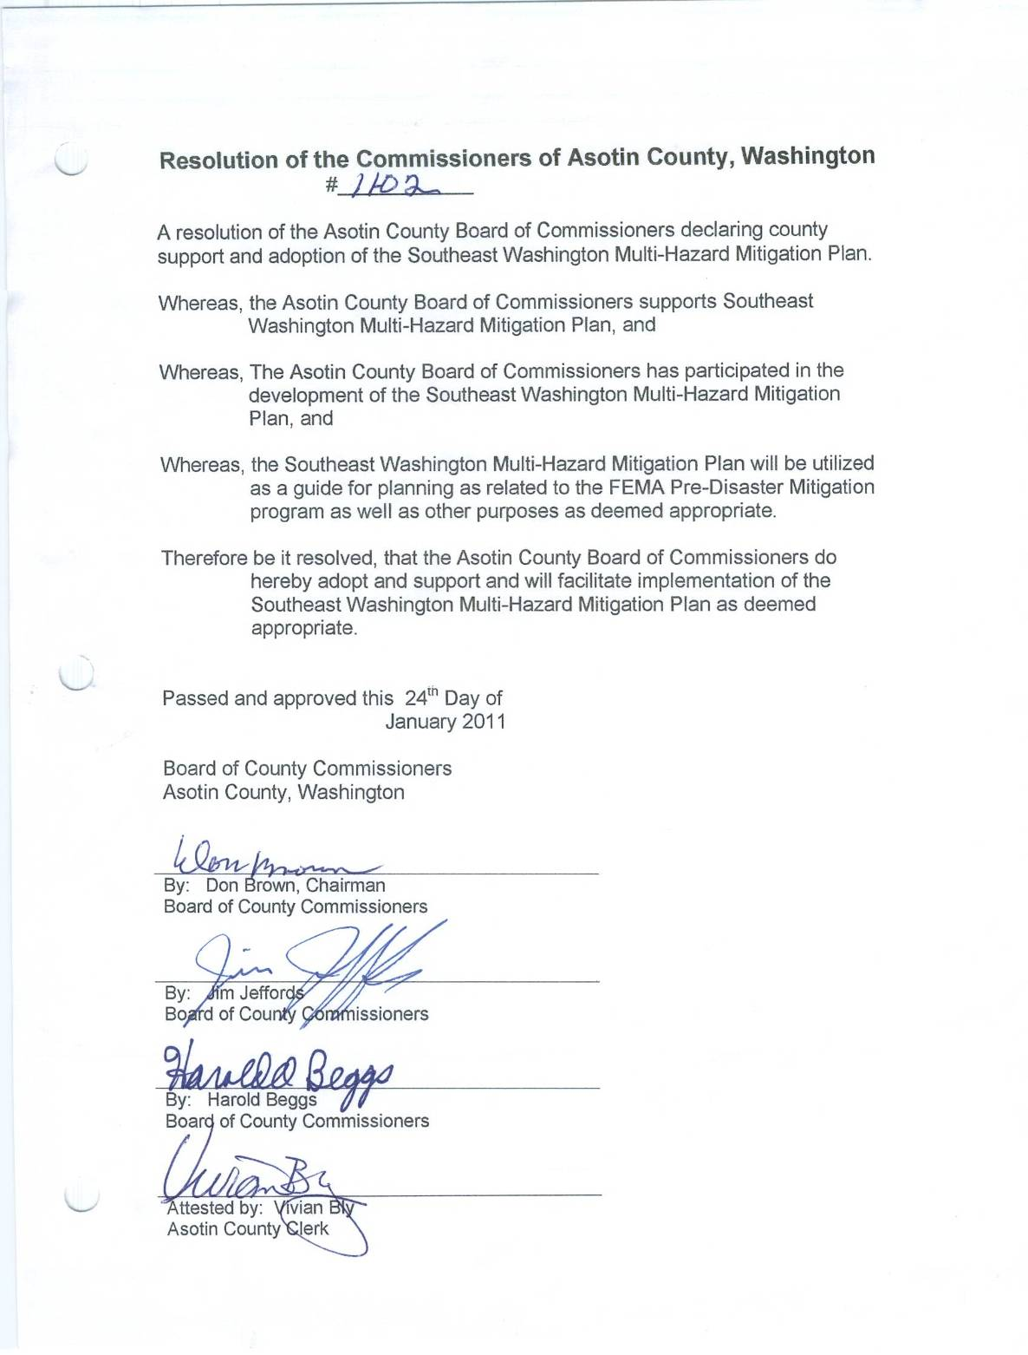
City of Asotin Resolution of Adoption
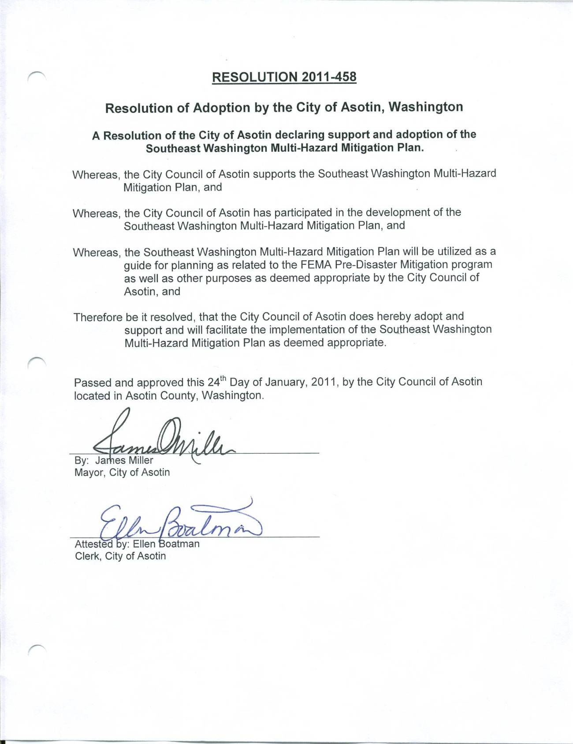
City of Clarkston Resolution of Adoption
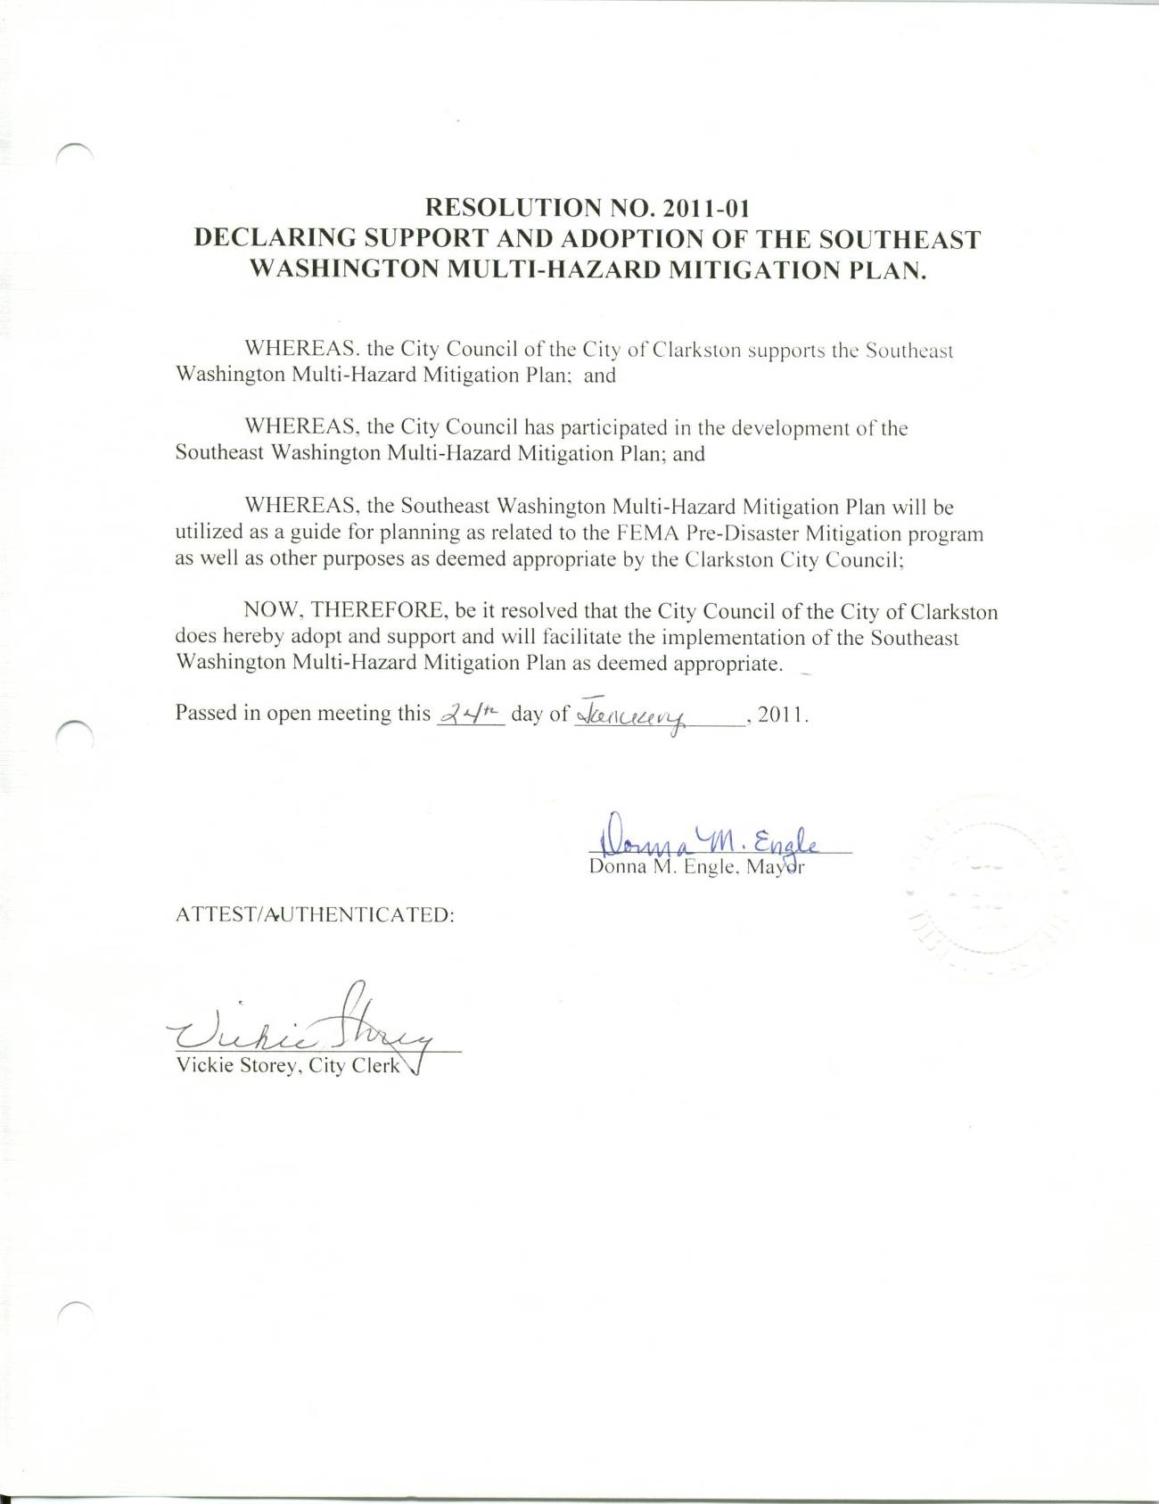
Asotin County Fire District #1 Resolution of Adoption
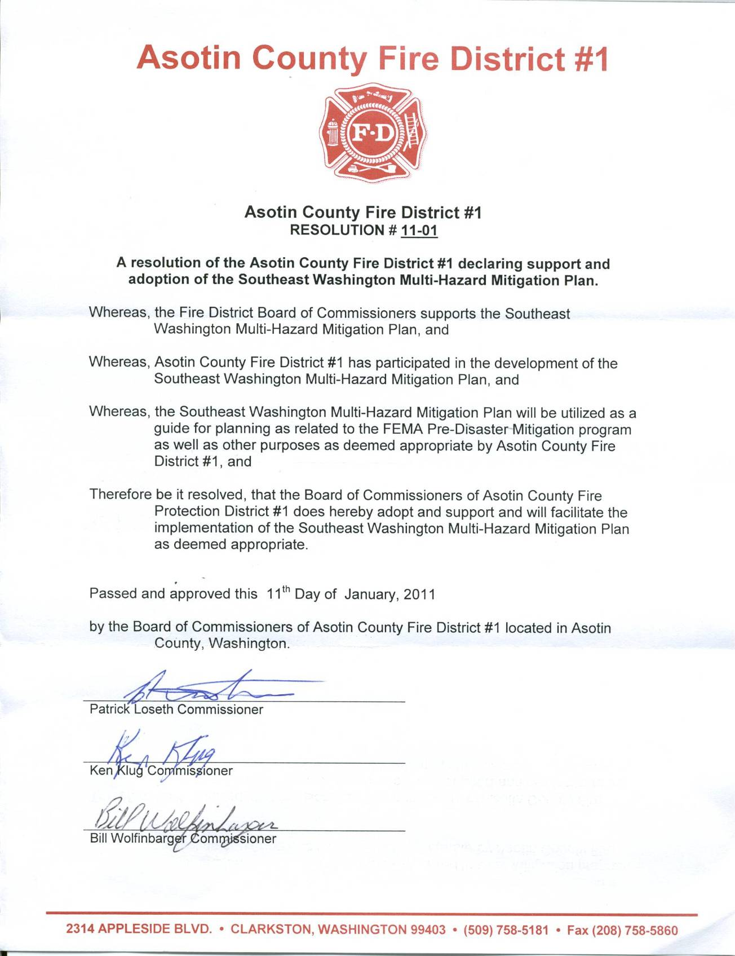
Columbia County Resolution of Adoption
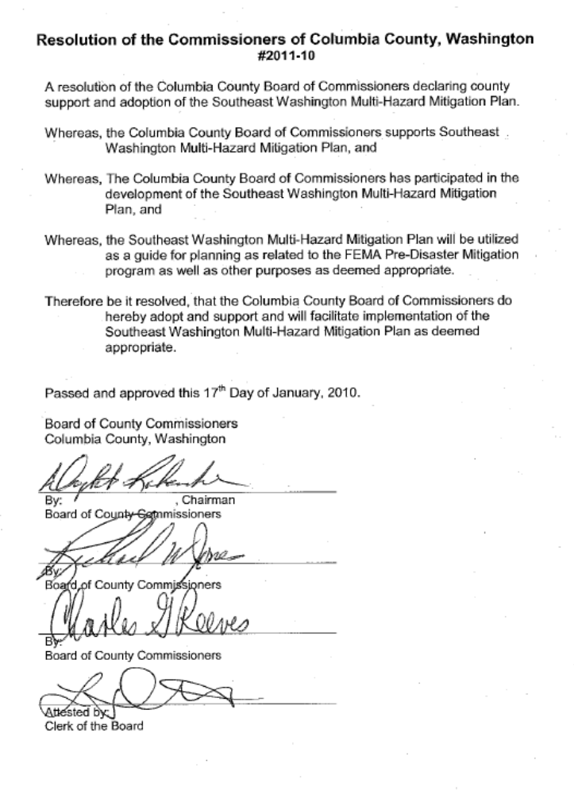
City of Dayton Resolution of Adoption
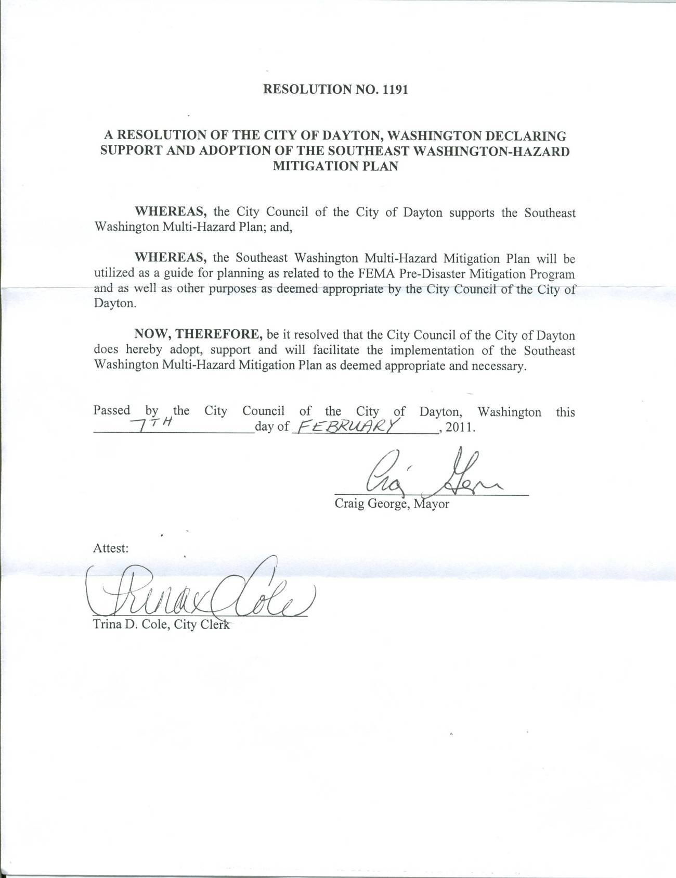
Town of Starbuck Resolution of Adoption
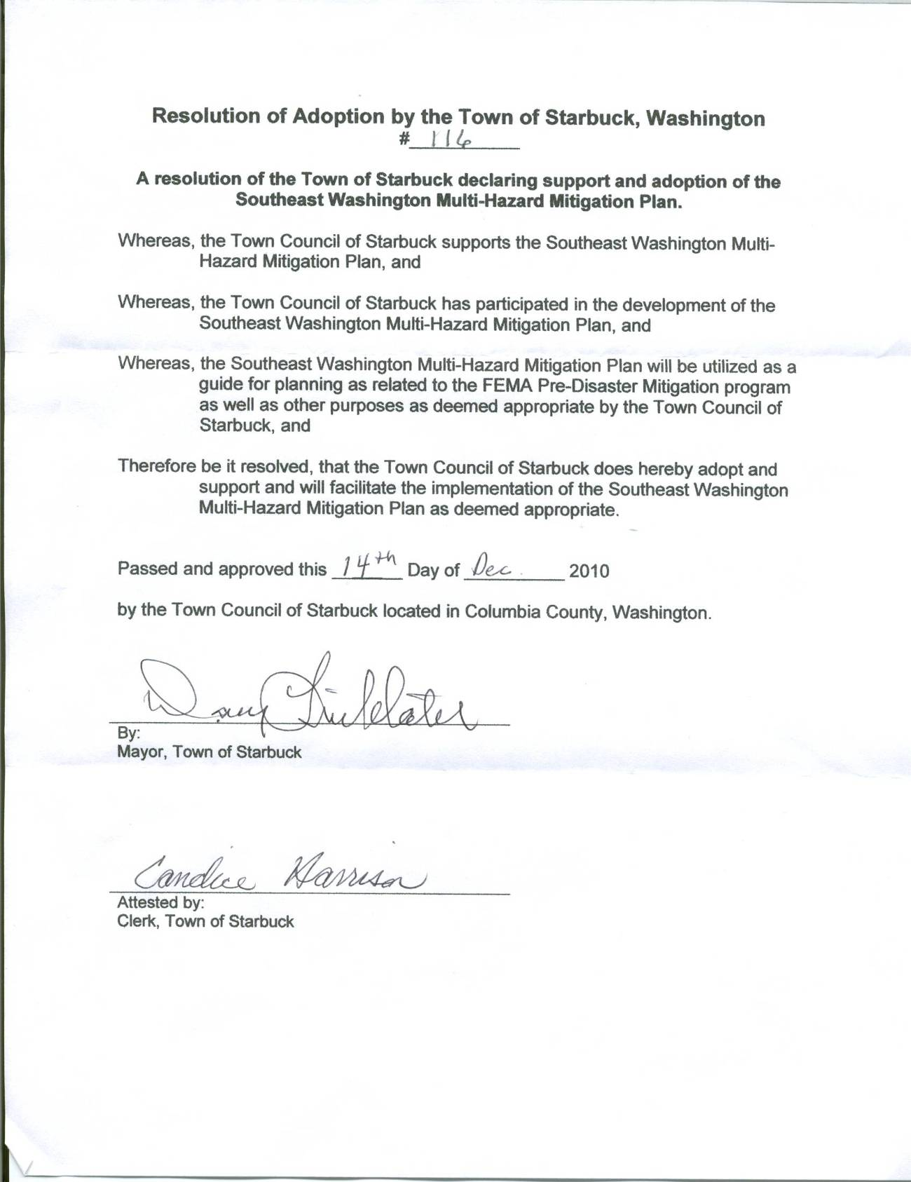
Columbia County Fire District #1 Resolution of Adoption
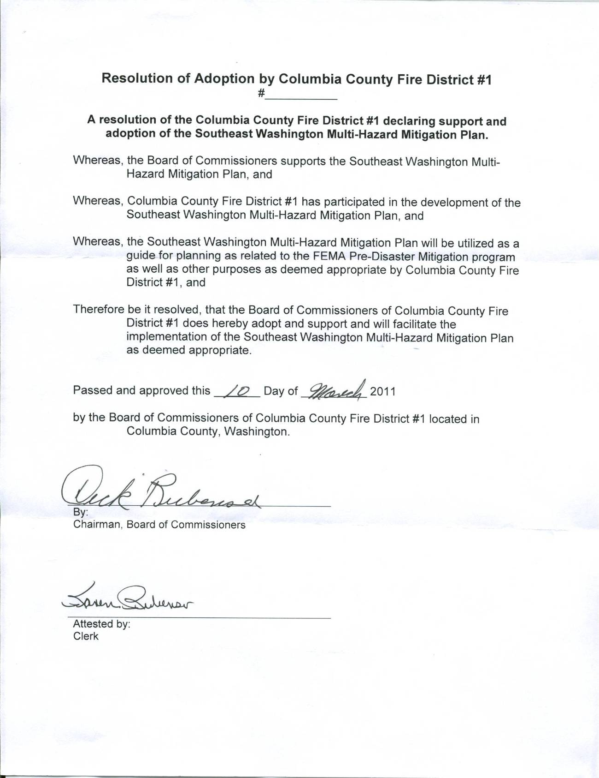
Columbia County Fire District #3 Resolution of Adoption
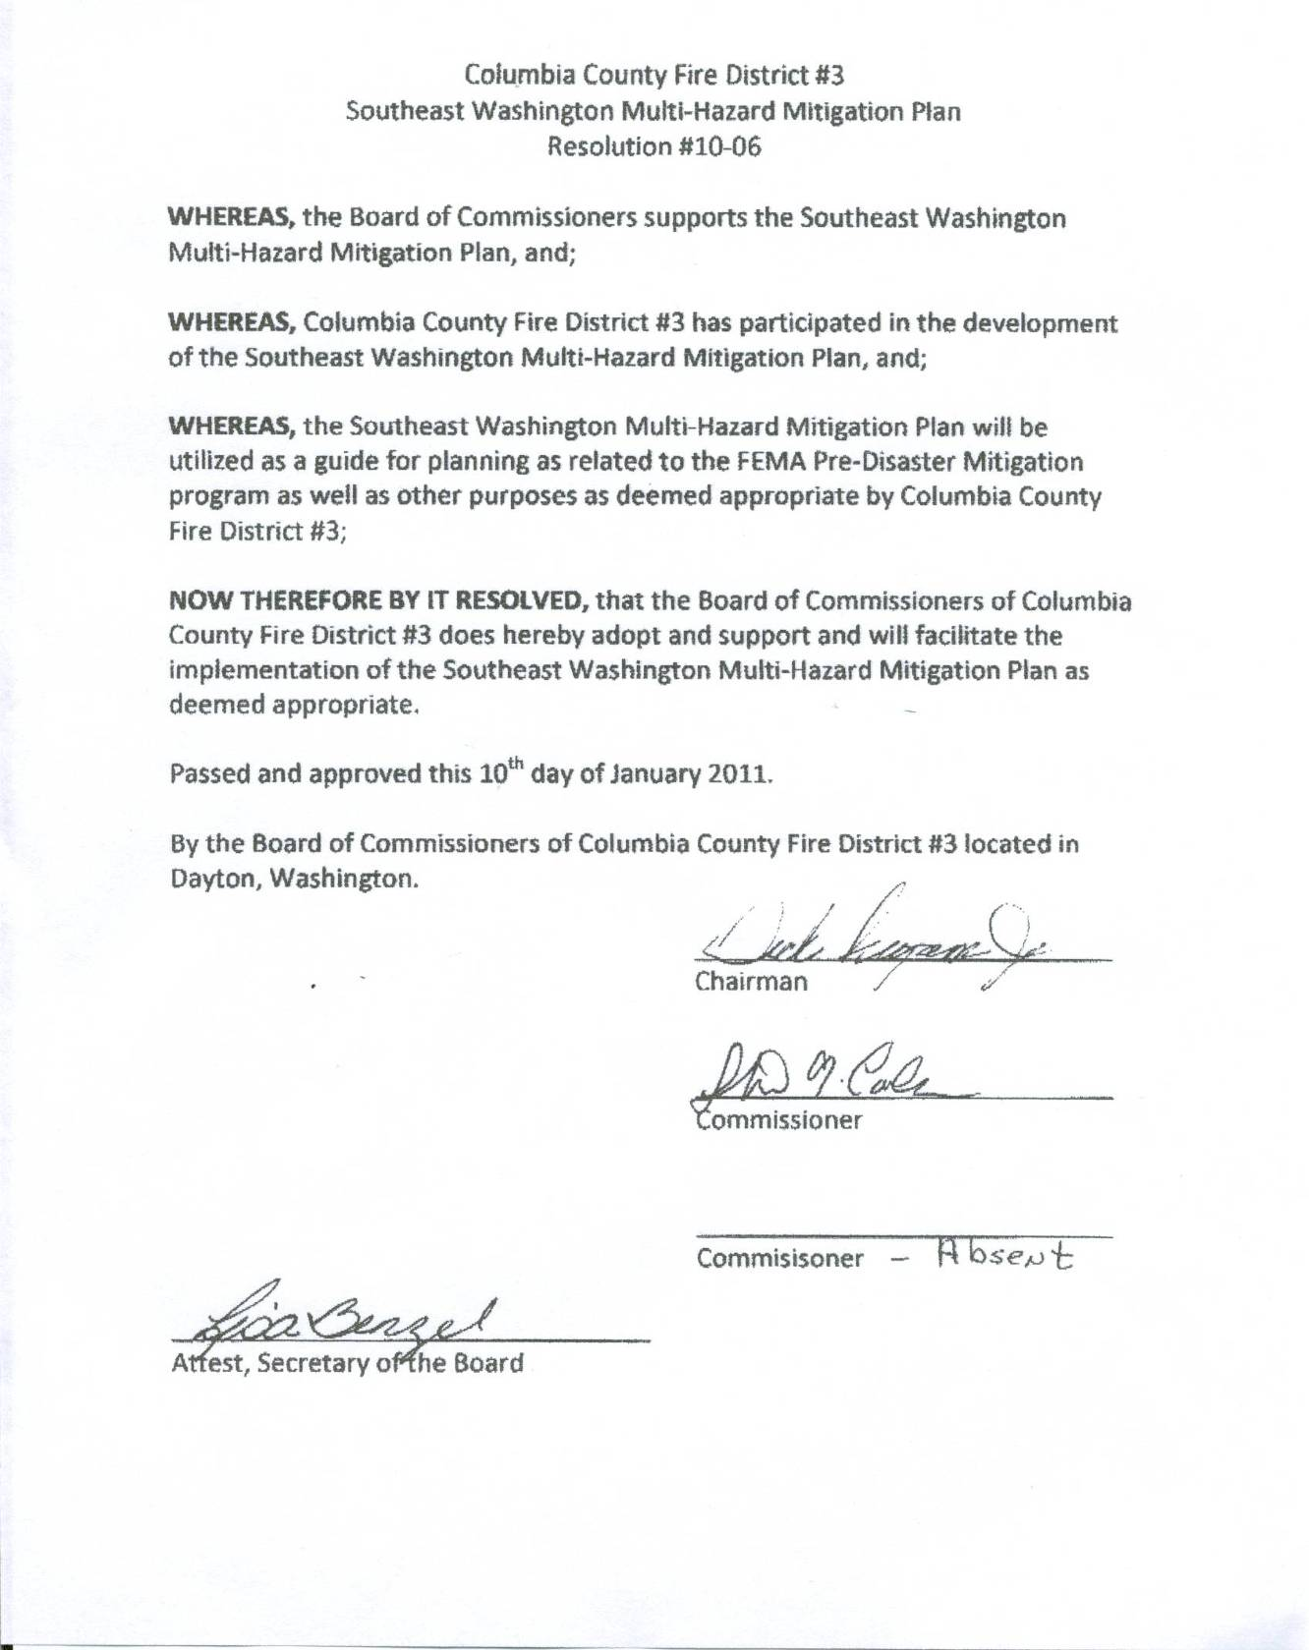
Columbia Rural Electric Association Resolution of Adoption
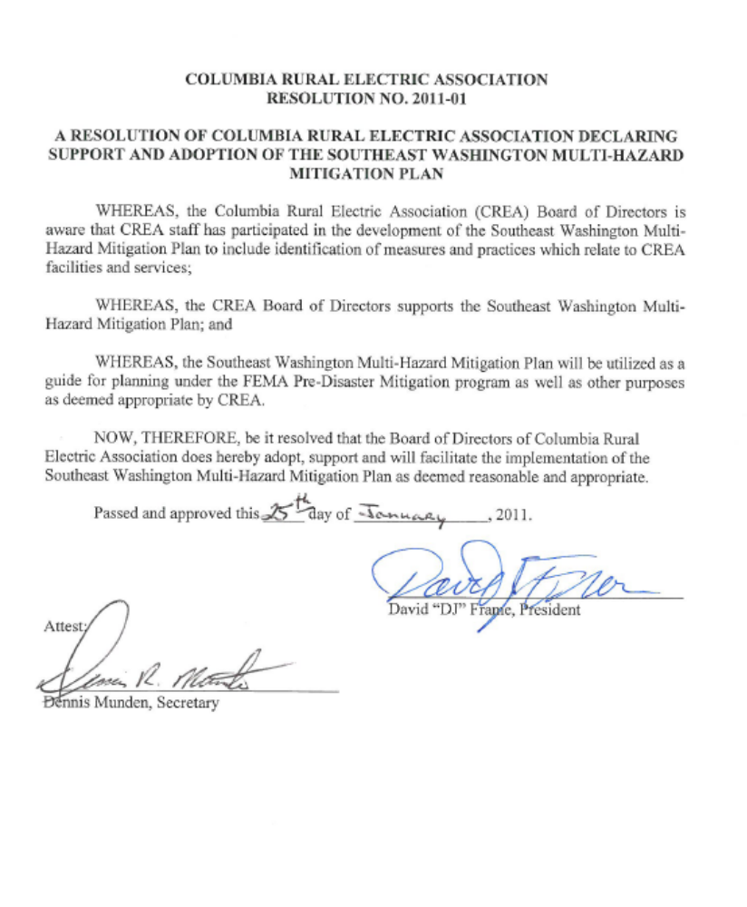
Garfield County Resolution of Adoption
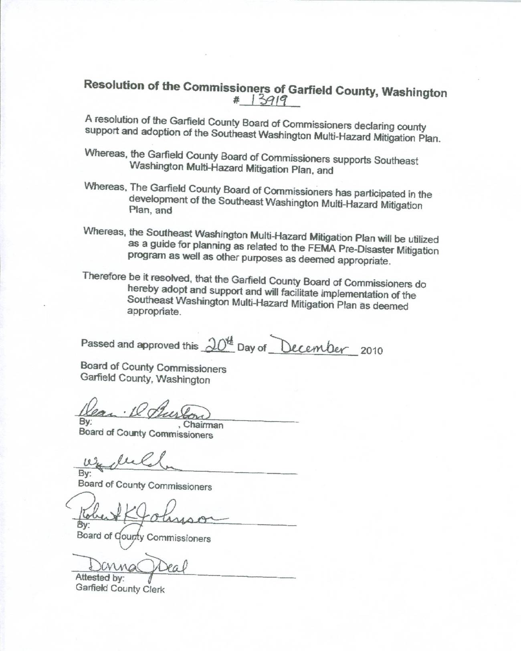
City of Pomeroy Resolution of Adoption
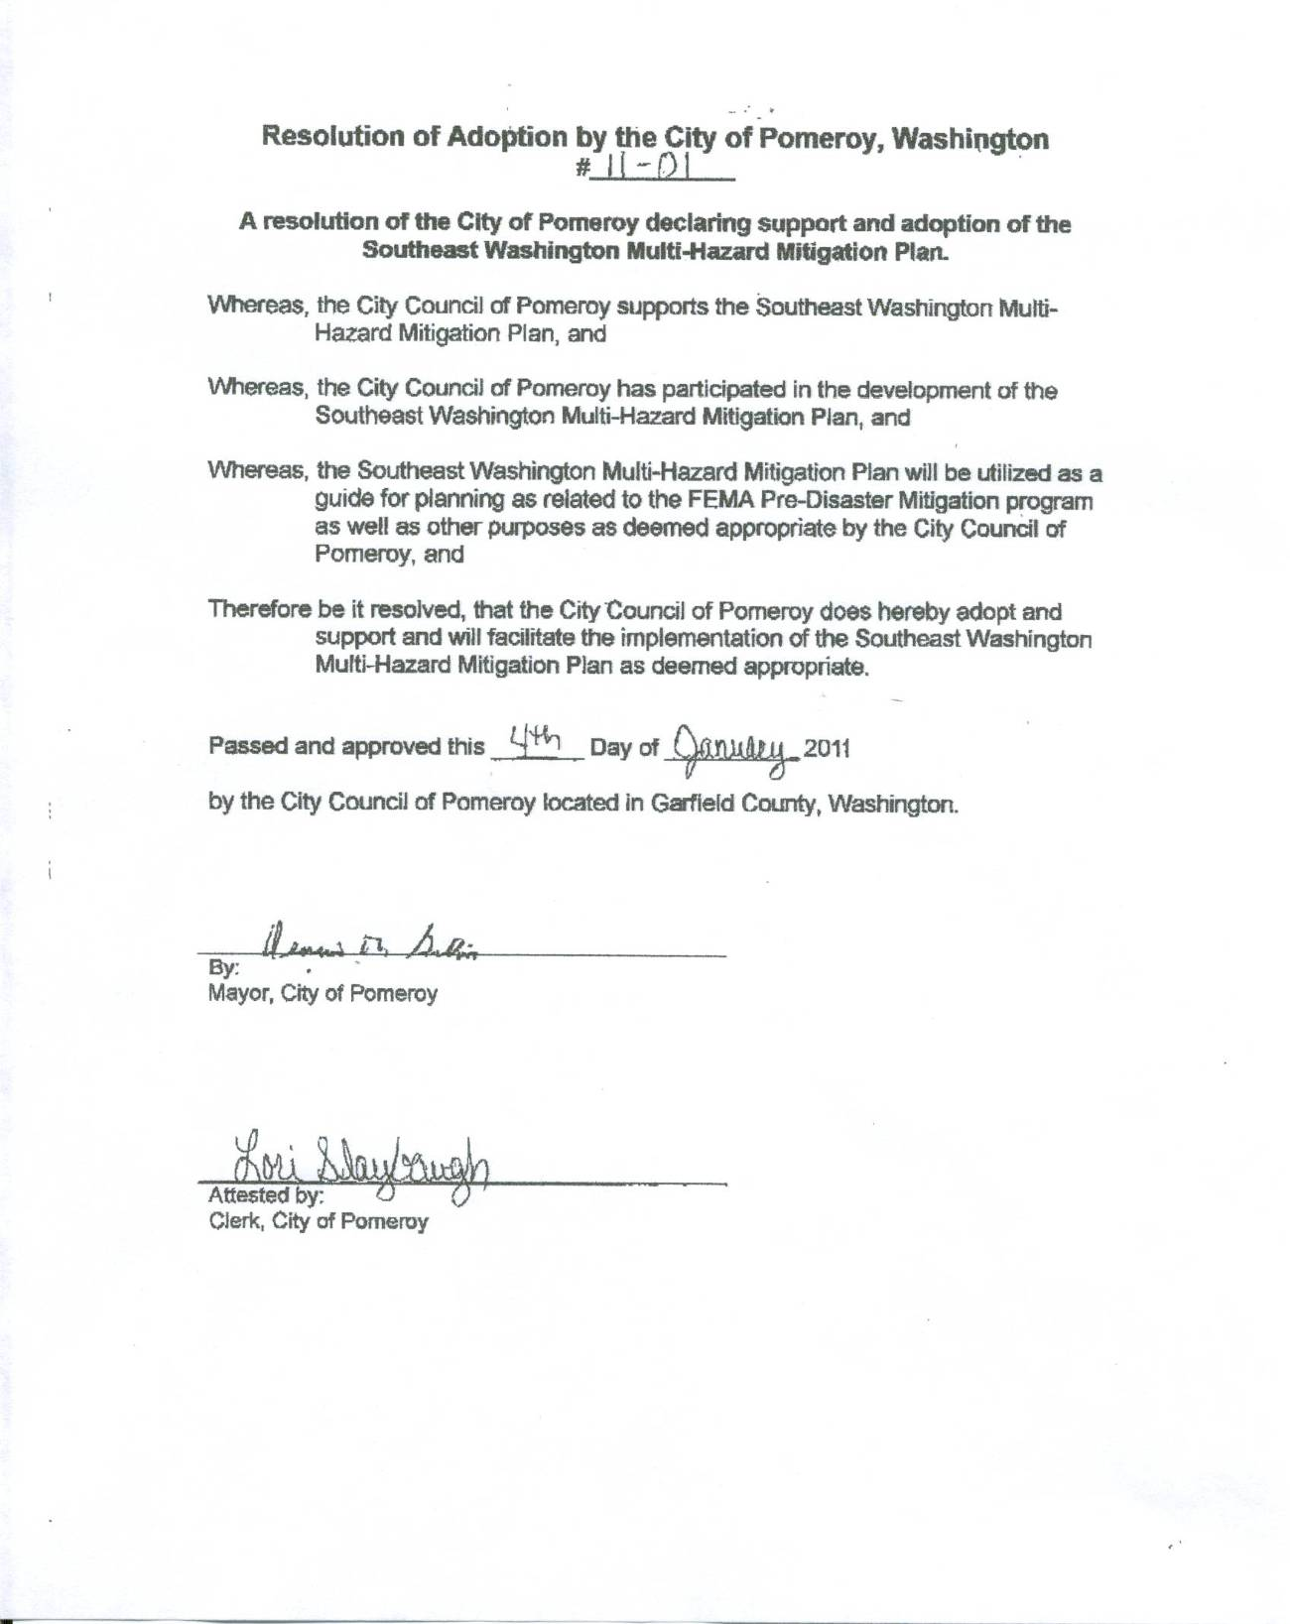
Garfield County Fire District #1 Resolution of Adoption
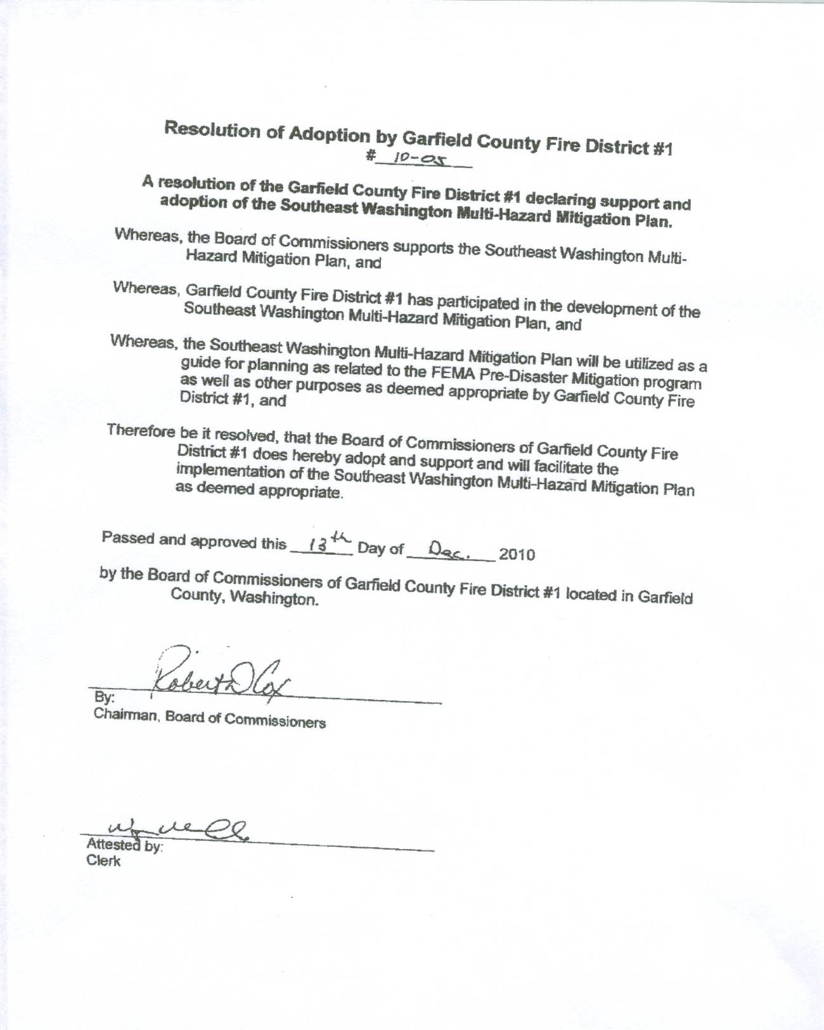
Garfield County Public Health District Resolution of Adoption
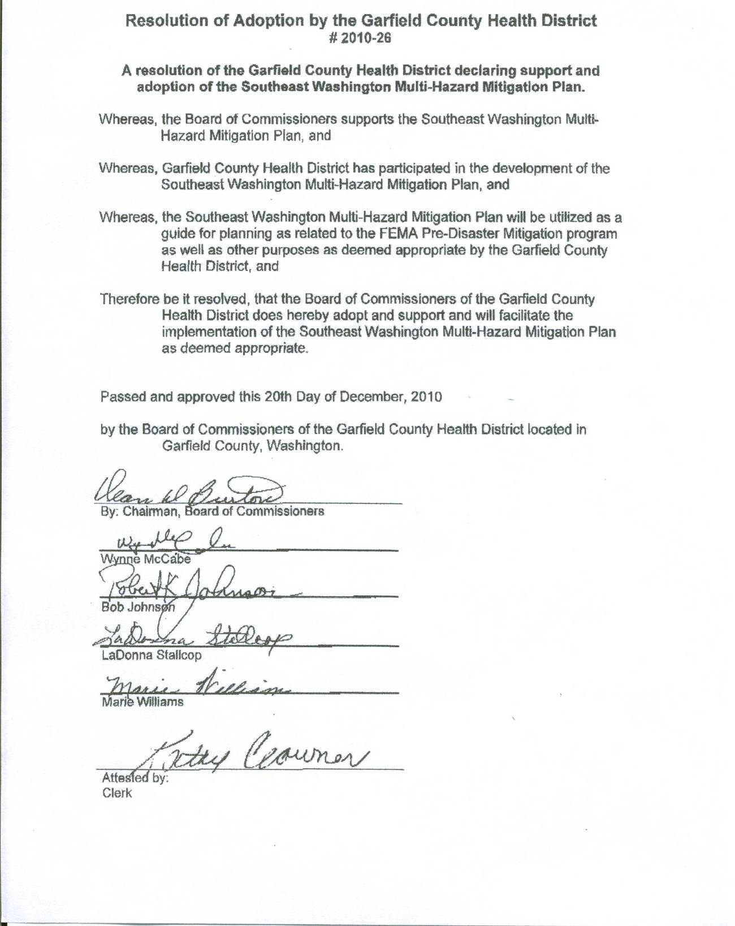
Pomeroy Conservation District Resolution of Adoption
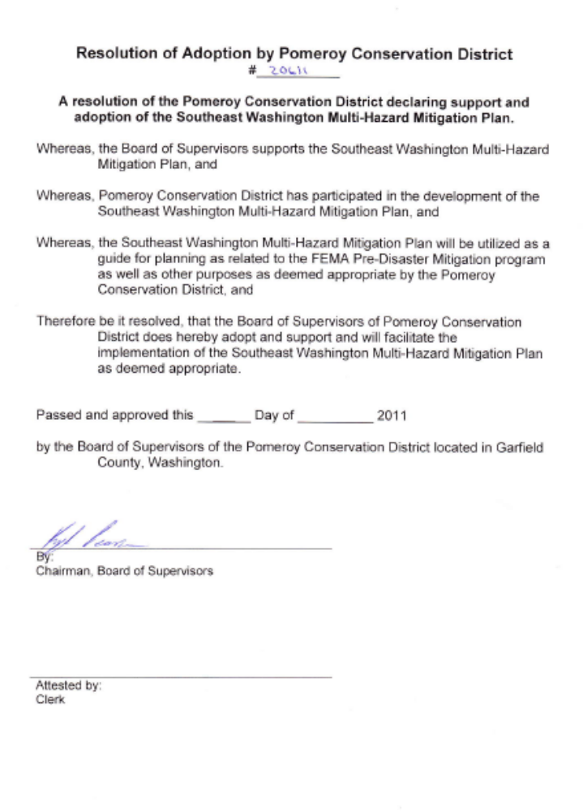
Pomeroy School District No. 110 Resolution of Adoption
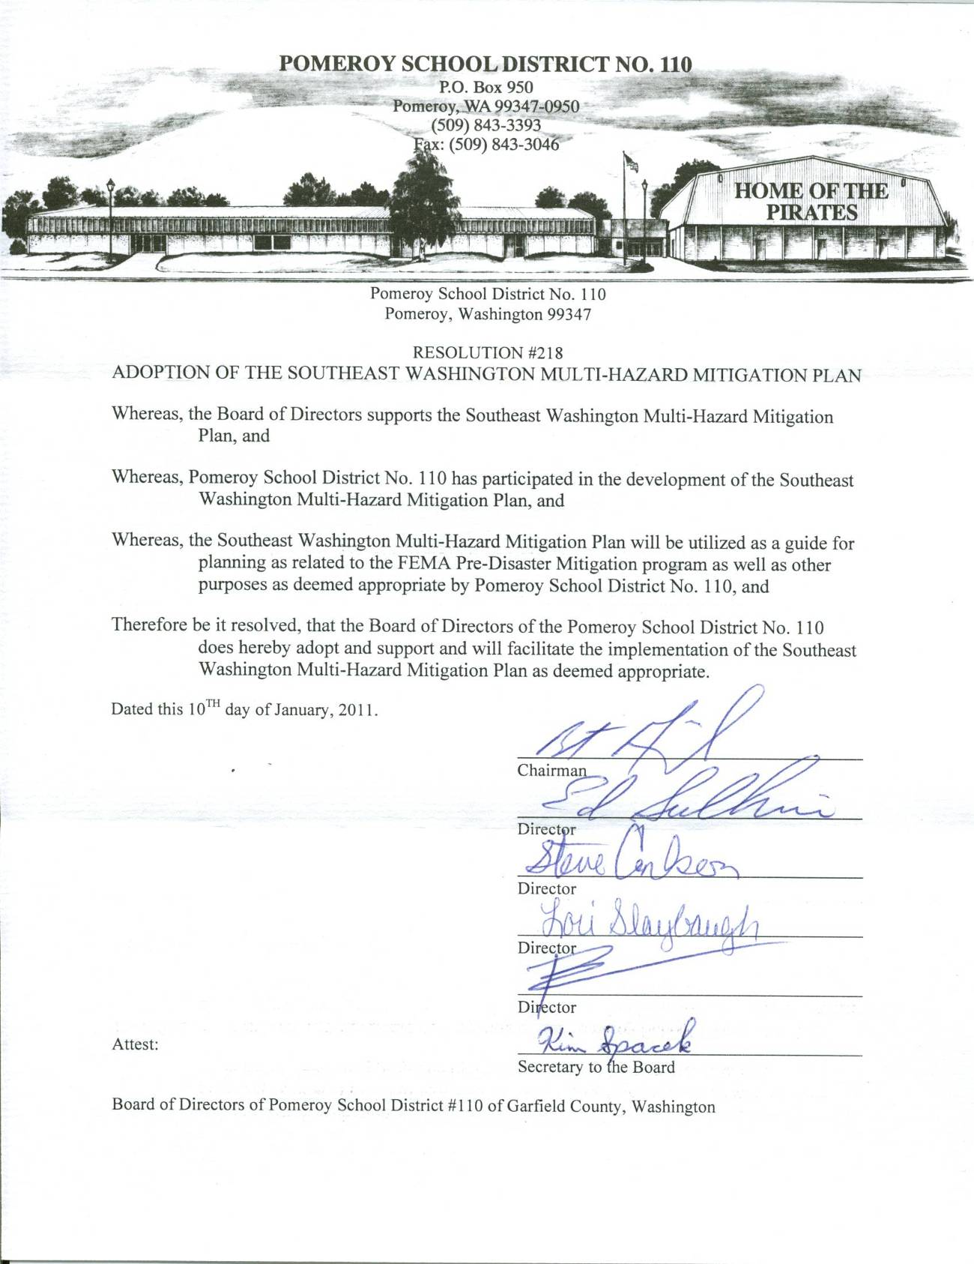
Garfield County Public Hospital District No. 1 Resolution of Adoption
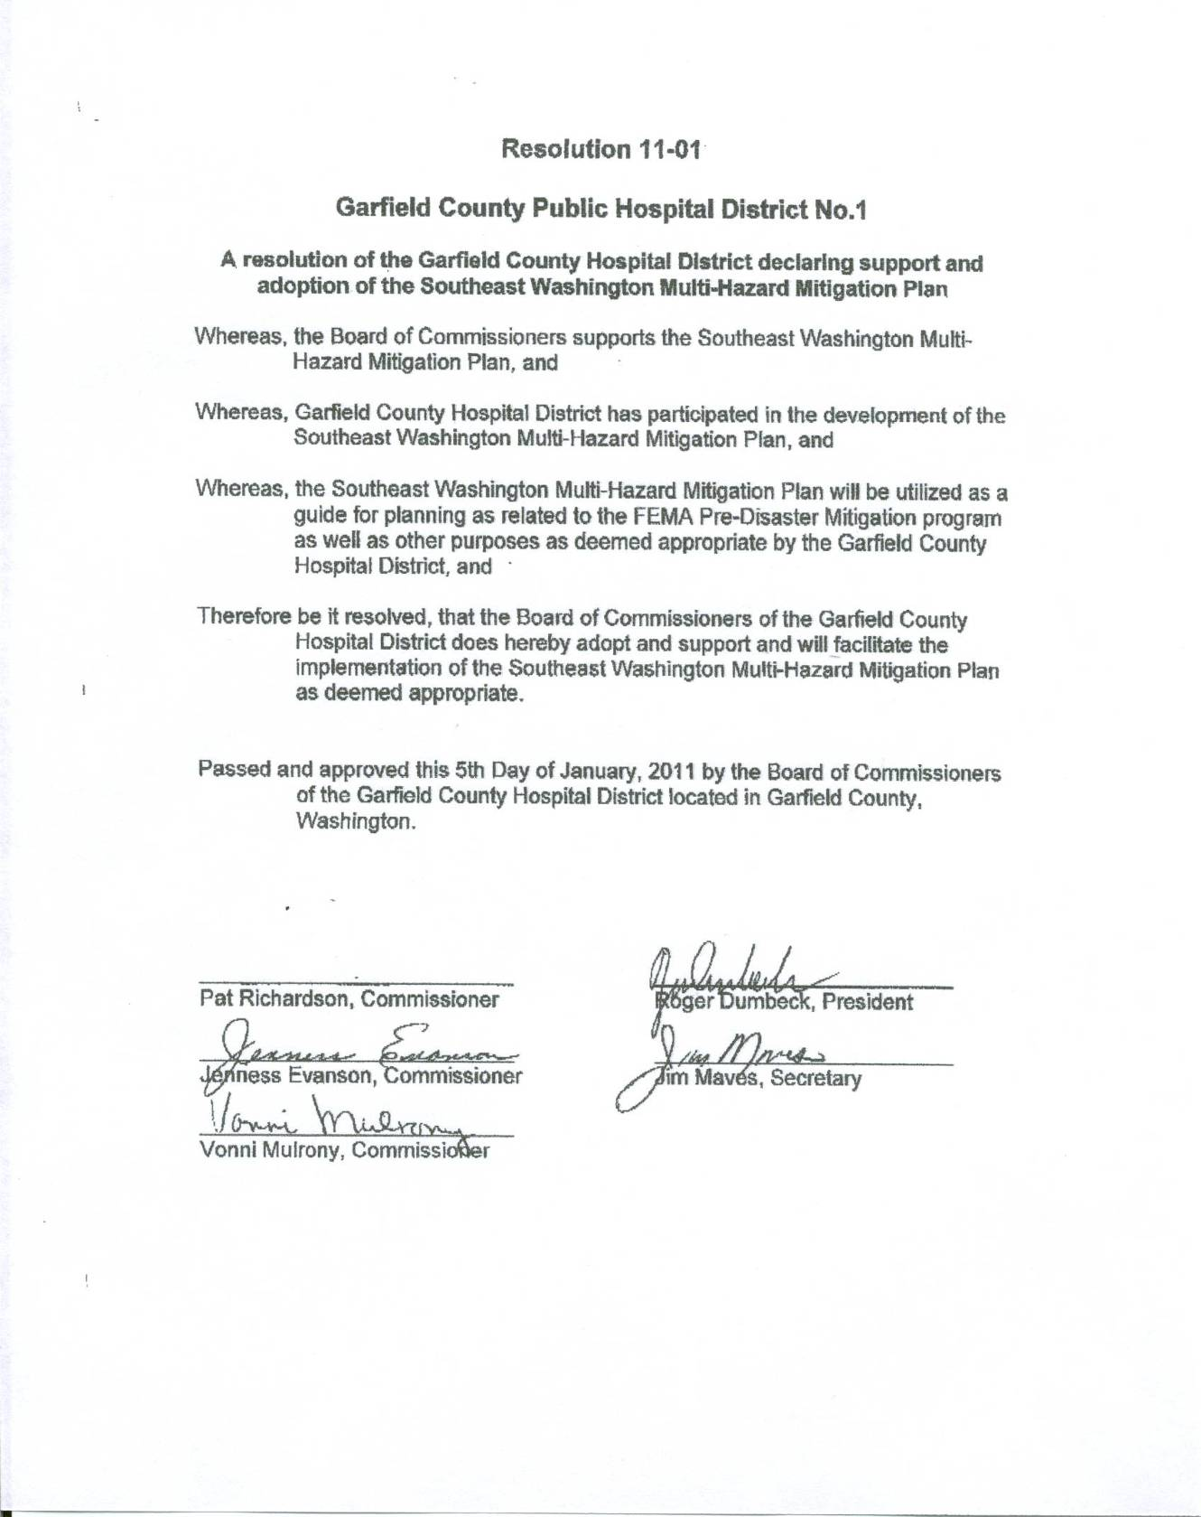
Port of Garfield Resolution of Adoption
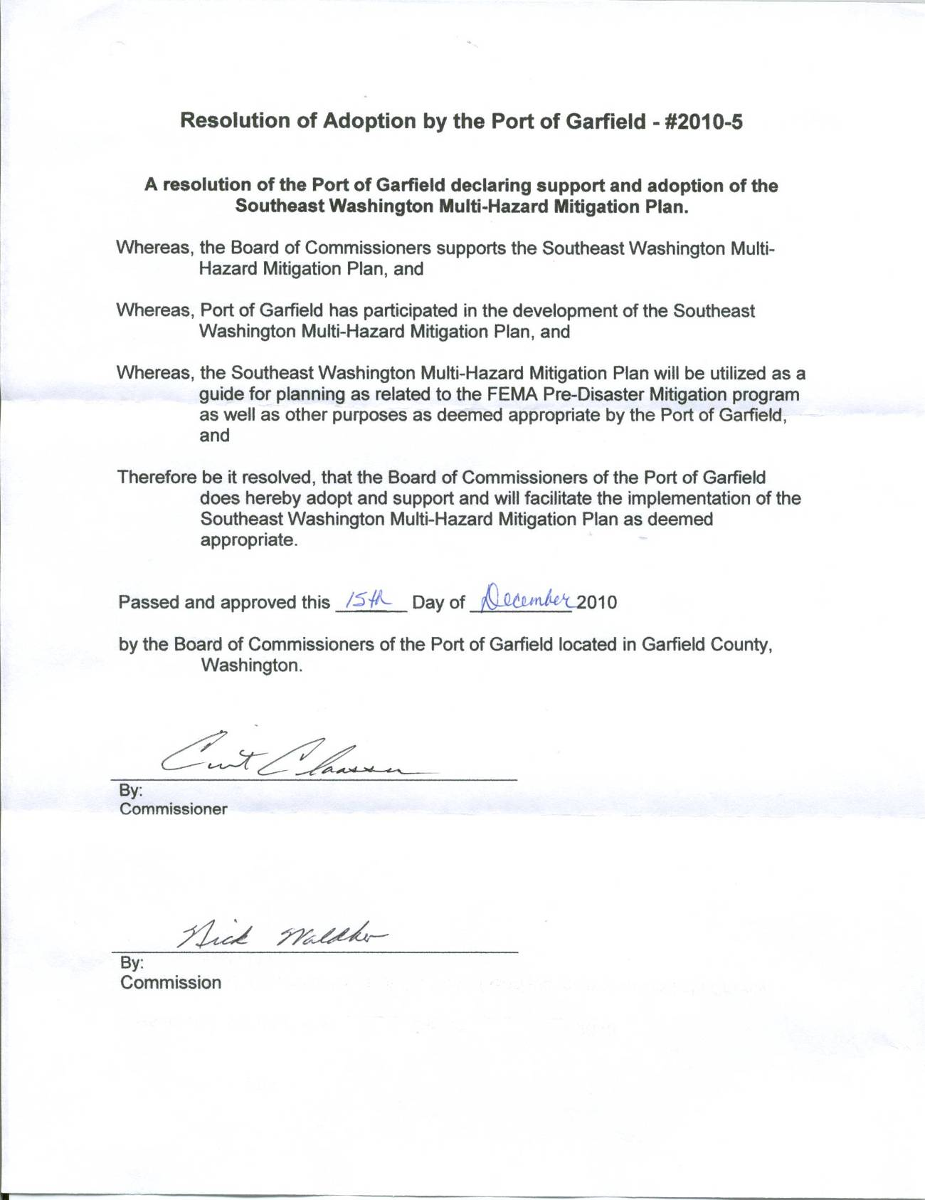

Planning Committee Minutes

First Round of County-level Meetings
Columbia County – 11/5/2009 |  | Garfield County – 11/24/2009 |  | Asotin County – 11/30/2009
Agenda Item #1 – Introduction:
As the committee chairs, Bill Peters, Clay Barr, and Butch Aiken began the meetings in their respective counties by providing a brief overview of the project and introducing NMI. NMI asked for a roundtable introduction of each committee member.
Agenda Item #2 – Northwest Management, Inc Presentation:
NMI gave a short Powerpoint presentation to explain the MHMP planning process and what hazards would be included in the analyses. The process will be similar to what was performed for the Community Wildfire Protection Plan previously developed, but will take other natural hazards including flood, drought, wildland fire, volcano, earthquake, landslide, severe storm, avalanche, and tsunami. Tera also explained that at the least each county and each municipality would have to participate in the process in order to receive FEMA approval and be eligible for FEMA pre-disaster mitigation funding and post-disaster aid. Washington also requires that any special districts that would like to participate, and therefore be eligible for FEMA monies, would also have to adopt the Plan. The following is a list of the participating jurisdictions for each county as of the first meeting as well as a list of potential special districts.
Asotin County:  Asotin County  Fire District #1  Potential Jurisdictions:  City of Clarkston  City of Asotin  Hospital Districts  School Districts  New Fire District  Public Utilities District | Garfield County:  Garfield County  City of Pomeroy  Fire District #1  Health District  Potential Jurisdictions:  Hospital District  School District  Port District | Columbia County:  Columbia County  City of Dayton  Fire District #3  Levee District  Potential Jurisdictions:  Town of Starbuck  Hospital District  School Districts  Fire Districts
GIS mapping will be integral in development of the plan. NMI will be gathering all current data available to assist in the mapping effort. Currently, County GIS departments, Asotin County Public Works, and Walla Walla Conservation District have been identified as sources of data. Please contact Northwest Management with other sources that may have relevant GIS data. NMI will be compiling and geographically locating critical facilities for impact analysis.
Agenda Item #3 – Phase I Hazard Severity Assessment:
NMI led each county through an exercise to help determine their perspective on the potential severity of each hazard within the county. Each hazard was scored for its frequency and potential impact and placed in a matrix to show how each hazard ranked relative to each other. The results of the assessment for each county are given below (see Chapter 1).
Agenda Item #4 – Mission and Goals Statement:
Tera explained that each participating/adopting jurisdiction would be required to attend at least one planning meeting, develop a list of goal statements, and recommend at least one mitigation strategy. In order to start this process, NMI handed out a list of examples goal statements and asked that each jurisdiction fill it out and bring it to the next meeting for discussion.
Agenda Item #5– Press Release:
NMI handed out a draft press release. The press release will be sent to all media outlets in the tri-county area once all of the counties have held their initial meeting. Committee members were asked to review the draft and send Tera edits.
Agenda Item #6 – Review Hazard Matrix:
In order to capture potential issues and project ideas, NMI provided a hazard matrix poster. Several committee members from each county added ideas to be further discussed at subsequent planning committee meetings. This also helps NMI research ideas and provide the committee with additional information.
Agenda Item #7 – Meeting Schedule:
NMI handed out tentative timeline for completion of the MHMP. If all goes as planned, the document would be completed by April and submitted to Washington EMD for review. Pending the review process by WAEMD, the plan would then be sent to FEMA in June for review and pre approval. Pending that review and approval, local adoption and FEMA final approval would take place in July/August 2010.
Agenda Item #8 – Task List:
**Information can be sent to Tera King at king@consulting-foresters.com .***
- Review draft press release by December 15th – Committees
- Fill out and return goal statements by next meeting – Each participating jurisdiction
- Send NMI existing HIVAs – Emergency Managers
- Send NMI existing critical facilities list – Emergency Managers
- Send NMI existing plans, EOPs, ordinances, codes, etc – Committees
- Send NMI levee information – Columbia County
Agenda Item #9 – Adjournment:
Each meeting lasted approximately 1.5 hours. The following is a schedule for the next round of planning committee meetings. Towards the end of the data gathering process, all three counties will meet as one group.
Columbia County: December 17th at the Dayton Fire Station at 2pm
Garfield County: TBD
Asotin County: January 14th at Donna’s Drive-In at 1:30pm

Second Round of County-level Meetings
Columbia County – 12/17/2009 |  | Garfield County – 1/12/2010 |  | Asotin County – 1/22/2010
Agenda Item #1 – Introduction:
As the committee chairs, Bill Peters, Clay Barr, and Butch Aiken began the meetings in their respective counties by providing a brief overview of the project and introducing NMI. NMI asked for a roundtable introduction of each committee member.
Agenda Item #2 – Old Business:
The committee had an opportunity over the last few weeks to make edits and changes to the initial draft press release. The revised version was approved; thus, the Columbia County Public Information Officer will distribute copies to the tri-county media outlets.
Tera reviewed some of the data and plans she had received so far and requested any additional information be sent immediately for review and inclusion in the MHMP.
The notes from the previous round of meetings included the Phase I Hazard Assessment completed for all three counties showing their ranking of hazards. The committee briefly discussed the differences between hazard rankings for each county.
Tera reviewed the participation of the various jurisdictions and who was currently considered an “adopting” jurisdiction. Additions to this list and the requirements were discussed for each county. Tera reiterated the need for each jurisdiction to fill out the goals statements provided in the handouts.
Agenda Item #3 – Draft Review:
Tera presented a draft copy of the MHMP to show overall format and the outline of the plan content. The committee was asket to review the draft and comment or make changes where necessary. As the plan develops, each section will be completed and returned to the committee for review and approval.
Agenda Item #4 – Critical Facilities:
NMI reviewed the current critical facilities list for each county and discussed how this list would be incorporated into the vulnerability assessments for each hazard. Additional critical structures or facilities were added to the list and several committee members agreed to provide additional location information to Vaiden as soon as possible.
Agenda Item #5– Mitigation Projects and Issues:
Tera reviewed some of the mitigation projects and action items recorded for each county to date. She asked that the committee add to this list. Discussions included stories and examples regarding past events and potential projects.
Agenda Item #6 – GIS Data and Map Products:
Vaiden has acquired the FEMA flood zone maps for all three counties and is in the process of placing them in the map projects. He is also in the process of acquiring the current road layer from the county along with any GIS data they have on critical facilities, projects and infrastructure. New 2009 NAIP aerial photography is available for the county and will be acquired and used to update structure locations and roads. The NRCS has extensive mapping of the county, they will be contacted to see if they can provide additional information for the project.
Agenda Item #7 – Meeting Schedule:
Public meetings are tentatively scheduled for the second week of March. The committees felt that public meetings should be held in Dayton, Starbuck, Pomeroy, and Asotin. NMI will work on scheduling dates, times, and locations for these meetings prior to the February committee meetings in order to have plenty of time to advertise.
Agenda Item #8 – Task List:
**Information can be sent to Tera King at king@consulting-foresters.com .***
- Fill out and return goal statements asap – adopting jurisdictions
- Send NMI existing HIVAs – Emergency Managers
- Send NMI amendments to critical facilities list – Committees
- Send NMI existing plans, EOPs, ordinances, codes, etc – Committees
- Schedule public meetings - NMI
Agenda Item #9 – Adjournment:
Each meeting lasted approximately 1.5 hours. The following is a schedule for the next round of planning committee meetings. Towards the end of the data gathering process, all three counties will meet as one group.
Columbia County: February 11th at Dayton Fire Station at 2pm
Garfield County: February 11th at Donna’s Drive-In at 10am
Asotin County: February 17th at Asotin Annex at 9am

Third Round of County-level Meetings
Columbia County – 2/11/2010 |  | Garfield County – 2/11/2010 |  | Asotin County – 2/17/2010
Agenda Item #1 – Introduction:
As the committee chairs, Bill Peters, Clay Barr, and Butch Aiken began the meetings in their respective counties by providing a brief overview of the project to date.
Agenda Item #2 – Old Business:
Tera reviewed the requirements for an adopting jurisdiction and showed the committees which jurisdictions qualified so far. She also went over the goals statements including which entities she had not received statements from.
Agenda Item #3 – Draft Review:
Tera presented draft copies of the earthquake, volcano, drought, and tsunami vulnerability annexes. It was explained that these annexes were written as southeast Washington regional summaries and were meant to answer questions regarding “why” the area was at risk to the various hazards. Tera asked that the committees review the annexes and provide comments and edits at least a week prior to their next committee meeting.
Agenda Item #4 – Jurisdiction Annexes:
The jurisdiction specific annexes are currently being developed; thus, NMI asked the committee members for information specific to their jurisdictions. This included discussions on the critical facilities and infrastructure lists, unreinforced masonry structures, repetitive loss structures, and landslide impact zones. The critical facilities lists are nearly completed, but Vaiden asked that any edits or additions be sent to him immediately. Tera asked that each jurisdiction also develop a list of unreinforced masonry structures with names and numbers being as specific as possible. The committees also discussed repetitive loss structures. This item is specifically for structures identified by FEMA as being damaged by flood on more than one occasion, but also includes other types of chronic issues such as road slumps, clogged or undersized culverts, etc.
Agenda Item #5– Mitigation Projects and Issues:
Tera reviewed the action item lists that had been recorded for each jurisdiction to-date. Areas requiring more specific wording or additional information were identified. Each jurisdiction is required to develop a mitigation strategy; thus, any entities that had not submitted information for this section were highlighted. Tera asked that jurisdictions send as much of their mitigation strategy as possible prior to the public meetings so they could be included in the presentation.
Agenda Item #6 – GIS Data and Map Products:
Vaiden explained the Landslide Prone Landscapes map and the Flood Zone maps. Areas in red are areas that may have a higher risk of sliding due to slope. He asked that the committee review the map and indicate any areas where there is a high sliding risk that will impact a large number of structures or other infrastructure. This will become the “Landslide Impact Zones”. The flood map is based on FEMA FIRM maps. Vaiden asked that the committee identify any areas that are obviously within the floodplain, but are not mapped by FEMA. Each county indicated that the FIRM maps are extremely dated and inaccurate.
Agenda Item #7 – Meeting Schedule:
Public meetings are tentatively scheduled for the second week of March. The committees felt that public meetings should be held in Dayton, Starbuck, Pomeroy, and Asotin. NMI will work on confirming the dates, and venues for these meetings. The committee reviewed the draft flyer and made some edits. NMI will update the flyer and send it for review prior to publication.
Agenda Item #8 – Task List:
**Information can be sent to Tera King at king@consulting-foresters.com .***
- Fill out and return goal statements asap – adopting jurisdictions
- Send NMI mitigation strategies before public meetings – adopting jurisdictions
- Develop URM lists – adopting jurisdictions
- Send NMI repetitive loss info – committee members
- Review vulnerability annexes – committee members
- Identify Landslide Impact Zone – committee members
- Schedule public meetings - NMI
Agenda Item #9 – Adjournment:
Each meeting lasted approximately 1.5 hours. The following is a schedule for the next round of planning committee meetings. Towards the end of the data gathering process, all three counties will meet as one group.
Columbia County: March 9th at Dayton Fire Station at 10am
Garfield County: March 18th at Donna’s Drive-In at 10am
Asotin County: March 10th at Asotin Annex at 4:30pm

Fourth Round of County-level Meetings
Columbia County – 3/9/2010 |  | Garfield County – 3/18/2010 |  | Asotin County – 3/10/2010
Agenda Item #1 – Introduction:
As the committee chairs, Bill Peters, Clay Barr, and Butch Aiken began the meetings in their respective counties by providing a brief overview of the project to date.
Agenda Item #2 – Old Business:
NMI reviewed several old business items including information that was still missing from some jurisdictions.
Agenda Item #3 – Draft Review:
NMI presented the flood vulnerability annex for the southeastern Washington region as well as the specific jurisdiction annexes for both flood and earthquake. The committee went through each of the annexes. NMI reviewed the information included in the write-ups and noted any holes in the information. Several corrections were made. NMI asked that the committees review the documents in-depth and provide comments before the next committee meeting so that a near complete draft plan can be presented before it goes out for public review
Agenda Item #4 – Information Needed:
NMI reminded the committee members to send NMI any historical accounts, pictures, reports, or other information they had on the remaining hazards.
Agenda Item #5– Mitigation Projects and Issues:
NMI reviewed the mitigation strategies with each jurisdiction and asked that they fill in some of the missing information and send in any additional projects or action items immediately. Most of the items were completed as a group at the meeting.
Agenda Item #6 – GIS Data and Map Products:
NMI reviewed the data and information that had been added to the GIS and associated mapping products. It was noted in the discussion that there had been some minor changes to the floodplain analysis information. Several critical facilities were out of place in Columbia County. Vaiden will meet with Bill Peters to make changes to the layer in Columbia County.
Agenda Item #7 – Meeting Schedule:
Public meetings occurred the week of March 8th concurrently with Asotin and Columbia County’s committee meetings. NMI plans to deliver a completed draft document at the next round of committee meetings. It was also noted that each county would like to schedule a regional meeting. The regional meeting wouldn’t require the full participation from each committee, but key players and those that would like to attend should be included.
Agenda Item #8 – Task List:
**Information can be sent to Tera King at king@consulting-foresters.com .***
- Send NMI revisions to mitigation strategies immediately – adopting jurisdictions
- Review flood vulnerability annex – committee members
- Review and send edits on the Jurisdiction Annexes – adopting jurisdictions
Agenda Item #9 – Adjournment:
Each meeting lasted approximately 1.5 hours. The following is a schedule for the next round of planning committee meetings. A regional group meeting will also be scheduled for May.
Columbia County: April 29th at 10am at Dayton Fire Station
Garfield County: April 29th at 1:30pm at Donna’s Drive-In
Asotin County: TBD

Fifth Round of County-level Meetings
Columbia County – 4/27/2010 |  | Garfield County – 4/29/2010 |  | Asotin County – 5/5/2010
Agenda Item #1 – Introduction:
As the committee chairs, Bill Peters, Clay Barr, and Butch Aiken began the meetings in their respective counties by providing a brief overview of the project to date.

Agenda Item #2 – Old Business:
There was no old business discussed

Agenda Item #3 – Draft Review:
Tera handed out the full draft document and walked the committees through each chapter. Many of the annexes had been reviewed individually, but there were also a few new sections as well as new jurisdictional annexes. Tera pointed out where additional information was needed.

Agenda Item #4 – Prioritization Scheme:
Each committee reviewed the action items listed for their respective jurisdictions. Tera explained that each action item had to be given a priority ranking; however, how each jurisdiction chose to rank the projects was up to them. Each committee discussed several examples of prioritization schemes and the most appropriate method for each jurisdiction. Tera asked that each jurisdiction complete their prioritization of action items and send her the results by the end of May.

Agenda Item #5– Regional Issues:
After all the committees have met and ranked action items, it was decided that the Emergency Managers should meet to discuss regional issues. A date will be set following the next round of committee meetings.

Agenda Item #6 – Public Review:
Tera explained the public review and comment period and process. Each committee discussed the appropriate venues for distribution. Tera will insert this information into a press release to be sent out once the committees finalize the draft Plan.

Agenda Item #7 – Task List:

**Information can be sent to Tera King at king@consulting-foresters.com .***
- Send NMI revisions to mitigation strategies immediately – adopting jurisdictions
- Review draft MHMP and send edits - committees
- Prioritize action items and send rankings - jurisdictions

Agenda Item #8 – Adjournment:
Each meeting lasted approximately 1.5 hours. The following is a schedule for the next round of planning committee meetings. A regional group meeting will also be scheduled for June.

Columbia County: May 25th at 2pm at Dayton Fire Station
Garfield County: TBD
Asotin County: TBD

Public Meeting Slideshow
Slide 1 |  | Slide 2 | 
Slide 3 | 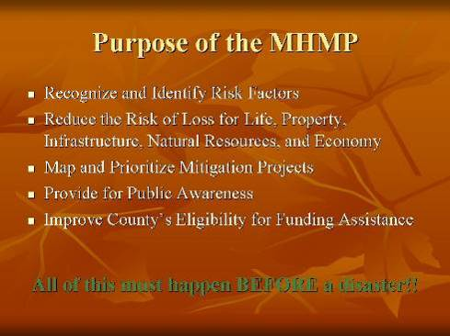 | Slide 4 | 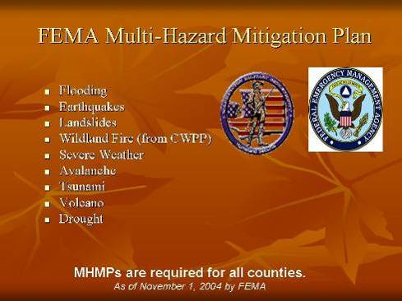
Slide 5 | 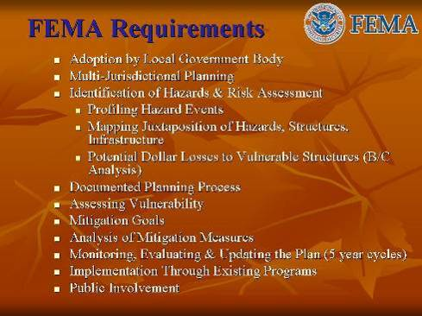 | Slide 6 | 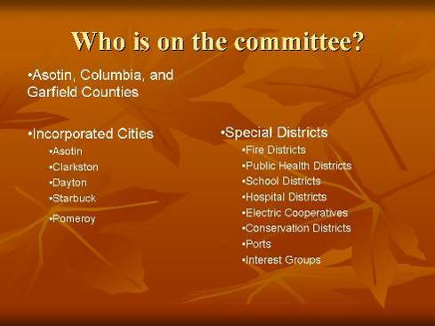
Slide 7 | 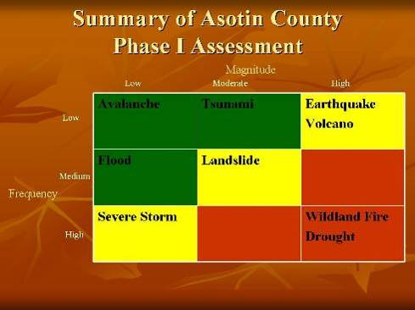 | Slide 8 | 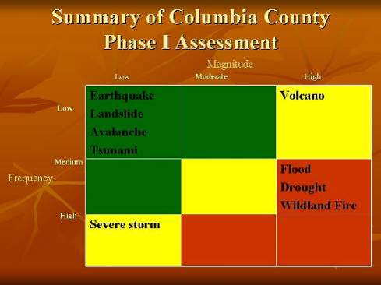
Slide 9 | 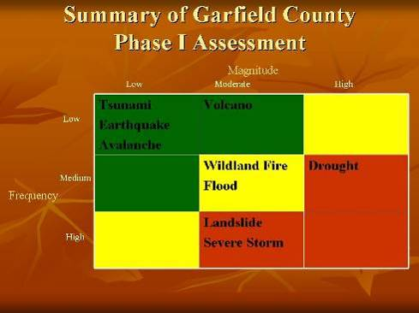 | Slide 10 | 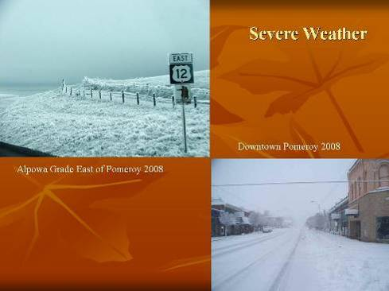
Slide 11 | 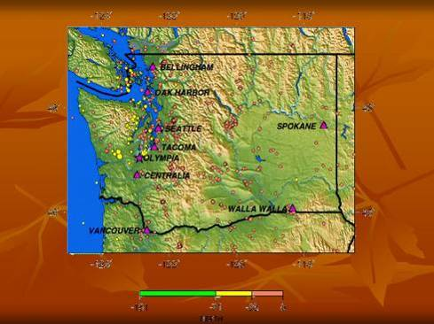 | Slide 12 | 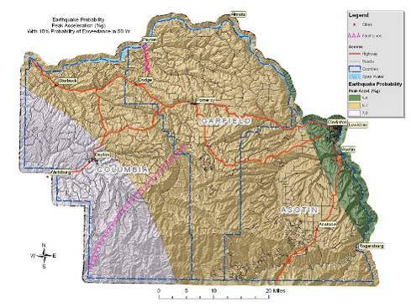
Slide 13 | 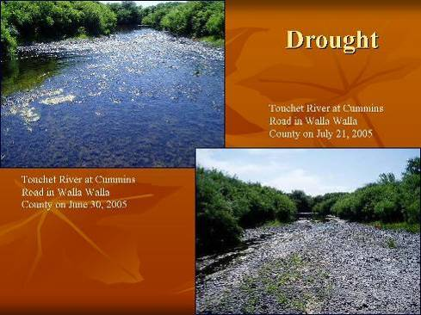 | Slide 14 | 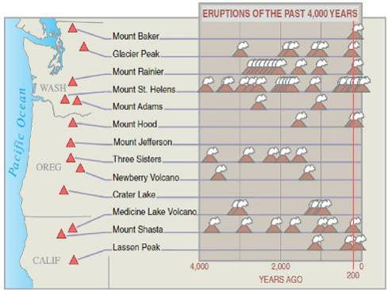
Slide 15 | 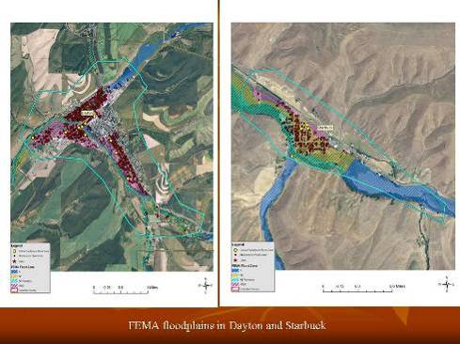 | Slide 16 | 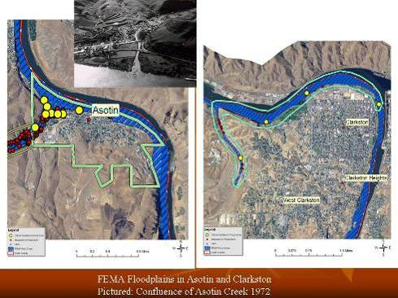
Slide 17 | 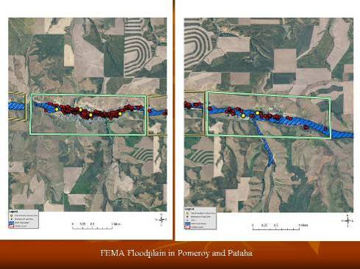 | Slide 18 | 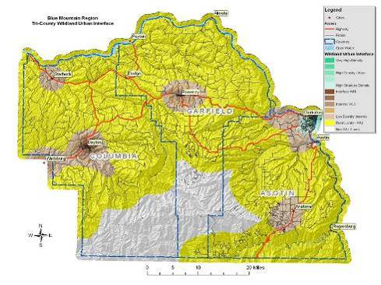
Slide 19 |  | Slide 20 | 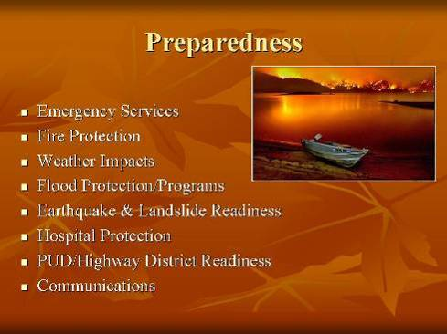
Slide 21 | 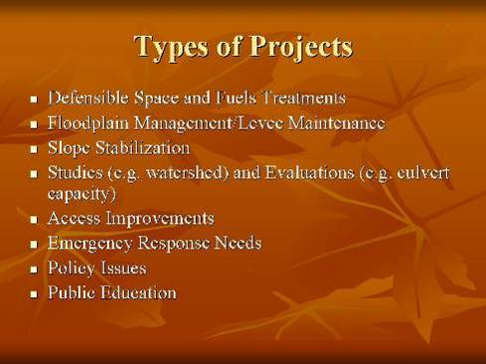 | Slide 22 | 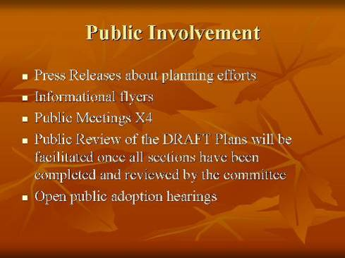
Slide 23 |  | Slide 24 | 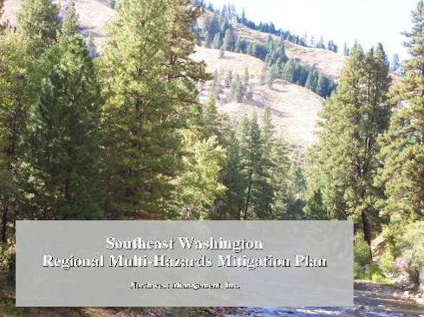

Potential Funding Sources
Program: Rural Fire Assistance
Source: Bureau of Land Management
Description: BLM provides funds to rural fire departments for wildfire fighting; also provides wildland fire equipment, training and/or prevention materials.
More info: Contact BLM RFA Coordinator
Program: Communities at Risk
Source: Bureau of Land Management
Description: Assistance to communities for hazardous fuels reduction projects in the wildland urban interface; includes funding for assessments and mitigation planning.
More info:
Program: State Fire Assistance
Source: US Forest Service
Description: USFS grants to state foresters through state and private grants, under authority of Cooperative Forestry Assistance Act. Grant objectives are to maintain and improve protection efficiency and effectiveness on non-federal lands, training, equipment, preparedness, prevention and education.
More info: www.fireplan.gov and www.fs.fed.us
Program: State Fire Assistance Hazard Mitigation Program
Source: National Fire Plan
Description: These special state Fire Assistance funds are targeted at hazard fuels treatment in the wildland-urban interface. Recipients include state forestry organizations, local fire services, county emergency planning committees and private landowners.
More info: www.fireplan.gov and www.fs.fed.us
Program: Volunteer Fire Assistance
Source: US Forest Service
Description: Provides funding and technical assistance to local and volunteer fire departments for organizing, training and equipment to enable them to effectively meet their structure and wildland protection responsibilities. US Forest Service grants provided to state foresters through state and private grants under the authority of Coop Forestry Assistance Act.
More info: www.fs.fed.us/fire/partners/vfa
Program: Forest Land Enhancement Program
Source: US Forest Service
Description: The 2002 Farm Bill repealed the Forestry Incentives Program (authorized in 1978) and Stewardship Incentive Program (1990) cost share programs and replaced it with a new Forest Land Enhancement Program (FLEP). FLEP purposes include 1) Enhance the productivity of timber, fish and wildlife habitat, soil and water quality, wetland, recreational resources, and aesthetic values of forest land through landowner cost share assistance, and 2) Establish a coordinated, cooperative federal, state and local sustainable forestry program to establish, manage, maintain, enhance and restore forests on non-industrial private forest land.
More info: www.usda.gov/farmbill
Program: Federal Excess Property
Source: US Forest Service
Description: Provides assistance to state, county and local governments by providing excess federal property (equipment, supplies, tools) for wildland and rural community fire response.
More info: Contact Washington Department of Natural Resources
Program: Economic Action Program
Source: US Forest Service
Description: A USFS, state and private program with involvement from local Forest Service offices to help identify projects. Addresses long-term economic and social health of rural areas; assists the development of enterprises through diversified uses of forest products, marketing assistance, and utilization of hazardous fuel byproducts.
More info:
Program: Forest Stewardship Program
Source: US Forest Service
Description: Funding helps enable preparation of management plans on state, private and tribal lands to ensure effective and efficient hazardous fuel treatment.
More info: Washington Department of Natural Resources
Program: Community Planning
Source: US Forest Service
Description: USFS provides funds to recipients with involvement of local Forest Service offices for the development of community strategic action and fire risk management plans to increase community resiliency and capacity.
More info:
Program: Firefighters Assistance
Source: Federal Emergency Management Agency and US Fire Administration Program
Description: Financial assistance to help improve fire-fighting operations, services and provide equipment.
More info: www.fema.gov
Program: Pre-Disaster Mitigation Program
Source: Federal Emergency Management Agency
Description: Emergency management assistance to local governments to develop hazard mitigation plans.
More info: Washington Military Department Emergency Management Division
Program: Community Facilities Loans and Grants
Source: Rural Housing Service (RHS) U. S. Dept. of Agriculture
Description: Provides grants (and loans) to cities, counties, states and other public entities to improve community facilities for essential services to rural residents. Projects can include fire and rescue services; funds have been provided to purchase fire-fighting equipment for rural areas. No match is required.
More info: http://www.rurdev.usda.gov or local county Rural Development office.
Program: Sale of Federal Surplus Personal Property
Source: General Services Administration
Description: This program sells property no longer needed by the federal government. The program provides individuals, businesses and organizations the opportunity to enter competitive bids for purchase of a wide variety of personal property and equipment. Normally, there is no use restrictions on the property purchased.
More info: www.gsa.gov
Program: Reimbursement for Firefighting on Federal Property
Source: U. S. Fire Administration, Federal Emergency Management Agency
Description: Program provides reimbursement to fire service organizations that have engaged in firefighting operations on federal land. Payments can be for direct expenses and direct losses.
More info: www.fema.gov
Program: Fire Management Assistance Grant Program
Source: Readiness, Response and Recovery Directorate, FEMA
Description: Program provides grants to states, tribal governments and local governments for the mitigation, management and control of any fire burning on publicly (nonfederal) or privately owned forest or grassland that threatens such destruction as would constitute a major disaster. The grants are made in the form of cost sharing with the federal share being 75 percent of total eligible costs. Grant approvals are made within 1 to 72 hours from time of request.
More info: www.fema.gov
Program: Hazard Mitigation Grant Program
Source: Federal Insurance and Mitigation Administration, FEMA
Description: Provides states and local governments with financial assistance to implement measures to reduce or eliminate damage and losses from natural hazards. Funded projects have included vegetation management projects. It is each State’s responsibility to identify and select hazard mitigation projects.
More info: www.fema.gov
Program: Boise State University Wildland Fire Academy.
Source: Partnership between BSU and SWIFT (Southwest Idaho Fire Training, a group including the BLM, Forest Service, and the Idaho Department of Lands).
Description: Provides a full range of fire training classes during one week in June at the Selland College of Technology on the BSU campus. Tuition is required. Open to federal, state, local fire fighters, contractors, and the public. Housing is available on campus. (Separate from, but in conjunction with, this academy, BSU recently began offering an associate degree program in fire science.)
More info: BLM training officer at 208-384-3403 or BSU’s Selland College at 208-426-1974.

This plan was developed by Northwest Management, Inc. under contract with Columbia County Emergency Management.

Citation of this work:
King, Tera R. and V. Bloch. Lead Authors. 2011 Southeast Washington Multi-Hazard Mitigation Plan. Northwest Management, Inc., Moscow, Idaho. 2011. Pp 338.

 | Northwest Management, Inc.  233 East Palouse River Drive  PO Box 9748  Moscow ID 83843 | 208-883-4488 Telephone  208-883-1098 Fax  NWManage@consulting-foresters.com http://www.Consulting-Foresters.com/

Federal Emergency Management Agency. “Local Multi-Hazard Mitigation Planning Guidance.” July 1, 2008.
Custer County, Idaho. Scoring system partially adapted from the Custer County Multi-Jurisdiction All Hazard Mitigation Plan. 2008. Pp 165-168.
Federal Emergency Management Agency. “Local Multi-Hazard Mitigation Planning Guidance.” July 1, 2008.
Idaho Power. Emergency Action Plan for the Hells Canyon Dam and Power Plant. Idaho Power Company. Boise, Idaho. September 2009.
USACE. Flood Emergency Subplans for Notification and Inundations Maps – Dworshak Dam and Reservoir North Fork Clearwater River, Idaho. US Army Corps of Engineers Walla Walla District. Envirecord, Inc. Walla Walla, Washington. August 1982.
Asotin County. Asotin County Hazard Identification and Vulnerability Assessment (HIVA). July 2003.
Shorelines Advisory Committee. Asotin County Shorelines Management Program. Washington Department of Ecology. Adopted August 1, 1994.
Asotin County. Flood Damage Prevention Ordinance No. 09-05. Washington State Department of Ecology. Adopted January 26, 2009.
King, Tera and V. Bloch. 2008. Asotin County Community Wildfire Protection Plan. Northwest Management, Inc. Moscow, Idaho.
Columbia County. Columbia County Comprehensive Emergency Management Plan. Columbia County Emergency Management. November 2007.
Columbia County. Comprehensive Flood Hazard Management Plan. January 2002.
King, Tera and V. Bloch. 2008. Columbia County Community Wildfire Protection Plan. Northwest Management, Inc. Moscow, Idaho.
City of Dayton. City of Dayton Comprehensive Land Use Plan. 2008. Don Brigham Plus Associates. Clarkston, Washington.
Garfield County. Garfield County Hazard Identification and Vulnerability Assessment. 2007.
Garfield County. Garfield County Comprehensive Emergency Management Plan. January 2008.
Garfield County Health District. Garfield County Health District Emergency Response Plan. July 2009.
Garfield County and City of Pomeroy. Garfield County and City of Pomeroy Hazardous Materials/Radiological Disaster Preparedness Plan. September 2009.
Garfield County Fire District #1. Mass Casualty Incident Plan. 2006.
Garfield County Hospital District. Hospital Emergency Incident Command System. February 2005.
Garfield County Hospital. Emergency Policies and Procedures Manual.
King, Tera and V. Bloch. 2008. Garfield County Community Wildfire Protection Plan. Northwest Management, Inc. Moscow, Idaho.
King, Tera and V. Bloch. 2008. Asotin County Washington Community Wildfire Protection Plan. Northwest Management, Inc. Moscow, Idaho.
King, Tera and V. Bloch. 2008. Columbia County Washington Community Wildfire Protection Plan. Northwest Management, Inc. Moscow, Idaho.
King, Tera and V. Bloch. 2008. Garfield County Washington Community Wildfire Protection Plan. Northwest Management, Inc. Moscow, Idaho.
HVRI. Natural Hazards Losses 1960-2008 (SHELDUS). Hazards &Vulnerability Research Institute. University of South Carolina. Columbia, South Carolina. Available online at http://webra.cas.sc.edu/hvri/. February 2010.
Washington Military Department Emergency Management Division. Washington State Hazard Mitigation Plan. Available online at http://www.emd.wa.gov/plans/washington_state_hazard_mitigation_plan.shtml. January 2008.
Idaho Bureau of Homeland Security. 2007. State of Idaho Hazard Mitigation Plan. Hazard Mitigation Program. November 2007. Available online at http://www.bhs.idaho.gov/Resources/PDF/SHMPFinalw-signatures.pdf.
FEMA. Federal Emergency Management Agency. National Flood Insurance Program. Washington D.C. Available online at www.fema.gov.
Idaho Power. Emergency Action Plan for the Hells Canyon Dam and Power Plant. Idaho Power Company. Boise, Idaho. September 2009.
USACE. Flood Emergency Subplans for Notification and Inundations Maps – Dworshak Dam and Reservoir North Fork Clearwater River, Idaho. US Army Corps of Engineers Walla Walla District. Envirecord, Inc. Walla Walla, Washington. August 1982.
FEMA. Federal Emergency Management Agency. Available online at www.fema.gov. September 2007.
USGS. “Earthquake Hazards in Washington and Oregon Three Source Zones.” U.S. Geological Survey. The Pacific Northwest Seismic Network. Available online at http://www.geophys.washington.edu/SEIS/PNSN/. August 2008.
Noson, Linda Lawrance, et al. Washington State Earthquake Hazards. Washington Division of Geology and Earth Resources Information Circular 85. Olympia, Washington. 1988.
Qamar, Anthony. “Earthquake Hazards in the Pacific Northwest.” Cascadia Region Earthquake Workgroup. University of Washington Geophysics. January 2008.
Noson, Linda Lawrance, et al. Washington State Earthquake Hazards. Washington Division of Geology and Earth Resources Information Circular 85. Olympia, Washington. 1988.
WAEMD. 2008. Washington State Hazard Mitigation Plan. Washington Military Department Emergency Management Division. Available online at http://www.emd.wa.gov/plans/washington_state_hazard_mitigation_plan.shtml.
Washington DNR. Washington Geological Survey, Landslide Database. “Washington Landslide Blog.” Washington Department of Natural Resources. Available online at http://slidingthought.files.wordpress.com.
Agee, J. K. Fire Ecology of the Pacific Northwest forests. Oregon: Island Press. 1993.
Brown. J. K. “Fire regimes and their relevance to ecosystem management.” Proceedings of Society of American Foresters National Convention. Society of American Foresters. Washington, D.C. 1995. Pp 171-178.
Hardy, C. C., et al. “Spatial data for national fire planning and fuel management.” International Journal of Wildland Fire. 2001. Pp 353-372.
Schmidt, K. M., et al. “Development of coarse scale spatial data for wildland fire and fuel management.” General Technical Report, RMRS-GTR-87. U.S. Department of Agriculture, Forest Service. Rocky Mountain Research Station. Fort Collins, Colorado. 2002.
Hann, W. J. and D. L. Bunnell. “Fire and land management planning and implementation across multiple scales.” International Journal of Wildland Fire. 2001. Pp 389-403.
Hardy, C. C., et al. “Spatial data for national fire planning and fuel management.” International Journal of Wildland Fire. 2001. Pp 353-372.
Schmidt, K. M., et al. “Development of coarse scale spatial data for wildland fire and fuel management.” General Technical Report, RMRS-GTR-87. U.S. Department of Agriculture, Forest Service. Rocky Mountain Research Station. Fort Collins, Colorado. 2002.
Norton, P. Bear Valley National Wildlife Refuge Fire Hazard Reduction Project: Final Environmental Assessment. Fish and Wildlife Services, Bear Valley Wildlife Refuge. June 20, 2002.
USFS. 2001. United States Department of Agriculture, Forest Service. Wildland Urban Interface. Web page. Date accessed: 25 September 2001. Accessed at: http://www.fs.fed.us/r3/sfe/fire/urbanint.html
USFS. 2001. United States Department of Agriculture, Forest Service. Wildland Urban Interface. Web page. Date accessed: 25 September 2001. Accessed at: http://www.fs.fed.us/r3/sfe/fire/urbanint.html
Norton, P. Bear Valley National Wildlife Refuge Fire Hazard Reduction Project: Final Environmental Assessment. Fish and Wildlife Services, Bear Valley Wildlife Refuge. June 20, 2002.
McCoy, L. K., et all. Cerro Grand Fire Behavior Narrative. 2001.
Wikipedia. “Seiche.” Wikipedia Foundation, Inc. Available online at http://en.wikipedia.org/wiki/Seiche. Accessed March 17, 2011.
Sliding Thought Blog. Washington’s Landslide Blog. Available online at http://slidingthought.wordpress.com/about/. April 2009.
Washington Military Department Emergency Management Division. Washington State Hazard Mitigation Plan. Available online at http://www.emd.wa.gov/plans/washington_state_hazard_mitigation_plan.shtml. January 2008.
Dzurisim, Dan, et al. “Living with Volcanic Risk in the Cascades.” U.S. Geological Survey – Reducing the Risk from Volcano Hazards. USGS. Vancouver, Washington. 1997.
Myers, Bobbie, et al. “What are Volcano Hazards?” U.S. Geological Survey. Vancouver, Washington. July 2004.
Dzurisim, Dan, et al. “Living with Volcanic Risk in the Cascades.” U.S. Geological Survey – Reducing the Risk from Volcano Hazards. USGS. Vancouver, Washington. 1997.
National Drought Mitigation Center. “U.S. Drought Monitor”. Available online at http://drought.unl.edu/dm/monitor.html. February 2010.
Hayes, Michael J. “Drought Indices.” National Drought Mitigation Center. Available online at http://drought.unl.edu/whatis/indices.htm#pdsi. 2006.
Washington Military Department Emergency Management Division. Washington State Enhanced Hazard Mitigation Plan. Available online at http://www.emd.wa.gov/plans/washington_state_hazard_mitigation_plan.shtml. January 2008.
Noson, Linda Lawrance, et al. Washington State Earthquake Hazards. Washington Division of Geology and Earth Resources Information Circular 85. Olympia, Washington. 1988.
McClelland, D.E., et al. 1977. Assessment of the 1995 and 1996 floods and landslides on the Clearwater National Forest Part 1: Landslide Assessment. Northern Region U.S. Forest Service. December 1977.
Weisz, D.W., et al. 2003. Surficial Geological Map of the Payette Quadrangle. Idaho and Lewis Counties, Idaho. Idaho Geological Survey.
FEMA. 2009. Severe Winter Storm and Record and near Record Snow. FEMA 1825-DR. Available online at http://www.fema.gov/pdf/news/pda/1825.pdf.
Tornado Project. 1999. St. Johnsbury, Vermont. Available online at http://www.tornadoproject.com/alltorns/watorn.htm#Columbia.
The National Weather Service. Deparment of Commerce. National Oceanic and Atmospheric Administration. Portland, Oregon. Available online at http://www.wrh.noaa.gov/pqr/paststorms/tornado.php.
King, Tera and V. Bloch. 2008. Asotin County Community Wildfire Protection Plan. Northwest Management, Inc.. Moscow, Idaho.
Johnson, C. G. 1998. Vegetation Response after Wildfires in National Forest of Northeastern Oregon. 128 pp.
Barrett, J. W. 1979. Silviculture of ponderosa pine in the Pacific Northwest: The state of our knowledge. USDA Forest Service. General Technical Report PNW-97. Pacific Northwest Forest and Range Experiment Station. Portland, Oregon. 106pp.
Johnson, C.G.; et al. 1994. Biotic and Abiotic Processes of Eastside Ecosytems: the Effects of Management on Plant and Community Ecology, and on Stand and Landscape Vegetation Dynamics. Gen. Tech. Report PNW-GTR-322. USDA-Forest Service. PNW Research Station. Portland, Oregon. 722pp.
Dougherty, Phil. “Asotin County – Thumbnail History.” HistoryLink.org Essay 7643. Available online at http://www.historylink.org/index.cfm?DisplayPage=output.cfm&file_id=7643.
Columbia County. Much of this section was excerpted from the Columbia County Comprehensive Flood Hazard Management Plan. January 2002. February 2006.
Washington Military Department Emergency Management Division. Washington State Enhanced Hazard Mitigation Plan. Available online at http://www.emd.wa.gov/plans/washington_state_hazard_mitigation_plan.shtml. January 2008.
Noson, Linda Lawrance, et al. Washington State Earthquake Hazards. Washington Division of Geology and Earth Resources Information Circular 85. Olympia, Washington. 1988.
USGS. 2008 United States National Seismic Hazard Maps. U.S. Geological Survey. U.S. Department of Interior. Available online at http://earthquake.usgs.gov/hazards/products/conterminous/2008/. October 2009.
McClelland, D.E., et al. 1977. Assessment of the 1995 and 1996 floods and landslides on the Clearwater National Forest Part 1: Landslide Assessment. Northern Region U.S. Forest Service. December 1977.
Weisz, D.W., et al. 2003. Surficial Geological Map of the Payette Quadrangle. Idaho and Lewis Counties, Idaho. Idaho Geological Survey.
FEMA. 2009. Severe Winter Storm and Record and near Record Snow. FEMA 1825-DR. Available online at http://www.fema.gov/pdf/news/pda/1825.pdf.
FEMA. 2009. Severe Winter Storm and Record and near Record Snow. FEMA 1825-DR. Available online at http://www.fema.gov/pdf/news/pda/1825.pdf.
Tornado Project. 1999. St. Johsnbury, Vermont. Available online at http://www.tornadoproject.com/alltorns/watorn.htm#Columbia.
King, Tera and V. Bloch. 2008. Columbia County Community Wildfire Protection Plan. Northwest Management, Inc.. Moscow, Idaho.
Johnson, C. G. 1998. Vegetation Response after Wildfires in National Forest of Northeastern Oregon. 128 pp.
Barrett, J. W. 1979. Silviculture of ponderosa pine in the Pacific Northwest: The state of our knowledge. USDA Forest Service. General Technical Report PNW-97. Pacific Northwest Forest and Range Experiment Station. Portland, Oregon. 106pp.
Johnson, C.G.; et al. 1994. Biotic and Abiotic Processes of Eastside Ecosytems: the Effects of Management on Plant and Community Ecology, and on Stand and Landscape Vegetation Dynamics. Gen. Tech. Report PNW-GTR-322. USDA-Forest Service. PNW Research Station. Portland, Oregon. 722pp.
Harwood, Joe. “Reminders of the devastation live on in Dayton.” Tri-City Herald. February 1997.
USGS. 2008 United States National Seismic Hazard Maps. U.S. Geological Survey. U.S. Department of Interior. Available online at http://earthquake.usgs.gov/hazards/products/conterminous/2008/. October 2009.
Much of this section is excerpted from the “Outline for Hazard Mitigation Plan” document provided by the Town of Starbuck. January 2010.
Department of Ecology. “Flooded Communities Get Grants to Repair Levees.” Press Release. June 10, 1996.
USGS. 2008 United States National Seismic Hazard Maps. U.S. Geological Survey. U.S. Department of Interior. Available online at http://earthquake.usgs.gov/hazards/products/conterminous/2008/. October 2009.
Bonneville Power Administration. Pataha Creek Model Watershed: Habitat Conservation Projects. Progress Report 2000-02. DOE/BP-14994-2. April 2003.
Washington Military Department Emergency Management Division. Washington State Enhanced Hazard Mitigation Plan. Available online at http://www.emd.wa.gov/plans/washington_state_hazard_mitigation_plan.shtml. January 2008.
Noson, Linda Lawrance, et al. Washington State Earthquake Hazards. Washington Division of Geology and Earth Resources Information Circular 85. Olympia, Washington. 1988.
McClelland, D.E., et al. 1977. Assessment of the 1995 and 1996 floods and landslides on the Clearwater National Forest Part 1: Landslide Assessment. Northern Region U.S. Forest Service. December 1977.
Weisz, D.W., et al. 2003. Surficial Geological Map of the Payette Quadrangle. Idaho and Lewis Counties, Idaho. Idaho Geological Survey.
FEMA. 2009. Severe Winter Storm and Record and near Record Snow. FEMA 1825-DR. Available online at http://www.fema.gov/pdf/news/pda/1825.pdf.
FEMA. 2009. Severe Winter Storm and Record and near Record Snow. FEMA 1825-DR. Available online at http://www.fema.gov/pdf/news/pda/1825.pdf.
Tornado Project. 1999. St. Johsnbury, Vermont. Available online at http://www.tornadoproject.com/alltorns/watorn.htm#Columbia.
The National Weather Service. Deparment of Commerce. National Oceanic and Atmospheric Administration. Portland, Oregon. Available online at http://www.wrh.noaa.gov/pqr/paststorms/tornado.php.
King, Tera and V. Bloch. 2008. Garfield County Community Wildfire Protection Plan. Northwest Management, Inc.. Moscow, Idaho.
Johnson, C. G. 1998. Vegetation Response after Wildfires in National Forest of Northeastern Oregon. 128 pp.
Barrett, J. W. 1979. Silviculture of ponderosa pine in the Pacific Northwest: The state of our knowledge. USDA Forest Service. General Technical Report PNW-97. Pacific Northwest Forest and Range Experiment Station. Portland, Oregon. 106pp.
Johnson, C.G.; et al. 1994. Biotic and Abiotic Processes of Eastside Ecosytems: the Effects of Management on Plant and Community Ecology, and on Stand and Landscape Vegetation Dynamics. Gen. Tech. Report PNW-GTR-322. USDA-Forest Service. PNW Research Station. Portland, Oregon. 722pp.
McClelland, D.E., et al. 1977. Assessment of the 1995 and 1996 floods and landslides on the Clearwater National Forest Part 1: Landslide Assessment. Northern Region U.S. Forest Service. December 1977.

