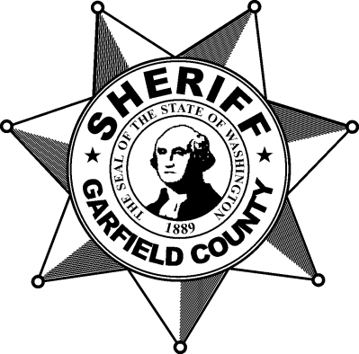
Garfield County
Sheriff’s Office
Code of Ethics

As a law enforcement officer, my fundamental obligation is to protect the constitutional rights and freedoms of the people whom I have been sworn to uphold.

While I consider the way I choose to conduct my private affairs a personal freedom,
I accept the responsibilities for my actions, as well as inactions, while on-duty or off-duty, when those actions bring disrepute on the public image of my employer, my fellow officers, and the law enforcement profession.

I vow to perform all my duties in a professional and competent manner. I consider the abilities to be courageous in the face of danger and to exercise restraint in the use of my power and authorities to be the ultimate public trust. I accept that I must consistently strive to achieve excellence in learning the necessary knowledge and skills associated with my duties. I will keep myself physically fit and mentally alert so that I am capable of performing my duties according to the standards of quality expected of my position.

I vow to be fully truthful and honest in my dealings with others. I deplore lies and half-truths that mislead or do not fully inform those who must depend upon my honesty. I will obey the very laws I am sworn to uphold. I will seek affirmative ways to comply with the standards of my agency and the lawful directions of my supervisors.

I vow to treat others with courtesy at all times. I consider it to be a professional weakness to allow another’s behavior to dictate my response. I will not allow others’ actions or failings to be my excuse for not performing my duties in a responsible, professional and expected manner.

I vow to empathize with the problems of people whom I come in daily contact. However, I cannot allow my personal feelings, prejudices, animosities, or friendships to influence the discretionary authorities entrusted to my job. I will affirmatively seek ways to avoid conflicts and potential conflicts of interest that could compromise my official authority or public image.

I hold the authority inherent in my position to be an affirmation of the public’s trust in me as a law enforcement officer. I do not take this trust lightly. As long as I remain in this position, I will dedicate myself to maintaining this trust and upholding all the ideals of the law enforcement profession.

